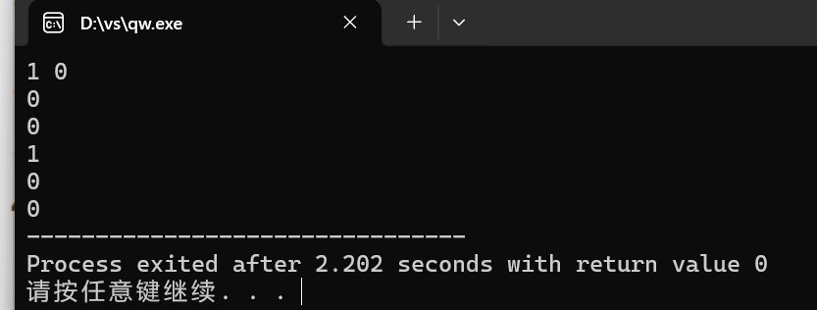

#include<bits/stdc++.h>

using namespace std;

int main(){

int p,q,a,b,c,d,e;

cin>>p>>q;

a=!p;

b= p && q;

c= p || q;

d=!p || q;

e= p == q;

cout<<a<<endl<<b<<endl<<c<<endl<<d<<endl<<e;

return 0;

}