docker-distribution 彻底删除镜像文件办法

1.环境

Version 2.6.0-1.el7.x86_64

rpm： docker-distribution-2.6.0-1.el7.x86_64

2. 默认不允许删除，需要设置下

vi /etc/docker-distribution/registry/config.yml

在storage下面加入

delete:

enabled: true #打开delete开关

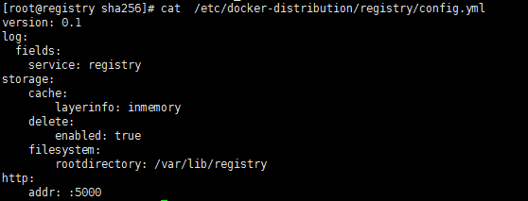

3. push 这个镜像到仓库中，一会在仓库中删除这个镜像

registry.example.com:5000/gitlab/gitlab-ce latest 2fb3cac83ed8 6 weeks ago 1.11 GB

docker push registry.example.com:5000/gitlab/gitlab-ce:latest

|  |
| --- |
| [root@registry sha256]# du -sh /var/lib/registry/ |

C:\Users\feng\AppData\Local\Temp\WeChat Files\a5958a6b8456ac5806f47d0938566ab.png

删除镜像前，仓库占用6.0G

4.删除manifest

查看要删除的镜像的digest，一会删除镜像必须要digest

|  |
| --- |
| [root@registry sha256]# curl -I -H "Accept: application/vnd.docker.distribution.manifest.v2+json" registry.example.com:5000/v2/gitlab/gitlab-ce/manifests/latest |

HTTP/1.1 200 OK

Content-Length: 2589

Content-Type: application/vnd.docker.distribution.manifest.v2+json

Docker-Content-Digest: sha256:d947725ba0453577f9113f6ed1b755a73f43c545c33da93a3c0e78bad4316450

Docker-Distribution-Api-Version: registry/2.0

Etag: "sha256:d947725ba0453577f9113f6ed1b755a73f43c545c33da93a3c0e78bad4316450"

Date: Thu, 04 May 2017 13:38:05 GMT

删之前，可以看到tags，latest

|  |
| --- |
| [root@registry sha256]# curl GET registry.example.com:5000/v2/gitlab/gitlab-ce/tags/list |

curl: (6) Could not resolve host: GET; Name or service not known

{"name":"gitlab/gitlab-ce","tags":["latest"]}

删除manifest

|  |
| --- |
| [root@registry sha256]# curl -i -X DELETE registry.example.com:5000/v2/gitlab/gitlab-ce/manifests/sha256:d947725ba0453577f9113f6ed1b755a73f43c545c33da93a3c0e78bad4316450 |

HTTP/1.1 202 Accepted

Docker-Distribution-Api-Version: registry/2.0

Date: Thu, 04 May 2017 14:01:10 GMT

Content-Length: 0

Content-Type: text/plain; charset=utf-8

删完manifest，查看不到镜像的tag



至此，只是删除了镜像的manifest，对应layer还没有被删除，占用的空间并没有被释放

5. 释放空间

|  |
| --- |
| [root@registry sha256]# registry garbage-collect /etc/docker-distribution/registry/config.yml |

C:\Users\feng\AppData\Local\Temp\WeChat Files\7d6e78d9f53b5dcb398177cf4bd35fe.png

空间减少了300M

6. 多镜像依赖依赖同一层的情况下，删除还未验证

参考内容

http://blog.csdn.net/xts_huangxin/article/details/51693890

https://github.com/docker/distribution/blob/master/docs/spec/api.md