Pi**pelins Lab**

在本实验中，您将探索持续集成和持续部署（CI / CD）的实践。您构建了一个管道，将openshift-tasks应用程序交付到生产环境中。构建过程集成了Gogs，Nexus，SonarQube和S2I构建。最终部署到生产中使用蓝绿色部署。将新版本的应用程序推送到Gogs时，可以配置要触发的管道。最后，将管道与OpenShift Web控制台集成。

# **Goals:**

设置OpenShift开发（包括测试）和生产项目

在jenkins建立一个管道项目

查看Gogs的源代码

使用Nexus作为Maven代理从源代码构建应用程序

将标记x.x-Buildnumber添加到构建的图像

运行单元测试

运行代码覆盖测试

将x.x tag添加到image

将docker image保存到Nexus Docker注册表

使用蓝绿部署将应用程序部署到生产环境

停止管道批准

批准后，将route切换到新部署

# Prerequisites

<https://www.opentlc.com/labs/ocp_advanced_development/04_1_CICD_Tools_Solution_Lab.html#labexercises>

jihongrui-beyondcent.com/-Pl,0Okm

Completion of the CI/CD Tools lab

The following tools available and configured (from the CI/CD Tools lab):

Jenkins

Custom Jenkins Maven slave image with **skopeo** installed

Gogs

**openshift-tasks-private** repository populated

Nexus

Configured as a Maven proxy repository

Configured as a release repository

Configured as a Docker registry

SonarQube

# Set Up Projects in OpenShift

在本节中，您将在OpenShift中设置开发和生产项目。

## 创建xyz-tasks-dev OpenShift项目

（用你的姓名首字母替换xyz）来保存openshift-tasks应用程序的开发版本：

1. 设置Jenkins的权限，以便能够操作xyz-tasks-dev项目中的对象。
2. 使用jboss-eap70-openshift：1.6 image stream创建二进制构建。
3. 创建指向任务的新部署：tasks:0.0-0。
4. 关闭自动构建和部署。
5. 将部署配置公开为服务（在端口8080上），将服务公开为路由。
6. 创建占位符ConfigMap（由管道更新）。
7. 将ConfigMap附加到部署配置。

# Set up Dev Project

oc new-project xyz-tasks-dev --display-name "Tasks Development"

oc policy add-role-to-user edit system:serviceaccount:xyz-jenkins:jenkins -n xyz-tasks-dev

# Set up Dev Application

oc new-build --binary=true --name="tasks" jboss-eap70-openshift:1.6 -n xyz-tasks-dev

oc new-app xyz-tasks-dev/tasks:0.0-0 --name=tasks --allow-missing-imagestream-tags=true -n xyz-tasks-dev

oc set triggers dc/tasks --remove-all -n xyz-tasks-dev

oc expose dc tasks --port 8080 -n xyz-tasks-dev

oc expose svc tasks -n xyz-tasks-dev

oc create configmap tasks-config --from-literal="application-users.properties=Placeholder" --from-literal="application-roles.properties=Placeholder" -n xyz-tasks-dev

oc set volume dc/tasks --add --name=jboss-config --mount-path=/opt/eap/standalone/configuration/application-users.properties --sub-path=application-users.properties --configmap-name=tasks-config -n xyz-tasks-dev

oc set volume dc/tasks --add --name=jboss-config1 --mount-path=/opt/eap/standalone/configuration/application-roles.properties --sub-path=application-roles.properties --configmap-name=tasks-config -n xyz-tasks-dev

## 创建xyz-tasks-prod OpenShift项目

（用您的姓名首字母替换xyz）来保存openshift-tasks应用程序的生产版本：

设置Jenkins的权限，以便能够操作xyz-tasks-prod项目中的对象。

创建两个新的部署配置：tasks-green和tasks-blue，并指向tasks：0.0。 关闭两个部署配置的自动构建和部署。

添加占位符ConfigMaps。

将ConfigMaps与部署配置相关联。

将部署配置公开为服务（在端口8080上），将蓝色服务公开为路由。

# Set up Production Project

oc new-project xyz-tasks-prod --display-name "Tasks Production"

oc policy add-role-to-group system:image-puller system:serviceaccounts:xyz-tasks-prod -n xyz-tasks-dev

oc policy add-role-to-user edit system:serviceaccount:public-services:jenkins -n xyz-tasks-prod

# Create Blue Application

oc new-app xyz-tasks-dev/tasks:0.0 --name=tasks-blue --allow-missing-imagestream-tags=true -n xyz-tasks-prod

oc set triggers dc/tasks-blue --remove-all -n xyz-tasks-prod

oc expose dc tasks-blue --port 8080 -n xyz-tasks-prod

oc create configmap tasks-blue-config --from-literal="application-users.properties=Placeholder" --from-literal="application-roles.properties=Placeholder" -n xyz-tasks-prod

oc set volume dc/tasks-blue --add --name=jboss-config --mount-path=/opt/eap/standalone/configuration/application-users.properties --sub-path=application-users.properties --configmap-name=tasks-blue-config -n xyz-tasks-prod

oc set volume dc/tasks-blue --add --name=jboss-config1 --mount-path=/opt/eap/standalone/configuration/application-roles.properties --sub-path=application-roles.properties --configmap-name=tasks-blue-config -n xyz-tasks-prod

# Create Green Application

oc new-app xyz-tasks-dev/tasks:0.0 --name=tasks-green --allow-missing-imagestream-tags=true -n xyz-tasks-prod

oc set triggers dc/tasks-green --remove-all -n xyz-tasks-prod

oc expose dc tasks-green --port 8080 -n xyz-tasks-prod

oc create configmap tasks-green-config --from-literal="application-users.properties=Placeholder" --from-literal="application-roles.properties=Placeholder" -n xyz-tasks-prod

oc set volume dc/tasks-green --add --name=jboss-config --mount-path=/opt/eap/standalone/configuration/application-users.properties --sub-path=application-users.properties --configmap-name=tasks-green-config -n xyz-tasks-prod

oc set volume dc/tasks-green --add --name=jboss-config1 --mount-path=/opt/eap/standalone/configuration/application-roles.properties --sub-path=application-roles.properties --configmap-name=tasks-green-config -n xyz-tasks-prod

# Expose Blue service as route to make blue application active

oc expose svc/tasks-blue --name tasks -n xyz-tasks-prod

# Build Pipeline

pipeline scripts example:

#!groovy

// Run this pipeline on the custom Maven Slave ('maven-appdev')

// Maven Slaves have JDK and Maven already installed

// 'maven-appdev' has skopeo installed as well.

node('maven-appdev') {

// Define Maven Command. Make sure it points to the correct

// settings for our Nexus installation (use the service to

// bypass the router). The file nexus_openshift_settings.xml

// needs to be in the Source Code repository.

def mvnCmd = "mvn -s ./nexus_openshift_settings.xml"

// Checkout Source Code.

stage('Checkout Source') {

// Replace xyz-gogs with the name of your Gogs project

// Replace the credentials with your credentials.

git credentialsId: '317bf993-9557-11e8-b7dc-005056a2342a', url: 'http://gogs.public-services.svc.cluster.local:3000/CICDLabs/openshift-tasks.git'

}

// The following variables need to be defined at the top level

// and not inside the scope of a stage - otherwise they would not

// be accessible from other stages.

// Extract version and other properties from the pom.xml

def groupId = getGroupIdFromPom("pom.xml")

def artifactId = getArtifactIdFromPom("pom.xml")

def version = getVersionFromPom("pom.xml")

// Set the tag for the development image: version + build number

// def devTag = "0.0-0"

// Set the tag for the production image: version

// def prodTag = "0.0"

// Set the tag for the development image: version + build number

def devTag = "${version}-${BUILD_NUMBER}"

// Set the tag for the production image: version

def prodTag = "${version}"

// Using Maven build the war file

// Do not run tests in this step

stage('Build war') {

echo "Building version ${devTag}"

sh "${mvnCmd} clean package -DskipTests"

}

// Using Maven run the unit tests

stage('Unit Tests') {

echo "Running Unit Tests"

sh "${mvnCmd} test"

}

stage('Code Analysis') {

echo "Running Code Analysis"

// Replace xyz-sonarqube with the name of your Sonarqube project

sh "${mvnCmd} sonar:sonar -Dsonar.host.url=http://sonarqube-public-services.apps.example.com/ -Dsonar.projectName=${JOB_BASE_NAME}-${devTag}"

}

// Publish the built war file to Nexus

stage('Publish to Nexus') {

echo "Publish to Nexus"

// Replace xyz-nexus with the name of your Nexus project

sh "${mvnCmd} deploy -DskipTests=true -DaltDeploymentRepository=nexus::default::http://nexus3.public-services.svc.cluster.local:8081/repository/releases"

}

// Build the OpenShift Image in OpenShift and tag it.

// Build the OpenShift Image in OpenShift and tag it.

stage('Build and Tag OpenShift Image') {

echo "Building OpenShift container image tasks:${devTag}"

// Start Binary Build in OpenShift using the file we just published

// The filename is openshift-tasks.war in the 'target' directory of your current

// Jenkins workspace

// Replace xyz-tasks-dev with the name of your dev project

sh "oc start-build tasks --follow --from-file=./target/openshift-tasks.war -n xyz-tasks-dev"

// OR use the file you just published into Nexus:

// sh "oc start-build tasks --follow --from-file=http://nexus3.xyz-nexus.svc.cluster.local:8081/repository/releases/org/jboss/quickstarts/eap/tasks/${version}/tasks-${version}.war -n xyz-tasks-dev"

// Tag the image using the devTag

openshiftTag alias: 'false', destStream: 'tasks', destTag: devTag, destinationNamespace: 'xyz-tasks-dev', namespace: 'xyz-tasks-dev', srcStream: 'tasks', srcTag: 'latest', verbose: 'false'

}

////////////////////////////////////////////////////

// Deploy the built image to the Development Environment.

// Deploy the built image to the Development Environment.

stage('Deploy to Dev') {

echo "Deploying container image to Development Project"

// Update the Image on the Development Deployment Config

sh "oc set image dc/tasks tasks=docker-registry.default.svc:5000/xyz-tasks-dev/tasks:${devTag} -n xyz-tasks-dev"

// Update the Config Map which contains the users for the Tasks application

sh "oc delete configmap tasks-config -n xyz-tasks-dev --ignore-not-found=true"

sh "oc create configmap tasks-config --from-file=./configuration/application-users.properties --from-file=./configuration/application-roles.properties -n xyz-tasks-dev"

// Deploy the development application.

// Replace xyz-tasks-dev with the name of your production project

openshiftDeploy depCfg: 'tasks', namespace: 'xyz-tasks-dev', verbose: 'false', waitTime: '', waitUnit: 'sec'

openshiftVerifyDeployment depCfg: 'tasks', namespace: 'xyz-tasks-dev', replicaCount: '1', verbose: 'false', verifyReplicaCount: 'false', waitTime: '', waitUnit: 'sec'

openshiftVerifyService namespace: 'xyz-tasks-dev', svcName: 'tasks', verbose: 'false'

}

// Run Integration Tests in the Development Environment.

stage('Integration Tests') {

echo "Running Integration Tests"

sleep 15

// Create a new task called "integration_test_1"

echo "Creating task"

sh "curl -i -u 'tasks:redhat1' -H 'Content-Length: 0' -X POST http://tasks.xyz-tasks-dev.svc.cluster.local:8080/ws/tasks/integration_test_1"

// Retrieve task with id "1"

echo "Retrieving tasks"

sh "curl -i -u 'tasks:redhat1' -H 'Content-Length: 0' -X GET http://tasks.xyz-tasks-dev.svc.cluster.local:8080/ws/tasks/1"

// Delete task with id "1"

echo "Deleting tasks"

sh "curl -i -u 'tasks:redhat1' -H 'Content-Length: 0' -X DELETE http://tasks.xyz-tasks-dev.svc.cluster.local:8080/ws/tasks/1"

}

// Copy Image to Nexus Docker Registry

// Copy Image to Nexus Docker Registry

stage('Copy Image to Nexus Docker Registry') {

echo "Copy image to Nexus Docker Registry"

sh "skopeo copy --src-tls-verify=false --dest-tls-verify=false --src-creds openshift:\$(oc whoami -t) --dest-creds admin:admin123 docker://docker-registry.default.svc.cluster.local:5000/xyz-tasks-dev/tasks:${devTag} docker://nexus-registry.public-services.svc.cluster.local:5000/tasks:${devTag}"

// Tag the built image with the production tag.

// Replace xyz-tasks-dev with the name of your dev project

openshiftTag alias: 'false', destStream: 'tasks', destTag: prodTag, destinationNamespace: 'xyz-tasks-dev', namespace: 'xyz-tasks-dev', srcStream: 'tasks', srcTag: devTag, verbose: 'false'

}

// Blue/Green Deployment into Production

// -------------------------------------

// Do not activate the new version yet.

def destApp = "tasks-green"

def activeApp = ""

stage('Blue/Green Production Deployment') {

// Replace xyz-tasks-dev and xyz-tasks-prod with

// your project names

activeApp = sh(returnStdout: true, script: "oc get route tasks -n xyz-tasks-prod -o jsonpath='{ .spec.to.name }'").trim()

if (activeApp == "tasks-green") {

destApp = "tasks-blue"

}

echo "Active Application: " + activeApp

echo "Destination Application: " + destApp

// Update the Image on the Production Deployment Config

sh "oc set image dc/${destApp} ${destApp}=docker-registry.default.svc:5000/xyz-tasks-dev/tasks:${prodTag} -n xyz-tasks-prod"

// Update the Config Map which contains the users for the Tasks application

sh "oc delete configmap ${destApp}-config -n xyz-tasks-prod --ignore-not-found=true"

sh "oc create configmap ${destApp}-config --from-file=./configuration/application-users.properties --from-file=./configuration/application-roles.properties -n xyz-tasks-prod"

// Deploy the inactive application.

// Replace xyz-tasks-prod with the name of your production project

openshiftDeploy depCfg: destApp, namespace: 'xyz-tasks-prod', verbose: 'false', waitTime: '', waitUnit: 'sec'

openshiftVerifyDeployment depCfg: destApp, namespace: 'xyz-tasks-prod', replicaCount: '1', verbose: 'false', verifyReplicaCount: 'true', waitTime: '', waitUnit: 'sec'

openshiftVerifyService namespace: 'xyz-tasks-prod', svcName: destApp, verbose: 'false'

}

stage('Switch over to new Version') {

input "Switch Production?"

echo "Switching Production application to ${destApp}."

// Replace xyz-tasks-prod with the name of your production project

sh 'oc patch route tasks -n xyz-tasks-prod -p \'{"spec":{"to":{"name":"' + destApp + '"}}}\''

}

}

// Convenience Functions to read variables from the pom.xml

// Do not change anything below this line.

// --------------------------------------------------------

def getVersionFromPom(pom) {

def matcher = readFile(pom) =~ '<version>(.+)</version>'

matcher ? matcher[0][1] : null

}

def getGroupIdFromPom(pom) {

def matcher = readFile(pom) =~ '<groupId>(.+)</groupId>'

matcher ? matcher[0][1] : null

}

def getArtifactIdFromPom(pom) {

def matcher = readFile(pom) =~ '<artifactId>(.+)</artifactId>'

matcher ? matcher[0][1] : null

}

## Create Pipeline Job

In Jenkins, create a **New Item**:

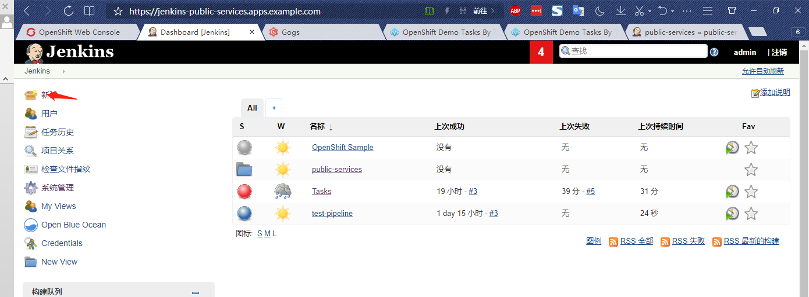

* **Type**: **Pipeline**
* **Name**: **Tasks**

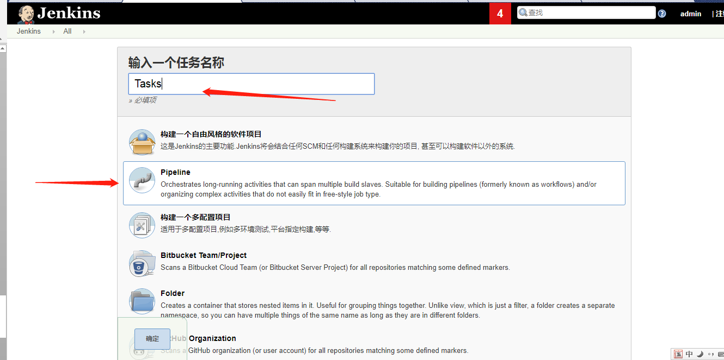

* **Pipeline Script**: See below

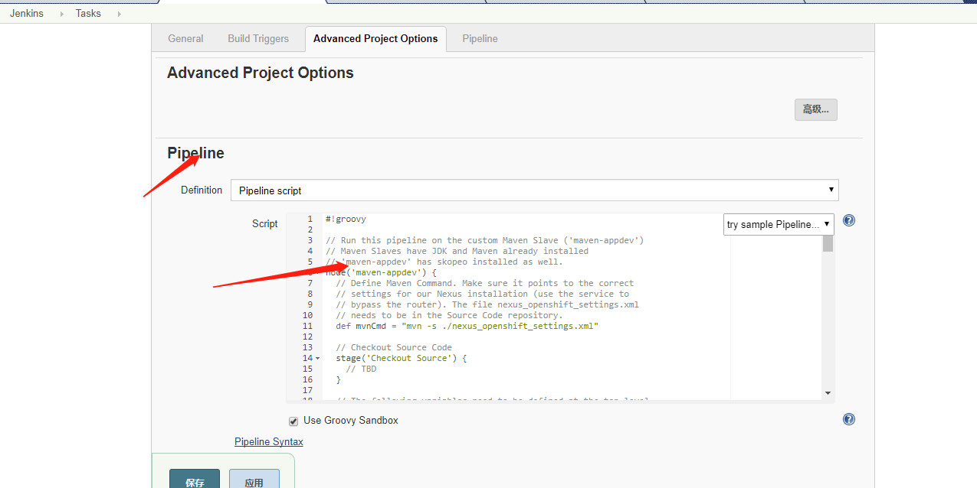

#!groovy

// Run this pipeline on the custom Maven Slave ('maven-appdev')

// Maven Slaves have JDK and Maven already installed

// 'maven-appdev' has skopeo installed as well.

node('maven-appdev') {

// Define Maven Command. Make sure it points to the correct

// settings for our Nexus installation (use the service to

// bypass the router). The file nexus_openshift_settings.xml

// needs to be in the Source Code repository.

def mvnCmd = "mvn -s ./nexus_openshift_settings.xml"

// Checkout Source Code

stage('Checkout Source') {

// TBD

}

// The following variables need to be defined at the top level

// and not inside the scope of a stage - otherwise they would not

// be accessible from other stages.

// Extract version and other properties from the pom.xml

def groupId = getGroupIdFromPom("pom.xml")

def artifactId = getArtifactIdFromPom("pom.xml")

def version = getVersionFromPom("pom.xml")

// Set the tag for the development image: version + build number

def devTag = "0.0-0"

// Set the tag for the production image: version

def prodTag = "0.0"

// Using Maven build the war file

// Do not run tests in this step

stage('Build war') {

echo "Building version ${version}"

// TBD

}

// Using Maven run the unit tests

stage('Unit Tests') {

echo "Running Unit Tests"

// TBD

}

// Using Maven call SonarQube for Code Analysis

stage('Code Analysis') {

echo "Running Code Analysis"

// TBD

}

// Publish the built war file to Nexus

stage('Publish to Nexus') {

echo "Publish to Nexus"

// TBD

}

// Build the OpenShift Image in OpenShift and tag it.

stage('Build and Tag OpenShift Image') {

echo "Building OpenShift container image tasks:${devTag}"

// TBD

}

// Deploy the built image to the Development Environment.

stage('Deploy to Dev') {

echo "Deploying container image to Development Project"

// TBD

}

// Run Integration Tests in the Development Environment.

stage('Integration Tests') {

echo "Running Integration Tests"

// TBD

}

// Copy Image to Nexus Docker Registry

stage('Copy Image to Nexus Docker Registry') {

echo "Copy image to Nexus Docker Registry"

// TBD

}

// Blue/Green Deployment into Production

// -------------------------------------

// Do not activate the new version yet.

def destApp = "tasks-green"

def activeApp = ""

stage('Blue/Green Production Deployment') {

// TBD

}

stage('Switch over to new Version') {

// TBD

echo "Switching Production application to ${destApp}."

// TBD

}

}

// Convenience Functions to read variables from the pom.xml

// Do not change anything below this line.

// --------------------------------------------------------

def getVersionFromPom(pom) {

def matcher = readFile(pom) =~ '<version>(.+)</version>'

matcher ? matcher[0][1] : null

}

def getGroupIdFromPom(pom) {

def matcher = readFile(pom) =~ '<groupId>(.+)</groupId>'

matcher ? matcher[0][1] : null

}

def getArtifactIdFromPom(pom) {

def matcher = readFile(pom) =~ '<artifactId>(.+)</artifactId>'

matcher ? matcher[0][1] : null

}

## Check Out Source Code

管道的第一步是从Gogs中的openshift-tasks-private存储库获取源代码。

考虑以下：

源代码库的URL是什么？

您想使用该服务或途径访问Gogs吗？

这是一个私人存储库。如何指定Jenkins的身份验证凭据？

使用Tasks：Pipeline Syntax：Snippet Generator来创建正确的git管道步骤。作为代码段生成器的一部分，将您的凭据存储到Jenkins中的Gogs。

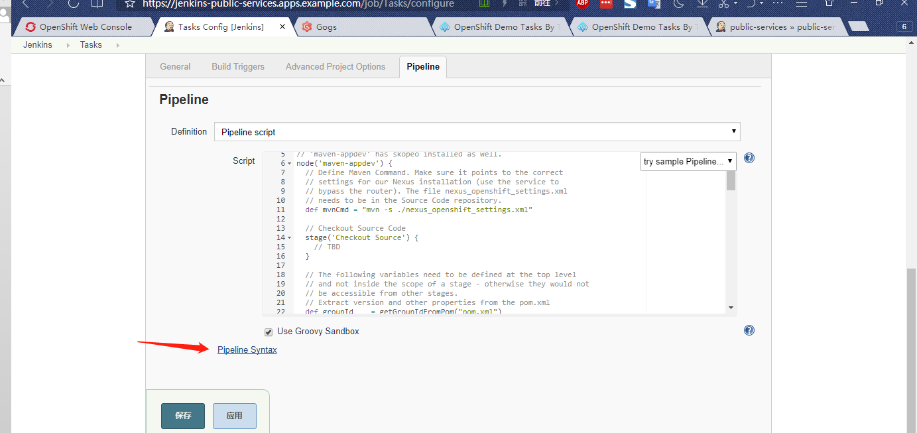

输入url

添加 jenkins , 输入user / password / id ...

Jenkins 会自动检测url user/password是否可以使用， 然后生成以下一个pipeline 中使用的git 字符串

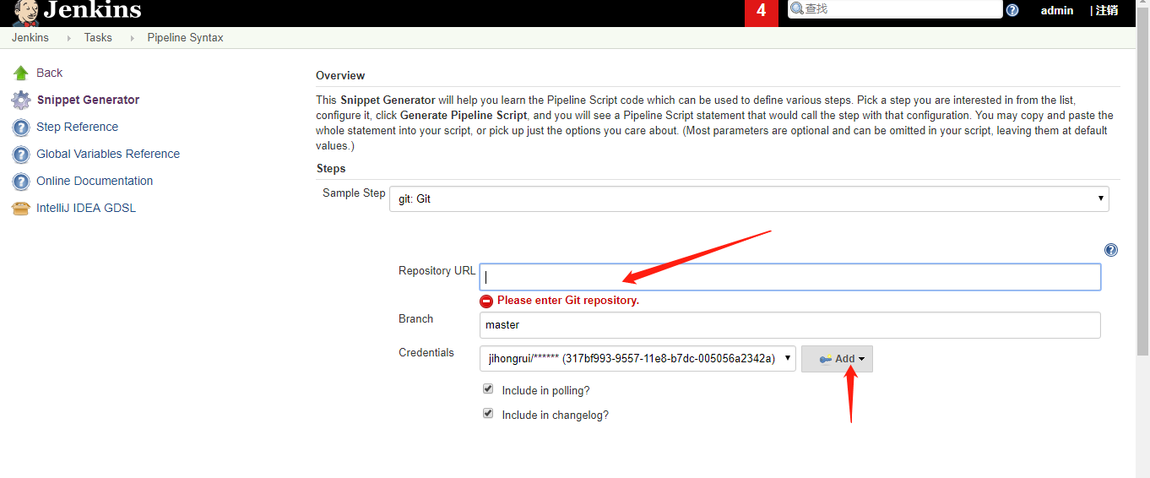

// Checkout Source Code.

stage('Checkout Source') {

// Replace xyz-gogs with the name of your Gogs project

// Replace the credentials with your credentials.

git credentialsId: '317bf993-9557-11e8-b7dc-005056a2342a', url: 'http://gogs.public-services.svc.cluster.local:3000/CICDLabs/openshift-tasks.git'

}

## Set Image Tags

Now that your source code is checked out, the pipeline can introspect the **pom.xml** file to determine the version of the application to be built. It is a best practice to set the development tag to a combination of the version number plus the actual build number from Jenkins. This way, you can run the pipeline multiple times and every time the version number is different. When the build passes all checks and tags the image as ready for production, the tag is just the version number.

1. In your pipeline, set the correct tags in the following section:
2. // Set the tag for the development image: version + build number
3. def devTag = "0.0-0"
4. // Set the tag for the production image: version

def prodTag = "0.0"

**Sample Solution**

// Set the tag for the development image: version + build number

def devTag = "${version}-${BUILD_NUMBER}"

// Set the tag for the production image: version

def prodTag = "${version}"

## Build WAR File

The second step in your pipeline is to build the WAR file from the source code.

1. Fill in the correct command(s) in this section:
2. *// Using Maven build the war file*
3. *// Do not run tests in this step*
4. stage('Build war') {
5. echo "Building version ${devTag}"
6. *// TBD*

}

1. Consider the following:
   * The pipeline defines an environment variable, **mvnCmd**, as **mvn -s ./nexus_openshift_settings.xml**.
   * **nexus_openshift_settings.xml** is in the Gogs repository and needs to point to the correct Nexus service.
   * Use **-DskipTests** to bypass unit tests. You run unit tests in the next section.

**Sample Solution**

// Using Maven build the war file

// Do not run tests in this step

stage('Build war') {

echo "Building version ${devTag}"

sh "${mvnCmd} clean package -DskipTests"

}

1. Run the pipeline and verify the following:
   * The build succeeds.
   * The build pulls build artifacts from Nexus instead of the Internet.
   * The build does not execute any unit tests.

## Run Unit Tests

Once you build the WAR file, run unit tests.

1. Fill in the correct command(s) in this section:
2. *// Using Maven run the unit tests*
3. stage('Unit Tests') {
4. echo "Running Unit Tests"
5. *// TBD*

}

1. Consider the following:
   * What is the Maven command to run unit tests?

**Sample Solution**

*// Using Maven run the unit tests*

stage('Unit Tests') {

echo "Running Unit Tests"

sh "${mvnCmd} test"

}

1. Run the pipeline and verify that the unit tests complete successfully.
2. Once the tests complete successfully, you can comment out the step in the pipeline to execute unit tests to save time in subsequent pipeline runs.

## Run Code Coverage Tests Using SonarQube

Once your unit tests succeed, run code coverage tests using SonarQube.

1. Fill in the correct command(s) in this section:
2. *// Using SonarQube to run code analysis*
3. stage('Code Analysis') {
4. echo "Running Code Analysis"
5. *// TBD*

}

1. Consider the following:
   * What is the Maven command to run SonarQube analysis?
   * What is the URL of the SonarQube service?
     + Do you want to use the service or the route?
   * What do you notice in the build log once the analysis is complete?
     + Again, consider if using a service or a route is better in this case.
   * What is the project name in SonarQube?
     + Do you prefer every pipeline run to update the same project in SonarQube or do you prefer individual projects for each pipeline run?

**Sample Solution**

stage('Code Analysis') {

echo "Running Code Analysis"

// Replace xyz-sonarqube with the name of your Sonarqube project

sh "${mvnCmd} sonar:sonar -Dsonar.host.url=http://sonarqube-xyz-sonarqube.apps.$GUID.example.opentlc.com/ -Dsonar.projectName=${JOB_BASE_NAME}-${devTag}"

}

1. Run the pipeline and verify that the code analysis tests complete successfully.
2. Verify the results in SonarQube.
3. Once the tests complete successfully, you can comment out the step to run code coverage tests to save time in subsequent pipeline runs.

## Store WAR File in Nexus

Once your code coverage tests succeed, you can be relatively certain that this current build is OK. The next step is to archive the built WAR file in Nexus.

1. Fill in the correct command(s) in this section:
2. *// Publish the built war file to Nexus*
3. stage('Publish to Nexus') {
4. echo "Publish to Nexus"
5. *// TBD*

}

1. Consider the following:
   * What is the Maven command to archive the WAR file in Nexus?
   * What is the correct URL of the Nexus release repository?
     + Do you want to use the service or the route?

**Sample Solution**

stage('Publish to Nexus') {

echo "Publish to Nexus"

*// Replace xyz-nexus with the name of your Nexus project*

sh "${mvnCmd} deploy -DskipTests=true -DaltDeploymentRepository=nexus::default::http://nexus3.xyz-nexus.svc.cluster.local:8081/repository/releases"

}

1. Run the pipeline and verify that the archiving completes successfully.
2. Verify the results in Nexus.

## Build Container Image in OpenShift

Once the WAR file has been archived, you can build the container image in OpenShift. Because you already built the WAR file in Jenkins, you can use a binary build to copy the WAR file into the new S2I build.

1. Fill in the correct command(s) in this section:
2. *// Build the OpenShift Image in OpenShift and tag it.*
3. stage('Build and Tag OpenShift Image') {
4. echo "Building OpenShift container image tasks:${devTag}"
5. *// TBD*

}

1. Consider the following:
   * Where in your Jenkins workspace is the WAR file that you want to use?
     + What is the filename of the built WAR file?
   * Can you use the WAR file from Nexus instead?
     + If so, what is the filename and location of the WAR file in Nexus?
   * Make sure you follow the binary build, which blocks the pipeline until the build is finished. Otherwise, you may be tagging the previously built image.
   * Your successfully built image has the tag **latest**.
   * Which additional tag does the built image need?

**Sample Solution**

*// Build the OpenShift Image in OpenShift and tag it.*

stage('Build and Tag OpenShift Image') {

echo "Building OpenShift container image tasks:${devTag}"

*// Start Binary Build in OpenShift using the file we just published*

*// The filename is openshift-tasks.war in the 'target' directory of your current*

*// Jenkins workspace*

*// Replace xyz-tasks-dev with the name of your dev project*

sh "oc start-build tasks --follow --from-file=./target/openshift-tasks.war -n xyz-tasks-dev"

*// OR use the file you just published into Nexus:*

*// sh "oc start-build tasks --follow --from-file=http://nexus3.xyz-nexus.svc.cluster.local:8081/repository/releases/org/jboss/quickstarts/eap/tasks/${version}/tasks-${version}.war -n xyz-tasks-dev"*

*// Tag the image using the devTag*

openshiftTag alias: 'false', destStream: 'tasks', destTag: devTag, destinationNamespace: 'xyz-tasks-dev', namespace: 'xyz-tasks-dev', srcStream: 'tasks', srcTag: 'latest', verbose: 'false'

}

1. Run the pipeline and verify that the build completes successfully.
2. Review the build logs in the OpenShift **xyz-tasks-dev** project.
3. Review the image stream in your **xyz-tasks-dev** project to verify that the correct tag was set.

## Deploy Built Image into Development Project

The next step is to deploy the container image that you just built. There is already a **tasks** deployment configuration in the **xyz-tasks-dev** project. It points to the **tasks:0.0-0** image, which does not exist. You need to update the deployment configuration to point to the correct image.

The project also contains a **tasks-config** ConfigMap that is supposed to hold two configuration files for the JBoss EAP image. In a regular S2I build, everything from the **configuration** directory in the source code repository automatically gets copied to the JBoss EAP configuration in the built image. However, because you built the image using a binary build, this did not happen. Therefore, you need to add the configuration files to the deployment configuration using a ConfigMap.

You need to delete the current ConfigMap and create a new one with the two files **./configuration/application-users.properties** and **./configuration/application-roles.properties**. You do not need to worry about associating this ConfigMap with the deployment configuration—you already did that when you set up the project.

Once the ConfigMap is created, you can deploy the application using the updated image and ConfigMap, and then verify that the deployment succeeds.

Finally, you need to check that the service for the deployment configuration reacts to traffic.

1. Fill in the correct command(s) in this section:
2. *// Deploy the built image to the Development Environment.*
3. stage('Deploy to Dev') {
4. echo "Deploying container image to Development Project"
5. *// TBD*

}

1. Consider the following:
   * How do you tell the deployment configuration which image to use?
   * How do you delete an existing ConfigMap?
   * How do you create a new ConfigMap with content from files?
   * How do you trigger the deployment once the deployment configuration points to the correct image?
     + Is there a built-in Jenkins pipeline command you can use?
   * How do you verify that the deployment was successful?
     + Is there a built-in Jenkins pipeline command you can use?
   * How do you verify that the service for the deployment configuration is working?
     + Is there a built-in Jenkins pipeline command you can use?

**Sample Solution**

*// Deploy the built image to the Development Environment.*

stage('Deploy to Dev') {

echo "Deploying container image to Development Project"

*// Update the Image on the Development Deployment Config*

sh "oc set image dc/tasks tasks=docker-registry.default.svc:5000/xyz-tasks-dev/tasks:${devTag} -n xyz-tasks-dev"

*// Update the Config Map which contains the users for the Tasks application*

sh "oc delete configmap tasks-config -n xyz-tasks-dev --ignore-not-found=true"

sh "oc create configmap tasks-config --from-file=./configuration/application-users.properties --from-file=./configuration/application-roles.properties -n xyz-tasks-dev"

*// Deploy the development application.*

*// Replace xyz-tasks-dev with the name of your production project*

openshiftDeploy depCfg: 'tasks', namespace: 'xyz-tasks-dev', verbose: 'false', waitTime: '', waitUnit: 'sec'

openshiftVerifyDeployment depCfg: 'tasks', namespace: 'xyz-tasks-dev', replicaCount: '1', verbose: 'false', verifyReplicaCount: 'false', waitTime: '', waitUnit: 'sec'

openshiftVerifyService namespace: 'xyz-tasks-dev', svcName: 'tasks', verbose: 'false'

}

1. Run the pipeline and verify that the deployment completes successfully.
2. Review the deployment configuration to double-check that the correct image was deployed.
   * You need to compare the image **sha256** hash code with the tag in the Image Stream.
3. Review the ConfigMap to verify that it has the correct data.
4. In a web browser, navigate to your application’s route to validate that it is working properly.

## Run Integration Tests

It is a good idea to test the running application/service to ensure that it is still behaving as expected. This is where integration tests come into play.

The **openshift-tasks** application is a simple task management application with a REST interface to create, retrieve, and delete tasks. The **README** file for the application has information about user IDs and possible commands to manipulate tasks.

In this pipeline, you create a task, retrieve it, and then delete that task. This leaves the database in the same state it was in before running the tests. When all commands succeed, you can be confident that your application is working properly.

1. Wait 15 seconds to ensure that the application has started successfully.
2. Create a task:

**Sample Output**

HTTP/1.1 201 Created

Expires: 0

Cache-Control: no-cache, no-store, must-revalidate

X-Powered-By: Undertow/1

Server: JBoss-EAP/7

Pragma: no-cache

Location: http://tasks.xyz-tasks-dev.svc.cluster.local:8080/ws/tasks/1

Date: Tue, 20 Feb 2018 16:40:52 GMT

Connection: keep-alive

Content-Length: 0

* + Note the **201 created** response status.

1. Retrieve the task:

**Sample Output**

HTTP/1.1 200 OK

Expires: 0

Cache-Control: no-cache, no-store, must-revalidate

X-Powered-By: Undertow/1

Server: JBoss-EAP/7

Pragma: no-cache

Date: Tue, 20 Feb 2018 16:40:52 GMT

Connection: keep-alive

Content-Type: application/xml

Content-Length: 151

<?xml version="1.0" encoding="UTF-8" standalone="yes"?><collection><task id="1" ownerName="tasks"><title>integration_test_1</title></task></collection>

* + Note the **200 OK** response status and the content of your task as XML payload.

1. Delete the task:

**Sample Output**

HTTP/1.1 204 No Content

Expires: 0

Cache-Control: no-cache, no-store, must-revalidate

X-Powered-By: Undertow/1

Server: JBoss-EAP/7

Pragma: no-cache

Date: Tue, 20 Feb 2018 16:40:53 GMT

* + Note the **204 No Content** response status.

1. Fill in the correct command(s) in this section:
2. *// Run Integration Tests in the Development Environment.*
3. stage('Integration Tests') {
4. echo "Running Integration Tests"
5. sleep 15
6. *// TBD*

}

1. Consider the following:
   * Which user ID and password combination do you want to use to access the **openshift-tasks** application?
   * What is the URL of the task application?
     + Do you want to use the route or the service?
   * What is the best way to call a REST service from within a Jenkins slave pod?

**Sample Solution**

*// Run Integration Tests in the Development Environment.*

stage('Integration Tests') {

echo "Running Integration Tests"

sleep 15

*// Create a new task called "integration_test_1"*

echo "Creating task"

sh "curl -i -u 'tasks:redhat1' -H 'Content-Length: 0' -X POST http://tasks.xyz-tasks-dev.svc.cluster.local:8080/ws/tasks/integration_test_1"

*// Retrieve task with id "1"*

echo "Retrieving tasks"

sh "curl -i -u 'tasks:redhat1' -H 'Content-Length: 0' -X GET http://tasks.xyz-tasks-dev.svc.cluster.local:8080/ws/tasks/1"

*// Delete task with id "1"*

echo "Deleting tasks"

sh "curl -i -u 'tasks:redhat1' -H 'Content-Length: 0' -X DELETE http://tasks.xyz-tasks-dev.svc.cluster.local:8080/ws/tasks/1"

}

1. Run the pipeline and verify that the integration tests complete as expected.

## Copy Container Image to Nexus Container Registry

Oftentimes the pipeline needs to move the tested container image to another container registry, or another OpenShift cluster entirely, for deployment to production.

In your environment, Nexus is configured to act as a Docker registry. You use **skopeo** to copy the tested image from the integrated OpenShift Container Registry to the Nexus container registry. Once the image is copied to Nexus, you need to tag the image as ready for production.

1. Fill in the correct command(s) in this section:
2. *// Copy Image to Nexus Docker Registry*
3. stage('Copy Image to Nexus Docker Registry') {
4. echo "Copy image to Nexus Docker Registry"
5. *// TBD*

}

1. Consider the following:
   * Using the customer **maven-appdev** slave builder image, you can use **skopeo** to manipulate container images.
   * What is the correct command for **skopeo** to copy an image from one registry to another?
   * What is the correct service/route for the OpenShift Container Registry?
   * What is the correct service/route for the Nexus container registry?
   * Both registries need credentials.
     + Which credentials do you use for the OpenShift Container Registry?
     + Which user does the **maven-appdev** pod run under?
     + When specifying a token, do you need to specify the user name?
     + Which credentials do you use for the Nexus container registry?
   * Both registries use self-signed certificates—how do you bypass certificate validation?
   * How can you test your **skopeo** command without running your pipeline repeatedly?
   * What is the correct tag for the image to roll it out into production?
     + What is the source tag for the production tag—is it **'latest'** or something else?
     + Which project are you using to manipulate the Image Stream?

**Sample Solution**

*// Copy Image to Nexus Docker Registry*

stage('Copy Image to Nexus Docker Registry') {

echo "Copy image to Nexus Docker Registry"

sh "skopeo copy --src-tls-verify=false --dest-tls-verify=false --src-creds openshift:\$(oc whoami -t) --dest-creds admin:admin123 docker://docker-registry.default.svc.cluster.local:5000/xyz-tasks-dev/tasks:${devTag} docker://nexus-registry.xyz-nexus.svc.cluster.local:5000/tasks:${devTag}"

*// Tag the built image with the production tag.*

*// Replace xyz-tasks-dev with the name of your dev project*

openshiftTag alias: 'false', destStream: 'tasks', destTag: prodTag, destinationNamespace: 'xyz-tasks-dev', namespace: 'xyz-tasks-dev', srcStream: 'tasks', srcTag: devTag, verbose: 'false'

}

1. Run the pipeline and verify that the container image gets copied from the OpenShift Container Registry to the Nexus container registry successfully.
2. Review the Nexus container registry to validate that the correct image was copied.
   * You need to compare the image **sha256** hash code with the tag in the Image Stream.

## Deploy to Production Using Blue-Green Deployment

Once your container image is safely stored in the Nexus container registry, you can deploy the image into your production environment.

|  |  |
| --- | --- |
|  | Because the image is in a registry external to OpenShift, you can deploy the image into a completely different cluster for production. In that case, you need to either enable your cluster to pull from this external registry—or use **skopeo**again to copy the image to the container registry in your production cluster. |

In this lab, you are deploying into the production project on the same cluster.

You are using a blue-green deployment methodology to execute the deployment. This means that:

* You need to determine which version of the application (blue or green) is currently active.
* You need to update the correct ConfigMap with the JBoss EAP server configuration as well.
* You deploy the application to the currently inactive application.
* In this pipeline, you need to stop for approval when the new version of the application has been deployed before you switch the route.

1. Fill in the correct command(s) in this section:
2. *// Blue/Green Deployment into Production*
3. *// -------------------------------------*
4. *// Do not activate the new version yet.*
5. def destApp = "tasks-green"
6. def activeApp = ""
7. stage('Blue/Green Production Deployment') {
8. *// TBD*

}

1. Consider the following:
   * How do you determine which version of the application is currently active?
     + Can you examine where the route is pointing to?
   * Once you know which deployment configuration to update, how do you update the image that is to be deployed?
   * What is the exact image that is to be deployed?
   * Where is that image located? In which project?
   * Which ConfigMap needs to be updated with the JBoss EAP server configuration?
   * How do you trigger a redeployment once you have updated your image?
   * How do you verify that the deployment was successful?

**Sample Solution**

// Blue/Green Deployment into Production

// -------------------------------------

// Do not activate the new version yet.

def destApp = "tasks-green"

def activeApp = ""

stage('Blue/Green Production Deployment') {

// Replace xyz-tasks-dev and xyz-tasks-prod with

// your project names

activeApp = sh(returnStdout: true, script: "oc get route tasks -n xyz-tasks-prod -o jsonpath='{ .spec.to.name }'").trim()

if (activeApp == "tasks-green") {

destApp = "tasks-blue"

}

echo "Active Application: " + activeApp

echo "Destination Application: " + destApp

// Update the Image on the Production Deployment Config

sh "oc set image dc/${destApp} ${destApp}=docker-registry.default.svc:5000/xyz-tasks-dev/tasks:${prodTag} -n xyz-tasks-prod"

// Update the Config Map which contains the users for the Tasks application

sh "oc delete configmap ${destApp}-config -n xyz-tasks-prod --ignore-not-found=true"

sh "oc create configmap ${destApp}-config --from-file=./configuration/application-users.properties --from-file=./configuration/application-roles.properties -n xyz-tasks-prod"

// Deploy the inactive application.

// Replace xyz-tasks-prod with the name of your production project

openshiftDeploy depCfg: destApp, namespace: 'xyz-tasks-prod', verbose: 'false', waitTime: '', waitUnit: 'sec'

openshiftVerifyDeployment depCfg: destApp, namespace: 'xyz-tasks-prod', replicaCount: '1', verbose: 'false', verifyReplicaCount: 'true', waitTime: '', waitUnit: 'sec'

openshiftVerifyService namespace: 'xyz-tasks-prod', svcName: destApp, verbose: 'false'

}

1. Run the pipeline and verify that the correct deployment configuration was updated.
2. Verify that the deployment configuration points to the correct image (you may need to compare with the **sha256** hash codes to verify this).
3. Verify that your route still points to the currently active configuration and not the one you just deployed.

## Switch Production Application

Your application is now ready for switchover. The application is fully running and ready to receive traffic. You can run another test using the live application in the production environment (cluster) before switching over traffic, if you want. In this lab, you are stopping the pipeline for approval. Once approved, the pipeline switches the route from the old application to the new one.

1. Fill in the correct command(s) in this section:
2. stage('Switch over to new Version') {
3. *// TBD*

}

1. Consider the following:
   * How do you stop the pipeline and ask for approval?
   * How do you change the route to point to the other service?

**Sample Solution**

stage('Switch over to new Version') {

input "Switch Production?"

echo "Switching Production application to ${destApp}."

// Replace xyz-tasks-prod with the name of your production project

sh 'oc patch route tasks -n xyz-tasks-prod -p \'{"spec":{"to":{"name":"' + destApp + '"}}}\''

}

1. Run the pipeline and double-check that the route changes to the new version of the application once you approve the switch.

## Move Pipeline to Source Code Repository

Now that you are happy with your pipeline, it is a good idea to move the pipeline into a source code repository.

1. In your **openshift-tasks-private** directory, create a **Jenkinsfile** file and copy the pipeline script from your Jenkins tasks into this file.
2. Add the **Jenkinsfile** file to the repository, then commit and push it into the repository.
3. Change the pipeline job definition in Jenkins to point to this **pipeline as code** from the Gogs repository.
4. Consider the following:
   * You may need to change the way your pipeline checks out the source code from Gogs.
   * Your Jenkins job may need credentials to retrieve the **Jenkinsfile** from Gogs.

**Sample Solution**

// Checkout Source Code

stage('Checkout Source') {

checkout scm

}

1. Make sure to run the pipeline one last time with all stages that you previously commented out enabled.
   * Your pipeline is now complete.

# Set Up Web Deployment Hook

To automate the build whenever new content is pushed to the **openshift-tasks-private** repository, set up a Git hook in Gogs. This way, a Jenkins build is triggered whenever code is pushed to the **openshift-tasks-private** source repository on Gogs.

1. Find the authorization token in Jenkins:
   1. Open a browser and log in to Jenkins.
   2. In the top right corner, click the down arrow next to your username and select **Configure**.
   3. Click **Show API Token** and make note of the **User ID** and **API Token** that are displayed.
2. Create the web hook in Gogs:
   1. Open a browser, navigate to the Gogs server, log in, and go to the **CICDLabs/openshift-tasks-private** repository.
   2. Click **Settings**, and then click **Git Hooks**.
   3. Click the pencil icon next to **post-receive**.
   4. Copy and paste this script into the **Hook Content** field, replacing **<userid>** and **<apiToken>** with your Jenkins user ID and API token, **<jenkinsService>** with the name of your Jenkins service, and **<jenkinsProject>** with the name of the OpenShift project your Jenkins service is located in:
   5. #!/bin/bash
   6. while read oldrev newrev refname
   7. do
   8. branch=$(git rev-parse --symbolic --abbrev-ref $refname)
   9. if [[ "$branch" == "master" ]]; then
   10. curl -k -X POST --user <userid>:<apiToken> http://<jenkinsService>.<jenkinsProject>.svc.cluster.local/job/Tasks/build
   11. fi

done

* + - This script signals the Jenkins **Tasks** build job each time a commit is made to the master branch.

1. Click **Update Hook**.

# Trigger New Build

Committing a new version of the application source code triggers a new build as a result of the Git hook you configured. It is a good practice to increment the version number each time you make changes to your application. You can increment the version number manually or automatically.

1. Increment the version number:
   1. Change the **openshift-tasks** source code to make sure you are seeing an updated version of your application after the pipeline completes.
      * Look near line 45 of the code—where the title of the page is rendered—in the **$HOME/openshift-tasks/src/main/webapp/index.jsp** file.
   2. Increment the version number of the project each time code is pushed using Maven—for example, updating the version number (**VERSION=1.0**) with the next minor or major number (**VERSION=1.1**):
   3. cd $HOME/openshift-tasks
   4. export VERSION=1.1
   5. mvn versions:set -f pom.xml -s nexus_settings.xml -DgenerateBackupPoms=false -DnewVersion=${VERSION}
   6. git add pom.xml src/main/webapp/index.jsp
   7. git commit -m "Increased version to ${VERSION}"

git push private master

1. Validate that this push triggered a new build in Jenkins.
2. After a few minutes, when prompted by the pipeline, approve the switch to the new version.
   1. Click **Proceed**.
3. Once the pipeline finishes successfully, verify that you can see the updated application.

# Build Configuration with Pipeline

Instead of defining the pipeline in Jenkins, you can create an OpenShift build configuration with a Pipeline build strategy. This build configuration must be in the same project as the Jenkins pod (unless you configure the **master-config.yaml** to point to another Jenkins instance).

1. To integrate the pipeline with the OpenShift web console, create a build configuration that points to the **Jenkinsfile** file in your **openshift-tasks-private** repository.
2. You need to create a YAML/JSON file containing your build configuration definition and then create the build configuration from that file.
   * Remember that your **openshift-tasks-private** repository is private, which means OpenShift needs credentials to access the **Jenkinsfile** file.
     1. Create the **tasks-pipeline.yaml** file:

**Sample Solution**

echo "apiVersion: v1

items:

- kind: "BuildConfig"

apiVersion: "v1"

metadata:

name: "tasks-pipeline"

spec:

source:

type: "Git"

git:

uri: "http://gogs.xyz-gogs.svc.cluster.local:3000/CICDLabs/openshift-tasks-private"

strategy:

type: "JenkinsPipeline"

jenkinsPipelineStrategy:

jenkinsfilePath: Jenkinsfile

kind: List

metadata: []" | oc create -f - -n xyz-jenkins

* + 1. Create a build secret:

oc secrets new-basicauth gogs-secret --username=<user_name> --password=<password> -n xyz-jenkins

* + 1. Associate the build secret with the build configuration:

oc set build-secret --source bc/tasks-pipeline gogs-secret -n xyz-jenkins

1. In the OpenShift web console, switch to your Jenkins project and navigate to **Builds → Pipelines**.
2. Click **Start Pipeline** to trigger a new pipeline.
3. Click **View Log** to view the pipeline progression and follow along in Jenkins.

# Clean Up Environment

1. To clean up the environment, delete all of your projects:
2. oc delete project xyz-tasks-dev
3. oc delete project xyz-tasks-prod
4. oc delete project xyz-gogs
5. oc delete project xyz-nexus
6. oc delete project xyz-sonarqube

oc delete project xyz-jenkins