1. Linux为Python添加TAB自动补全和命令历史功能。
2. 听语音

* |
* 浏览：2123
* |
* 更新：2017-02-12 15:58
* |
* 标签：[PYTHON](https://jingyan.baidu.com/tag?tagName=PYTHON)
* [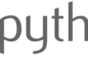](http://jingyan.baidu.com/album/425e69e6ba30c4be15fc162a.html?picindex=1)1
* [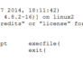](http://jingyan.baidu.com/album/425e69e6ba30c4be15fc162a.html?picindex=2)2
* [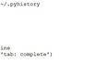](http://jingyan.baidu.com/album/425e69e6ba30c4be15fc162a.html?picindex=3)3
* [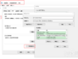](http://jingyan.baidu.com/album/425e69e6ba30c4be15fc162a.html?picindex=4)4

[分步阅读](http://jingyan.baidu.com/album/425e69e6ba30c4be15fc162a.html)

为Python添加交互模式下TAB自动补全以及命令历史功能。

linux python tab 补全    windows python tab 补全

[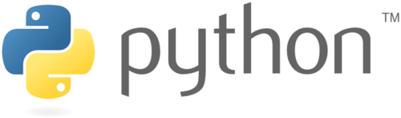](http://jingyan.baidu.com/album/425e69e6ba30c4be15fc162a.html?picindex=1)

工具/原料

* linux vim
* linux python readline
* windows python pyreadline

方法/步骤

1. Linux Python Tab 自动补全方法：

新建Python环境变量配置文件：

vim ~/.pystartup

# Add auto-completion and a stored history file of commands to your Python

# interactive interpreter. Requires Python 2.0+, readline. Autocomplete is

# bound to the Esc key by default (you can change it - see readline docs).

#

# Store the file in ~/.pystartup, and set an environment variable to point

# to it:  "export PYTHONSTARTUP=~/.pystartup" in bash.

import atexit

import os

import readline

import rlcompleter

readline.parse_and_bind('tab: complete')

historyPath = os.path.expanduser("~/.pyhistory")

def save_history(historyPath=historyPath):

    import readline

    readline.write_history_file(historyPath)

if os.path.exists(historyPath):

    readline.read_history_file(historyPath)

atexit.register(save_history)

del os, atexit, readline, rlcompleter, save_history, historyPath

1. 设置Python环境变量：

即时生效，重启失效：export PYTHONSTARTUP=~/.pystartup

永久生效：echo "export PYTHONSTARTUP=~/.pystartup" >> /etc/profile

1. 验证：

[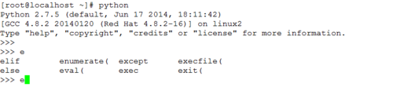](http://jingyan.baidu.com/album/425e69e6ba30c4be15fc162a.html?picindex=2)

[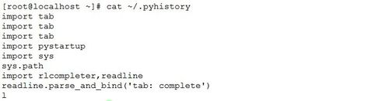](http://jingyan.baidu.com/album/425e69e6ba30c4be15fc162a.html?picindex=3)

1. 注：默认补全是ESC。

readline.parse_and_bind('tab: complete') 这条命令用来设定为tab补全。

1. Windows Python Tab 自动补全方法：

a. 安装python

b. pip install pyreadline

c. 在Python安装路径的Lib文件夹下新建一个tab.py

例如：C:\Program Files (x86)\Python2\Lib

用编辑器编辑：

# Add auto-completion and a stored history file of commands to your Python

# interactive interpreter.

import atexit

import os

import readline

import rlcompleter

import sys

# Tab completion

readline.parse_and_bind('tab: complete')

# history file

histfile = os.path.join("D:\\Tmp\\history\\", ".pythonhistory")

try:

    readline.read_history_file(histfile)

except IOError:

    pass

atexit.register(readline.write_history_file, histfile)

del os, histfile, readline, rlcompleter

注：

histfile = os.path.join("D:\\Tmp\\history\\", ".pythonhistory") 这个路径可以自定义设置。

1. d. 输入python就自动加载tab补全

 和linux类似，如果想输入python就自动加载tab补全，在系统属性中的环境变量里增加PYTHONSTARTUP变量，值为绝对路径的 tab.py，例如：

变量名：PYTHONSTARTUP

变量值：C:\Program Files (x86)\Python2\Lib\tab.py

注：不做这步的话，每次输入python进入交互界面后，需要手动import tab

[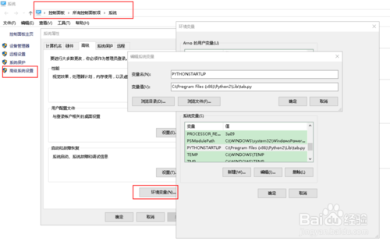](http://jingyan.baidu.com/album/425e69e6ba30c4be15fc162a.html?picindex=4)

END

注意事项

* 注意环境变量设定的方式
* 对当前用户永久生效，请编辑：~/.bash_profile