CISC7204 — Data Science and Data Visualization
Coursework item: Assignment 02 · Revised Pair Project Proposal
Leisure-Time Physical Activity and the Network Structure of Depressive Symptoms among U.S. Adults: a NHANES 2017–March 2020 Analysis
Class K · Pair 01 · Team 02
ZHU ZHONGXIN (Student ID: MC662722) · DENG YI (Student ID: MC662921)
Submission date: 25 October 2026
1. Project Title and Research Question
Title: “Does leisure-time physical activity go with fewer depressive symptoms and a differently connected symptom system? A dose–response and network analysis of PHQ-9 data from NHANES.” This is the revised version of the individual proposal submitted with Assignment 01, reworked as pair work and rebuilt around the correct exposure definition (see Section 7).
Research question: among U.S. adults aged 20–80, how is habitual leisure-time physical activity related to the level and to the structure of depressive symptoms measured by the PHQ-9? The level part asks how common each symptom is, how severe the total score is, and whether the odds of clinically relevant depression (PHQ-9 ≥ 10) fall as activity rises. The structure part asks which symptoms act as hubs of the inter-connected symptom system, and whether that system is wired differently in active and inactive adults.
2. Region and Domain
Region: United States — a nationally representative sample (NHANES 2017 – March 2020 pre-pandemic cycle, National Center for Health Statistics).
Domain category: mental health and psychology, specifically the nine PHQ-9 depressive symptoms, crossed with physical-activity behaviour (leisure-time and occupational) and body measures.
3. Purpose
Outcomes. The pair consolidates the pipeline practised in Assignments 01 and 02 — importing and cleaning a large public survey, exploratory analysis, model development and evaluation — and extends it toward uncertainty-aware visualisation (confidence intervals, a forest plot, a permutation test) and multivariate structure (a partial-correlation network). It supports a data-science and public-health direction, since the physical-activity–mental-health link remains an open public-health question.
Skills. Merging multi-table survey data with documented item non-response; deriving standardised scores and exposure variables; group comparison with formal tests and effect sizes; adjusted logistic regression reported as odds ratios; network estimation with centrality indices and a permutation-based group comparison; and producing figures that report results clearly, with titles, axis labels and legends in place.
Knowledge. The NHANES survey design and public-use files; the PHQ-9 as a screening measure and its cut-offs; the difference between leisure-time and occupational physical activity and the resulting physical-activity paradox; and the network approach to psychopathology, which treats a disorder as a system of mutually reinforcing symptoms rather than a single latent cause.
4. Data Sources
Four NHANES 2017 – March 2020 components are used: Depression (DPQ), Demographics (DEMO), Body Measures (BMX) and Physical Activity (PAQ). From PAQ the project keeps the leisure-time items (PAQ650, PAQ665) and the occupational items (PAQ605, PAQ620). All files are free to download without registration; the official SAS-XPORT files were converted to CSV and the verification notebook reads the CSV copies.
- Survey page: https://wwwn.cdc.gov/nchs/nhanes/continuousnhanes/default.aspx?BeginYear=2017
- Depression file: https://wwwn.cdc.gov/Nchs/Data/Nhanes/Public/2017/DataFiles/DPQ_J.xpt
- Physical activity file: https://wwwn.cdc.gov/Nchs/Data/Nhanes/Public/2017/DataFiles/PAQ_J.xpt
- Documentation: https://www.cdc.gov/nchs/nhanes/
5. Tasks and Deliverables
- Merge the four files on SEQN, keep adults 20–80, and document non-response at each step (5,533 DPQ records → 5,265 adults → 4,846 with a complete PHQ-9).
- Derive PHQ-9 total and severity bands, the clinical flag (≥ 10), leisure-time activity as a flag and as four intensity levels, occupational activity, BMI and age bands.
- Descriptives and exposure figures: symptom prevalence by activity, mean score across activity levels, prevalence of clinical depression with 95% Wilson intervals and a chi-square test.
- Adjusted logistic regression of clinical depression on age, sex, BMI, leisure-time and occupational activity, drawn as an odds-ratio forest plot.
- Network layer: partial-correlation network of the nine symptoms, strength and expected-influence centrality, strongest edges, and a 1,000-permutation comparison of global strength between active and inactive adults.
- Deliverables: an executed Jupyter notebook reproducing every number and figure, the composite figure set, and this proposal. The full 11-figure exploratory set stays in the notebook.
6. Criteria for Success, Scope and Limitations
- The notebook runs end to end from the raw CSV copies and reproduces every figure and number quoted here.
- Exposure estimates carry uncertainty: confidence intervals on prevalences and means, a permutation p-value for the network comparison.
- Leisure-time and occupational activity stay separate, so the two are not pooled into one general claim.
- Every figure is mapped to the part of the question it answers (Table 1).
Limitations: NHANES is cross-sectional, so no causal claim is made and reverse causation cannot be excluded; activity and symptoms are self-reported and the PHQ-9 is a screening instrument, not a diagnosis; residual confounding by income, education and chronic disease is possible.
7. Project Collaboration (Pair 01)
This is pair work. Partner information: ZHU ZHONGXIN (MC662722) and DENG YI (MC662921), both of Class K, registered as Pair 01 on 5 October 2026.
Division of work. Both members jointly define the research question, clean and validate the data, interpret the results and revise this document. Within that shared base, ZHU ZHONGXIN leads study design and the formulation of the question, the data pipeline, the statistical modelling and network estimation, the verification notebook, and final assembly and submission. DENG YI leads the sourcing and documentation of the NHANES files and their usage permissions, the readability pass over all figures, the literature scan on the physical-activity paradox and the PHQ-9 cut-offs, the drafting of the background, purpose and collaboration sections, and the critical review of the final text.
Ground rules. A fixed weekly check-in; one shared project folder with version history so no work is held by only one member; every figure and number reviewed by both members before submission; substantive decisions by consensus; a 48-hour personal buffer before each deadline.
Group structure. ZHU ZHONGXIN is project coordinator and technical lead for the modelling, and liaison to the instructor and the TA. DENG YI is project scribe (written record, meeting notes, the document) and progress tracker (task list and deadline calendar). Both roles apply throughout the project period.
8. How the Visualisation Addresses the Research Question
The level part of the question is answered by Figures 1 and 2. Figure 1a shows which symptoms are reported on more than half the days in each activity group, so the reader sees where the groups differ before any model is fitted; every symptom is more common among inactive adults, from anhedonia to self-harm. Figure 1b shows the association is graded: mean PHQ-9 total falls from 3.94 with no leisure-time activity to 2.87 with moderate activity only and 2.32 with vigorous activity only. Figure 2a turns this into the headline estimate with uncertainty: clinically relevant depression affects 12.14% of inactive adults against 6.28% of active adults (χ² = 48.1, p < 0.001), and Figure 2b shows why the exposure has to be defined carefully: within both occupational strata the leisure-time active still score lower, while occupational activity itself goes with higher scores.
The structure part is answered by Figures 3 and 4. Figure 3a reports the adjusted model: the odds ratio for clinical depression is 0.49 (95% CI 0.39–0.60) for leisure-time activity, against 1.34 (95% CI 1.10–1.65) for occupational activity, with n = 4,788. Figure 4a draws the partial-correlation network of the nine symptoms, where each edge is an association with the other seven held constant, and Figure 4b ranks the hubs: sad mood (1.12), self-worth (1.05) and fatigue (0.92), with the strongest bridges sleep–fatigue (0.31), worthlessness–self-harm (0.29) and sad mood–worthlessness (0.27). Figure 3b answers the last part: global strength is 7.59 for active and 7.58 for inactive adults (permutation p = 0.99), so in this sample leisure-time activity is associated with how common the symptoms are rather than with how they are wired together. The full project will test that further with bootstrap edge-wise comparisons.
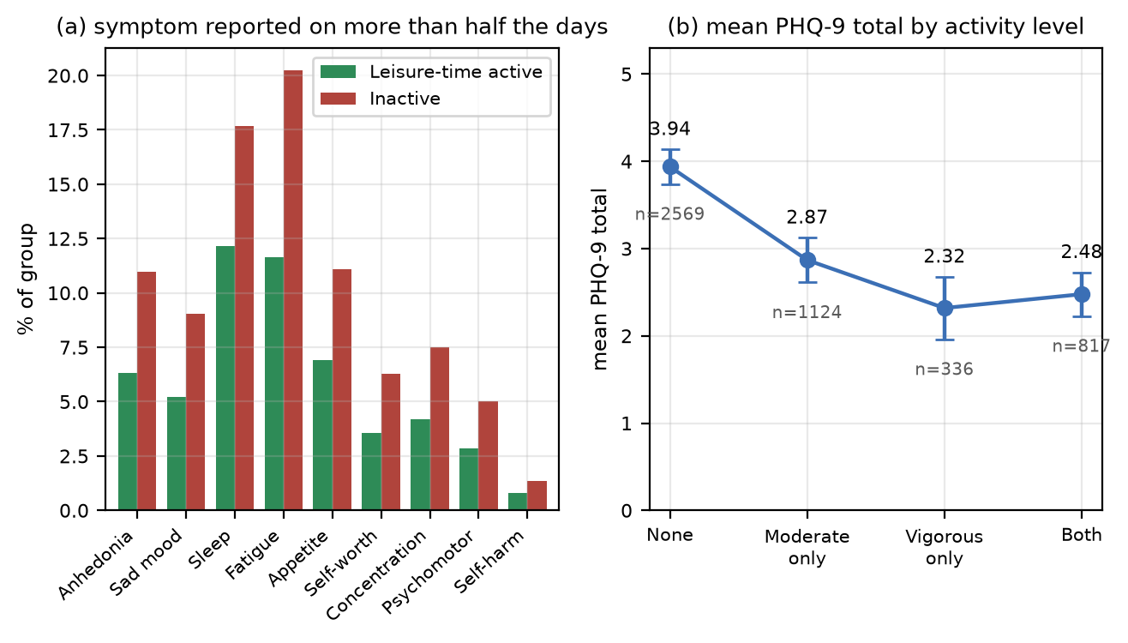
Figure 1. (a) Share of adults reporting each PHQ-9 symptom on more than half the days (score ≥ 2) by leisure-time activity. (b) Mean PHQ-9 total across activity levels, 95% CI.
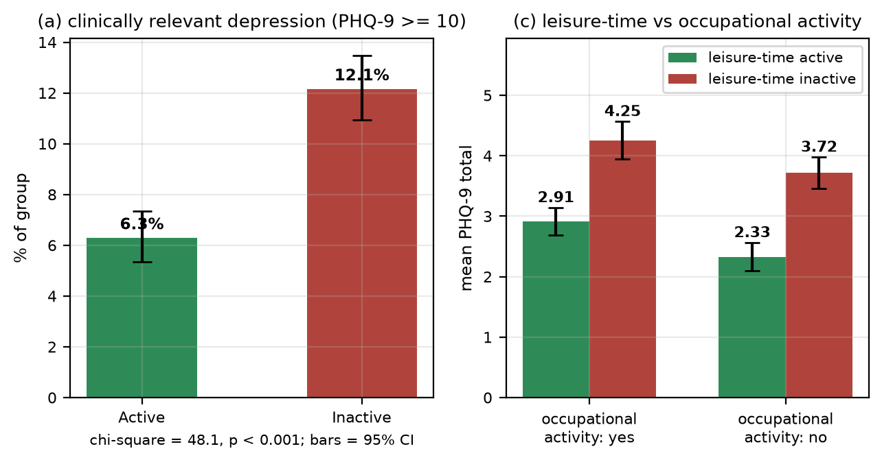
Figure 2. (a) Clinically relevant depression (PHQ-9 ≥ 10) by leisure-time activity, 95% Wilson CI. (b) Mean PHQ-9 total in the 2 × 2 of leisure-time × occupational activity.
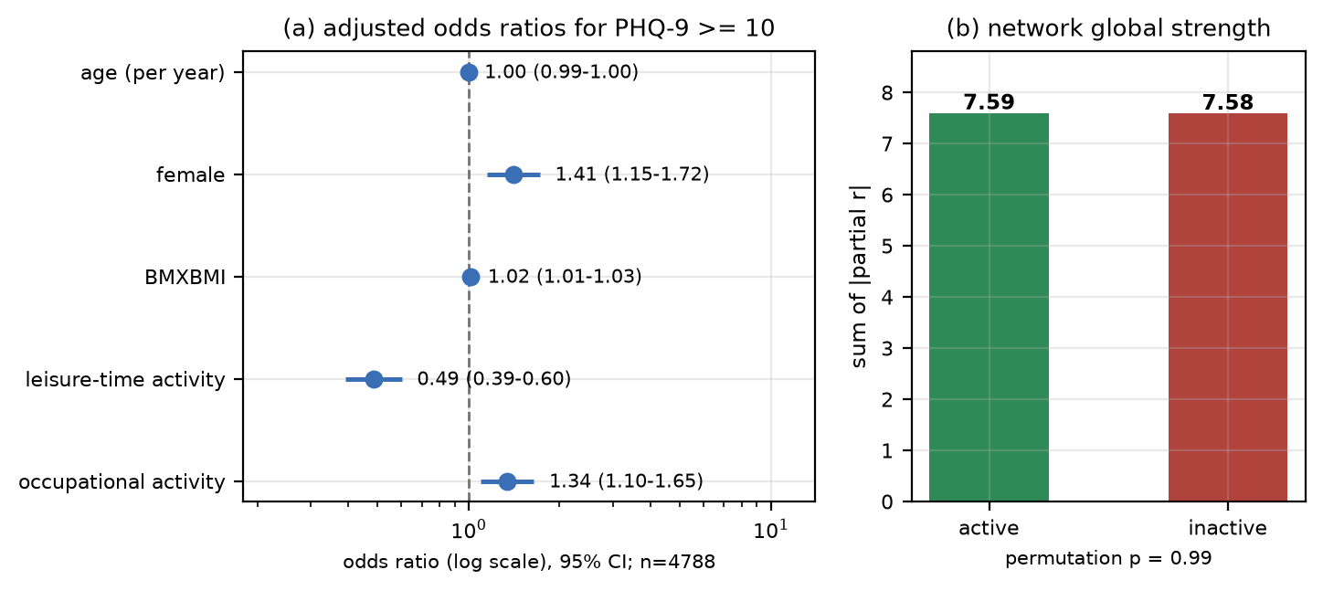
Figure 3. (a) Adjusted odds ratios for clinical depression, 95% CI, leisure-time and occupational activity entered together. (b) Network global strength by group, permutation test.
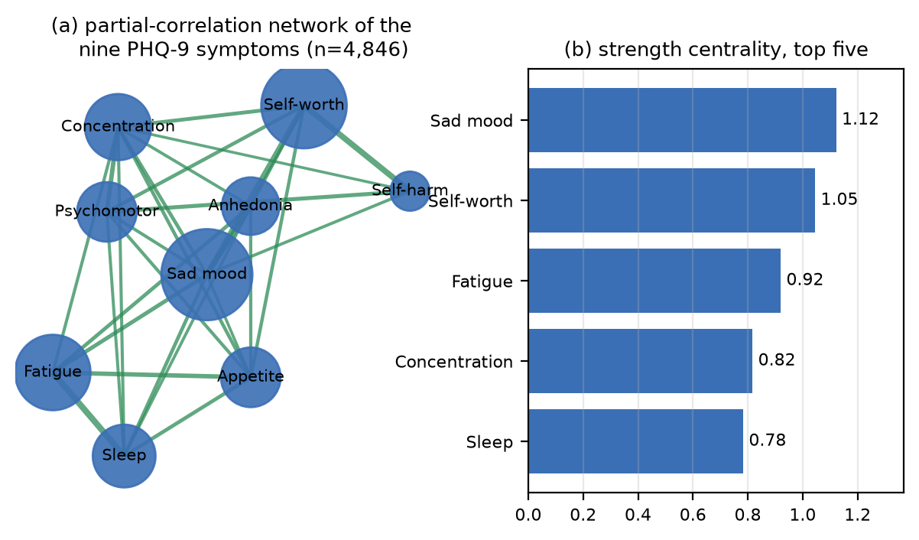
Figure 4. (a) Partial-correlation network of the nine PHQ-9 symptoms (green positive, node size = strength). (b) Strength centrality of the five most central symptoms.
Table 1. Figure-to-question checklist
Panel | What it shows | Part of the research question
Fig 1a | Symptom prevalence by activity | Which symptoms differ between the groups
Fig 1b | Mean score across activity levels | Is the association graded (dose–response)
Fig 2a | Depression prevalence with 95% CI | Is clinical depression less common when active
Fig 2b | Leisure-time × occupational activity | Does the paradox survive stratification
Fig 3a | Adjusted odds ratios | Is the link independent of age, sex, BMI, work activity
Fig 3b | Global strength, permutation test | Is the network wired differently by activity
Fig 4a | Partial-correlation network | How the nine symptoms inter-connect
Fig 4b | Strength centrality ranking | Which symptoms act as hubs

