CISC7204 — Data Science and Data Visualization
Assignment 01 · Preliminary Project Proposal
Project Topic Name
The Network Structure of Depressive Symptoms in U.S. Adults
Submitted by
ZHU ZHONGXIN (Student ID: MC662722)
DENG YI (Student ID: MC662921)
Class K · Team-based project
18 September 2026

1. Project Title and Research Question
Working title: “Which depressive symptoms sit at the centre of the network, and does physical activity change how they connect? A network analysis of PHQ-9 data from NHANES.”
Research question: What is the network structure of depressive symptoms among U.S. adults, and how does it differ between physically active and inactive adults? Rather than treating depression as a single total score, the project models it as a system of inter-connected symptoms and asks which symptoms act as hubs and whether habitual physical activity is linked to a differently organised symptom system.
2. Region and Domain
Region: United States (nationally representative sample).
Domain category: mental health and psychology — specifically the nine depressive symptoms of the PHQ-9 — with physical activity and body measures as related behavioural and health factors.
3. Purpose
Outcomes. The project consolidates the skills developed across Assignment 01 — importing and cleaning data, exploratory data analysis, model development and evaluation — and extends them into network analysis, which leads naturally into the visualisation work of Assignment 02. It also supports a data-science or public-health direction by working with a recognised population survey.
Skills. Cleaning and merging a large public dataset, reproducible Python programming, exploratory visualisation, logistic regression, and Gaussian partial-correlation network estimation with centrality indices and a permutation-based group comparison.
Knowledge. The NHANES survey design and its public-use files, the PHQ-9 as a measure of depressive symptoms, and the network approach to psychopathology that views a disorder as a set of mutually reinforcing symptoms rather than a latent cause.
4. Data Sources
At least two public links to the tabular data are provided; all files are free to download without registration. The four components used are Depression (DPQ), Demographics (DEMO), Body Measures (BMX) and Physical Activity (PAQ) from the NHANES 2017 – March 2020 release. The official SAS-XPORT (.xpt) files have been converted to CSV, and the analysis is run on the CSV copies.
- NHANES 2017 – March 2020 data page: https://wwwn.cdc.gov/nchs/nhanes/continuousnhanes/default.aspx?BeginYear=2017
- Direct data file (Depression): https://wwwn.cdc.gov/Nchs/Data/Nhanes/Public/2017/DataFiles/DPQ_J.xpt . The same folder also holds DEMO_J.xpt, BMX_J.xpt and PAQ_J.xpt.
- NHANES overview and documentation: https://www.cdc.gov/nchs/nhanes/
- CSV copies of all four files (DPQ_J.csv, DEMO_J.csv, BMX_J.csv, PAQ_J.csv), converted from the official SAS-XPORT (.xpt) files, are provided in the project folder and are the files the verification notebook reads.
5. Tasks
The analysis proceeds through a conventional pipeline and then adds a network layer on top.
- Import the four files and merge on the respondent ID (SEQN); restrict to adults aged 20 and over; handle item non-response; compute the PHQ-9 total and its standard severity bands; derive a physically-active flag and BMI categories.
- Descriptive statistics: sample profile, mean score and prevalence of each symptom, and the distribution of severity bands.
- Exploratory visualisation: symptom-prevalence bar chart, PHQ-9 total distribution, box plots by activity and sex, and a nine-item correlation heatmap.
- Group comparisons: chi-square test of clinically relevant depression by activity and t-tests of the PHQ-9 total by activity and by sex.
- Model development: logistic regression of clinically relevant depression (PHQ-9 ≥ 10) on age, sex, BMI and physical activity, reported as odds ratios with confidence intervals.
- Network analysis: estimate a partial-correlation network of the nine symptoms, compute strength and expected-influence centrality, and identify the strongest connections.
- Subgroup comparison: re-estimate the network for physically active and inactive adults and test the difference in global strength with a permutation test.
Deliverables: an annotated, reproducible Jupyter notebook, a set of figures, and a short written report.
6. Criteria for Success
- A notebook that runs end to end and reproduces every number and figure from the raw files.
- A readable symptom network with interpretable centrality and edge estimates.
- A defensible group comparison that reports uncertainty (bootstrap or permutation), not just point estimates.
- Visualisations that are self-explanatory — descriptive titles, labelled axes and a legend — and sized so that nothing is too small or too large to read.
- A short checklist that maps each key figure back to the research question.
7. Project Collaboration
This is a team-based project with two members. The core analytical work is jointly owned; each member also leads a distinct strand.
Division of work (shared core). Both members are jointly responsible for the statistical modelling, the data analysis and the visualisation, and also for defining the research question, cleaning and validating the data, interpreting the symptom network, and writing and revising the report. These core stages are co-owned by the pair rather than divided between them.
Individual emphasis. Within that shared base, ZHU ZHONGXIN takes the lead on statistical modelling and network estimation (partial correlations and centrality), on data cleaning and analysis, and on the reproducible Python notebook. DENG YI takes the lead on the visualisation and its polish, and on the literature review, report drafting and coordination of the schedule and formatting.
Ground rules. A weekly check-in; a shared version-controlled folder; every deliverable is reviewed by both members before submission; substantive decisions are made by consensus.
Group structure. ZHU ZHONGXIN acts as project coordinator and technical lead for the modelling; DENG YI acts as visualisation lead and project scribe; both members share progress tracking and act as liaisons to the TA.
8. How the Visualisation Addresses the Research Question
The figure below shows the estimated partial-correlation network of the nine PHQ-9 symptoms. Each node is one symptom and each edge is the association between two symptoms once the other seven are held fixed, so the picture presents depression as an interconnected system rather than as a single summed score. Node size encodes strength centrality, which flags the symptoms most tightly bound to the rest; in our preliminary run on 4,846 complete cases these are low mood (strength 1.12), feelings of worthlessness (1.05) and fatigue (0.92), and the strongest links are sleep–fatigue (0.31), worthlessness–self-harm (0.29) and low-mood–worthlessness (0.27). Those hubs and bridges are exactly what the research question asks for: they indicate which symptoms a clinical intervention would most plausibly target to disturb the rest of the network.
The same network is estimated separately for physically active and inactive adults so the figure also speaks to the second half of the question. In this first pass the two groups are almost identical in overall connectivity (global strength 7.57 vs 7.61; permutation p = 0.92), suggesting that physical activity is associated with how common the symptoms are rather than with how they are wired together — a result worth testing further in the full project.
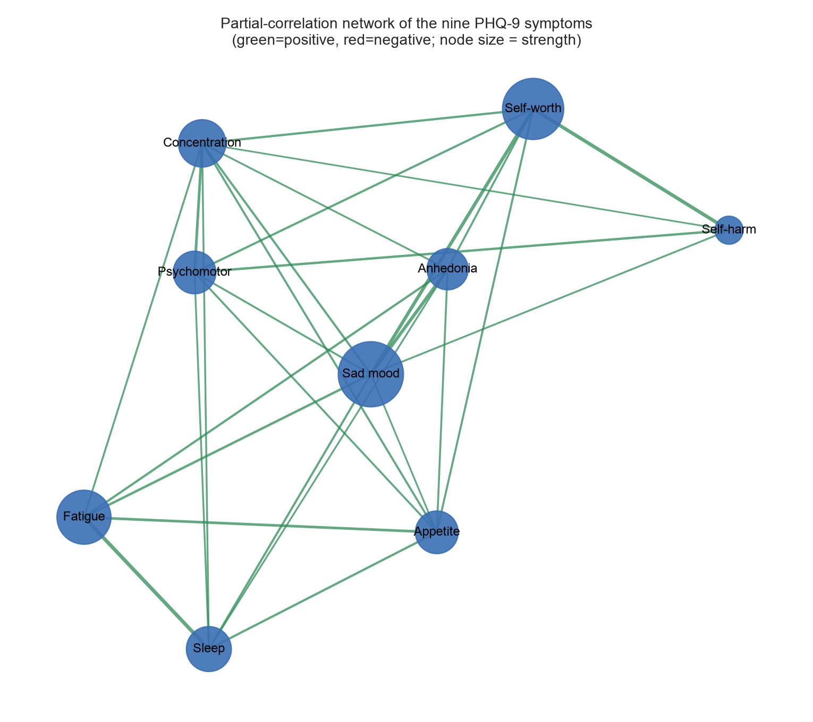
Figure 1. Partial-correlation network of the nine PHQ-9 symptoms among U.S. adults (NHANES 2017–March 2020). Green edges are positive, node size is proportional to strength centrality.

