Thinkphp-区块链-以太坊开发技术文档(Windows)

一、安装以太坊(Ethereum)源码运行环境
一）、使用github上go语言环境(go-ethereum)
1、安装步骤链接
https://github.com/ethereum/go-ethereum/wiki/Installation-instructions-for-Windows
a）、安装geth客户端，所有版本的Geth都可以在https://geth.ethereum.org/downloads/下载并下载，建议安装最新版本
b)、用Chocolatey软件包管理器编译geth，请确保已安装的Go版本是1.7（或更高版本）
然后打开管理员命令提示符并安装我们需要的构建工具：
C:\Windows\system32> choco install git
C:\Windows\system32> choco install golang
C:\Windows\system32> choco install mingw
c）、设置go语言环境变量
C:\Users\xxx> set "GOPATH=%USERPROFILE%"
C:\Users\xxx> set "Path=%USERPROFILE%\bin;%Path%"
C:\Users\xxx> setx GOPATH "%GOPATH%"
C:\Users\xxx> setx Path "%Path%"
Go语言安装完后请在允许目录下新建bin、pkg、src三个目录
d)、克隆以太坊源码go-ethereum, 编译geth
C:\Users\xxx> mkdir src\github.com\ethereum
C:\Users\xxx> git clone https://github.com/ethereum/go-ethereum src\github.com\ethereum\go-ethereum
C:\Users\xxx> cd src\github.com\ethereum\go-ethereum
C:\Users\xxx> go get -u -v golang.org/x/net/context
编译geth的命令是：C:\Users\xxx\src\github.com\ethereum\go-ethereum> go install -v ./cmd/...
运行完以上命令后文件目录层级类似：
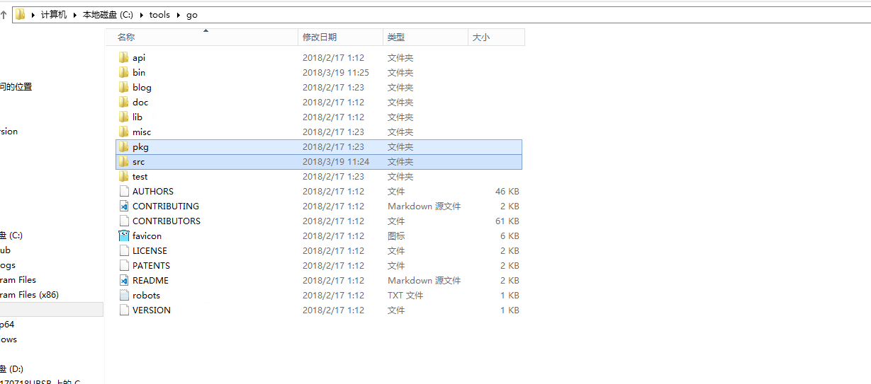

以太坊源码存储目录在：
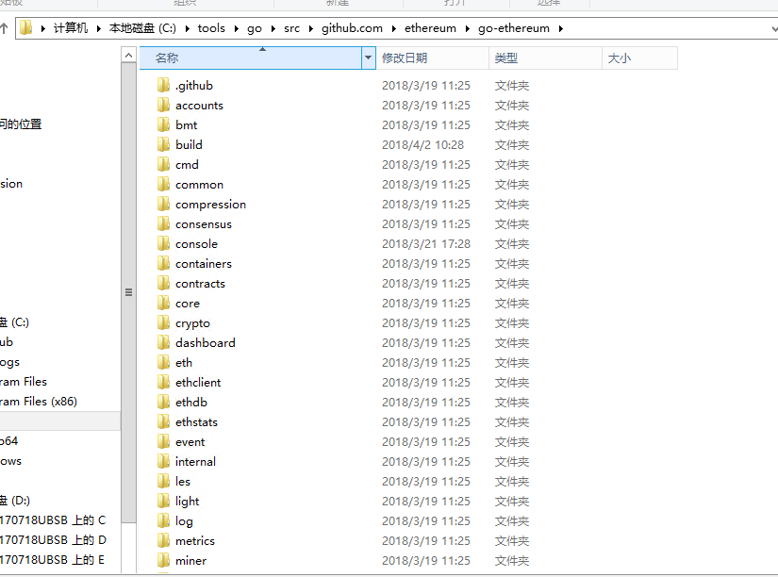

二、同步以太坊区块
由于geth同步时间过长，且geth同步区块不一定完成，建议使用Parity
- 安装parity：现在链接地址https://www.parity.io/，下载完后一路next默认安装
- Parity默认的区块文件存储位置C:\Users\Administrator\AppData\Local\Parity\Ethereum，由于C盘空间有限，可以试用一下方法将区块同步文件以软链接的形式连接到其他盘：
  - 、先将cache和chains复制到D:\ETH\Ethereum目录下，然后将这两个文件夹(在C:\Users\Administrator\AppData\Local\Parity\Ethereum下的)删除
  - 、运行命令mklink /j C:\Users\Administrator\AppData\Local\Parity\Ethereum D:\ETH\Ethereum，这样同步的区块文件就在D盘目录下了
  - 、Parity安装完成后钱包的kinstore文件在C:\Users\Administrator\AppData\Roaming\Parity\Ethereum\keys\ethereum，为了防盗，可以将这里的密钥文件拷贝到U盘或其他地方，
  - 、在以太坊源码目录C:\tools\go\src\github.com\ethereum\go-ethereum下，在cmd窗口运行
  - netsh interface portproxy add v4tov4 listenport=8545 listenaddress=27.102.101.57 connectport=8545 connectaddress=127.0.0.1 //8545端口映射
  - parity --geth --jsonrpc-hosts "http://27.102.101.57:8545" --rpcapi "eth,net,web3,personal" --rpcaddr "127.0.0.1" --rpcport "8545" //公网ip加入白名单，开启rpc进行http请求，parity --geth --rpcapi "eth,net,web3,personal" --rpccorsdomain "http://localhost:8545"
  - ，此命令是在geth模式下同步区块，并且开启RPC接口，启动http访问端口
可以看到parity连接节点已经开始同步区块了
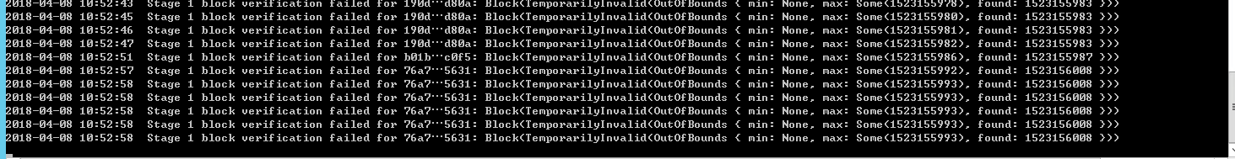

三、安装以太坊钱包：
1、选择版本安装：https://github.com/ethereum/mist/releases
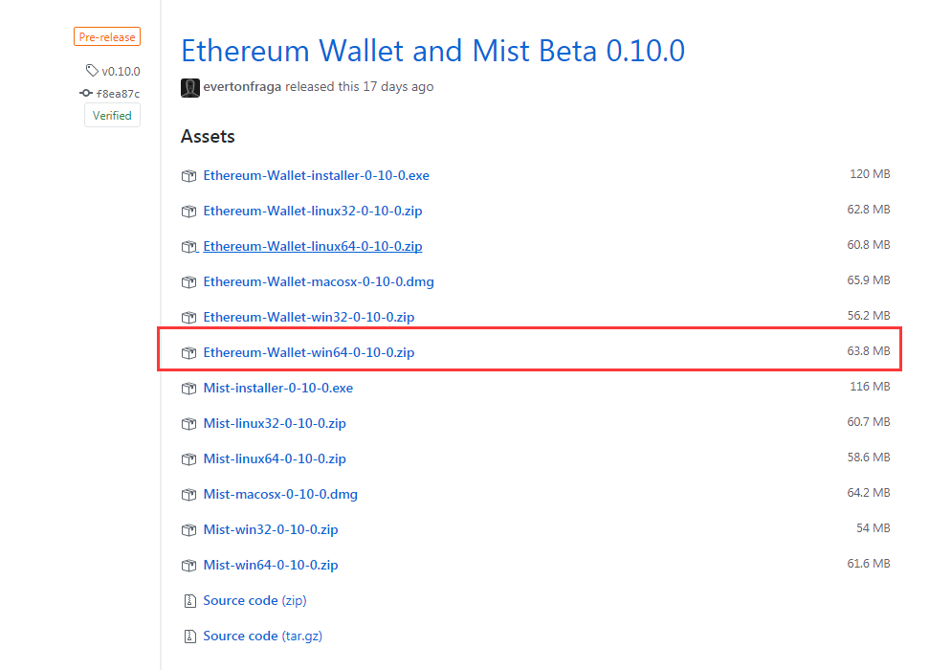
- 打开钱包：
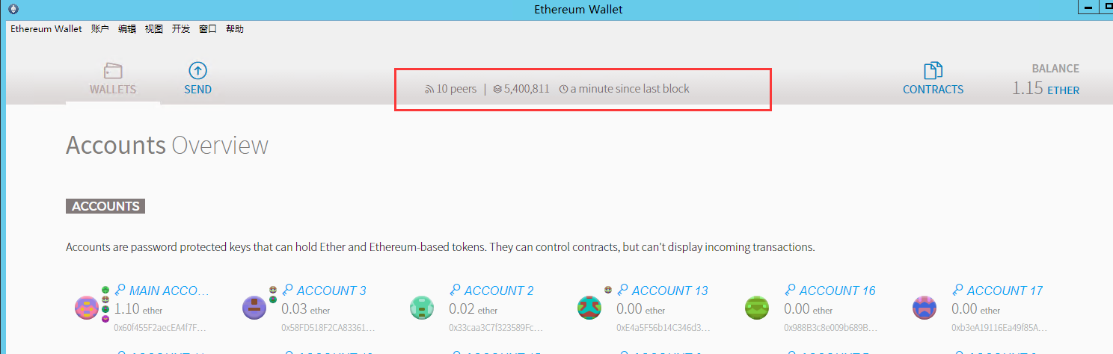
这里显示以太坊区块连接的节点数peers及已经同步的百分比，上图是已经完成同步的数据
以太坊浅白的使用可以参考：https://ethfans.org/topics/78 、http://www.wanbizu.com/p/54471.html、或自行baidu，这里就不赘述了

四、搭建web开发环境，通过rpc请求实现创建账户，以太坊转账、合约转账功能
1、安装WAMP：http://www.wampserver.com/，步骤在这里就不描述了
2、运行WAPM,浏览器输入http://localhost,显示以下内容说明安装成功:
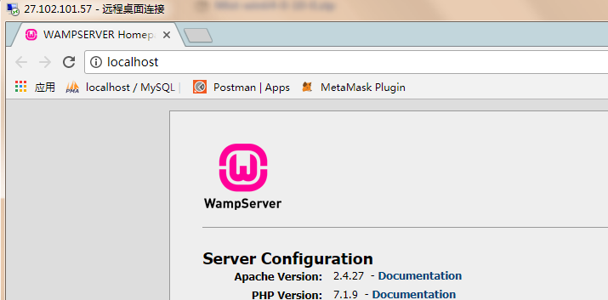

- 使用Thinkphp5为开发web应用框架：https://github.com/top-think/think.git，开发手册https://www.kancloud.cn/manual/thinkphp5/118003，
- 为了使用以太坊源码暴露的JsonRPC接口，以便通过we3和以太坊源码交互，这里需要安装nodejs，web3服务
JsonRPC参考资料：https://github.com/ethereum/wiki/wiki/JSON-RPC#eth_getlogs，
Web3API参考资料：https://github.com/ethereum/wiki/wiki/JavaScript-API，
a)、安装nodejs：https://nodejs.org/en/download/，
b)、使用npm安装web3: npm install web3
c)、使用npm安装yargs: npm install yargs ,用于js文件接收外部传入的参数
6、测试可以直接使用postman工具，如下（前提是必须运行parity命令）
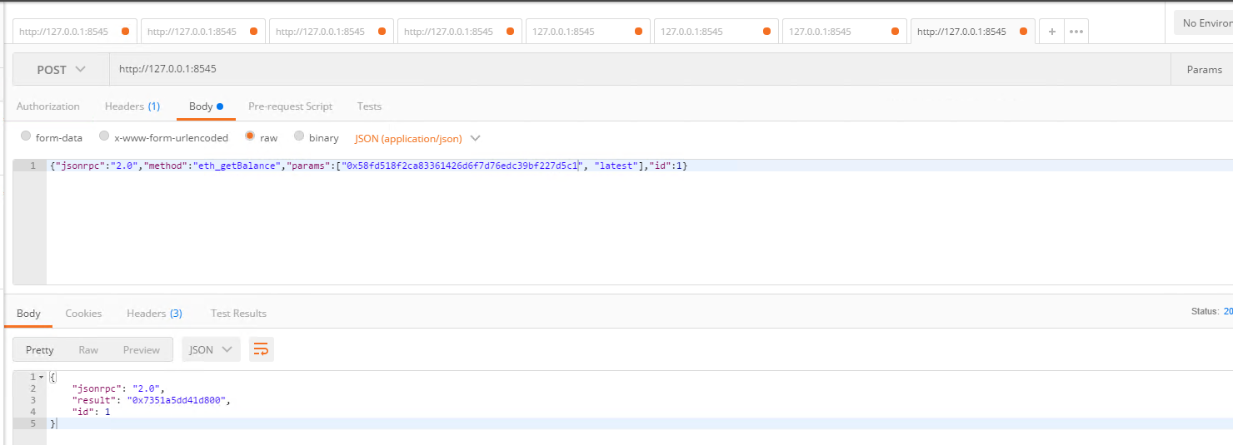
这里选择post传参，且传入body选raw，格式选择JSON，因为要传json数据给以太坊节点源码，
返回结果为0x开头的16进制数据，前面安装web3模块就是为了解析这种数据，以太坊有专门的进制转换接口，后面再讲。

- 以太坊rpc机制与Api实例，参考http://www.mamicode.com/info-detail-2166090.html，

五、WebSocket：获得交易所数字货币交易行情，php代码
1、搭建websocket运行环境,tp5有封装好的socket类库，workman: https://www.kancloud.cn/manual/thinkphp5/235128,
在tp5代码目录,例如：D:\xqshop\vendor，下运行cmd命令（前提是已安装composer）：
composer require topthink/think-worker
如果需要在window下做服务端，还需要
composer require workerman/workerman-for-win
2、这里我们本地服务器websocket的作用是，从其他交易所，例如火币网、币安、okex或bitfinex拿到实时交易数据，再将拿到的数据返给前段，例如手机APP或wap前段应用程序,
3、以下是从火币网获得的交易数据，https://github.com/huobiapi/API_Docs/wiki, 这里以以太币的交易行情为例，不多说，直接上类文件代码:
<?php
namespace app\socket\controller;
use think\worker\Server;
use Workerman\Connection\AsyncTcpConnection;
use Workerman\Autoloader;
use think\Db;
class EthWorker extends Server
{
protected $socket = 'websocket://xxx.xxx.xxx.xxx:8080';
protected $sendData = [];
/**
* 收到信息
* @param $connection
* @param $data
*/
public function onMessage($connection, $data)
{
}
/**
* 当连接建立时触发的回调函数
* @param $connection
*/
public function onConnect($connection)
{
}
/**
* 当连接断开时触发的回调函数
* @param $connection
*/
public function onClose($connection)
{
}
/**
* 当客户端的连接上发生错误时触发
* @param $connection
* @param $code
* @param $msg
*/
public function onError($connection, $code, $msg)
{
echo "error $code $msg\n";
}
/**
* 每个进程启动
* @param $worker
*/
public function onWorkerStart($worker)
{
// 火币网
$con_huobi = new AsyncTcpConnection('ws://api.huobi.pro:443/ws');
// 设置以ssl加密方式访问，使之成为wss
$con_huobi->transport = 'ssl';
$con_huobi->onConnect = function($con) {
$data = json_encode([
'sub' => "market.ethusdt.kline.1min",//$GLOBALS['sub_str'],
'id' => 'depth' . time()
]);
$con->send($data);
};
$con_huobi->onMessage = function($con, $data) use($worker){
$data = gzdecode($data);
$data = json_decode($data, true);
if(isset($data['ping'])) {
$con->send(json_encode([
"pong" => $data['ping']
]));
}else{
call_user_func_array(function(){}, array($data));
}
if(isset($data['tick'])){
$data = $data['tick'];
//汇率
$rate = M('exchange_rate')->where("scur", 'USD')->getField('rate');
$data['open'] = round($rate * $data['open'],4);
$data['close'] = round($rate * $data['close'],4);
$data['low'] = round($rate * $data['low'],4);
$data['high'] = round($rate * $data['high'],4);
$data['vol'] = round($rate * $data['vol'],4);
$sendData = json_encode($data);
//print_r($data);
foreach($worker->connections as $connection)
{
// 向客户端发送以太坊实时价格
$connection->send($sendData);
}
}
};
$con_huobi->onClose = function($con){
echo '连接断开了';
$con->reConnect(1);
};
$con_huobi->connect();
/*//bitfinex
$con_bitfinex = new AsyncTcpConnection('ws://api.bitfinex.com:443/ws');
// 设置以ssl加密方式访问，使之成为wss
$con_bitfinex->transport = 'ssl';
$con_bitfinex->onConnect = function($con) {
$con->send('{"event":"subscribe","channel":"ticker","pair":"ETHUSD"}');
};
$con_bitfinex->onMessage = function($con, $data) {
$sendData = json_decode($data);
if(is_array($sendData) && count($sendData) >= 11){
//汇率
$rate = M('exchange_rate')->where("scur", 'USD')->getField('rate');
$sendData = [
'channel_id' => $sendData[0],
'bid' => round($rate * $sendData[1], 4),
'bid_size' => $sendData[2],
'ask' => round($rate * $sendData[3], 4),
'ask_size' => $sendData[4],
'daily_change' => $sendData[5],
'daily_change_perc' => $sendData[6],
'close' => round($rate * $sendData[7], 4),
'vol' => round($rate * $sendData[8], 4),
'high' => round($rate * $sendData[9], 4),
'low' => round($rate * $sendData[10], 4),
];
print_r($sendData);
$sendData = json_encode($sendData);
foreach($this->worker->connections as $connection)
{
// 向客户端发送以太坊实时价格
$connection->send($sendData);
}
//$con->close();
}
};
$con_bitfinex->onClose = function($con){
echo '连接断开了';
$con->reConnect(1);
};
$con_bitfinex->connect();*/
/*//OKEX
$con_okex = new AsyncTcpConnection('ws://real.okex.com:10440/websocket/okexapi');
// 设置以ssl加密方式访问，使之成为wss
$con_okex->transport = 'ssl';
$con_okex->onConnect = function($con) {
$con->send("{'event':'addChannel','channel':'ok_sub_spot_eth_usdt_kline_1min'}");
};
$con_okex->onMessage = function($con, $data) {
$data = json_decode($data);
$data = $data[0]->data;
if(is_array($data)){
if(isset($data[0])){
$sendData = $data[0];
//汇率
$rate = M('exchange_rate')->where("scur", 'USD')->getField('rate');
$sendData = [
'time' => $sendData[0],
'open' => round($rate * $sendData[1], 4),
'high' => round($rate * $sendData[2], 4),
'low' => round($rate * $sendData[3], 4),
'close' => round($rate * $sendData[4], 4),
'vol' => round($rate * $sendData[5], 4),
];
print_r($sendData);
$sendData = json_encode($sendData);
foreach($this->worker->connections as $connection)
{
// 向客户端发送以太坊实时价格
$connection->send($sendData);
}
}
}
};
$con_okex->onClose = function($con){
echo '连接断开了';
$con->reConnect(1);
};
$con_okex->connect();*/
}
}

六、以太坊账户生成:
/**
* 以太坊创建账号
* @param $user_id 用户的ID
* @return string
*/
private function makeEthAccount($user_id){
$eth_address = '';
if($user_id){
$pass_word = makePassword(rand(111111,999999));
$eth_pwd = makePassword($pass_word,3);
$json_data = json_encode(
[
'jsonrpc' => '2.0',
'method' => 'personal_newAccount',
'params' => [$eth_pwd],
'id' => 1
]
);
$eth_result = curlJson('http://127.0.0.1:8545',$json_data);
if(isset($eth_result['error'])){
$this->makeEthAccount($user_id);
exit;
}else{
//将以太坊的地址存入数据库
$eth_data = ['eth_address' => $eth_result['result'],'eth_pwd' => $pass_word, 'update_time' => time()];
if(!(Db::name('users')->where(['user_id' => $user_id])->save($eth_data))){
$this->makeEthAccount($user_id);
exit;
}else{
$eth_address = $eth_result['result'];
}
}
}
return $eth_address;
}

七、以太坊转账
/**
* @param $user_info//当前用户的信息,其中包含用户的以太坊地址eth_address
* @param $transf_value//转账数目,ether
* @param $to_address//接收以太币地址
*/
public function pay_eth($user_info,$transf_value,$to_address){
if(!$user_info['user_id']){
$this->ajaxReturn(array('status'=>-1,'msg'=>'你还没有登录','result'=>''));
}
set_time_limit(0);//让程序一直执行下去
//Todo 1、生成web3的签名
$web3_sign = $this->execTask('eth','3-'.time());
$web3_sign = str_replace(array("\r\n", "\r", "\n"), "", $web3_sign);
if($web3_sign){
//Todo 2、解锁账户
//$unlock_account = $this->unlock_account($user_info['eth_address'],$user_info['eth_pwd']);
//if($unlock_account){
//Todo 3、获得16进制hash
$hash_data = $this->eth_sign($user_info['eth_address'],$web3_sign,$user_info['eth_pwd']);//'0xde0b6b3a7640000'
if($hash_data){
//Todo 4、转账
$value = $this->execTask('eth','2-'.$transf_value);
$value = str_replace(array("\r\n", "\r", "\n"), "", $value);
if($value){
$trans_result = $this->transfer($user_info['eth_address'],$to_address,$value,$hash_data,$user_info['eth_pwd']);
$data = [
'user_id' => $user_info['user_id'],
'from_address' => $user_info['eth_address'],
'to_address' => $to_address,
'value' => $transf_value,
'tx_type' => 'eth',
'add_time' => time()
];
if($trans_result['status'] == 0){
$data['tx_status'] = 0;//交易提交失败
$data['tx_remark'] = $trans_result['msg'];
//Todo 5、将交易数据添加到数据库
M('vitural_transfer')->insertGetId($data);
return false;
}else{
$data['tx_status'] = 1;//交易提交成功
$data['tx_hash'] = $trans_result['msg'];
//Todo 5、将交易数据添加到数据库
$transf_id = M('vitural_transfer')->insertGetId($data);
//Todo 6、查询交易的hash数据，交手续费更新到数据库
$this->eth_getTransactionByHash($transf_id,$data['tx_hash']);
return $transf_id;
}
}
}
//}
}
return false;
}
/**
* 解锁账户
* @param $eth_address
* @param $db_pwd
* @return bool
*/
private function unlock_account($eth_address,$db_pwd){
//{"jsonrpc":"2.0","method":"personal_unlockAccount","params":["0x58FD518F2CA83361426d6f7d76EdC39BF227D5C1","09118231226hpHP","0x3"],"id":1}
$eth_pwd = makePassword($db_pwd,3);
$json_data = json_encode(
[
'jsonrpc' => '2.0',
'method' => 'personal_unlockAccount',
'params' => [$eth_address,$eth_pwd,'0x5'],
'id' => 1
]
);
$eth_result = curlJson('http://127.0.0.1:8545',$json_data);
if(isset($eth_result['error'])){
$this->unlock_account($eth_address,$db_pwd);
exit;
}
return $eth_result['result'];
}
/**
* 获得签名
* @param $eth_address
* @param $web3_sign
* @param $db_pwd
* @return mixed
*/
private function eth_sign($eth_address,$web3_sign,$db_pwd)
{
$this->unlock_account($eth_address,$db_pwd);
//{"jsonrpc":"2.0","method":"eth_sign","params":["0x58FD518F2CA83361426d6f7d76EdC39BF227D5C1","0x650288610dd224f7ccc85994de2c5ccd2ce291559083f009b76a082e1b968eb2"],"id":1}
$json_data = json_encode(
[
'jsonrpc' => '2.0',
'method' => 'eth_sign',
'params' => [$eth_address,$web3_sign],
'id' => 1
]
);
$eth_result = curlJson('http://127.0.0.1:8545',$json_data);
if(isset($eth_result['error'])){
$this->eth_sign($eth_address,$web3_sign,$db_pwd);
exit;
}
return $eth_result['result'];
}
/**
* 转账
* @param $from_address
* @param $to_address
* @param $value
* @param $data
* @param $db_pwd
* @return mixed
*/
private function transfer($from_address,$to_address,$value,$data,$db_pwd)
{
/*{"jsonrpc":"2.0","method":"eth_sendTransaction","params":[{
"from": "0x58FD518F2CA83361426d6f7d76EdC39BF227D5C1",
"to": "0x60f455F2aecEA4f7F889aF5658e420a6D32d10D1",
"value": "0xb1a2bc2ec50000",
"data": "0x5545d61d18ae2e7140b9597397f70cf985a59c159c9dac7cb05c983603c46f5212813d51cf8908a9b01b88ea9b721caa37ad68e3bb5e208a7d668f8fd5187a891b"
}],"id":1}*/
/*"jsonrpc": "2.0",
"error": {
"code": -32010,
"message": "Insufficient funds. The account you tried to send transaction from does not have enough funds. Required 67779870745259000 and got: 64579870745259008."
},
"id": 1*/
$result = [];
$nonce = $this->getNonceByAddress($from_address);
$json_data = json_encode(
[
'jsonrpc' => '2.0',
'method' => 'eth_sendTransaction',
'params' => [[
"from" => $from_address,
"to" => $to_address,
"value" => $value,
"nonce" => $nonce,
"data" => $data,
]],
'id' => 1
]
);
$this->unlock_account($from_address,$db_pwd);
$eth_result = curlJson('http://127.0.0.1:8545',$json_data);
if(isset($eth_result['error'])){
$result['status'] = 0;
$result['msg'] = $eth_result['error']['message'];
}else{
$result['status'] = 1;
$result['msg'] = $eth_result['result'];
}
return $result;
}
/**
* 获得nonce值
* @param $eth_address
* @return mixed
*/
private function getNonceByAddress($eth_address)
{
//{"jsonrpc":"2.0","method":"eth_getTransactionCount","params":["0x33caa3C7f323589Fc529B020B217F5feb2455E01","pending"],"id":1}
$json_data = json_encode(
[
'jsonrpc' => '2.0',
'method' => 'eth_getTransactionCount',
'params' => [$eth_address,"pending"],
'id' => 1
]
);
$eth_result = curlJson('http://127.0.0.1:8545',$json_data);
if(isset($eth_result['error'])){
$this->getNonceByAddress($eth_address);
exit;
}
return $eth_result['result'];
}
/**
* @param $transf_id
* @param $trans_hash
*/
private function eth_getTransactionByHash($transf_id,$trans_hash){
//{"jsonrpc":"2.0","method":"eth_getTransactionByHash","params":["0xb6aab4a68ca98b99474c9a2d60dfe7006e154ba092858886d91e43ee97174bd2"],"id":1}
$json_data = json_encode(
[
'jsonrpc' => '2.0',
'method' => 'eth_getTransactionByHash',
'params' => [$trans_hash],
'id' => 1
]
);
$eth_result = curlJson('http://127.0.0.1:8545',$json_data);
if(isset($eth_result['error'])){
$this->eth_getTransactionByHash($transf_id,$trans_hash);
exit;
}
$gasPrice = $eth_result['result']['gasPrice'];
$gasPrice = $this->execTask('eth','1-'.$gasPrice);
M('vitural_transfer')->where("transf_id = ".$transf_id)->setInc('gasPrice',$gasPrice);
}

/**转换以太坊的值
* @param $param
* @return string
*/
public function execTask($virtual, $param)
{
$value = '';
switch ($virtual){
case 'eth':
$value = shell_exec('node C:\tools\go\src\github.com\ethereum\go-ethereum\exchage.js -t "'.$param.'"');
break;
case 'btc':
break;
case 'eos':
break;
case 'small':
$value = shell_exec('node C:\tools\go\src\github.com\ethereum\go-ethereum\contracts.js -t "'.$param.'"');
break;
default:
break;
}
return $value;
}

八、exchage.js文件处理以太坊rpc进制转换问题，并有获得签名的方法
#!/usr/bin/env node
const yargs = require('yargs');
const Web3 = require("web3");
if(!web3){
var web3 = new Web3();
}
var argv = yargs
.options({
't': {
alias: 'text',
demandOption: true,
default: '',
describe: 'Source text.',
type: 'string'
}
})
.argv;
var sp = argv.t.split('-');
var result = '';
if(sp[0] == 0){//将以太坊Wei转为ether
//sp[1] 应当是 "1000000000000000000",18个零
result = web3.fromWei(sp[1], 'ether');
//value = web3.toWei('1', 'ether');// "1000000000000000000",18个零
}
else if(sp[0] == 1){//将十六进制转为多少个以太币
//sp[1] 应当是 '0x6f05b59d3b20000'
result = web3.fromWei(web3.toDecimal(sp[1]))
}
else if(sp[0] == 2){//将多少个以太币转为十六进制
//sp[1] 应当是 '0.5'个以太币
result = web3.fromDecimal(web3.toWei(sp[1]))
}
else if(sp[0] == 3){//做以太坊转账的hash签名用的
var message = 'STAR MALL' + sp[1];
result = web3.sha3('\x19Ethereum Signed Message:\n' + message.length + message)
}
console.info(result);

九、contracts.js合约转账：
1、先扣除手续费，因为代币转账，以太坊账户必须有一定的以太币给矿工当手续费，不然合约转账是不能成功的,也就是执行第七步，以太坊转账，
2、合约转账
#!/usr/bin/env node
var yargs = require('yargs');
var Web3 = require("web3");
// 创建web3对象
if(!web3){
var web3 = new Web3();
}
var argv = yargs
.options({
't': {
alias: 'text',
demandOption: true,
default: '',
describe: 'Source text.',
type: 'string'
}
})
.argv;
var sp = argv.t.split('-');
var result = {"status":0,"msg":"","tx_hash":""};
// 连接到以太坊节点
web3.setProvider(new Web3.providers.HttpProvider("http://localhost:8545"));
// 合约ABI
var abi = [{ "constant": true, "inputs": [], "name": "name", "outputs": [ { "name": "", "type": "string", "value": "Star Mall" } ], "payable": false, "stateMutability": "view", "type": "function" }, { "constant": false, "inputs": [ { "name": "_spender", "type": "address" }, { "name": "_value", "type": "uint256" } ], "name": "approve", "outputs": [ { "name": "success", "type": "bool" } ], "payable": false, "stateMutability": "nonpayable", "type": "function" }, { "constant": true, "inputs": [], "name": "totalSupply", "outputs": [ { "name": "", "type": "uint256", "value": "2.1e+27" } ], "payable": false, "stateMutability": "view", "type": "function" }, { "constant": false, "inputs": [ { "name": "_from", "type": "address" }, { "name": "_to", "type": "address" }, { "name": "_value", "type": "uint256" } ], "name": "transferFrom", "outputs": [ { "name": "success", "type": "bool" } ], "payable": false, "stateMutability": "nonpayable", "type": "function" }, { "constant": true, "inputs": [], "name": "decimals", "outputs": [ { "name": "", "type": "uint8", "value": "18" } ], "payable": false, "stateMutability": "view", "type": "function" }, { "constant": false, "inputs": [ { "name": "_value", "type": "uint256" } ], "name": "burn", "outputs": [ { "name": "success", "type": "bool" } ], "payable": false, "stateMutability": "nonpayable", "type": "function" }, { "constant": true, "inputs": [ { "name": "", "type": "address" } ], "name": "balanceOf", "outputs": [ { "name": "", "type": "uint256", "value": "0" } ], "payable": false, "stateMutability": "view", "type": "function" }, { "constant": false, "inputs": [ { "name": "_from", "type": "address" }, { "name": "_value", "type": "uint256" } ], "name": "burnFrom", "outputs": [ { "name": "success", "type": "bool" } ], "payable": false, "stateMutability": "nonpayable", "type": "function" }, { "constant": true, "inputs": [], "name": "symbol", "outputs": [ { "name": "", "type": "string", "value": "SMALL" } ], "payable": false, "stateMutability": "view", "type": "function" }, { "constant": false, "inputs": [ { "name": "_to", "type": "address" }, { "name": "_value", "type": "uint256" } ], "name": "transfer", "outputs": [], "payable": false, "stateMutability": "nonpayable", "type": "function" }, { "constant": false, "inputs": [ { "name": "_spender", "type": "address" }, { "name": "_value", "type": "uint256" }, { "name": "_extraData", "type": "bytes" } ], "name": "approveAndCall", "outputs": [ { "name": "success", "type": "bool" } ], "payable": false, "stateMutability": "nonpayable", "type": "function" }, { "constant": true, "inputs": [ { "name": "", "type": "address" }, { "name": "", "type": "address" } ], "name": "allowance", "outputs": [ { "name": "", "type": "uint256", "value": "0" } ], "payable": false, "stateMutability": "view", "type": "function" }, { "inputs": [ { "name": "initialSupply", "type": "uint256", "index": 0, "typeShort": "uint", "bits": "256", "displayName": "initial Supply", "template": "elements_input_uint", "value": "2100000000" }, { "name": "tokenName", "type": "string", "index": 1, "typeShort": "string", "bits": "", "displayName": "token Name", "template": "elements_input_string", "value": "Star Mall" }, { "name": "tokenSymbol", "type": "string", "index": 2, "typeShort": "string", "bits": "", "displayName": "token Symbol", "template": "elements_input_string", "value": "SMALL" } ], "payable": false, "stateMutability": "nonpayable", "type": "constructor" }, { "anonymous": false, "inputs": [ { "indexed": true, "name": "from", "type": "address" }, { "indexed": true, "name": "to", "type": "address" }, { "indexed": false, "name": "value", "type": "uint256" } ], "name": "Transfer", "type": "event" }, { "anonymous": false, "inputs": [ { "indexed": true, "name": "from", "type": "address" }, { "indexed": false, "name": "value", "type": "uint256" } ], "name": "Burn", "type": "event" }];
// 合约地址s
var address = "0xB14cB857E2CFDBbB27d67791B31d58F36F3fF9b4";//"0x0337347c4FF81966286E793D01a886F04b9669bf";
// 通过ABI和地址获取已部署的合约对象
//var metacoin = web3.eth.contract(abi).at(address);
var account_one = "0x60f455F2aecEA4f7F889aF5658e420a6D32d10D1";
var value = sp[0];//转账数量
var account_two = sp[1];//接收星球币的账户"0x58FD518F2CA83361426d6f7d76EdC39BF227D5C1";
var pwd = sp[2];
//解锁账户
web3.personal.unlockAccount(account_one,pwd,"0x3");
// 提交交易到区块链，会立即返回交易hash，但是交易要等到被矿工收录到区块中后才生效
var token = web3.eth.contract(abi).at(address);
var count = web3.eth.getTransactionCount(account_one);
var nonce = web3.toHex(count);
var tx_hash = token.transfer(account_two, web3.toWei(value), {from: account_one,nonce:nonce});
result.tx_hash = tx_hash;
var myEvent = token.Transfer();
myEvent.watch(function (err, res) {
if (!err) {
if (res.transactionHash == tx_hash) {
//var account_one_balance = token.balanceOf(account_one);
//console.log("account one balance after sendCoin:", account_one_balance.toNumber());
result.status = 1;
result.msg = "success";
}
} else {
result.status = 0;
result.msg = err;
}
myEvent.stopWatching();
result = JSON.stringify(result)
console.info(result);
});
return;

十、以太坊、比特币实时价格、交易记录获取
1、以太坊交易信息可以通过https://etherscan.io/查询
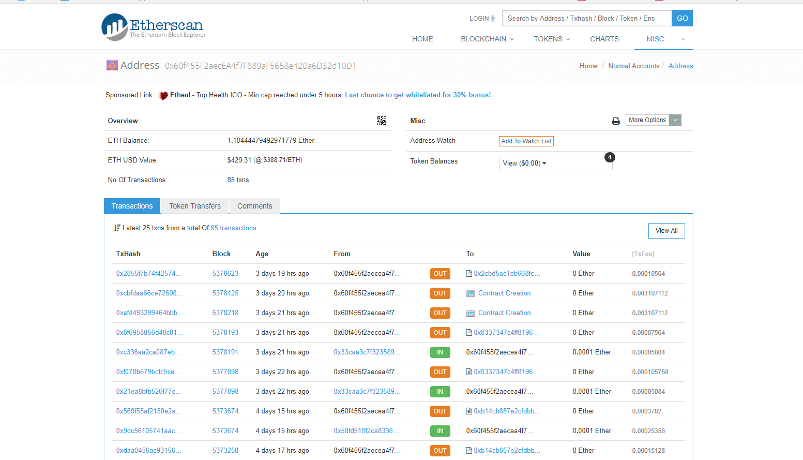
2、以太坊交易记录可以通过这个网站：https://www.blockcypher.com，提供的接口获取，拿到数据后在本地数据库想怎么存就可以怎么存，具体业务逻辑自己斟酌，不过最好是注册获取接口token,一个账号提供5个免费的token
/**
* 获取交易记录并且添加到数据库,且更新账户余额
* @param $virtual
* @param $user_id
*/
public function transferRecord($address,$virtual='eth')
{
//将交易记录写入数据库
// 启动事务
Db::startTrans();
$sub_mit = true;
switch ($virtual) {
case 'eth':
$tx_number = M('vitural_transfer_log')->where(['user_id' => $this->user_id, 'virtual_type' => $virtual])->count();
$tx_hash_list = json_decode(curlGet('https://api.blockcypher.com/v1/eth/main/addrs/' . $address.'?token=xxxxxxxxxxxxxxxxxxxx'));
if (!empty($tx_hash_list) && !isset($tx_hash_list->error)) {//请求到了hash记录
$insert_step = $tx_hash_list->final_n_tx - $tx_number;
if ($insert_step != 0) {//有新的转账记录
if (!empty($tx_list = $tx_hash_list->txrefs)) {//存在交易的hash记录
$time = time();
//查询区块上该账户的余额
//$eth_balance = $this->getBalanceByRpc($user_info[$virtual . '_address']);
for ($i = 0; $i < $insert_step; $i++) {
$tx_type = $tx_list[$i]->tx_input_n == 0 ? 2 : 1;
$data = [
'user_id' => $this->user_id,
'virtual_type' => $virtual,
'address' => $address,
'tx_hash' => '0x' . $tx_list[$i]->tx_hash,
'tx_type' => $tx_type,
'confirmed' => $tx_list[$i]->confirmed
];
//插入数据库
if (!(M('vitural_transfer_log')->where(['user_id' => $this->user_id, 'virtual_type' => $virtual, 'tx_hash' => $data['tx_hash']])->find())) {
$log_id = M('vitural_transfer_log')->insertGetId($data);
//获取交易详情
$token = 'xxxxxxxxxxxxxxxxxxxxxxxxxxxxxx';
if($i % 2 ==0) $token='xxxxxxxxxxxxxxxxxxxxxxxxxxxxxxxx';
$result = json_decode(curlGet('https://api.blockcypher.com/v1/eth/main/txs/' . $data['tx_hash'].'?token='.$token));
if(isset($result->error)){
$sub_mit = false;
break;
}
$update['value'] = round($this->execTask($virtual,'0-'.$result->total),8);
$update['fees'] = round($this->execTask($virtual,'0-'.$result->fees),8);
$update['update_time'] = $time;
$tx_status = true;
$update['tx_status'] = 1;
if(isset($result->execution_error)){//交易失败
$update['tx_status'] = 0;
$tx_status = false;
}
$up_id = M('vitural_transfer_log')->where(['log_id' => $log_id])->save($update);
$coin_1 = true;
if($tx_status && $tx_type == 1 && $update['value'] > 0){//如果是充值记录
$coin_1 = M('users')->where("user_id = ".$this->user_id)->setInc('eth_coin',$update['value']);
}
if(!$log_id || !$up_id || !$coin_1){
$sub_mit = false;
break;
}
}
}
}
}
}
if($sub_mit == true){
Db::commit();
}else{
Db::rollback();
$this->transferRecord($address,$virtual);
}
break;
case 'btc':
break;
case 'eos':
break;
default:
break;
}
}

3、注册登录币安，创建并获取app_key和app_secket, https://www.binance.com/userCenter/createApi.html,
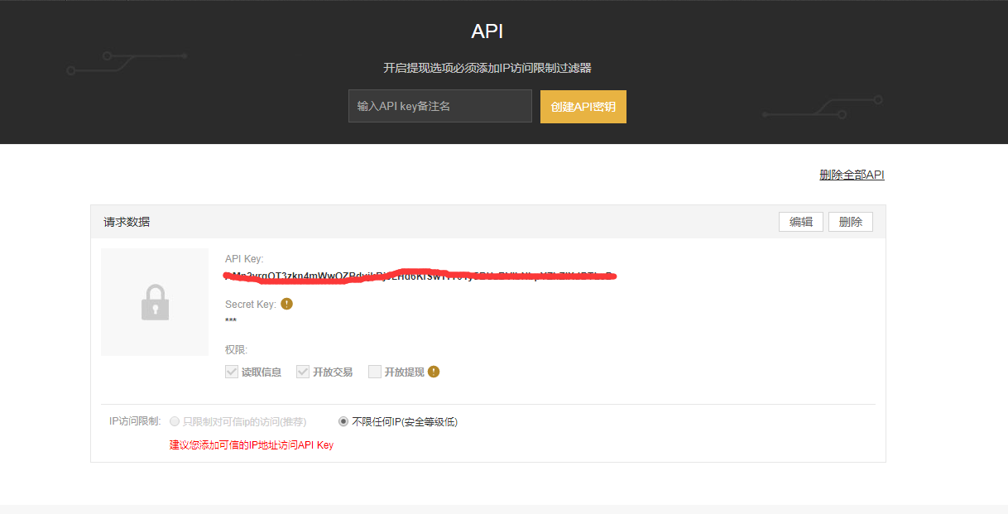
4、将https://github.com/binance-exchange/php-binance-api/blob/master/php-binance-api.php，的文件复制到项目application/controller中,命名为Binance
5、获取以太坊实时价格：
/**
* 最新以太币价格,RMB
* @param bool $flg
*/
public function get_eth_price($flg = false){
$eth = [];
//从币安获得
try {
$ticks = $this->bianApi->candlesticks('ETHUSDT','1m',1);
if(is_array($ticks) && !empty($ticks)) {//如果请求到数据
foreach ($ticks as $k => $v) {
$eth['ts'] = $k;//时间1522050600000
$eth['id'] = substr($k, 0, 10);//k线ID
$eth['open'] = round($this->rate * $v['open'], 4); //开盘价
$eth['vol'] = round($this->rate * $v['volume'], 4); //成交额
$eth['close'] = round($this->rate * $v['close'], 4); //收盘价,当K线为最晚的一根时，是最新成交价
$eth['low'] = round($this->rate * $v['low'], 4); //最低价
$eth['high'] = round($this->rate * $v['high'], 4); //最高价
$eth['open_usd'] = round($v['open'], 4); //开盘价(美元)
$eth['close_usd'] = round($v['close'], 4); //收盘价(美元),当K线为最晚的一根时，是最新成交价
$eth['low_usd'] = round($v['low'], 4); //最低价(美元)
$eth['high_usd'] = round($v['high'], 4); //最高价(美元)
$eth['vol_usd'] = round($v['volume'], 4); //成交额(美元)
if ($res = M('virtual_price')->where(['virtual_type' => 'eth'])->find()) {
$eth['update_time'] = time();
Db::name('virtual_price')->where(['virtual_id' => $res['virtual_id'], 'virtual_type' => 'eth'])->save($eth);
} else {
$eth['virtual_type'] = 'eth';
$eth['add_time'] = time();
Db::name('virtual_price')->insert($eth);
}
array_splice($eth, 7, 5);
}
}else{
if($flg == true){
$this->get_eth_price(true);
}else{
$eth = M('virtual_price')->where(['virtual_type' => 'eth'])->field('ts,id,open,close,high,low,vol,amount,count,update_time')->find();
}
}
}catch (Exception $e) {//没有请求到就从数据库去
if($flg == true){
$this->get_eth_price(true);
}else{
$eth = M('virtual_price')->where(['virtual_type' => 'eth'])->field('ts,id,open,close,high,low,vol,amount,count,update_time')->find();
}
}
return $eth;
}
6、获取美元对人名币汇率
a)、登录https://www.nowapi.com/?app=intf.appkey，注册并获取APPKey和SignSign，免费3个月，50 次/小时调用
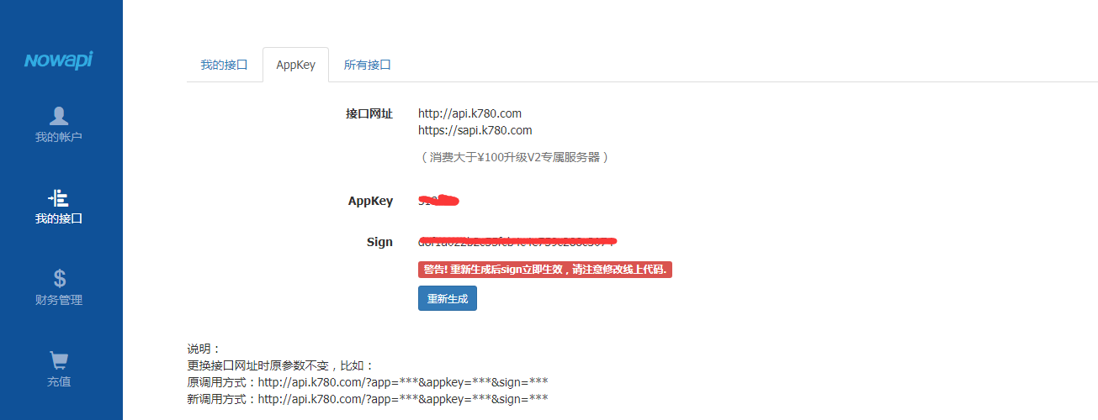

b)、获取汇率，保存数据库
$result = curl_get('http://api.k780.com/?app=finance.rate&scur=USD&tcur=CNY&appkey=31867&sign=d8f1a022b2c55fcb4c4e759c288c3074&format=json');
$result = json_decode($result);
if(isset($result->success) && ($result->success) == 1){
$result = $result->result;
$con = mysqli_connect("27.102.101.57","root","Star2828",'xqshop');
//$con = mysqli_connect("119.23.8.41","root","root",'xqshop');
if ($con)
{
$row = mysqli_query($con,"SELECT * FROM eth_exchange_rate where scur='USD'");
if($row->num_rows > 0){
mysqli_query($con,"UPDATE eth_exchange_rate set
status ='".$result->status."', scur='".$result->scur."',tcur='".$result->tcur."',ratenm='".$result->ratenm."',rate='".$result->rate."',`update`='".$result->update."' where scur='USD'");
}else{
mysqli_query($con,"INSERT INTO eth_exchange_rate (status, scur, tcur, ratenm, rate, `update`)
VALUES ('".$result->status."', '".$result->scur."','".$result->tcur."','".$result->ratenm."','".$result->rate."','".$result->update."')");
}
mysqli_close($con);
}
}

c)、postman请求返回实例
