# 练习一

**一、emp表**

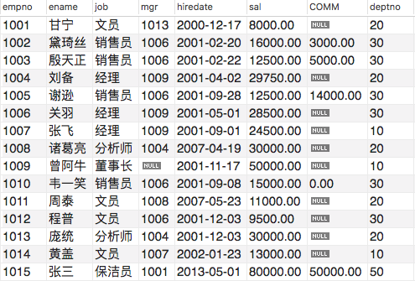

**二、练习**

**1. 查询出部门编号为30的所有员工**

**Select * from emp where deptno = 30;**

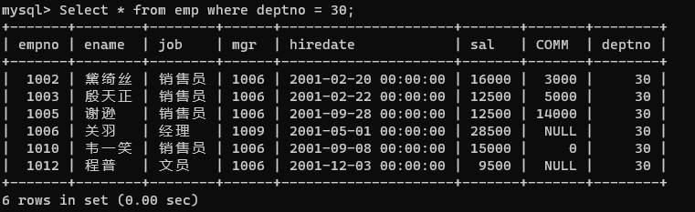

1. **所有销售员的姓名、编号和部门编号。**

**select ename,empno,deptno from emp;**

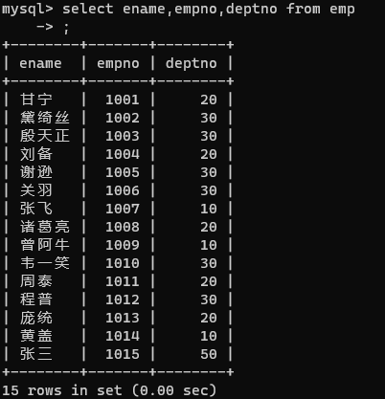

1. **找出奖金高于工资的员工。**

**select * from emp where comm > sal;**

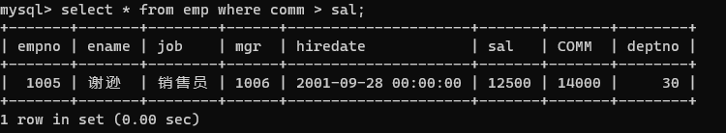

1. **找出奖金高于工资60%的员工。**

**select * from emp where comm > sal*0.6;**

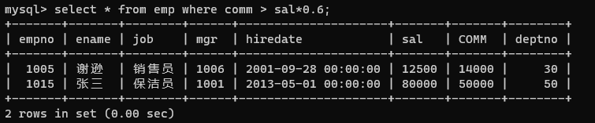

1. **找出部门编号为10中所有经理，和部门编号为20中所有销售员的详细资料。**

**select * from emp where ( deptno = 10 and job = '经理' ) or deptno = 20;**

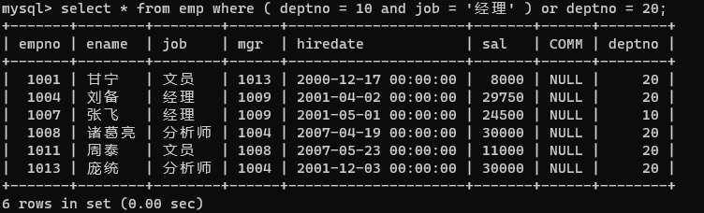

1. **找出部门编号为10中所有经理，部门编号为20中所有销售员，还有即不是经理又不是销售员但其工资大或等于20000的所有员工详细资料。**

**select * from emp where ( deptno = 10 and job = '经理' ) or (deptno = 20 and job = '销售员') or (job not in ('经 理','销售员') and sal >= 20000);**

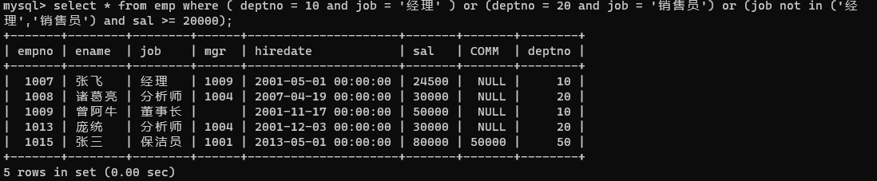

1. **无奖金或奖金低于1000的员工。**

**select * from emp where comm is null or comm < 1000;**

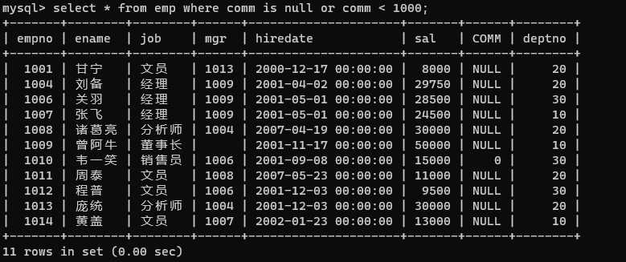

1. **查询名字由三个字组成的员工。**

**select * from emp where char_length(ename) = 3;**

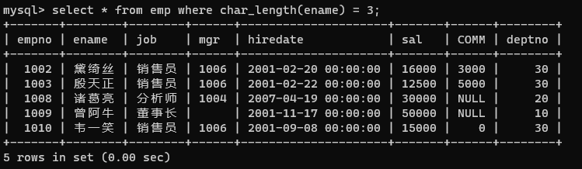

1. **查询2000年入职的员工。**

**select * from emp where year(hiredate) = 2000;**

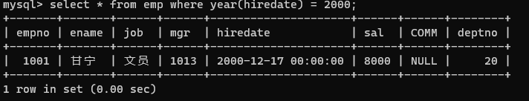

1. **查询所有员工详细信息，用编号升序排序**

**select * from emp order by empno asc;**

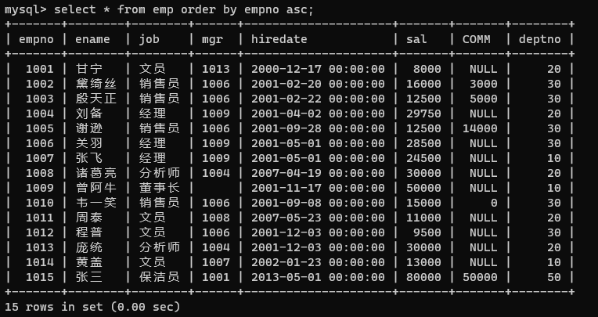

1. **查询所有员工详细信息，用工资降序排序，如果工资相同使用入职日期升序排序**

**select * from emp order by sal desc ,hiredate asc;**

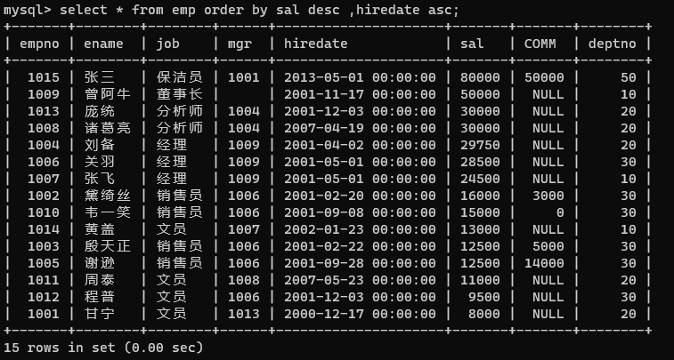

**三、练习题解**

**/*1. 查询出部门编号为30的所有员工*/**

**SELECT \***

**FROM emp**

**WHERE deptno=30;**

**/*2. 查询所有销售员的姓名、编号和部门编号。*/**

**SELECT ename, empno, deptno**

**FROM emp**

**WHERE job='销售员';**

**/*3. 找出奖金高于工资的员工。*/**

**SELECT \***

**FROM emp**

**WHERE comm > sal**

**/*4. 找出奖金高于工资60%的员工。*/**

**SELECT \***

**FROM emp**

**WHERE comm > sal*0.6;**

**/*5. 找出部门编号为10中所有经理，和部门编号为20中所有销售员的详细资料。*/**

**SELECT \***

**FROM emp**

**WHERE (deptno=10 AND job='经理') OR (deptno=20 AND job='销售员')**

**/*6. 找出部门编号为10中所有经理，部门编号为20中所有销售员，还有即不是经理又不是销售员但其工资大或等于20000的所有员工详细资料。*/**

**SELECT \***

**FROM emp**

**WHERE (deptno=10 AND job='经理') OR (deptno=20 AND job='销售员') OR (job NOT IN ('经理', '销售员') AND sal >= 20000)**

**/*7. 无奖金或奖金低于1000的员工。*/**

**SELECT \***

**FROM emp**

**WHERE comm IS NULL OR comm < 1000**

**/*8. 查询名字由三个字组成的员工。*/**

**SELECT \***

**FROM emp**

**WHERE ename LIKE '___'**

**/*9.查询2000年入职的员工。*/**

**SELECT \***

**FROM emp**

**WHERE hiredate LIKE '2000-%'**

**/*10. 查询所有员工详细信息，用编号升序排序*/**

**SELECT \***

**FROM emp**

**ORDER BY empno**

**/*11. 查询所有员工详细信息，用工资降序排序，如果工资相同使用入职日期升序排序*/**

**SELECT \***

**FROM emp**

**ORDER BY sal DESC, hiredate ASC**

# 练习二

**CREATE TABLE exam(**

**id INT PRIMARY KEY AUTO_INCREMENT,**

**NAME VARCHAR(20),**

**english INT,**

**chinese INT,**

**math INT**

**);**

**INSERT INTO exam VALUES (NULL,'张三',85,74,91);**

**INSERT INTO exam VALUES (NULL,'李四',95,90,83);**

**INSERT INTO exam VALUES (NULL,'王五',85,84,59);**

**INSERT INTO exam VALUES (NULL,'赵六',75,79,76);**

**INSERT INTO exam VALUES (NULL,'田七',69,63,98);**

**INSERT INTO exam VALUES (NULL,'李老八',89,90,83);**

**#查询所有学生考试成绩信息**

**SELECT *FROM exam;**

**#查询所有学生的姓名和英语成绩**

**SELECT NAME,english FROM exam;**

**#查询英语成绩信息（不显示重复的值）**

**SELECT DISTINCT english FROM exam;**

**#查看学生姓名和学生的总成绩**

**SELECT NAME,SUM(english + chinese + math) sumGrade FROM exam GROUP BY NAME;**

**#查询学生的姓名和平均分,平均分用avg别名展示**

**SELECT NAME,(english+chinese+math)/3 AVG FROM exam GROUP BY NAME;**

**#查询李四学生的成绩：**

**SELECT NAME,english,chinese,math FROM exam WHERE NAME ='李四';**

**#查询名称叫李四学生并且英文大于90分**

**SELECT NAME,english FROM exam WHERE english>90 AND NAME ='李四';**

**#查询姓李的学生的信息**

**SELECT *FROM exam WHERE NAME LIKE '李%';**

**#查询英语成绩是69,75,89学生的信息**

**SELECT *FROM exam WHERE english IN (69,75,89);**

**#查询数学成绩在80-90之间的学生信息**

**SELECT *FROM exam WHERE math BETWEEN 80 AND 90;**

**#只要有一门不及格,就找出来**

**SELECT *FROM exam WHERE english< 60 OR chinese < 60 OR math < 60;**

**#查询学生信息，并且按照语文成绩进行排序：**

**SELECT *FROM exam ORDER BY chinese;**

**#查询学生信息，并且按照语文成绩倒序排序：**

**SELECT *FROM exam ORDER BY chinese DESC;**

**#查询学生信息，先按照语文成绩进行倒序排序，如果成绩相同再按照英语成绩升序排序**

**SELECT *FROM exam ORDER BY chinese DESC, english ASC;**

**#查询姓李的学生的信息，按照英语成绩降序排序**

**SELECT * FROM exam WHERE NAME LIKE '李%' ORDER BY english DESC;**

**#查询学生信息,按照总成绩排序,只展示学生的姓名和总分(SUM)**

**SELECT NAME,SUM(english + chinese + math) SUM FROM exam GROUP BY NAME ORDER BY SUM;**

**#获取所有学生的英语成绩的总和:**

**SELECT SUM(english) FROM exam;**

**#获取所有学生的英语成绩和数学成绩总和：**

**SELECT SUM(english+math) FROM exam;**

**#查询姓李的学生的英语成绩的总和**

**SELECT SUM(english) FROM exam WHERE NAME LIKE '李%' ;**

**#查询所有学生各科的总成绩：**

**SELECT SUM(english),SUM(chinese),SUM(math) FROM exam;**

**#获得姓李的学生的个数**

**SELECT COUNT(*) FROM exam WHERE NAME LIKE '李%';**

**#获得数学成绩的最高分：**

**SELECT MAX(math) FROM exam;**

**#获得语文成绩的最小值**

**SELECT MIN(chinese) FROM exam;**

**#获取语文成绩的平均值**

**SELECT AVG(chinese) FROM exam;**

# 练习三

**CREATE TABLE orderitem(**

**id INT PRIMARY KEY AUTO_INCREMENT,**

**product VARCHAR(20),**

**price DOUBLE**

**);**

**INSERT INTO orderitem VALUES (NULL,'电视机',2999);**

**INSERT INTO orderitem VALUES (NULL,'电视机',2999);**

**INSERT INTO orderitem VALUES (NULL,'洗衣机',1000);**

**INSERT INTO orderitem VALUES (NULL,'洗衣机',1000);**

**INSERT INTO orderitem VALUES (NULL,'洗衣机',1000);**

**INSERT INTO orderitem VALUES (NULL,'冰箱',3999);**

**INSERT INTO orderitem VALUES (NULL,'冰箱',3999);**

**INSERT INTO orderitem VALUES (NULL,'空调',1999);**

**#按商品名称统计，每类商品所购买的个数：**

**SELECT product,COUNT(*) FROM orderitem GROUP BY product;**

**#按商品名称统计，每类商品所花费的总金额：**

**SELECT product,SUM(price) FROM orderitem GROUP BY product;**

**#按商品名称统计，统计每类商品花费的总金额在5000元以上的商品**

**SELECT product,SUM(price) SUM FROM orderitem GROUP BY product HAVING SUM(price) > 5000 ;**

**#按商品名称统计，统计每类商品花费的总金额在5000元以上的商品，并且按照总金额升序排序**

**SELECT product,SUM(price) SUM FROM orderitem GROUP BY product HAVING SUM(price) > 5000 ORDER BY SUM ASC;**

**#按商品名称统计，统计每类商品购买数量大于1的商品，并且按照购买数量降序排序,只展示商品和购买数量**

**SELECT product,COUNT(*) num FROM orderitem GROUP BY product HAVING num>1 ORDER BY num DESC;**