**The 2-year influence of hard drug use on HIV treatment response**

**Wenru Zhou**

Introduction: Scientists are interested in whether hard drug use, such as heroin and cocaine, will influence the effect of HARRT- a standard treatment for HIV infected patients. We assessed this association in men with HIV-1 infection from the ongoing perspective Multicenter AIDS Cohort Study. The following variables are of primary interests: SF36 MCS score, which is a kind of mental score measurements, SF36 PCS score, which is a kind of physical score measurements, CD4 positive cells, Standardized viral load. Other important variables: Whether using hard drug at baseline and adherence to HARRT since year-1 visit. We also included smoke status, BMI, age, race and education in our analytic dataset. The null hypotheses is that there is no association between two-year changes in SF36 MCS score, SF36 PCS score, CD4 positive cells , viral load and hard drug use status at baseline.

Methods:

Data clean: We used information at baseline and at 2-year visit to conduct our analysis. Participants without follow up at 2-year visit or with impossible demographic information were excluded from the analysis dataset. From previous analyses, age, BMI, adherence, race, income and smoking status should be adjusted. However, education was used to adjust for socioeconomic status due to many missing in income. Levels of race, smoke status and adherence to medicine were collapsed due to low number of records. We did not exclude any records with missing SF36 MCS score, SF36 PCS score, CD4 cell counts or standardized viral load because they were fitted separately.

Data analyses: The outcomes were changes in SF36 MCS score, SF36 PCS score, change of log10 CD4 positive cells, and log10 Standardized viral load from baseline visit to 2-year visit. We used changed measurements instead of measurements at 2-year visit because this is a cohort study, and the measurements at baseline for each participants are quite different. The main predictor was hard drug use at baseline. Other covariates were smoke status, BMI, age, race and education.

Non-Bayesian framework: Multivariate linear regression were conducted. Least square method was used to estimate the coefficients. F test was performed to test significance. The significant level for this study was set as 0.05. We used QQ-plot and residual plot to check linearity and equal variance assumption. We set seeds to ensure reproducible results.

Bayesian framework: Bayesian theory and Markov chain Monte Carlo method were used to make inference of mean and variance of coefficients and error. Priors were non-informative. The coefficients were assumed to have normal distribution (mean=0, variance=100000), and the error is assumed to have inverse-gamma distribution (shape=2.001, scale=1.001). DIC was used to compare full models and reduce models in order to find the influence of variables. We also checked autocorrelation function and trace plot to check the convergence and autocorrelation of models.

Results:

715 participants were at baseline from Perspective Multicenter AIDS Cohort Study. 506 of participants available at 2-year visit. We excluded 18 (3.6%) records due to invalid or missing BMI. After excluding missing BMI, we have totally 488 patients. Participants ranged from age 20 years to 73 years old and from BMI 16 to BMI 45. The percent of whites was 68%. 57% of participants never completed 4-year College or had college degree. 21% of them finished 4 year college or had a college degree. 62% of them were not current smokers (Table 1).

**Table 1. Demographic characteristics Baseline**

|  |  |  |  |  |
| --- | --- | --- | --- | --- |
| **Characteristic at baseline** |  | **All (n=488)** | **No hard drug use at baseline (n=452)** | **Hard drug use at baseline (n=36)** |
| **SF36 MCS score#** |  | 45.24±13.67 | 45.5±13.8 | 42.01±11.64 |  |
| **SF36 PCS score#** |  | 51.08±9.04 | 51.23±9.17 | 49.16±7.05 |  |
| **Number of CD4 positive cells# (helpers)#** |  | 375.43±203 | 376.66±203.34 | 360.04±200.8 |  |
| **Standardized viral load (copies/ml)#** |  | 32600.5 (11186.22, 136972.5) | 33291.5 (11009.25, 136952.75) | 29255.5 (12909, 293871) |  |
| **Age, years** |  | 43.16±8.83 | 43.1±8.78 | 43.89±9.52 |  |
| **BMI(kg/m2)** ## |  | 25.26±4.41 | 25.39±4.46 | 23.62±3.45 |  |
| **Race** |  |  |  |  |  |
| Non-White |  | 158 (32%) | 141 (31%) | 17 (47%) |  |
| White |  | 330 (68%) | 311 (69%) | 19 (53%) |  |
| **Education** |  |  |  |  |  |
| less than college |  | 280 (57%) | 254 (56%) | 26 (72%) |  |
| college |  | 101 (21%) | 100 (22%) | 1 (3%) |  |
| greater than college |  | 107 (22%) | 98 (22%) | 9 (25%) |  |
| **Smoke** |  |  |  |  |  |
| Noncurrent smoker |  | 302 (62%) | 293 (65%) | 9 (25%) |  |
| Current smoker |  | 186 (38%) | 159 (35%) | 27 (75%) |

|  |  |  |  |
| --- | --- | --- | --- |
| **Table 1. Demographic characteristics at 2-year visit-continued** | | | |
| **Characteristic at 2-year visit** | **All (n=488)** | **No hard drug use at baseline (n=452)** | **Hard drug use at baseline (n=36)** |
| **SF36 MCS score#** | 47.6±11.94 | 47.73±11.76 | 45.9±14.06 |  |
| **SF36 PCS score#** | 49.45±10.34 | 49.86±10.1 | 44.36±11.96 |  |
| **Number of CD4 positive cells (helpers)#** | 543.03±267.99 | 557.15±264.85 | 371.22±248.8 |  |
| **Standardized viral load (copies/ml)#** | 31.02 (10, 251.25) | 31 (10.17, 285.84) | 44 (8.85, 160.25) |  |
| **If Adherence to meds since last visit** |  |  |  |  |
| No | 48 (10%) | 47 (10%) | 1 (3%) |  |
| Yes | 440 (90%) | 405 (90%) | 35 (97%) |  |

# there were 14 missing in count of CD4 cells and viral load**.** There were 7 missing in SF36 MCS score and SF36 PCS score; ##There were 18 invalid BMI: 1 record with impossible BMI. 5 records with insufficient data. 7 records with improbable value. 5 records with missing BMI.

Table 2 summarized the multivariate regression using frequentist approch. All baseline measurements has significantly negative association with outcomes (p-value <.0001). Age was negatively associated with change in physical score (-0.0946±0.0434, p-value=0.03). Education was significantly associated with change in log number of standardized viral load (p-value=0.048) and change in mental score (p-value=0.04). Further investigation on education needs pairwise t-test, we would not discuss it here. Hard drug use at baseline significantly decrease change in log10 CD4 cell counts 0.213 times from baseline to 2-year visit (-0.213±0.0345, p-value<.0001). Hard drug use at baseline significantly decrease change in physical score 3.528 times from baseline to 2-year visit (-3.528±1.419, p-value=0.013). Hard drug use at baseline was not associated with change in log10 number of virus load and change in mental score.

**Table 2. Multivariate regression-** **Frequentist approach**

|  |  |  |  |  |  |  |  |  |
| --- | --- | --- | --- | --- | --- | --- | --- | --- |
| **Characteristics** | **Change in log10 number of CD4 positive cells(N=474)** | | **Change in log10 number of virus load (N=474)** | | **Change in mental score (N=481)** | | **Change in physical score (N=481)** | |
|  | **Regression coefficient** | **P-value** | **Regression coefficient** | **P-value** | **Regression coefficient** | **P-value** | **Regression coefficient** | **P-value** |
| **Baseline measurements#** | -0.473±0.0272 | <.0001** | -0.508±0.0571 | <.0001** | -0.511±0.0334 | <.0001** | -0.301±0.0429 | <.0001** |
| **Age** | -0.00140±0.00103 | 0.2 | -0.00517±0.00602 | 0.4 | 0.0582±0.0528 | 0.3 | -0.0946±0.0434 | 0.03* |
| **BMI** | 0.00349±0.00209 | 0.1 | -0.0205±0.0122 | 0.09 | 0.0182±0.105 | 0.9 | 0.0680±0.0848 | 0.4 |
| **White (Non-white as reference)** | -0.0130±0.0199 | 0.5 | -0.185±0.118 | 0.1 | 0.281±1.0118 | 0.8 | -0.352±0.829 | 0.7 |
| **Education (<College as reference)** |  | 0.6 |  | 0.048* |  | 0.04* | -0.227±0.953 | 0.8 |
| College | 0.0116±0.0232 |  | -0.292±0.136 |  | 1.564±1.184 |  |  |  |
| >College | 0.0220±0.0234 |  | 0.0659±0.139 |  | 2.990±1.192 |  | 0.126±0.961 | 0.9 |
| **Smoke**  (Non-current smoker as reference) | -0.0105±0.0194 | 0.6 | 0.0325±0.113 | 0.8 | 1.544±0.988 | 0.1 | -1.471±0.795 | 0.07 |
| **Whether use hard drug at baseline**  (No hard drug as reference) | -0.213±0.0345 | <.0001** | -0.0711±0.202 | 0.7 | -0.702±1.766 | 0.7 | -3.528±1.419 | 0.013* |
| **Whether adherence to medicine**  (Non-adherence as reference) | 0.0937±0.0296 | 0.002** | -0.466±0.174 | 0.008** | 2.387±1.524 | 0.1 | 2.463±1.226 | 0.045* |

*p-value<0.05; **p-value<0.01; #log number of CD4 positive cells, log number of virus load, log number of mental score and log number of physical score at baseline accordingly for four columns.

As for Bayesian approach, The sample of trace plot, ACF, and distribution plot were in Figure1. The coefficients of four models did not change much using Bayesian approach compared to Frequentist approach (Table 3). Hard drug use at baseline decrease change in log10 CD4 cell counts 0.211 times from baseline to 2-year visit (-0.211±0.0367, DIC decrease by 35.008). Hard drug use at baseline decrease change in physical score 3.461 times from baseline to 2-year visit (-3.461±1.410, DIC decrease by 4.391), therefore, including hard drug at baseline helps improve those two models. Removing hard drug use at baseline when modeling change in log10 number of CD4 positive cells and change in mental score decrease DIC, which means that hard drug use at baseline did not help improve model fit.

**Table 3. Multivariate regression- Bayesian approach**

|  |  |  |  |  |  |  |
| --- | --- | --- | --- | --- | --- | --- |
| **Characteristics** | **Change in log10 number of CD4 positive cells(N=474)** | | | | **Change in log10 number of virus load (N=474)** | |
|  | **Regression coefficient,  DIC=-207.330** | **Regression coefficient without hard drug at baseline, DIC=-172.322** | **Regression coefficient, DIC=1462.723** | | | **Regression coefficient without hard drug at baseline, DIC=1460.933** |
| **Baseline** | -0.471±0.0285 | -0.470±0.0298 | -0.506±0.0571 | | | -0.507±0.0562 |
| **Age** | -0.00139±0.00108 | -0.00148±0.00113 | -0.00505±0.00600 | | | -0.00517±0.00623 |
| **BMI** | 0.00350±0.0022 | 0.00440±0.00228 | -0.0206±0.0121 | | | -0.0201±0.0122 |
| **Race (Non-white as reference)** | -0.0130±0.0209 | -0.00509±0.0219 | -0.1869±0.119 | | | -0.183±0.118 |
| **Education (<College as reference)** |  |  |  | | |  |
| College | 0.0125±0.0245 | 0.0262±0.0251 | -0.297±0.136 | | | -0.290±0.134 |
| >College | 0.0220±0.0244 | 0.0171±0.0254 | 0.0693±0.139 | | | 0.0565±0.141 |
| **Smoke**  (Non-current smoker as reference) | -0.0116±0.0203 | -0.0331±0.0207 | 0.0319±0.113 | | | 0.0261±0.112 |
| **Whether use hard drug at baseline**  (No hard drug as reference) | -0.211±0.0367 |  | -0.0757±0.204 | | |  |
| **Whether adherence to medicine** (Non-adherence as reference) | 0.0933±0.0313 | 0.0755±0.0318 | -0.465±0.175 | | | -0.469±0.173 |
| **Variance of the errors σ2** | 0.0408±0.00267 | 0.0437±0.00286 | 1.2484±0.0818 | | | 1.2466±0.0818 |
| **Table 3. Multivariate regression- Bayesian approach-continued** | | | | | | |
|  | **Change in mental score (N=481)** | | | **Change in physical score (N=481)** | | |
| **Characteristics** | **Regression coefficient, DIC=3571.608** | **Regression coefficient without hard drug at baseline, DIC=3569.714** | **Regression coefficient, DIC=3361.911** | | | **Regression coefficient without hard drug at baseline, DIC=3366.382** |
| **Baseline** | -0.511±0.0336 | -0.510±0.0333 | -0.302±0.0423 | | | -0.301±0.0426 |
| **Age** | 0.0577±0.0531 | 0.0582±0.0537 | -0.0940±0.0422 | | | -0.0965±0.0437 |
| **BMI** | 0.0186±0.1032 | 0.0229±0.107 | 0.0658±0.0854 | | | 0.0872±0.0848 |
| **Race (Non-white as reference)** | 0.290±1.0252 | 0.328±1.012 | -0.380±0.826 | | | -0.254±0.817 |
| **Education (<College as reference)** |  |  |  | | |  |
| College | 1.538±1.198 | 1.634±1.188 | -0.238±0.925 | | | 0.00822±0.945 |
| >College | 2.953±1.221 | 2.980±1.191 | 0.136±0.939 | | | 0.0321±0.972 |
| **Smoke**  (Non-current smoker as reference) | 1.532±1.0145 | 1.499±0.949 | -1.469±0.773 | | | -1.836±0.775 |
| **Whether use hard drug at baseline**  (No hard drug as reference) | -0.700±1.763 |  | -3.461±1.410 | | |  |
| **Whether adherence to medicine** (Non-adherence as reference) | 2.413±1.522 | 2.313±1.526 | 2.487±1.237 | | | 2.171±1.221 |
| **Variance of the errors σ2** | 95.438±6.176 | 95.231±6.190 | 61.744±4.010 | | | 62.420±4.035 |

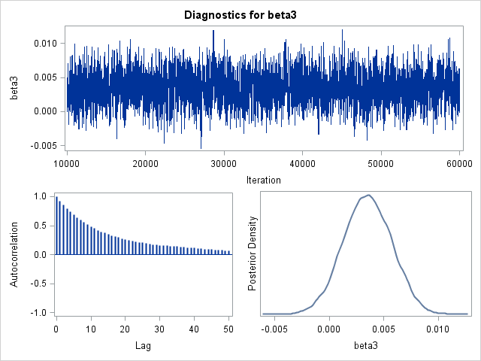 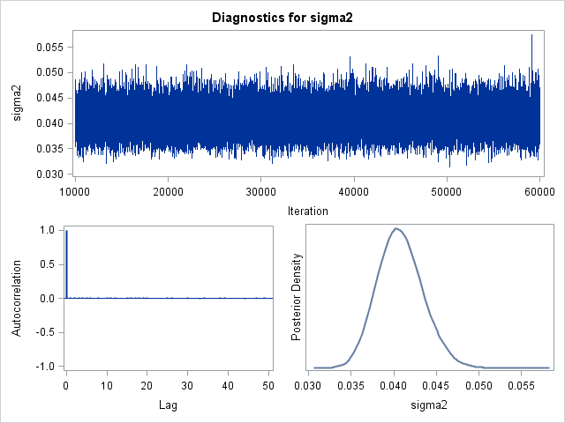

**Figure 1. Lower left: Trace plot, density plot, and autocorrelation plot of BMI when modeling change in log10 of CD4 counts. Lower right: Trace plot, density plot, and autocorrelation plot of the variance of the errors σ2 when modeling change in log10 of CD4 counts**

Conclusions: In the population from Multicenter AIDS Cohort Study, using hard drug at baseline decreases change in log10 CD4 cell in two years comparing to those who did not use hard drug at baseline. Using hard drug use at baseline decreases change in physical scores in 2 years comparing to those who did not use hard drug at baseline. There were many improvements that could be made in future. First, we did not know the missing reason for those participants who did not show up at two-year visit, so as to those with missing BMI and outcomes. If those data missed because of hard drug use, the analysis will not be validated because missing not at random happened. Second, in Bayesian method, although the trace plots indicated convergence, the autocorrelations through time (result was not shown) were relatively high (around 20-50). We tried thinning a Markov chain (k=2,3) and tried to center age and BMI(result was not shown), but there result was not improved. However, autocorrelation does not lead to biased estimates, our results were still valid.

Reproducible research information

Link to Code

**https://github.com/BIOS6624-UCD/bios6624-zhwr7125/tree/master/Project0**1