**Investigation on the heart surgeries Mortality Rate on last six months of 1982**

**Wenru Zhou**

**11/26/2018**

**Introduction:**

Scientists want to know whether the death rate in VA hospitals in the last six months in 1982 is too high or too low compared to a hospital-level risk-adjusted estimate of death rate. 44 VA hospitals are in this study. To calculate the estimated death rate based on historical data, data is available from 1980 to 1982 on the six-month unit, which is numbered 34-39. Our aim is to use period 34-38 to estimate death rate in period 39 and then compared with observed death rate in period 39. There are 26,491 records from 44 hospitals and 2 years in this dataset. The data included hospital number(1-44), six month period (34-39), 30 day mortality (dummy variable, 0 is alive and 1 is dead), height (inches), weight (lbs), BMI (kg/cm^2), procedure (dummy variable, 0 = valve surgery, 1 = CABG surgery). Patient’s condition at start of surgery (1 = good health, 5 = near death), and albumin (The normal range is 3.4 - 5.4 grams per deciliter (g/dL))

**Methods:**

Data clean: Among 9 variables, procedure, patient’s condition, height, weight, BMI and albumin had missing values. We defined the missing status of each variable as dummy variables, then checked their association with other missing status and other variables using chi-sq test, logistic regression, t-test or Welch-Satterthwaite T-Test. Because this is not a longitudinal data (subjects were not followed up), we did not check the lag of variables and the missing status of variables. Significant level was 0.05. Because height, weight, and BMI are highly correlated, we only included BMI in our model.

Procedure: We excluded two observations with procedure=2, because we were only interested in valve surgery (proced=0) and CABG surgery (proced=1). In addition, a patient who died in 30 days was likely with the missing procedure (OR=1.705, 95%CI: 1.125 2.586). A patient with missing BMI was less likely with the missing procedure (OR= 0.361, 95% CI: 0.149, 0.873)

BMI: After checking with the investigator, we found that the unit of weight for hospital 1-16 at period 39 should be kg, not pounds. Three outliers were corrected with new BMI calculated by weight and height. In addition, hospital 30 at period 39 had all weight, height, and BMI missing. A person who died in 30 days showed more missing BMI (OR= 2.377, 95%CI: 1.711 3.302)

Patient’s condition: hospital17, 34 and 39 has higher missing in patient’s condition compared to other hospitals (hospital 17 OR=2.415, 95%CI: 1.211, 4.816; hospital 34 OR=2.203, 95%CI: 1.110, 4.374; hospital 39 OR=2.138, 95%: CI1.073, 4.261). A patient with the non-missing procedure is more likely to have missing patient’s condition (OR=0.214, 95%CI: 0.069, 0.667). A patient who died in 30 days was more likely to have missing patient’s condition (OR=1.537, 95%CI: 1.038 2.275). A patient with BMI missing was less likely to have missing patient’s condition (OR=0.288, 95%CI: 0.119 0.696). A patient with missing Patient’s condition tended to have larger BMI (difference of means= 0.5379, p<0.01) and less albumin (difference of means= 0.1847, p=0.014).

Therefore, the missing status of the patient’s condition, procedure and BMI were related to outcome 30-day mortality. The patterns were MAR. When we used complete case of data, though observations with missing covariates will be deleted, the bias would not be a problem because the number of missing was low (2~2.5%, see table 0 in the appendix). The association between the missing statuses of covariates would also not cause bias because we were not modeling covariates.

Albumin had around 50% missing values. The sample size would be reduced by 50% if we use it as a covariate. The missing pattern of albumin was MCAR because the missing of albumin did not relate to any other variables.

Observed rate: observed death rate is calculated by dividing aggregated total death by aggregated total observations and for each hospital in period 39. The standard error of death rate was calculated by binomial variance formula. We kept all the observations with missing patient’s condition, procedures, and BMI.

Expected rate: We fitted logistic regression to calculate the expected death rate. The outcome was 30-day mortality, and predictors were procedure, patients’ condition, and BMI. Observations with missing covariates were excluded. We did not use albumin because of 50% missing values. We combined level 1 and 2 in patient’s condition because of small sample size. The association between each variable and outcome were checked with chi-sq test, Fisher test, t-test, or Welch-Satterthwaite T-Test. The bootstrap method was used to create 1000 data stratified by hospital. Significant level was 0.05.

**Result:**

Characteristics of each variable are shown in Table 1 separately for period 34-38 and 39. From table 1, we can see that the distribution of each variable did not change much. Although we have more significant associations for covariates with outcome in period 34-38, this might due to small sample size in period 39.

Table 1. Characteristics$

| Years | Period 34-38 | | | | Period 39 | | | |
| --- | --- | --- | --- | --- | --- | --- | --- | --- |
| Characteristics | All (N=20622) | Alive (N=20096) | Dead (N=526) | P value | All (N=4011) | Alive (N=3911) | Dead (N=100) | P value |
| Patient's condition | N=20622 | N=20096 | N=526 | <.0001 | N=4011 | N=3911 | N=100 | <.0001& |
| 1,2 | 942(4.6%) | 933(4.6%) | 9(1.7%) |  | 171(4.3%) | 169(4.3%) | 2(2.0%) |  |
| 3 | 6364(30.9%) | 6285(31.3%) | 79(15.0%) |  | 1254(31.3%) | 1239(31.7%) | 15(15.0%) |  |
| 4 | 12216(59.2%) | 11829(58.9%) | 387(73.6%) |  | 2363(58.9%) | 2290(58.6%) | 73(73.0%) |  |
| 5 | 1100(5.3%) | 1049(5.2%) | 51(9.7%) |  | 223(5.6%) | 213(5.4%) | 10(10.0%) |  |
|  |  |  |  |  |  |  |  |  |
| Procedure | N=20622 | N=20096 | N=526 | <.0001 | N=4011 | N=3911 | N=100 | 0.51 |
| Valve surgery | 4074(19.8%) | 4004(19.9%) | 70(13.3%) |  | 703(17.5%) | 683(17.5%) | 20(20.0%) |  |
| CABG surgery | 16548(80.2%) | 16092(80.1%) | 456(86.7%) |  | 3308(82.5%) | 3228(82.5%) | 80(80.0%) |  |
|  |  |  |  |  |  |  |  |  |
| Weight,lb | N=20622 | N=20096 | N=526 | <.0001 | N=4011 | N=3911 | N=100 | 0.211 |
| (Mean, median) | (171.8,171.5) | (171.6,171.3) | (181.0,180.6) |  | (171.5,170.5) | (171.4,170.4) | (175.2,174.3) |  |
| (25th, 75th quantile) | (151.7,191.4) | (151.5,191.2) | (160.5,200.1) |  | (151.0,191.8) | (150.9,191.7) | (156.7,198.0) |  |
| (Minimum. Maximum) | (80.3,288.2) | (80.3,288.2) | (108.9,270.0) |  | (78.3,277.4) | (78.3,277.4) | (113.6,252.9) |  |
|  |  |  |  |  |  |  |  |  |
| Height,inch | N=20622 | N=20096 | N=526 | 0.172 | N=4011 | N=3911 | N=100 | 0.708 |
| (Mean, median) | (65.3,65.3) | (65.3,65.3) | (65.5,65.4) |  | (65.3,65.3) | (65.3,65.3) | (65.4,65.3) |  |
| (25th, 75th quantile) | (63.6,67.1) | (63.6,67.1) | (63.7,67.1) |  | (63.5,67.1) | (63.5,67.1) | (63.8,67.0) |  |
| (Minimum. Maximum) | (54.7,76.6) | (54.7,76.6) | (58.2,72.4) |  | (55.8,74.9) | (55.8,74.9) | (59.1,72.6) |  |
|  |  |  |  |  |  |  |  |  |
| BMI,kg/cm2 | N=20622 | N=20096 | N=526 | <.0001 | N=4011 | N=3911 | N=100 | 0.196 |
| (Mean, median) | (28.2,28.2) | (28.2,28.1) | (29.6,29.6) |  | (28.2,28.2) | (28.2,28.2) | (28.7,28.7) |  |
| (25th, 75th quantile) | (25.5,30.9) | (25.5,30.9) | (26.9,32.4) |  | (25.4,30.9) | (25.4,30.9) | (26.0,31.9) |  |
| (Minimum. Maximum) | (15.8,45.0) | (15.8,42.9) | (17.3,45.0) |  | (17.1,42.3) | (17.1,42.3) | (19.1,38.5) |  |
|  |  |  |  |  |  |  |  |  |
| Albumin,g/dL | N=10338 | N=10068 | N=270 | 0.354 | N=2015 | N=1969 | N=46 | 0.496 |
| (Mean, median) | (4.0,4.0) | (4.0,4.0) | (4.0,4.0) |  | (4.0,4.0) | (4.0,4.0) | (4.0,4.0) |  |
| (25th, 75th quantile) | (3.7,4.4) | (3.7,4.5) | (3.6,4.4) |  | (3.6,4.4) | (3.6,4.4) | (3.7,4.2) |  |
| (Minimum. Maximum) | (1.8,6.1) | (1.8,6.1) | (2.5,5.7) |  | (2.2,6.3) | (2.2,6.3) | (3.0,5.5) |  |
|  |  |  |  |  |  |  |  |  |

& fisher exact test is used

$ Those two sample has excluded missing in patient’s condition, procedure and BMI.

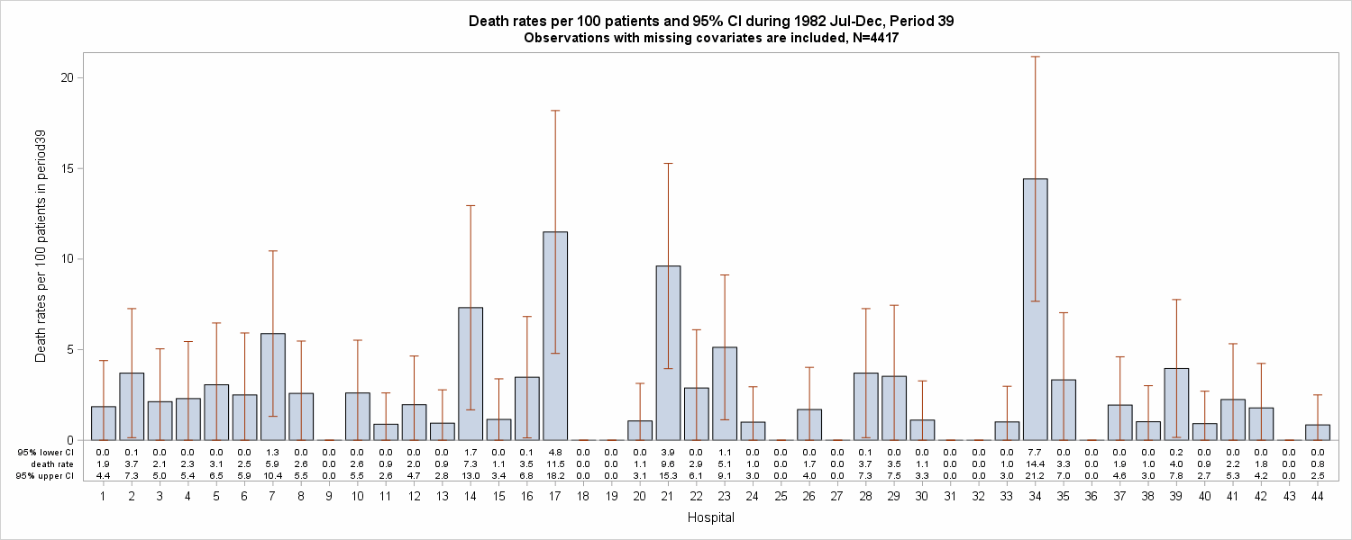The result from observed data in period 39 is shown in Figure 1. Hospital 9, 18, 19, 25, 27, 31, 32, 36 and 43 does not have any death. Hospital 34 has the highest death rate (14.4 per 100 patients in period 39, 95% CI: 7.7, 21.2) Observed and expected rates are shown in Figure 2 and Table 2 (in the appendix).

Figure1. Counted death rates per 100 patients in period 39

For observed death rates, some lower ends of confidence interval are below zero. This happens because the death rate is low, but the sample size is not large enough. When the death rate is very low or high, we need more observations to let standard error to be small enough to keep upper and lower confidence interval stay between zero and one.

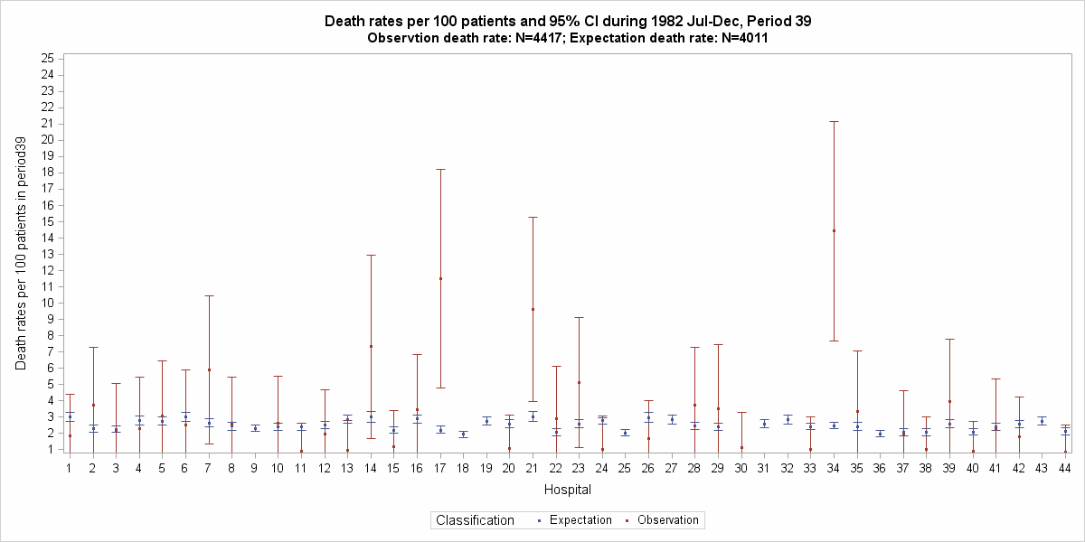Figure2. Death rates per 100 patients in period 39, comparison

*The lower end of confidence interval of observed rates are set to be zero if it is negative.

**Hospital 30 does not have expected death rate because all BMI are missing in period 39 for hospital 30.

The binomial theoretical confidence intervals are much wider than the bootstrap interval. This happens because the death rate is not extremely low or high, and the sample size is not large enough. When sample size remains the same, the more the percentage approximates 0.5, the larger the standard deviation will be. So we need a larger sample size to keep confidence interval narrow.

As for interpretation, we took hospital 21 for example. The expected death rate per 100 patients in period 39 is 3.03 (95% CI: 2.74, 3.35). The observed death rate per 100 patients in period 39 is 9.62 (95% CI: 3.95,15.28). Because the confidence interval of observed death rate is higher than the expected death rate, we conclude that the death rate of hospital 21 does increase in period 39 comparing to period 34-38.

**Conclusion:**

3 hospitals (6.98%), which are hospital 17, 21 and 34, had more severe death rates in period 39 than expectation. 9 hospitals (20.93%), which are hospital 9, 18, 19, 25, 27, 31, 32, 36 and 43, had zero death rates in period 39, which are better than the expectation of period 39 using the data in period 34-38. Hospital 30 was excluded from comparison because of missing BMI. Death rates from other hospitals (72.09%) did not change much.

One limitation is the way we calculated the confidence interval for the observed death rate. It is not very accurate because of the limiting sample size compared to the proportion of death. One approach that might be helpful is the bootstrap method. We can use the bootstrap method to create a large number of samples (for example, 1x105) from each hospital during period 39, and then calculate the mean death rate and confidence interval. Another limitation is that we have so many missing in albumin, which might be a useful predictor to explain the variation in outcome. Although it did not show significance in univariate test (p=0.496), we still tried ROC analysis, and albumin definitely increased the AUC (from 0.6316 to 0.6377, N= 10338).

**Reproducible research information:**

<https://github.com/BIOS6624-UCD/bios6624-zhwr7125>

**Reference:**

Rachel Weber: <https://github.com/BIOS6624-UCD/bios6624-r-weber>

Luke Patten: <https://github.com/BIOS6624-UCD/bios6624-lukepatten15>

**Appendix**

Table 0. Missing summary

|  |  |
| --- | --- |
| Variable | Missing  (Total N=26491) |
| Procedure | 2.03% |
| Patient’s condition | 2.52% |
| Weight,lb | 2.51% |
| Height, inches | 2.51 |
| BMI, kg/cm2 | 2.51% |
| Albumin | 49.92% |

Table 2. Death rates in 44 hospitals during period 39

| *Hospital* | *Expected death rate(95%CI)* | *Actual death rate(95%CI)* | *Reality compared to expectation, period 39* |
| --- | --- | --- | --- |
| hospcode1 | 3(2.74,3.29) | 1.85(0,4.39) | Not change much |
| hospcode2 | 2.28(2.06,2.51) | 3.7(0.14,7.27) | Not change much |
| hospcode3 | 2.26(2.07,2.46) | 2.13(0,5.04) | Not change much |
| hospcode4 | 2.78(2.52,3.06) | 2.3(0,5.45) | Not change much |
| hospcode5 | 2.73(2.48,3.01) | 3.06(0,6.47) | Not change much |
| hospcode6 | 3(2.73,3.29) | 2.5(0,5.92) | Not change much |
| hospcode7 | 2.64(2.41,2.9) | 5.88(1.32,10.45) | Not change much |
| hospcode8 | 2.43(2.2,2.67) | 2.59(0,5.47) | Not change much |
| hospcode9 | 2.29(2.1,2.5) | 0(0,0) | Lower |
| hospcode10 | 2.41(2.2,2.62) | 2.61(0,5.52) | Not change much |
| hospcode11 | 2.39(2.18,2.61) | 0.88(0,2.61) | Not change much |
| hospcode12 | 2.49(2.26,2.74) | 1.96(0,4.65) | Not change much |
| hospcode13 | 2.85(2.59,3.14) | 0.94(0,2.78) | Not change much |
| hospcode14 | 2.98(2.69,3.33) | 7.32(1.68,12.95) | Not change much |
| hospcode15 | 2.2(2,2.41) | 1.15(0,3.39) | Not change much |
| hospcode16 | 2.87(2.62,3.14) | 3.48(0.13,6.83) | Not change much |
| hospcode17 | 2.2(1.98,2.43) | 11.49(4.79,18.2) | Higher |
| hospcode18 | 1.94(1.76,2.13) | 0(0,0) | Lower |
| hospcode19 | 2.75(2.5,3.02) | 0(0,0) | Lower |
| hospcode20 | 2.56(2.31,2.81) | 1.06(0,3.14) | Not change much |
| hospcode21 | 3.03(2.74,3.35) | 9.62(3.95,15.28) | Higher |
| hospcode22 | 2.06(1.87,2.26) | 2.88(0,6.1) | Not change much |
| hospcode23 | 2.59(2.34,2.85) | 5.13(1.13,9.13) | Not change much |
| hospcode24 | 2.8(2.54,3.08) | 1(0,2.95) | Not change much |
| hospcode25 | 2.02(1.84,2.2) | 0(0,0) | Lower |
| hospcode26 | 2.96(2.65,3.31) | 1.69(0,4.02) | Not change much |
| hospcode27 | 2.83(2.58,3.09) | 0(0,0) | Lower |
| hospcode28 | 2.43(2.23,2.67) | 3.7(0.14,7.27) | Not change much |
| hospcode29 | 2.37(2.16,2.59) | 3.53(0,7.45) | Not change much |
| hospcode30 | N/A | 1.11(0,3.28) | N/A |
| hospcode31 | 2.57(2.34,2.82) | 0(0,0) | Lower |
| hospcode32 | 2.83(2.56,3.1) | 0(0,0) | Lower |
| hospcode33 | 2.41(2.21,2.63) | 1.01(0,2.98) | Not change much |
| hospcode34 | 2.48(2.27,2.7) | 14.42(7.67,21.18) | Higher |
| hospcode35 | 2.41(2.18,2.66) | 3.33(0,7.04) | Not change much |
| hospcode36 | 1.97(1.79,2.16) | 0(0,0) | Lower |
| hospcode37 | 2.07(1.86,2.3) | 1.94(0,4.61) | Not change much |
| hospcode38 | 2.06(1.86,2.27) | 1.02(0,3.01) | Not change much |
| hospcode39 | 2.58(2.34,2.84) | 3.96(0.16,7.76) | Not change much |
| hospcode40 | 2.08(1.9,2.28) | 0.92(0,2.71) | Not change much |
| hospcode41 | 2.41(2.19,2.64) | 2.25(0,5.33) | Not change much |
| hospcode42 | 2.55(2.32,2.81) | 1.79(0,4.24) | Not change much |
| hospcode43 | 2.73(2.5,2.98) | 0(0,0) | Lower |
| hospcode44 | 2.13(1.92,2.33) | 0.85(0,2.5) | Not change much |