BUEC 333, Answers to problem set exercises
Part 1: Probability and Statistics
-----------------------------------------------

1
- 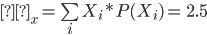
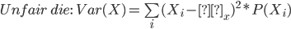
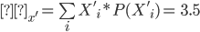
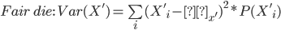

2
X1 X2
HHH 3 3
HHT 2 1
HTH 2 1
THH 2 1
HTT 1 -1
TTH 1 -1
THT 1 -1
TTT 0 -3
- X1 3 2 1 0
Prob ⅛ ⅜ ⅜ ⅛
b. X2 3 1 -1 -3
Prob ⅛ ⅜ ⅜ ⅛

3
- Given , we have

4. The variance question.
- Table 3. E(X)=½*(-1)+½*2=0.5. So the variance is (-1-0.5)^2*0.5+(2-0.5)^2*0.5=2.25. Alternatively, call the RV in Table 1 “X”, and the one in Table 3 “Y”. Note that Y=1.5*X+0.5. Therefore, Var(Y)=1.5^2 Var(X)
- Table 4. E(X)=8/10. Then Var(X)=1/10*(-1-8/10)^2 + 9/10*(1-8/10)^2 = 1/10*(-18/10)*(-18/10)+9/10*2/10*2/10 = 360/1000=0.36

7
Let X1 be the first shot, X2 be the second shot.
X1 = 1 if has a bullet, 0 otherwise
X2 = 1 if has a bullet, 0 otherwise

Spin again:
Pr(X2=0) = ½
Pull the trigger without spinning:
Pr(X2=0|X1=0) = ⅔

Better not to spin.

8
- Recall and if and are independent. Thus
- , which is just the same as unconditionally.
- No.

9
a.

b.

c.

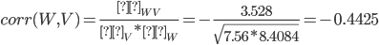

10 (a) P(X=6|Y=1) = P(X=6,Y=1) / P(Y=1) = ¼ / ½ =½.
(b) P(Y=0|X=4) = P(X=4,Y=0) / P(X=4) = 1/12 / (1/12+1/20) = ⅝
(c ) P(X=3) = P(X=3,Y=0) + P(X=3,Y=1) = 1/12 + 1/20 = 2/15.
(d) E(X|Y=0) = 3.5, because the conditional prob P(X=x|Y=0)=⅙
P(X=6|Y=1) = ½, P(X=x|Y=1)=1/10 for x=1,...,5, so
E(X|Y=0) = ½*6 + 1/10*(1+...+5) = 3 + 15/10 = 4.5
(e) 3.5*½ + 4.5*½ = 4
(f) 1/10*( (1-4.5)^2 + (2-4.5)^2 + (3-4.5)^2 + (4-4.5)^2 + (5-4.5)^2)) + 0.5*(6-4.5)^2 = 3.25.

11

- Old computers are more likely to crash

12
Cov(X,Y) = E(XY)-E(X)E(Y) = 171.7 - 5.33 x 30.15 = 11
Corr(X,Y) = Cov(X, Y)/[SD(X)SD(Y)] = 11/(2.6 x 14.77) = 0.286

13
- Recall that if , then 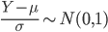. Thus, given , .
- Given ,
- Given ,
- Given ,
14 P(X^2 > 4) = P(X< -2) + P(X>2)
= P( (X-3) / 2 < -5/2) + P( (X-3) / 2 > -½)
= P(Z< -5/2) + P(Z> -½) where Z is a standard normal.

16
      - Because has a uniform probability distribution. is time and as a result is continuous.
      - 0, 15



e. 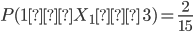,
f.


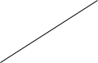


Statistics

1 SW 2.17
and
- i.
ii.
- Pr(-1.96Z1.96)=0.95
therefore we need to find n such that:
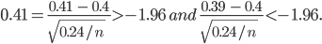 solving this gives us:
SW 3.1
The CLT suggests that when the sample size (n) is large, the distribution of the sample average () is approximately with .
Given population , =43 , we have
- n=100, and
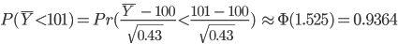
- n=64, and

- n=165, and
2

3
Stock and Watson 3.8
Given that n = 1000, = 1110, = 123, a 95% confidence interval for the population mean is 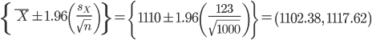.

Stock and Watson 3.13 (a)
Given that n=420, , a 95% confidence interval for the population mean is 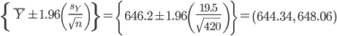.

4 SW 3.11
Assume that n is an even number. Then is constructed by applying a weight of ½ to the n/2 “odd” observations and a weight of 3/2 to the remaining n/2 observations.

5.
- E(1/2(Y1+Y2))=1/2 E(Y1+Y2) = 1/2 * (E(Y1) + E(Y2)) = 1/2 * 2 mu = mu
- 1/8 var(Y), which is smaller than var(Y-bar) , so you prefer Y-tilde
- It is biased
- The estimator is based on the unknown quantity that you are trying to estimate!

6 Stock and Watson 3.2.
- Let be the number of successes in the trial. Then the fraction of success in trials is 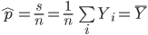
- 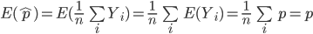

7

8 Stock and Watson 3.15
Given that and are Bernoulli random variables with and , thus and .
- Recall that and 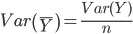, hence and 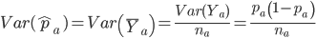. Similarly, and 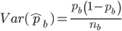.
- ( because the sample from population a is independent of the sample from population b.)
- Given Equation (3.21) from the text, a 95% confidence interval for is . To construct 90% confidence interval, use 1.64 instead of 1.96.

9 Stock and Watson 2.7. Let and denote the randomly selected male and female earnings, respectively. Then and .
- From the correlation formula we get where the units are squared thousands of dollars per year.
- Let the exchange rate be Euros per dollar. Then the mean combined income would be Euros per year, with standard deviation Euros per year. The correlation is unit free, and thus unchanged after conversion.

10
- 3
- (2-3)^2+(3-3)^2+(4-3)^2 / (n-1) = 1.
- [3-1.64*SE(Xbar), 3+1.64*SE(Xbar)] = [3-1.64/sqrt(3), 3+1.64/sqrt(3)]
- Incorrect answer: “contains μ with 90% probability”. Correct: “If we would repeat this procedure many, many times, it would contain μ ~90% of the time.”.

11 No. Note X-tilde = (n-2) /n X-bar, so that E[X-tilde] = (n-2)/n * mu

12

