mkdir wordpress && cd wordpress
mkdir nginx-conf
nano nginx-conf/nginx.conf
server {
listen 80;
listen [::]:80;

server_name example.com www.example.com;

index index.php index.html index.htm;

root /var/www/html;

location ~ /.well-known/acme-challenge {
allow all;
root /var/www/html;
}

location / {
try_files $uri $uri/ /index.php$is_args$args;
}

location ~ \.php$ {
try_files $uri =404;
fastcgi_split_path_info ^(.+\.php)(/.+)$;
fastcgi_pass wordpress:9000;
fastcgi_index index.php;
include fastcgi_params;
fastcgi_param SCRIPT_FILENAME $document_root$fastcgi_script_name;
fastcgi_param PATH_INFO $fastcgi_path_info;
}

location ~ /\.ht {
deny all;
}

location = /favicon.ico {
log_not_found off; access_log off;
}
location = /robots.txt {
log_not_found off; access_log off; allow all;
}
location ~* \.(css|gif|ico|jpeg|jpg|js|png)$ {
expires max;
log_not_found off;
}
}
nano .env
MYSQL_ROOT_PASSWORD=your_root_password
MYSQL_USER=your_wordpress_database_user
MYSQL_PASSWORD=your_wordpress_database_password

nano docker-compose.yml
version: '3'

services:
db:
image: mysql:8.0
container_name: db
restart: unless-stopped
env_file: .env
environment:
- MYSQL_DATABASE=wordpress
volumes:
- dbdata:/var/lib/mysql
command: '--default-authentication-plugin=mysql_native_password'
networks:
- app-network
docker-compose up -d
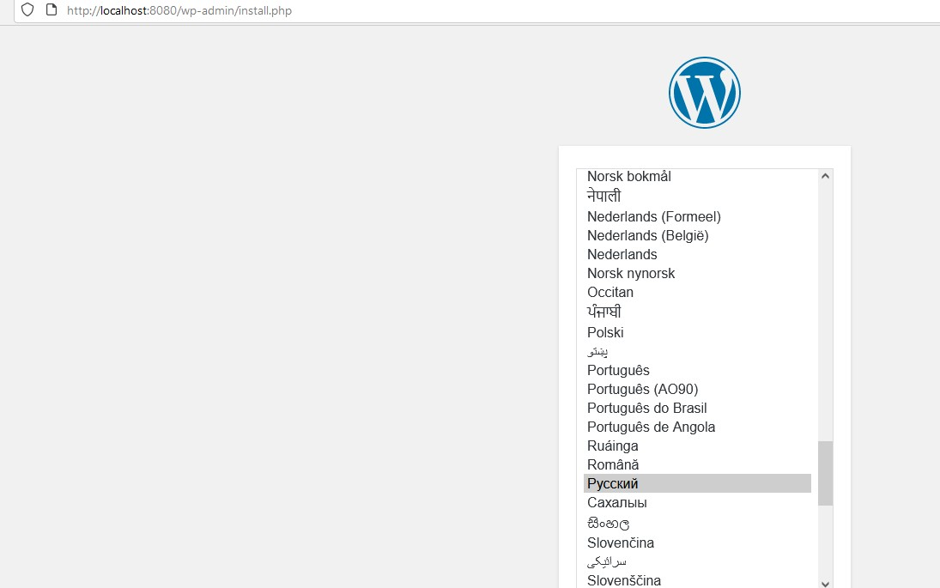

mkdir ~/phpmyadmin && cd ~/phpmyadmin
nano docker-compose.yml
version: '3'

services:
db:
image: mariadb:10.8
container_name: db
restart: unless-stopped
volumes:
- dbdata:/var/lib/mariadb
networks:
- app-network
wordpress:
depends_on:
- db
image: phpmyadmin
container_name: wordpress
restart: unless-stopped
env_file: .env
environment:
- WORDPRESS_DB_HOST=db:3306
- WORDPRESS_DB_USER=$MYSQL_USER
- WORDPRESS_DB_PASSWORD=$MYSQL_PASSWORD
- WORDPRESS_DB_NAME=wordpress
volumes:
- wordpress:/var/www/html
networks:
- app-network
webserver:
depends_on:
- phpmyadmin
image: nginx:1.15.12-alpine
container_name: webserver
restart: unless-stopped
ports:
- "80:80"
volumes:
- ./nginx-conf:/etc/nginx/conf.d
networks:
- app-network

volumes:
phpmyadmin:
dbdata:

networks:
app-network:
driver: bridge

Понимаю что здесь нужно сделать новый файл .env нагуглить в него директивы, но времени совсем не остаётся, “доделаю потом» для спортивного интереса

