**CPT_S 534 Project**

**Yang Zhang**

**11529139**

In this project, I implement 3 kinds of perceptron algorithms:

1. Standard Perceptron

2. Passive Aggressive Perceptron

3. Averaged Perceptron

I will compare their performance on 2 different cases:

1. Binary Classification
2. MultiClass Classification

Data source:

OCR handwriting data. There are 10 different training and testing sets (named as folds 0 to 9).

The format of the file is as follows. Each line is one classifcation example: the 128 binary

bits after im correspond to the input features (binary image of the handwritten character)

and the character letter at the end correspond to the output label. So, in total 26 classes. All graphs below show the averaged results for the 10 different folds.

**Part I Binary Classification**

**Objective: Learn a binary classifier to classify vowels (a, e, i, o, u) and consonants (non-vowels).**

1. The training accuracy and testing accuracy comparasion between Perceptron and PA perceptron

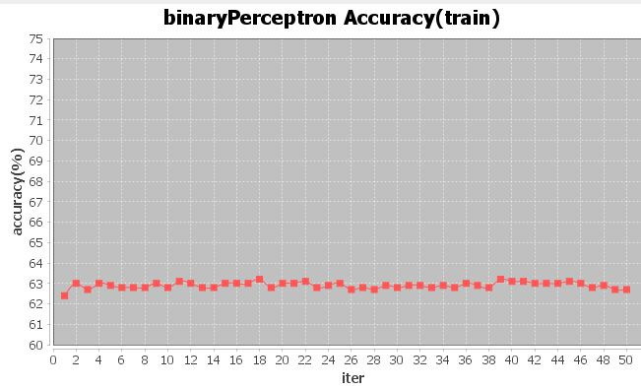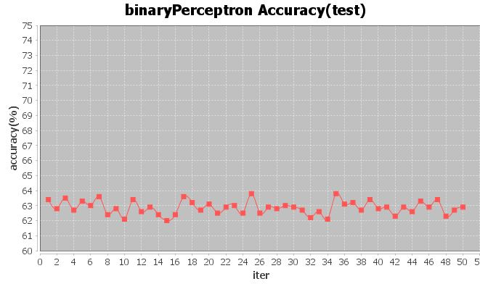

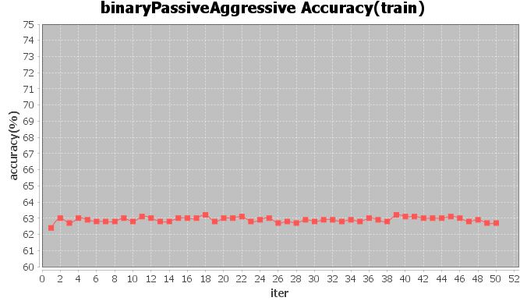

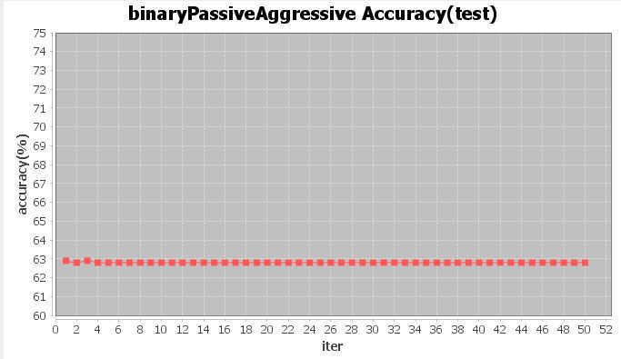

Comparing the 4 accuracy curves, I found that the accuracy of passive aggressive training is similar with the accuracy of standard perceptron training and the accuracy of standard perceptron testing, while the accuracy of passive aggressive testing is significantly more stable than accuracy of standard perceptron testing.

1. The training accuracy and testing accuracy comparasion between Perceptron and Averaged perceptron

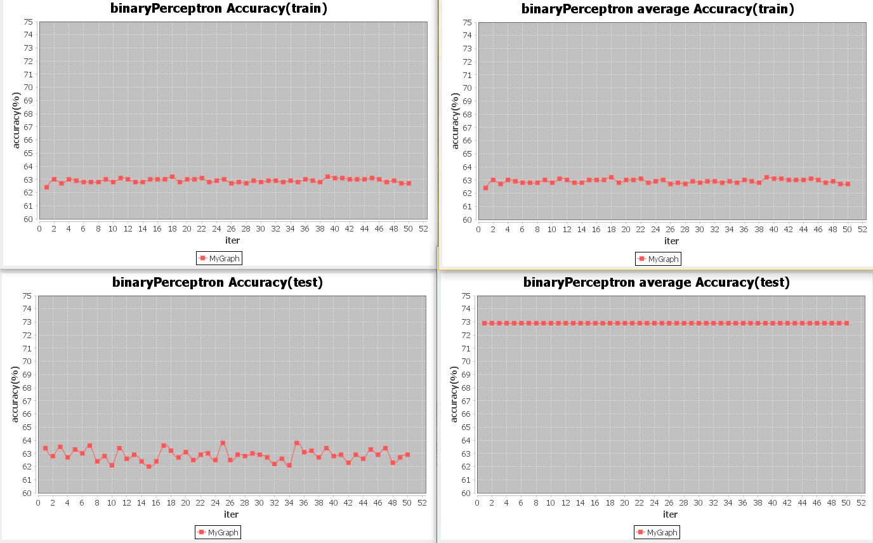

Comparing the graphs above, I found that the accuracy of perceptron averaged training is same as the accuracy of standard perceptron training, this because for the training part, both algorithms use the same weight vector to learn. While the accuracy of perceptron averaged testing is significantly higher than accuracy of standard perceptron testing and is very stable.

1. The learning rate comparasion between the 3 perceptrons

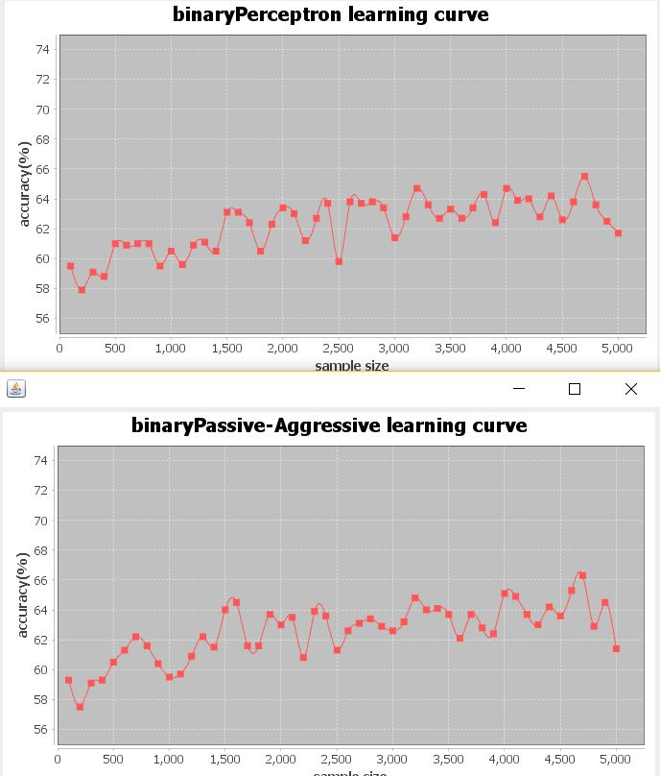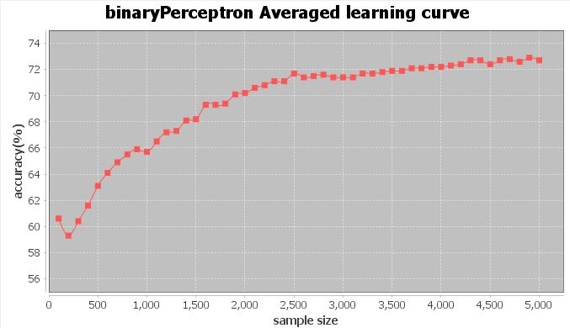

Comparing the graphs above, in general, all the three algorithms increase their accuracy with increased training data size, while the perceptron averaged increased its accuracy more and more stable than other two algorithms.

**Part II MultiClass Classification**

**Objective: Learn a multiClass classifier to map binary handwrittencharacter images to the corresponding character letter (a-z).**

1. The training accuracy and testing accuracy comparasion between Perceptron and PA perceptron

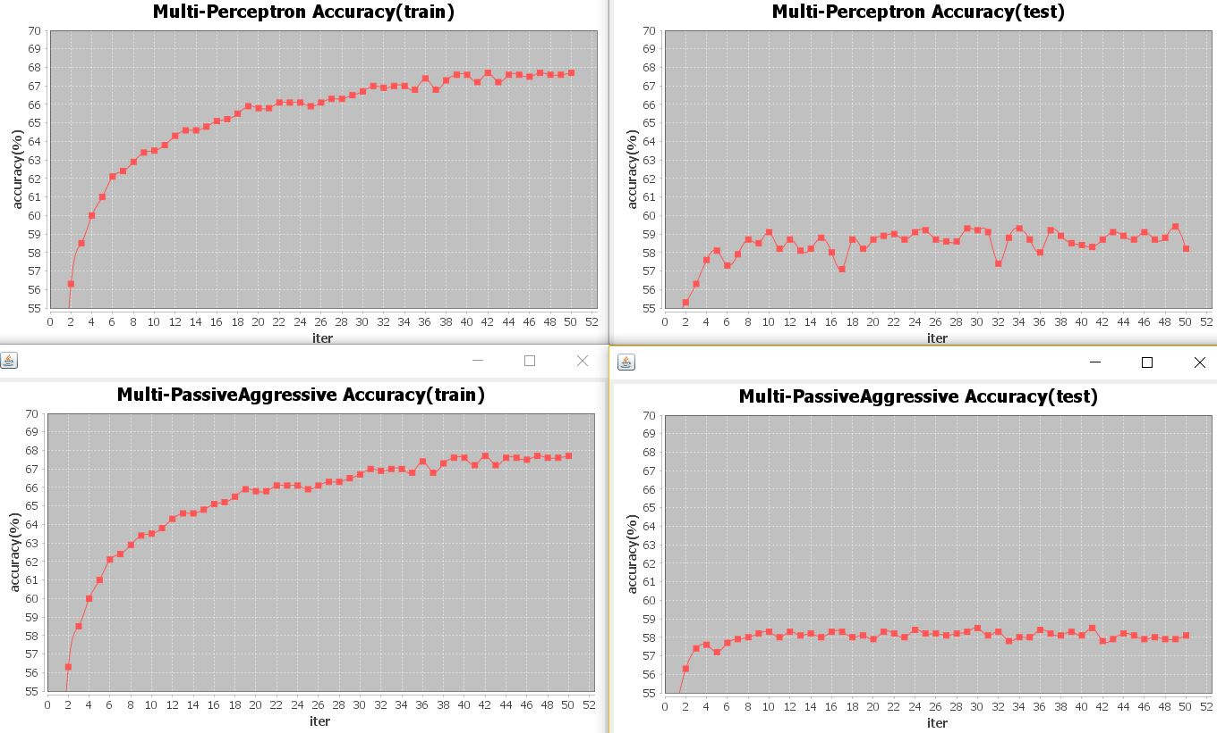

Comparing the 4 accuracy curves, in general, both algorithms increased the accuracy with increased iteration times. I found that the accuracy of passive aggressive training is similar with the accuracy of standard perceptron training, while the accuracy of passive aggressive testing is significantly more stable than accuracy of standard perceptron testing.

1. The training accuracy and testing accuracy comparasion between Perceptron and Averaged perceptron

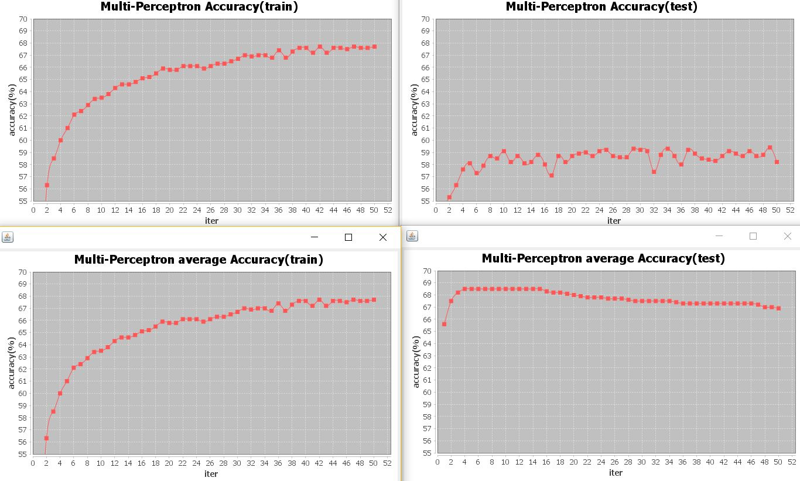

Comparing the graphs above, I found that the accuracy of perceptron averaged training is same as the accuracy of standard perceptron training, this because for the training part, both algorithms use the same weight vector to learn. While the accuracy of perceptron averaged testing is significantly higher than accuracy of standard perceptron testing and is more stable.

1. The learning rate comparasion between the 3 perceptrons

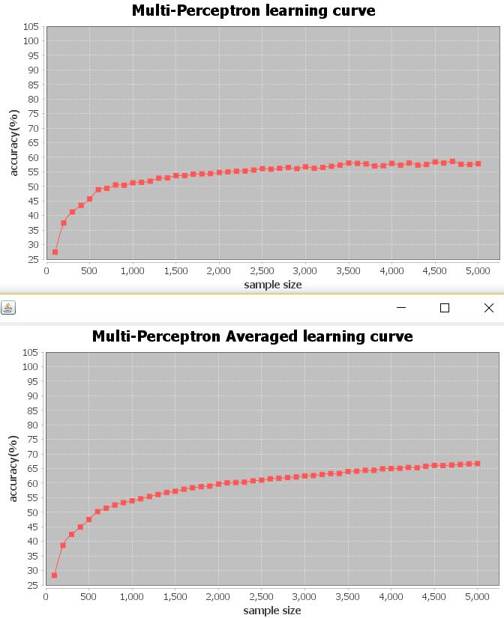

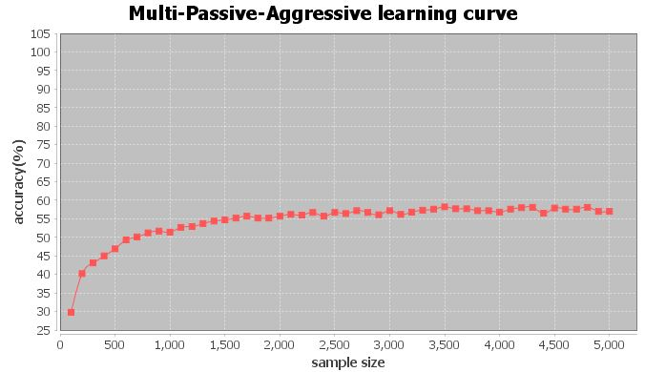

Comparing the graphs above, in general, all the three algorithms increase their accuracy with increased training data size, while the perceptron averaged has smoother curve and higher accuracy.