**CPT_S 540 HW3**

**Yang Zhang**

**11529139 (graduate)**

**2. The alpha-beta pruning**

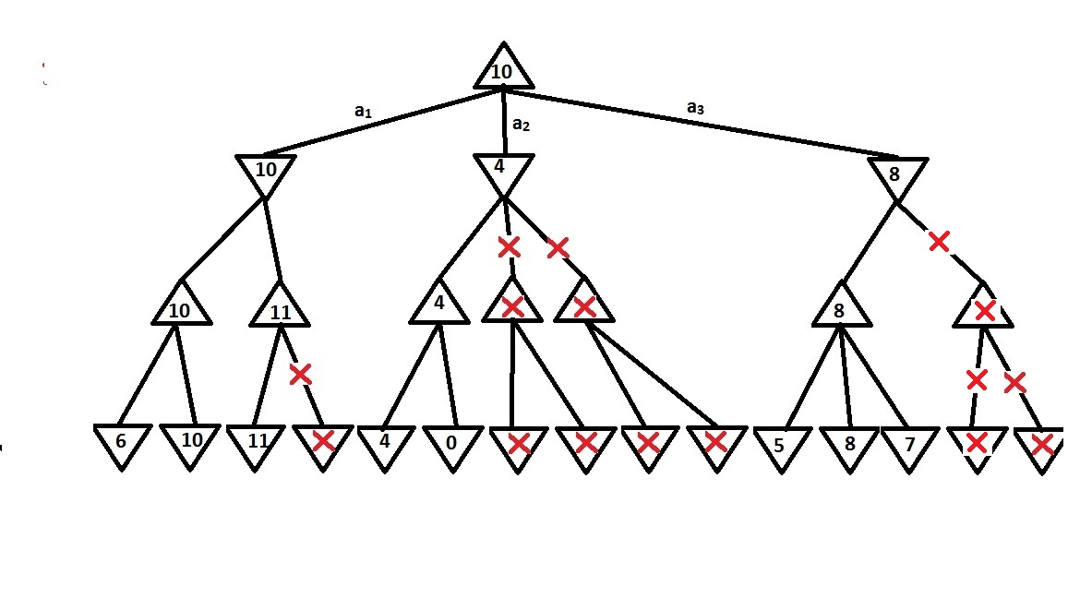

The max player should take the action a1, because a1 provides the best value over other two actions.

**3. Problem 6.2**

**(a)** Variables are K knights.

**(b)** The possible values of each variables are all the possible position on the n2 size board.

**(c)** The constraints:

1. No two knights can stay in the same position

2. Every pair of knights must be separated by a knight’s move

**(d)** Action function: make a move for the input variable (a knight object) in a direction within [up , down, left, right]

Result function: test the input variable (a state of current knights’ positions), return true if no knight violet the constraints.

Sensible objective function: Return the number of knights placed on the board. The optimal result of this function is the optimal solution.

**Programming Part**

**Test Run Result:**

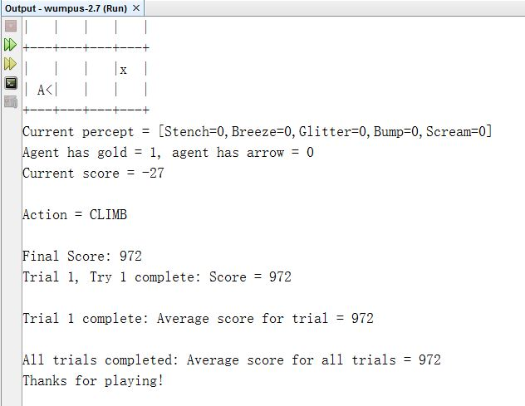

**Scores for 3 different Wumpus Locations:**

**1st run: 972**

**2nd run: 982**

**3rd run: 982**

**Average score: 978.67**

The agent could successfully grab the gold and climb out of the cave safely. By achieving the goal, Firstly, the agent tries to move toward location (4, 4) where the gold is located. If encountering stench, the agent shoots an arrow towards to its current orientation, and then the agent can move forward safely, because it will either kill the Wumpus or know that Wumpus is not in front. When the agent is at location (4,4), it grabs the gold and start going back to location (1,1) along the same route from (1,1) to (4,4) (The agent marked safe places along the way to (4,4), so the route from (1,1) to (4,4) is safe). Finally, the agent climbs out when reach location (1,1).