**CPT_S 580 HW4**

**Yang Zhang**

**11529139 (graduate)**

**4.3**

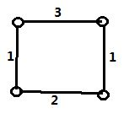

**4.4.1**

|  |  |  |
| --- | --- | --- |
| Vertex | Df# | low# |
| a | 0 | 0 |
| b | 2 | 2 |
| c | 1 | 0 |
| d | 3 | 0 |
| e | 4 | 0 |
| f | 5 | 0 |
| g | 6 | 3 |
| h | 7 | 6 |
| i | 8 | 6 |

Vertex g and c are cut vertices, and dfnumber(c) <= low(b), dfnumber(g) <= low(h), which verifies the assertion of Corollary 4.4.12

**4.4.2**

|  |  |  |
| --- | --- | --- |
| Vertex | Df# | low# |
| a | 2 | 1 |
| b | 0 | 0 |
| c | 1 | 1 |
| d | 4 | 1 |
| e | 3 | 1 |
| f | 6 | 2 |
| g | 5 | 2 |
| h | 7 | 5 |
| i | 8 | 5 |

Vertex g and c are cut vertices, and dfnumber(c) <= low(b), dfnumber(g) <= low(h), which verifies the assertion of Corollary 4.4.12

**4.4.3**

|  |  |  |
| --- | --- | --- |
| Vertex | Df# | low# |
| a | 1 | 0 |
| b | 8 | 8 |
| c | 0 | 0 |
| d | 3 | 0 |
| e | 2 | 0 |
| f | 5 | 1 |
| g | 4 | 3 |
| h | 6 | 4 |
| i | 7 | 4 |

**4.4.4**

Vertex g is cut vertex, and dfnumber(g) <= low(h), which verifies the assertion of Corollary 4.4.12

|  |  |  |
| --- | --- | --- |
| Vertex | Df# | low# |
| a | 1 | 0 |
| b | 3 | 3 |
| c | 2 | 0 |
| d | 4 | 0 |
| e | 0 | 0 |
| f | 6 | 0 |
| g | 5 | 3 |
| h | 6 | 6 |
| i | 7 | 6 |

Vertex g and c are cut vertices, and dfnumber(c) <= low(b), dfnumber(g) <= low(h), which verifies the assertion of Corollary 4.4.12

**5.1.2**

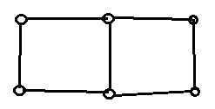

**5.1.4**

It is impossible, because if the 3 connected graph G only has 1 bridge, then kE(G) = 1 and kV(G) = 3, which violates the Corollary 5.1.6 (kV(G) <= kE(G)).

**5.1.14**



**5.1.15**

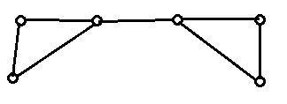

**5.1.20**

Any 3-connected simple graph must have at least 5 vertices and min degree number >= 3. Therefore, the smallest possible 3-connected graph is as shown below:

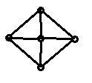

Which has 8 egdes. Therefore, there doesn’t exist such a graph with 7 edges.

**5.2.2**

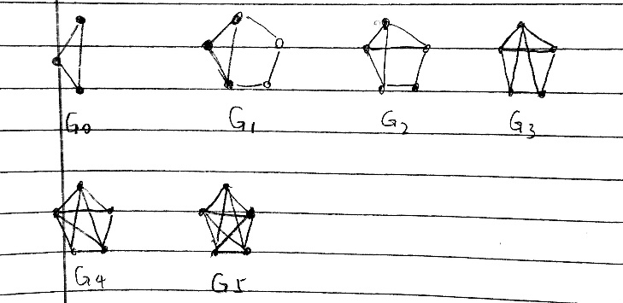

**5.2.3**

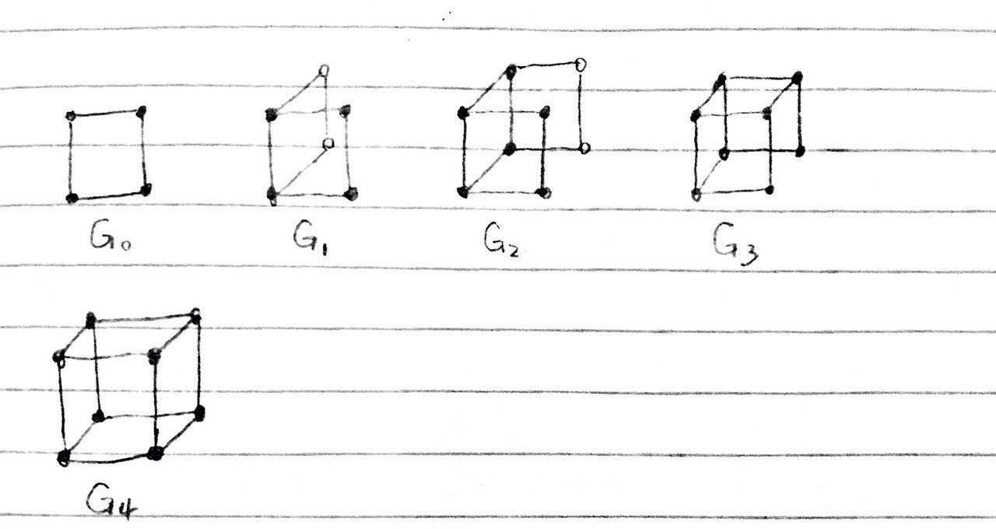

**5.2.6**

A 3-connected graph can be constructed from a wheel graph by applying Tutte Synthesis

Q3 can be constructed from a wheel graph as follow steps:

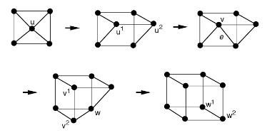

Therefore, Q3 is 3-connected graph.

**5.3.2**

One collection of two internally disjoint paths could be P={(u,t,y,v), (u,s,w,x,v), (u,a,b,v)}. The u-v separating vertex set {t,s,a} shows that P is maximum-size collection.

**5.3.11**

Since SUV is a u-v separating set, each u-v path in Puv must include at least one vertex of Suv. Since the paths in Puv are internally disjoint, no two of them can include the same vertex. Thus, the number of internally disjoint u-v paths in G is at most |Suv|. Therefore, if |Puv| = |Suv|, Puv has the maximum size.

**Coding Part**

The question is asking to implement the Prim Algorithm

The Prim’ Algorithm will produce the MST. To implement the Prim:

1. Transfer a graph into its adjacent matrix
2. Initialize an array checklist to track on the vertex already visited
3. Initialize an array parent to track on the vertex’ parent (i.e. the edge)
4. Initialize an array v to store the frontier edge weight of current vertex
5. Growing the tree:

Pick the 1st vertex u as starting point, and set v[u] = 0; parent[u] = -1;

#Vertices = n

Iterates the building process n-1 times:

Pick the vertex s with minimum v[s]

Mark s as visited

Iterates other vertices x:

If s and x are adjacent to each other and x is unvisited and edge between s and x has smaller weight than other edge on s:

Record the weight of edge between s and x (v[x])

And mark s as the parent of x

The input is the adjacent matrix of a graph

The output is the list of edges that Prim would pick

Output result:

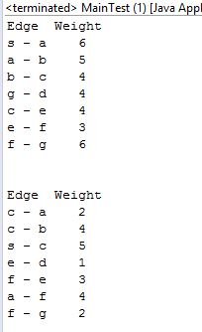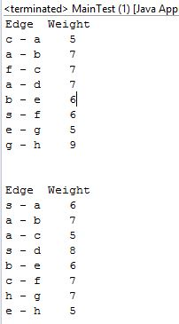

4.3.4

4.3.3

4.3.2

4.3.1

4.3.1

Verification of correctness:

Hand produced prim MST of 4.3.3:

Program output on 4.3.3:

Edge Weight

c - a 5

a - b 7

f - c 7

a - d 7

b - e 6

s - f 6

e - g 5

g - h 9

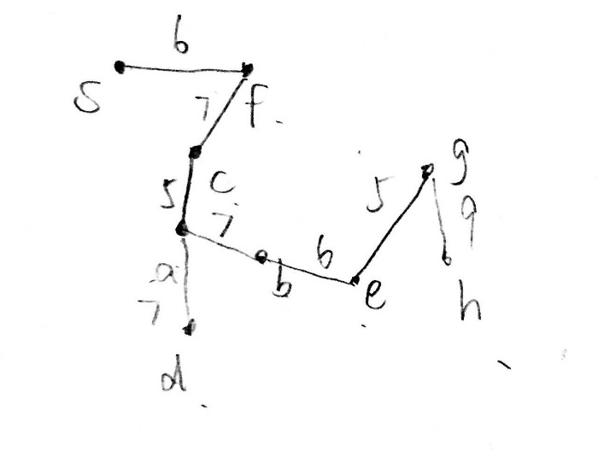

The program pick the same edge set building the MST as doing it by hand

As a conclusion, the Prim algorithm would produce an MST successfully.