# **CPTS 543 HW4**

# **YANG ZHANG 11529139**

Draft1:

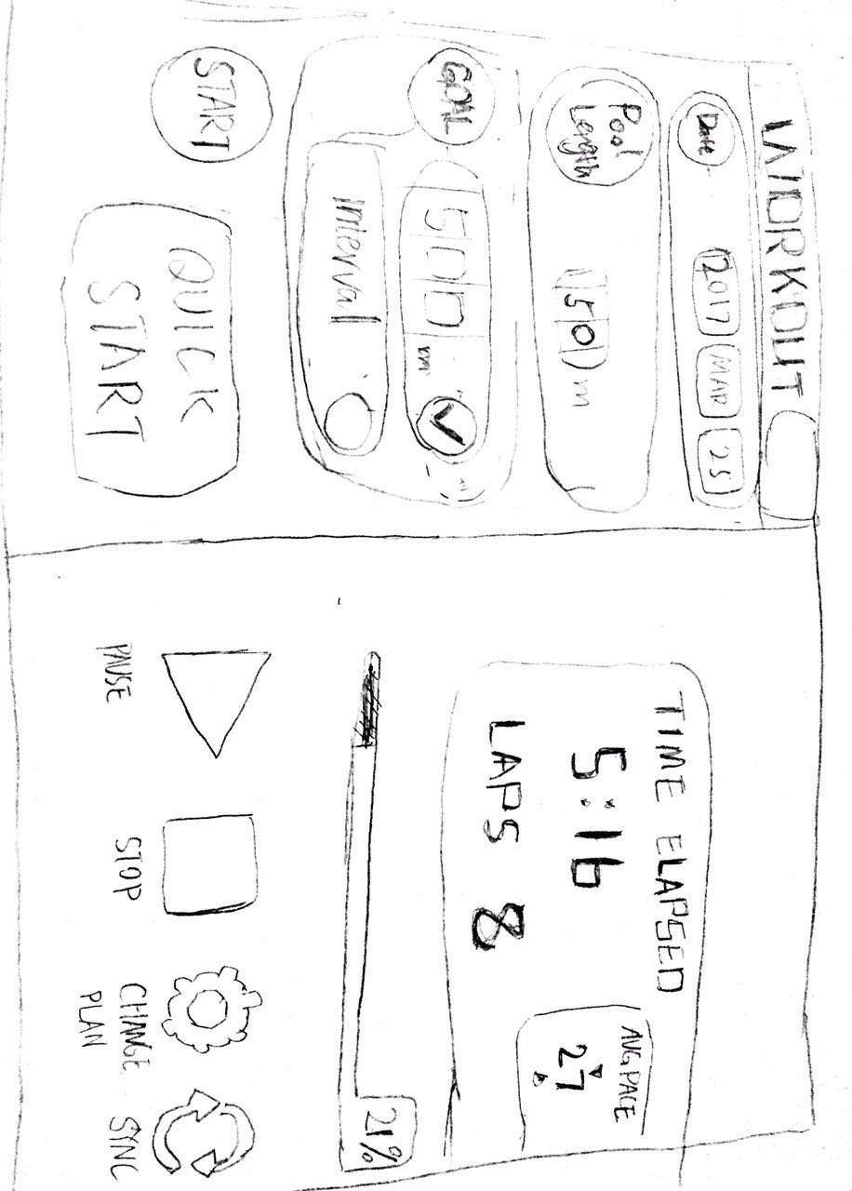

Draft2:

