CptS 443/543 Early Data Gathering Report

Carla de Lira, Siddhant Srivstava, Jessamyn Dahmen

March 8, 2016

***Abstract***

In this study, three contextual inquiries were conducted in order to learn more about disc golf in a more authentic setting, as well as to be able to initially design an application suited for this community. As a result of the contextual inquiries, the empirical findings (recorded through notes and video) show that there is a strong sense of community within the network of disc golfers who enjoy playing rounds with each other and organize their games through social networking (Facebook). There is also currently a need for a more efficient tech tool to enable players to keep track of scores, view course maps, and monitor weather conditions. As many have cited, there exists no efficient or user-friendly way to enhance the disc golf experience through technology, which makes a study like this relevant in the pursuit of a more usable application design for this sport.

***Design project focus and research questions***

1. *The problem the software aims to address*

We aim to provide a tech solution for the Disc golfers giving them a functional app with the ability to track scores, view and update maps, procure current wind directions and weather conditions among others.

1. *Proposed software solution description*

*Score Tracking*

The current way of doing it for the players is in their heads or on paper. Further, league scores are maintained in an excel sheet separately. We anticipate to incorporate these features directly into the app.

*Wind Directions and Weather Conditions*

There is no current methodology in place to see weather conditions except general weather apps but for current wind direction from the player’s position, we would want to provide this feature on the app.

*View and Update Maps*

The current physical maps on each hole are usually vandalized or weared down by weather and the maps on websites are not updated. We want to not only provide digital representations of the map but also give the user the ability to update it.

*Overarching problem is that they don’t have an app to plan and play the game.*

1. *Proposed software’s prospective users*

Our proposed users are primarily causal disc golfers that occasionally engage in competitions and pro disc golfers concerned about course information and condition. Our demographic seems to be primarily composed of older white males that are either students or employed.

The experience level of the people we interviewed were above intermediate but they did not consider themselves “pros”. All of them were casual players but we anticipate encountering more serious players in the future.

1. *The key research questions that the contextual inquiry set out to answer*

*RQ1* How do disc golfers plan their game before actually engaging in the activity?

*RQ2* How do disc golfers keep track of their progress and performance while they are playing disc golf?

*RQ3* What kinds of information do users want to analyze and know about after they play disc golf?

*RQ4* What kinds of technologies do users already use to play disc golf and what are their weaknesses?

*RQ5* How do disc golfers connect with other disc golfers in terms of socializing and community?

*RQ6* What other resources do disc golfers use to help them play?

*RQ7* How would disc golfers feel about having a disc golf app? Would they use it?

***Participants***

Participant 1 is a Civil Engineering graduate student at Washington State University. Participant 1 is American and identifies as male. He is 27 years old and very enthusiastic about disc golf and the disc golf community. Participant 1 seems to be an above intermediate player but does not consider himself a “pro” or advanced. He seems to enjoy playing casually but is not averse to participating in more competitive scenarios such as tournaments.

Participant 2 is a white American male and he is 37 years old. He is a software developer and is interested in collecting different discs and outdoor gear. He is a casual player but also seems to have engaged in more competitive games as well. He enjoys playing disc golf with friends and seems to be an above intermediate player.

Participant 3 is a white American male, he is 33 years old, and he is a flooring installer. He has a family with young children and enjoys playing the game casually and with friends. He also has extensive knowledge of different types of discs and enjoys being outdoors. He seems to be an above intermediate player and has engaged in competitive tournaments and visited other courses besides Sunnyside.

***Contextual Inquiry Sessions***

***Process and Environment***

During the span of two days[1], the contextual inquiries were conducted at Sunnyside Park in Pullman, Washington which currently boasts two disc golf courses. Both Sunnyside Park’s golf courses have 18 “holes” that span throughout every corner of the park which has a variety of features such as one small pond, one large lake, clusters of short and tall trees, and some rolling hills. On Day One, a contextual inquiry was conducted during somewhat “unfavorable” conditions such as light rain and wind that was eventually cleared up during the middle of the session with some some. However, this served as an optimal opportunity for us to gather information about playing disc golf under unfavorable weather as well as a glimpse on a good sunny day.

On Day Two, the contextual inquiry, again, was conducted during unfavorable conditions when gusts of wind were rushing through the hills of Sunnyside Park. This became a centerpiece to our contextual inquiry since wind conditions definitely affects disc trajectory in both high and low winds. This allowed the participants to comment more on the weather which will change according to different course placements.

In general, our contextual review was conducted by three people who each had a different role. One person was responsible for recording the footage, the second person for main note taking, and the third person was the main interviewer. We each followed the participant throughout their disc golf game along each course hole and asked them a series of questions (including follow up) throughout the session. Each session approximately lasted 30-40 minutes depending on their elaboration in responses. To see the set of questions asked, see ***Design project focus and research questions.***

***Common Tasks and Themes***

A typical day on the Sunnyside park Disc Golf course looks something like this. 18 holes lined up haphazardly, identified by mere maps which if not vandalised or tore down by weather stood on a short pole on each hole which vaguely identified the path and surroundings. A group stands waiting behind a disc golfer flexing his muscle on the throwing platform while a few who got the goal at par or below and have their score memorized in their head are on the following holes.

If there is a league happening, the community head would just ask for a sheet of paper to have the scores written onto and then maintain an excel sheet, which he would probably put on a facebook page or group which might not have all the participants. While the novice individual who came after seeing the dated map and ratings of the course on a website feels disappointed, is still oblivious as to which of the three discs he owns, has to be thrown for the first hole. Lastly, when the winds start the disc golfers scramble as they are unaware of how to tackle it.

***Unique features of individual CI sessions***

*Leaderboard*

Participant 1 stressed on the idea of having a leaderboard wherein they could see their daily or local standings and make it more competitive and get done with the need to maintain excel sheets.

*Disc Inventory and Resale Discs Options*

Participant 2 wanted to keep an inventory of his discs as he has over a 100 discs and would want to know what he wants to carry from them. Further, they would want a community or group wherein they can resale or exchange discs.

*Aesthetic Appeal based Ratings*

Participant 3 wished to come out and experience nature with his kids so wanted to know which courses are well-kept and closer to nature in the form of ratings or user pictures.

***Synthesis of Findings***

***Requirements***

|  |  |  |
| --- | --- | --- |
| **Functional Requirement** | **Associated Usability Target(s)** | **Empirical Source/Rationale** |
| Users must be able to modify course maps in order to keep the maps updated. | Users must be able to modify a course map by adding or deleting a feature within one minute | Participants all cited the fact that course maps are often not well documented in both online resources like DG Course Review and on the map plates. Having the users update the maps themselves will enable a sense of community effort (which they also cited as important). |
| Users must be able to post user pictures of the course itself. | Users must be to post a course picture within 30 seconds | This is visually provide the user information on its scenic quality, kept conditions, and foster curiosity. |
| Users must be able to access a community disc resale page. | Users must be able to navigate to the community disc resale page from the main page within 5 seconds | The participants suggested that a way to resale and buy used discs could help foster a sense of community while also improving their extensive disc collections. |
| Users must be able to check in and check out from the disc golf course via application. | Users must be able to check in/out within 15 seconds | The participants told us that the social aspect of disc golf is what makes the game attractive so by providing and check in and check out feature, the users will be able to let other users know that they are on the same course. |
| Users must be able to construct an inventory of their discs in their bag and at home. | Users must be able to create an inventory of their disc bag within 5 minutes (we’ll establish more specific targets for subtasks later) | The participants all had an extensive collection of discs that they brought with them in large bags. Each disc has a specific type of behavior. A detailed inventory listing the characteristics of each disc would be helpful for them to keep track of them. |
| Users must be able to view a leaderboard for every course. | Users must be able to access the leaderboard from main page within 5 seconds | The participant suggested that a leaderboard for each course would continue to foster friendly community competition. |
| Users must be able to keep track of date, time and also view previous and current scores. | Users must be able to record each hole-by-hole score during a game within 10 seconds | Based on our CIs, each participant seems to not keep track of their games and usually keep their games in their heads. |
| Users must be able to assess their performance based on a comparison of current and previous games played. | Users must be able to access graphic of current/previous games played within 10 seconds (from home screen) | Every participant heavily relies on their scores to assess their progress and performance in the sport. By being able to see their performance via scores of previous and current games, they can view their improvement. |
| User must be able to access information about wind and weather conditions before and during the game. | Users must be able to access wind/weather conditions within 10 seconds (from game play screen) | All three participants cited the idea of weather and wind conditions as having a major effective of their disc golf game performance. As we have learned during our observations on the CI in unfavorable weather, weather has a huge impact on their game socially and performance wise. |
| User must be able to analyze wind direction based on person’s posture via gyroscope or 3D axis accelerometer. | Users must be able to see and understand current wind direction and strength from game play screen within 3 seconds | Wind has a huge effect on the direction of the disc during the game. Knowing the wind direction on the spot could serve as a useful feature before they decide to throw. |
| Users must be able to rate each course based on a variety of characteristics, such as overall enjoyment, ease of hole locations, and difficulty level. | Users must be able to rate a course within 10 seconds | Every participant suggested that a rating for each course would serve as a way to get overall feedback from the community. |
| Users must be able to receive tips based on each course's holes. | Users must be able to access tips from game play screen within 5 seconds | Every hole is positioned different and holds its own set of challenges and tricks. Letting the user know how to details about each standing pad to the corresponding hole will allow them to think about how they are throwing. This could be a community content built feature. |
| Users must be able to communicate and meet with other disc golfers via Facebook or other social networking platforms. | None | All participants heavily suggested that the social aspect of the game is very important. Disc golfs are usually organized in Facebook so they could easily benefit from this feature. |
| Users must be able to access a feature that let’s them know what condition the course is in (in terms of how well kept it is) | Users must be able to access community condition reports from a course screen within 5 seconds | All participants would appreciate the conditions the course is particularly via updated community condition reports. This would be especially helpful after rain has fallen on the course. |
| Users must be able to see rating based on scenery and ambience. | Users must be able to access scenery rating from course screen within 5 seconds | The participant noted that the nature aspect of disc golf is important to them and family members who also play. |
| Users must be able to view disc golf courses on a live map using GPS | Users must be able to view a map of the disc course they are currently playing from the game play screen within 5 seconds | According to our participants, maps are often unavailable on the course so there will be a benefit to having a feature that will serve as an alternative to look at the map of a disc golf course during gameplay. |

|  |  |
| --- | --- |
| **User Experience Requirement** | **Empirical Source/Rationale** |
| Users must rate the live map feature as a 9 or higher on a scale of 1-10 in terms of ease of use. | For participant 1 and 2 updated course map information was very important (see CI notes) so high rating is needed. |
| Users must rate social media features including sharing progress, communicating with other players, and accessing community pages on facebook as an 8 or higher on a scale of 1-10 in terms of satisfaction. | For all participants connecting with friends was important to them but not crucial. We are combining the social media features as a whole since they will work together as a whole for the full social media experience of the app. |
| Users must rate course hole “tips” as a 9 or higher on a scale of 1-10 in terms of ease of learning. | All participants use disc golf websites to navigate unfamiliar courses. It seems to be an important feature to help users learn about how to best tackle new holes, especially if they are unfamiliar with the path and obstacles. |
| Users must rate the keeping track and updating score component of the app as a 9 or higher on a scale of 1-10 in terms of ease of use. | All participants keep score in their heads when playing casually but use scorecards in more competitive situations where time matters more. It is important to be able to easily update and record score in competitive situations for accuracy and in order to not distract from the game. |
| Users must rate the information about course condition, weather, wind conditions, ratings, and ambience as a 9 or higher in terms of satisfaction on a scale from 1-10. | All users used website to check this info about the course but were dissatisfied with how infrequently they were updated. To ensure people use our app, checking course info is a very common need and needs to be a satisfying experience. |
| Users must rate the disc inventory feature as a 8 or higher in terms of confidence on a scale from 1-10 | Some users were interested in keeping a library of their discs for trading purposes and keeping track of the various unique qualities each disc possesses. Users want to be confident that their collection is accurate and informative. |
| Users must rate performance stats, progress tracking and visualization as a 9 or higher in terms of satisfaction on a scale of 1-10 | Some users are interested in sharing their stats with others so they must be satisfied with the stats the app provides or they will not want to share this information. |

|  |  |
| --- | --- |
| **Usability Requirements** | **Empirical Source/Rationale** |
| User would see the next hole on the map as he presses completed button within 1 second or just walks ahead via GPS | For participant 1 and 2, a live map is of great importance as the physical maps on the course are usually vandalized |
| User must be able to see his position on the leaderboard in 2 seconds of him posting his performance. | Participant 1 and 2 highly stressed on this as this would make the game more competitive and also because they do it now on an excel sheet |
| User sees the course ratings and conditions within 2 seconds of him selecting the course from the drop-down list | Participant 3 mentioned this explicitly that he wishes to know more about the course as soon as he sees it |
| User must be able to see the weather and wind conditions and directions in a second as soon as he presses the weather icon in the top right from anywhere in the app | Participant 2 specifically mentioned this as he would want to know the current wind direction as per where they are standing |
| User sees the number of players on the course in 1 second of him selecting check-in now or check-in at a particular time | Participant 1 mentioned that it would be convenient to know the number of players in the field now to know how busy it is |
| User sees his uploaded track picture in 5 seconds of completed uploading in the user course pictures | Participant 2 wishes that he could see the course in reality |
| User sees the updated track in 5 seconds as he punches in tags on the google map for exact hole positions | All 3 participants wanted the updated maps on the app |
| User sees his previous scores and performances in 1 second as soon as he clicks his profile tab or picture button | All 3 participants wished to see their previous scores and performances at one place. |

***Personas***

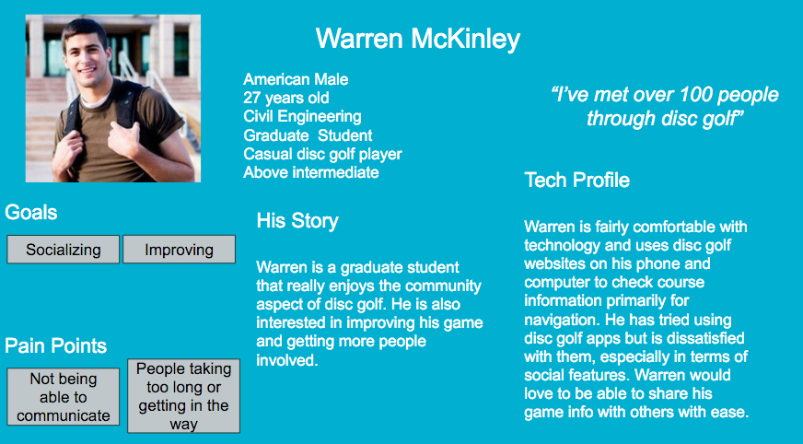

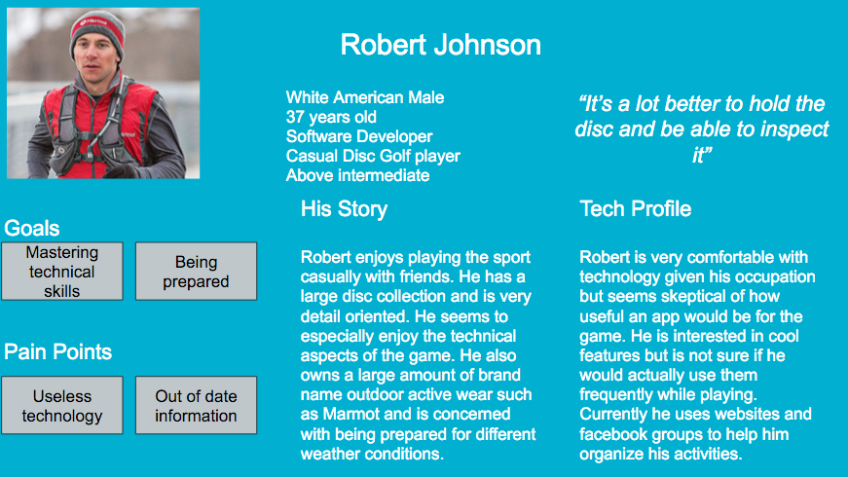

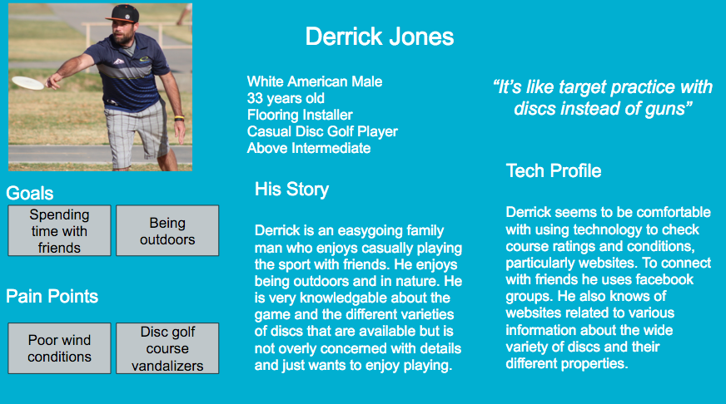

***Scenarios***

*Scenario 1: What matters to Warren when playing disc golf*

Warren is a Civil Engineering graduate student at Washington State University and uses disc golf to meet new friends and unwind after a long week of writing papers. He usually plays during the weekend and tends wake up around 11 as sleeping in is a luxury. It’s Sunday afternoon around 2pm and Warren has just played an exciting round of disc golf with his friends Peter and Tracy during a Palouse Disc Golf league meeting. Although this disc golf game was casual rather than competitive, Warren is very interested in comparing his score and performance to his friends and other players so that he can improve and connect with other disc golfers. His goals are to share his scores with others and see how he has progressed over time. He also would like to see how others have progressed, make new friends, and plan disc golf activities online.

Warren is comfortable using technology such as facebook to connect with other players but is frustrated about how this form of communication is not well suited to collecting and sharing information specific to disc golf. Today, Warren decided to download a new disc golf app to help him record and share his stats. Tracy and Peter have also downloaded this app. While they were playing Warren and his friends used the app’s voice input to record their scores. The app automatically captured the time for each hole based on voice commands and overall time and also factored in conditions such as weather and course difficulty.

After the game Warren opens the app on his phone and sees a graphical representation of his performance broken down by each hole in terms of score, weather, and difficulty. He presses share to share make this information public to his friends on Facebook and within the app. Tracy “likes” this update and Peter comments “Good job man, it was pretty windy today!”. Warren is excited about how this app can let him share detailed disc golf info and happily posts a download link to it on the Palouse Disc Golf Facebook group inviting other players to join. His goal is to grow a community that all use this app to share disc golf activities and form friendships.

*Scenario 2: What matters to Robert when playing disc golf*

It’s Saturday morning and Robert is planning to play a casual round of disc golf with friends at Sunnyside park. Robert is a software developer by trade and is very detailed oriented. He is concerned about being prepared for any eventuality and really cares about the technical aspects of his disc golf game even though he typically plays casually. Robert walks into his living and asks his Amazon Echo “Alexa, what is the weather today?”. Alexa responds “In Pullman it’s 46 degrees with a chance of showers and high winds.” Robert is disappointed that the weather is poor today but he is determined to go anyway because he promised his friend Derrick he would go. Derrick never seems to be bothered about the weather, he loves being outdoors. Robert carefully chooses from his active-wear collection so that he can stay warm but still have range of motion. He then brings out his disc carrying case and begins to choose discs that will be best suited for the weather today.

Robert’s goal is to bring a set of discs that will be able to fly well given the current weather conditions. He is also excited to try out some of the new discs he bought online that have special properties due to their materials and imperfections even if they aren’t well-suited to windy and rainy conditions.

Robert opens a new disc golf app he heard about through the Palouse Disc Golf facebook group. In addition to collecting stats this app also has a feature that helps people organize their disc inventory, select discs, suggest discs for today’s conditions, and share/sell discs to others. Some discs had to be manually entered into the app’s disc library but to make it faster Robert was also able to snap pictures of brand name discs and the app automatically uploaded the discs information. Robert notices that he is running late and doesn’t want to keep Derrick waiting. In the app he presses the “Choose for me” button. Sunnyside park in Pullman is set as Robert’s “Home” course. The app automatically reads in the weather conditions and difficulties for each hole for Sunnyside’s course and generates a list of discs that would be good for today’s conditions. It also suggests some new discs to bring that Robert hasn’t used before. Robert quickly grabs the discs, shoves them in his bag, and heads out the door to join Derrick for a challenging game of disc golf in the wind.

*Scenario 3: What matters to Derrick when playing disc golf*

Derrick is planning a vacation with his wife and young children next month. Derrick is a an enthusiastic disc golf player and is very knowledgable about the sport and the different types and discs and gear. Despite his expertise he is really just interested in hanging out with friends and having a good time. Another goal he has is to spend as much time as possible outdoors and in nature. He currently lives in Pullman WA but would like to travel to a different part of the country besides the PNW. His criteria for a good vacation spot is one with plenty of safe outdoor family activities including some new and scenic disc golf courses he can try out.

In the past Derrick has used the DGCourseReview website to plan his trips but it has not been ideal. The website includes a short description of the course including some pictures but it is hard for Derrick to find all the information he wants in one place. The website seems to be focused on the course almost exclusively with little information on the surrounding area or the community of people. To check amenities and other activities near the course Derrick usually has to Google that information. The pictures and information posted on this website also make it difficult to determine typical conditions for different seasons. In addition to Googling Derrick relies on asking his disc golf buddies in the Palouse Disc Golf facebook group or navigating to disc golf facebook groups in the areas he is interested in. This makes planning a trip a large undertaking with many disjoint components.

Derrick heard about a new disc golf app from his friend Robert. This app helps disc golfers connect with other disc golfers around the world. It also includes information not only about the course, but of the surrounding area and community for people planning to travel for tournaments and for leisure. Derrick opens the app and uses the search feature to type in City Park Disc Golf course in New Orleans. The app returns search results for this course and Derrick selects the correct result and gets brought to a page showing the course information. Robert selects the “Community” tab and immediately sees recommendations for hotels, food, and activities. He also sees contact information posted by disc golfers in the area looking to meet new people and show out of towners around. In addition to this, the app also has a section that shows “If you like this course you will also like…” and nearby courses with similar features.

Robert uses this info to quickly form a plan for booking a hotel. He contacts a disc golfer in the New Orleans area in this app and learns about some cool activities to try out in the area that only locals would know. He also makes a new friend in the process.

***Appendix A: Informed Consent***

Informed Consent Agreement to Participate In Contextual Inquiry

Carla De Lira, Jessamyn Dahmen, Siddhant Srivastava

School of Electrical Engineering and Computer Science

Washington State University

Description of Study:

Although traditional golf has many mobile applications to suite the needs of leisure and professional golfers, there has yet to be more options available for disc golfers of all different skill levels. The purpose of this study is for the designers to gather as much information about disc golfer’s involvement in the sport. This will help construct a clearer understanding of the unique needs required in terms of creating an application suited to disc golf. By doing this, the designers hope to create a more user-friendly application design for disc golf players.

Participation in Study:

I understand that I, _________________________________________ have been asked to participate in a contextual inquiry to inform the design of a new software application being created as part of the above persons’ (henceforth, “the designers”) course project for CptS 443/543 at Washington State University. My participation in this activity will help the designers to better understand the needs of prospective users of the software.. I have been asked to spend about 60 minutes participating in this test. This will involve my engaging in disc golf while the designers observe, ask questions, and take notes. The designers will record the session on videotape and/or record audio of my responses. My name will not be on the videotape or associated with any audio recordings. When the designers describe their work to other people in class (which may entail showing segments of the videotape or playing segments of the audiotape), they will not use my name.

Risks and Benefits Expected: The contextual inquiry will not do me any harm. It is not expected to help me directly. The results may help inform the design of the designers’ software.

Confidentiality: I understand that any information about me that is obtained from this contextual inquiry, including what I say, will be confidential. My real name will be kept in a locked file and only the researchers will have access to it. Only my code name will be associated with data collected on me. Reports and presentations involving those data will not use my real name, and will not present other data that could be used to identify me. Any recordings made within this contextual inquiry will be destroyed within two years.

Right to Refuse or End Participation: I understand that I may refuse to participate in this study or stop participating at any time.

Certification: I certify that I have read and that I understand the foregoing, that I have been given satisfactory answers to my inquiries concerning this contextual inquiry, and that I have been advised that I am free to withdraw my consent and to discontinue participation in the project or activity at any time.

I herewith give my consent to participate in this activity with the understanding that such consent does not waive any of my legal rights, nor does it release the researchers or any agent thereof from liability for negligence. I understand that I shall remain anonymous in all written and verbal reports of this study. If I am recorded, I agree to allow the designers to present to their instructor and classmates excerpts of any recordings taken during the study for educational purposes. I understand that I may request a copy of this form to keep.

Signature of individual participant Date

(If you cannot obtain satisfactory answers to your questions or have comments or complaints about your treatment in this activity, please contact Professor Christopher Hundhausen, Washington State University, 509-335-4590 or hundhaus@wsu.edu.)

***Appendix B: Raw Data***

***Links to Recordings***

Link: https://goo.gl/yBOLQB

***Notes***

*Notes for Participant 1*

a. How do you currently plan your disc golf game?

* Each hole in the sunnyside course contains this basic info
  + A very low res map of the suggested paths to the hole
  + where the next hole is
  + distance
  + obstacles such as trees etc.
  + Use these signs to plan approach
  + sometimes the hole is not in view
* Also a website called http://www.dgcoursereview.com/ used before going to a place or using a phone while you are there
  + Has ratings
  + course condition
  + tips for each hole
* No real time limit for the game itself, but time may be an issue for planning if it’s crowded, don’t want to get in people’s way or have to wait forever behind others

b. How do monitor or keep track of your disc golf game while you are playing?

* This person adds the score in their head as they go, seems simple to remember when just doing a casual game by self, different for more competitive environments?
* There are apps to keep track of overall score and compare to friends
* This person dissatisfied with existing apps, especially the social element of it
* Doesn’t feel it is easy to connect and share progress with friends, would really like this or some way to tie with social media

c. What kinds of information do you want to know after your disc golf game? / How do you assess your performance?

* Par, over/under
* Want to know “I did well” like a feeling rather than a quantitative value, seems to be based on other factors than just being under or on par
* This person really cares about having fun and connecting with others as much as they care about their score
* Time doesn’t seem to be important to this person
* Seems to care about how far they can “drive”, keeps track of farthest distance they can throw

d. Do you share your activity/progress with others? How?

* Does through primarily facebook pages
* Not using an app to do this, because apps are limited and not everyone uses them
* Seems to be similar to Google+ issue, no fun to use if you’re friends aren’t using it

e. How do you stay motivated to do disc golf, both when playing and outside of playing?

* Other people, meeting people seems to be important to this person
* “I’ve met over 100 people though disc golf”

f. Do you use any technologies or other resources (including people) to assist in any of the above? Which ones? How are they used?

* Seems limited to checking the http://www.dgcoursereview.com/ at home or on phone
* Using facebook pages to connect and organize with other players

g. How would you feel about having an app for disc golf?

* Seems positive, especially about social aspects of the game
* Would like, fly trajectories, compare scores to others
* Maybe leaderboard for different courses? Similar to bowling league
* Wind
* Busyness of course? Feels like not knowing is part of the fun, thinks knowing it’s busy might prevent you from going and meeting new people

h. Use tech while playing? Or offline, would it be a distraction while playing?

* Only seems to use phone to check maps of holes and tips for each hole if in unfamiliar course
* Thinks it would be “amazingly helpful” to know live wind conditions, especially in sunnyside where wind is a problem, other courses in wooded areas to block wind, not so much here

i. May we contact you in the future?

* Yes, person seems enthusiastic

Other observations/ Notes unique to this session

* Special carrying bag for discs, many different types of discs. Common for this player to throw several discs on the same hole for practice and taking the best outcome.
* 3 main types of discs
* Putter
* Basic approach
* driver
* Each disc made of different plastics and weight
* xout discs that flawed from the regular mold, some players like these, they will fly differently than the perfect mold ones
* Collection discs kind of like a hobby
* Each disc range $9-$16, only need one disc to get started, easy for newcomers to get involved
* Pick up discs as you go
* Disc needs to be in basket and stay there for it to count
* Most courses professionals want to be right on par, but sunnyside is an easier course so goal is try for under par
* Some people to running start on the pads
* Pull back more distance, ideally people with long arms would be better
* Must throw behind the wood “line” on the pads, similar to bowling
* For putting a little different, there is some sort of 33ft restriction
* Determining this distance seems to be subjective in some situations, rely on consensus of other players or walking the distance out
* Keep up on development of courses and professionals occasionally, PNW fliers page
* Quote “More about technique than raw power”
* Not many easily accessible courses here
* Avg distance par 3 300 - 360
* Par 4 500
* Par 5 1,000
* 9 - 18 holes common
* Carries around a cloth got at tournament to wipe off mud on discs
* Need to be careful of walkers, non disc golf players, discs could really hurt them
* Avg time 1 - 2 hours, better players less time

*Notes for Participant 2*

Questions

a. How do you currently plan your disc golf game?

* Chooses discs appropriate for weather conditions
* Uses a website called http://www.dgcoursereview.com/ used before going to a place
* Has ratings
* course condition
* tips for each hole
* Makes sure to have proper active wear, loose fitting stuff for range of motion
* Check weather conditions in order to find out if there are any necessary clothing and equipment needed for their game
* Looking at course maps to see if they are long and if there is a need for snacks.

b. How do monitor or keep track of your disc golf game while you are playing?

* This person adds the score in their head as they go
* In league games or tournaments used paper scorecards in past
* Scorecards have been used and later transferred into an Excel sheet
* When there were scorecards during leagues, weather often affects the writing of the scores on them

c. What kinds of information do you want to know after your disc golf game? / How do you assess your performance?

* Wants to know score mostly
* Not interested in leaderboard since playing casually

d. Do you share your activity/progress with others? How?

* Does through primarily facebook pages if at all

e. How do you stay motivated to do disc golf, both when playing and outside of playing?

* Friends mostly

f. Do you use any technologies or other resources (including people) to assist in any of the above? Which ones? How are they used?

* checking the http://www.dgcoursereview.com/ at home or on phone
* Using facebook pages to connect and organize with other players
* Also texting friends

g. How would you feel about having an app for disc golf?

* Doesn’t think they would really use an app
* Maybe interested in disc inventory helper or assessing wind conditions
* Pointed out different parts of the course will have different wind conditions

h. Use tech while playing? Or offline, would it be a distraction while playing?

* Doesn’t seem to use much tech except websites beforehand for weather, conditions, and purchasing discs
* Prefers to be able to hold the discs in person, feels disc selection limited in this area
* Thinks that the course info could be updated more frequently, estimates some courses out of date around 5 years, no way for rapid course change updates

i. May we contact you in the future?

* Yes, person seems fine with that

Other observations/ Notes unique to this session

* “It’s better to hold the disc, to inspect it”

*Notes for Participant 3*

Questions

a. How do you currently plan your disc golf game?

* Chooses discs appropriate for weather conditions
* Uses a website called http://www.dgcoursereview.com/
* Enjoys outdoors, seems to prefer scenic locations
* Texting other disc golfers to be able to plan games together

b. How do monitor or keep track of your disc golf game while you are playing?

* This person adds the score in their head as they go

c. What kinds of information do you want to know after your disc golf game? / How do you assess your performance?

* Wants to know score mostly
* May be interested in comparing scores/ social element

d. Do you share your activity/progress with others? How?

* Does through primarily facebook pages if at all

e. How do you stay motivated to do disc golf, both when playing and outside of playing?

* Friends

f. Do you use any technologies or other resources (including people) to assist in any of the above? Which ones? How are they used?

* checking the http://www.dgcoursereview.com/ at home or on phone
* checking flight analyzer for discs
* Using facebook pages to connect and organize with other players
* Also texting friends
* Interested in trading and selling discs

g. How would you feel about having an app for disc golf?

* May use an app if had more of a social/outdoors element
* interested in disc inventory helper or assessing wind conditions

h. Use tech while playing? Or offline, would it be a distraction while playing?

* Doesn’t seem to use much tech except websites beforehand for weather, conditions, and purchasing discs
* May use for checking out how scenic and natural a course is

i. May we contact you in the future?

* Yes, person seems okay with that

Other observations/ Notes unique to this session

* Were there issues, observations, or insights that were unique to individual CI sessions? If so, describe them here.
* “It’s like target practice with discs instead of guns”
* Lots of overlapping fairways in small spaces, may be dangerous to other players if crowded

1. To be referred to as “Day One” and “Day Two” for the purposes of this contextual inquiry.