CptS 543 Early Data Gathering Report

Yang Zhang, Samaneh Aminikhanghahi

March 20, 2017

## **Abstract**

We performed contextual inquiries to find out what are the key features that should be implemented in a social application which specially target at graduate students. Knowing what graduate students mostly care about in both their academic and non-academic life are essential to design the graduate students social app. As a result of inquiries, we found that there are two kinds of academic goals that graduate students are after. One is to continue their academic career by applying doctoral or post-doc programs. The other one is to find a job in industry world. From the above finding, we concluded that it is important to provide both job postings and graduate program information to users of graduate students social app. This defined the principal line in our design and other functions are discussed in the later part of this report.

## **Design project focus and research questions**

1. ***Design problem we aim to address***

We want to design a social application to not only provide a platform that allow graduate student to post activities and exchange information with others but also help them in their career (jobs, or grad school).

1. ***Proposed functions***
2. Account Management

Users can create a new account or close their existing accounts. They can also edit their account information and preferences.

1. Dashboard

Dashboard are composed by 3 categories, which are Academic, Career and Hobbits. In Academic, users can post academic questions and find out research opportunities and course info. In career, they can get recent job postings and grad school info (due dates, requirements) In Hobbits, they can post or join activities based on their interests and hobbits

1. Search Function

User can search for public users, activities and other postings.

1. Message system

User can send private message to friends.

1. ***Related products or technologies***

[www.quora.com](http://www.quora.com) --- A question and answer site that users can post their question and receive answers from other users.

[www.linkedin.com](http://www.linkedin.com) --- LinkedIn is a business and employment-oriented social networking website

1. ***Proposed software’s prospective users***

The prospective users for our application are current graduate students.

1. ***Key research questions***

RQ1. How do graduate students search for jobs or graduate programs?

RQ2. What tools do they use to post activities or questions and why do they choose them?

RQ3. What are their favorite features in social apps (Facebook, twitter, etc.)?

RQ4. What kind of information are grad students interested in.

RQ5. What kind of topics are they mostly use when talk to other grad students.

## **Participants**

Participant 1 is a veterinary Graduate student and she is Asian American female. After her graduation, she wants to became veterinarian in small animal practice. She likes to use Twitter to follow her friends and other veterinarian around world. She usually use text message to arrange a study activity or review session.

RQ1. How do graduate students search for jobs or graduate programs?

1. LinkedIn (connect with recruiter directly)
2. Department emails (job posting)

RQ2. What tools do they use to post activities or questions and why do they choose them?

1. Post questions on class Facebook page.

Reason: people in the group are from the same field

1. Post question on vin.com (a website that every veterinarian around the world can share their knowledge)

RQ3. What are their favorite features in social apps (Facebook, twitter, etc.)?

Facebook, (most of her friends are using it, so she can keep in touch with her friends through it)

RQ4. What kind of information are grad students interested in.

Job openings, the prospect of her major

RQ5. What kind of topics are they mostly use when talk to other grad students.

Study session, movies, academic subjects

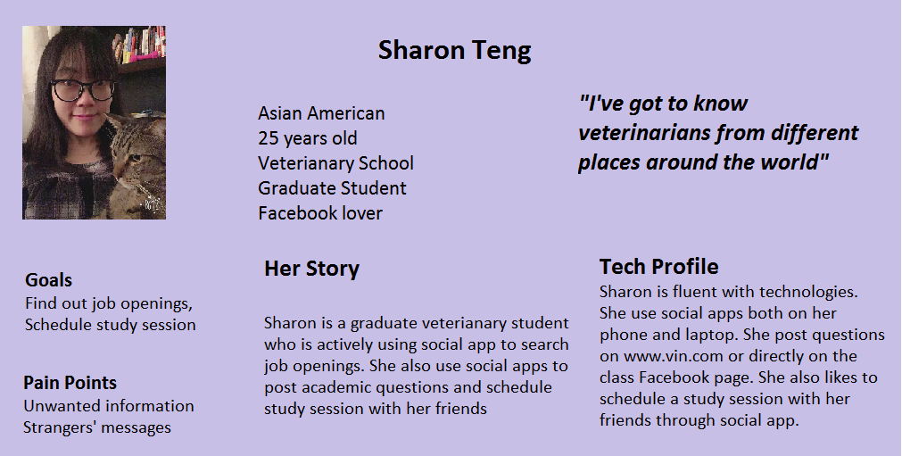

***Scenarios***

*Scenario 1:*

Sharon is a 3rd year veterinary graduate student at Washington State University and she has only 1 year till her graduation. Finding a job is her priority thing to do in the rest of her academic life. On one Saturday, Sharon wake up at 9:30 AM. After having her breakfast, she turned on her laptop and logged in her LinkedIn account. There are were two messages need her actions, one was to ask for her connection and the other one was to notify her a job status update from one of her friends. She accepted the connection request and talk to her friend about the job change. Then, Sharon opened account information, because she wants to update her experience section by adding a surgery experience she just performed on this Wednesday. She also checked a few LinkedIn pages of animal clinics to see if there was any opening that match her skill sets. She began to study for her upcoming exam on Monday. There were certain topics that she didn’t understand thoroughly, so she was thinking about study with her friends. She opened Facebook on her phone and sent messages to her friends and then they decide to study together on Sunday. It was going to be another productive weekend for Sharon!