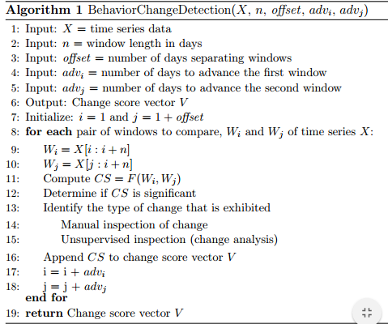

To adapt algorithm 1, W1 and W2 can be abstracted as 2d array W[days][hours], and we can use Euclidean distance function as change score function F(W1, W2) For change detection, we can compare each score of a pair of windows with base scorekk.

Scorebase = Euclidean(Wmost_active - Wmost_inactive)/2;

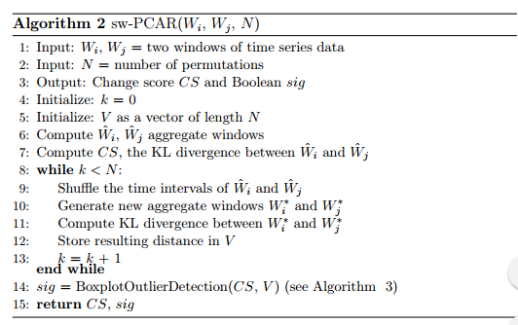

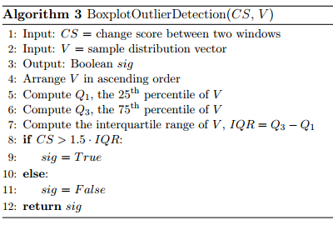



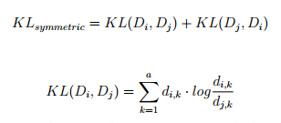

Algorithm 2 needs a activity recognition algorithm first.