**CPTS 543**

**Assignment #1**

**Yang Zhang 11529139**

Good design: La Source lotion bottle

|  |  |
| --- | --- |
|  |  |

The lotion bottle is elegant container that not only provide user the basic function of storing lotion but also allow user to seal the bottle safety.

**Conceptual model:** The conceptual model of the lotion bottle product is straight-forward. The interface is just the pump at the top which affords user to press it and get lotion out of the bottle.

**Affordances**: The pump of the bottle affords user two actions, one is obvious, which allows user to press it like common pumps. The other affordance is somewhat invisible, that is the pump also affords users to turn it. (Turn clockwise to lock the pump preventing accidentally press the pump)

**Mappings**: The mapping of the bottle is natural and understandable. Most of the user know to press the pump to get lotion out of it without further instruction even if the very first time they use the product. This is because the useable of pump is a common knowledge blended in people’s life. The second affordance is not that obvious as the first one, but the manufacture brilliantly prints the signifier on the top of the pump. The signifier combines both arrow and text, which can clearly guide user how to lock the pump.

**Feedback**: When pushing the pump, the lotion will be out of the bottle and when turning the pump, a clicking feedback returns to user that indicated the pump is locked or released.

**Constraints**: This bottle shows physical constraint which the pump part can be pressed or turned;

Bad Design: Hamilton Beach Kettle  
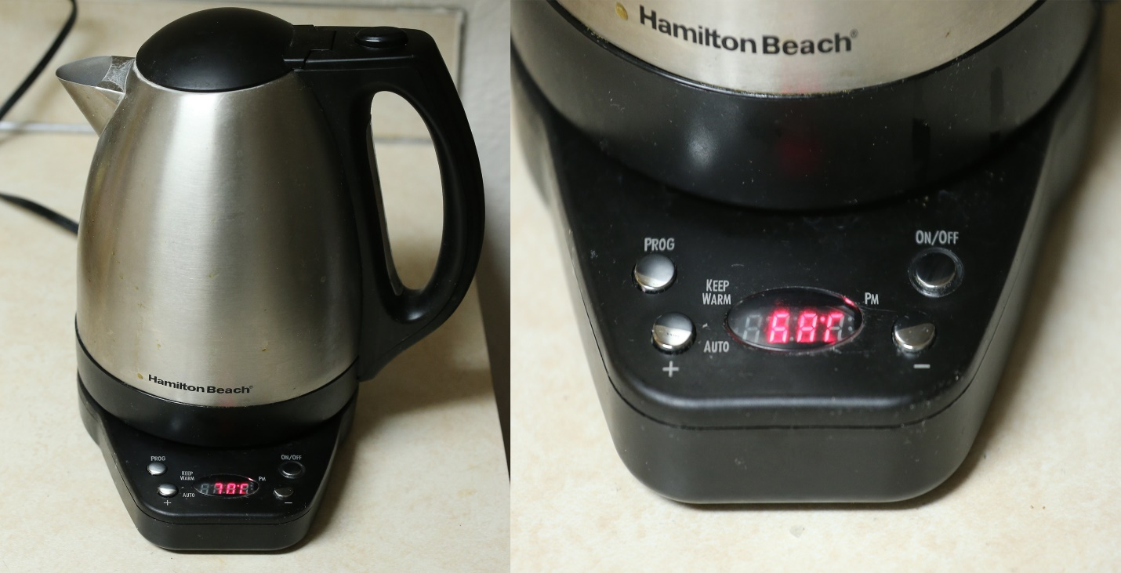

The kettle provides user a variety of settings for heating water and there is also a display on the base to show user information (temperature or time)

**Conceptual Model**: The button panel of the kettle provides a button-screen interface. There are four labeled button around a screen. The signifiers are clear, such as “on/off” suggests the turn on or off the kettle, but the adjusting temperature is not as clear as it labeled.

**Affordances**. The buttons affords press and the screen affords displaying information.

**Mappings**. The interface of kettle gives out terrible mappings which is against natural mapping principle. The screen displays temperature by default and the button with “+” sign suggests to increase the temperature, but in fact when I press the “+" button, temperature is not changed, the time changed (advanced by 1).

**Feedback**. The kettle will be beeping when the water is at desired temperature.

**Constraints**. A physical constraint is shown by that the button can only be pressed, and a logical constraint is shown by not allowing to set negative temperature.

Augmented Design: I-clicker

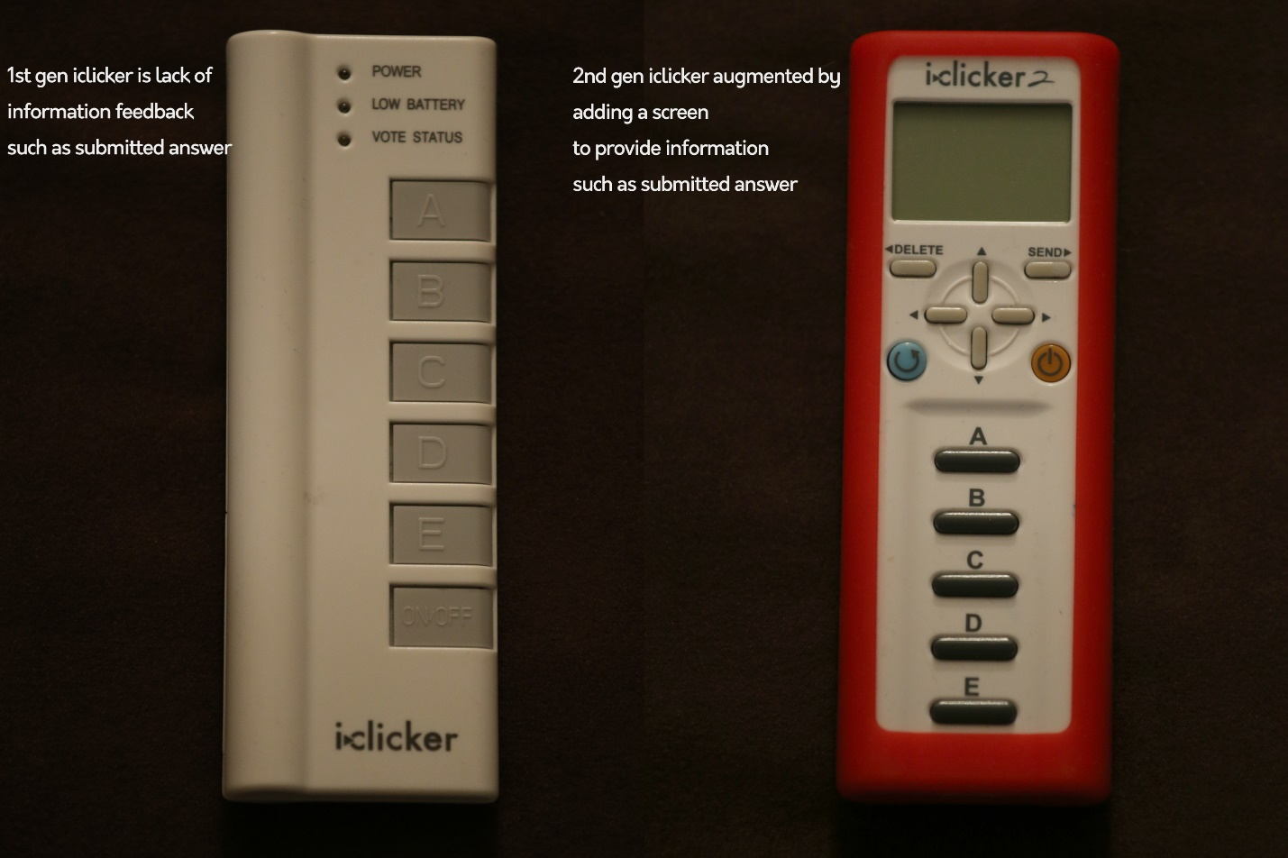

I-clicker is a remoting device that allow students participate in class activity by answering multiple-choice question remotely. The interface of the device is simple, there are 5 choice buttons and 1 power button. Each button is clearly labeled. However, the feedback of the 1st gen i-clicker is weak. The company augmented by adding a screen (**signifiers**) to the 2nd gen i-clicker.

**Conceptual Model**: 1st gen provides a simple interface, selects frequency and answers questions by pressing the according button. The 2nd gen added a screen to display information such as frequency code and option.

**Affordances**. I-clicker provides buttons that afford pushing. And the 2nd gen provides a screen that afford observing information.

**Mappings**. I-clicker uses natural mapping. Each button does exactly what the label says.

**Feedback**. The 1st gen has immediate feedback, when press the on/off button the light of power indicator will be on or off. The signal light will blink by press any option button. While there is no feedback to tell students that what is current frequency or the answer they submitted, which can cause confusion if the student forget what they submit or letting them know the wrong option selected by accidently press. The 2nd gen added screen to display those information that 1st gen doesn’t have.

**Constraints**. Each button has a *physical* constraint: It is either pressed or it is not. And a logical constraint is shown by not allowing to select 3-bit frequency code.