**CPTS 543**

**Assignment #2**

**Yang Zhang 11529139**

External Design

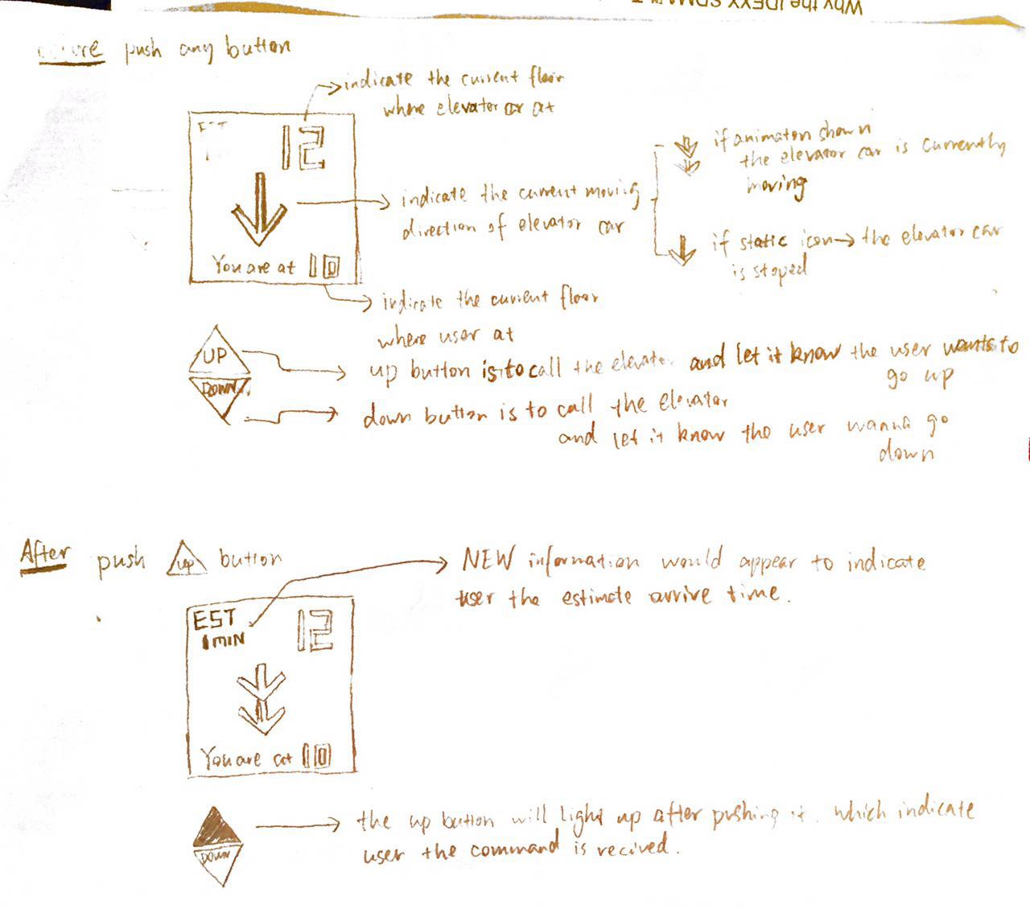

**Conceptual model:** The conceptual model of external control panel is straight-forward. The interface is combined with buttons and screen. Those buttons provide passages the possible actions to control the elevator car. The screen prints out the essential information.

**Affordances**: The buttons afford users the push action. The screen affords users to fetch information, such as estimate time and current location of elevators car.

**Mappings**: The mapping of the button area is natural and understandable. The up button is placed at the top and the down button is at bottom. Moreover, each button is shaped as an arrow. The pointing direction of the arrow shaped button indicates the direction where passengers want to go. Therefore, the user should be able to call the elevator correctly even without the text signifiers.

**Feedback**: The button will light up when passengers push it, which gives the feedback that the command was received successfully. Moreover, the screen also provides information the passengers are likely to know. Such as the current floor where the car is at and the estimate time that the car will be arrived.

**Constraints**: The control buttons show physical constraint which they can only be pressed; The shape of the buttons and the direction indictor of the screen reflects the logical constrain that maps the moving direction of the car with the arrow pointing and the button position.

My design of the external control panel successfully delivers a simple user interface. The buttons are designed with strong signifiers (both shape and text) that guides users directly. This makes sure that in most of cases, the passenger should operate the elevators smoothly without any further instruction or knowledge. My design also provides various feedbacks. The light button shows the user clearly that the command was received. The screen displays the information that users may want to know. Such as the estimation time that can reduce the waiting time psychologically.

Internal Design

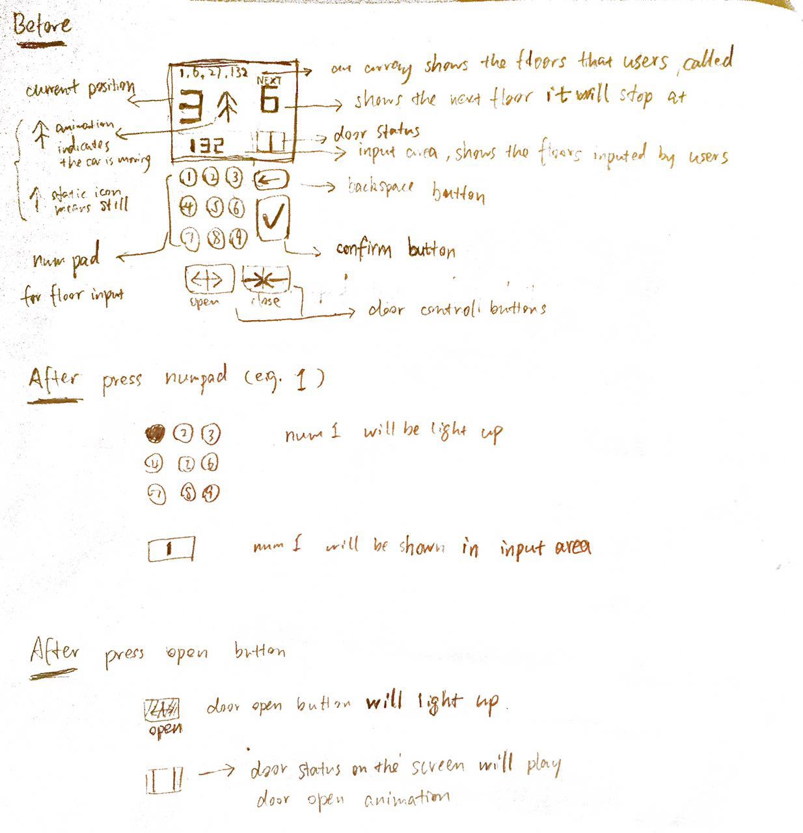

**Conceptual model:** The conceptual model of internal control panel is straight-forward. The interface is combined with buttons and screen. Passengers can input their destination floor through numpad. And the screen display the essential information.

**Affordances**: The buttons afford users the push action. The screen affords users to fetch information, such as floor queue and current location of elevators car.

**Mappings**: The mapping of the button area is natural and understandable. The numpad is followed by design of phone numpad. The passenger can use it to input like using their phone to dial. For example, if user’s destination floor is 123, he or she push the button 1, 2, 3 sequentially. Moreover, the text or the icon printed on the button are strong signifiers that imply its functionality clearly. For example, the backspace button with left arrow icon on it reminds user the backspace key in the keyboard. Therefore, the user should be able input their destination floor or modify it without further knowledge.

**Feedback**: The button will light up when passengers pushed it, which gives the feedback that the command was received successfully. Moreover, the screen also provides information the passengers wanted to know, such as the floor they input (help passengers to make sure they input the correct floor number), the next floor where the car will be arrived (help passenger to prepare getting out) is at and the floor queue (let passengers know their floor is in the queue and help them to estimate the travel time).

**Constraints**: The control buttons show physical constraint which they can only be pressed; The input screen reflects the logical constrain that only valid floor number can be inputted.

My design of the internal control panel successfully delivers a simple user interface. The buttons are designed with strong signifiers (both shape and text) that guides users directly. This makes sure that in most of cases, the passenger should input their destination floors smoothly without any further instruction or knowledge. My design also provides various feedbacks. The light button shows the user clearly that the command was received. However, the potential issue is that if the queue size is huge due to many destination floor inputs, the screen may not be able display all of them (The screen size is limited).