**CPT_S 534 Extra Homework**

**Yang Zhang**

**11529139**

1. **Result of using MLP**

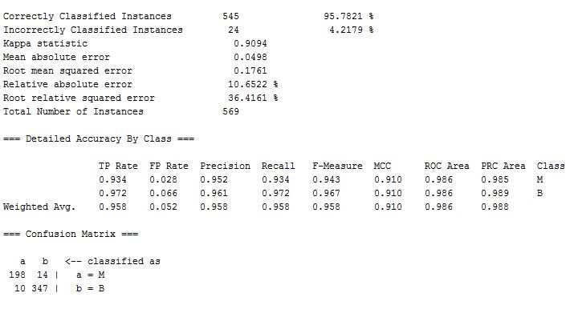

1. **Result of using SVM**

