**CPT_S 534 HW10**

**Yang Zhang**

**11529139**

**MLP Result:**

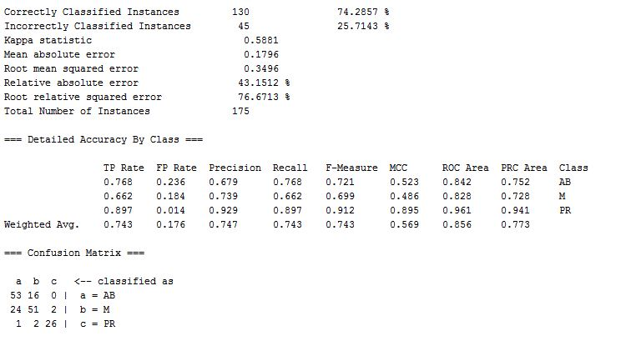

**MLR Result:**

Correctly Classified Instances 119 68 %

Incorrectly Classified Instances 56 32 %

=== Confusion Matrix ===

a b c <-- classified as

40 29 00 | a = AB

22 54 01 | b = M

00 04 25 | c = PR