**CPT_S 534 HW2**

**Yang Zhang**

**11529139**

**Q1. Use the equality of discriminants to derive a quadratic equation for Bayes’ discriminant points in a 1D, 2-class problem with Gaussian class likelihoods**

The curves of C1 and C2 intersects when g1(x) = g2(x).

Where , and = = 0.5 since priors are equal.

Thus,

,

,

,

Finally,

,

**Q2. Mean and variance of C1 class likelihood are 3 and 1, respectively. Mean and variance of C2 class likelihood are 2 and 0.3, respectively. Assume priors are equal, with a sample size of 100, compare the MLE estimators to the true means and variances.**

Data set:



Write C++ code based on the equations:

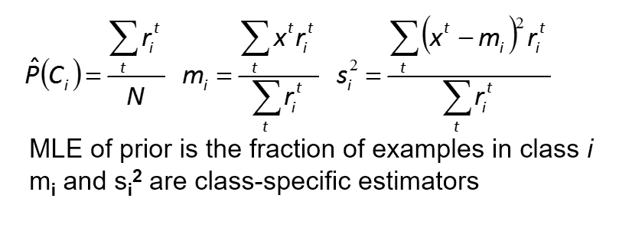



Output Result:

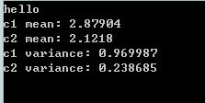

(Real Mean and Variance for C1: 3, 1,

Real Mean and Variance for C2: 2, 0.3)

The MLE estimators of mean and variance calculated are similar compared to real mean and variance.

**Q3. For the same sample, compare Bayes’ discriminant points calculated from MLE estimators with those derived from the true means and variances.**

Equation from Q1:

,

Substitutes (s1, s2, m1, m2) with (1, 0.3, 3, 2) respectively,

We got:

Solve it for x,

Again, substitutes (s1, s2, m1, m2) with (0.97, 0.24, 2.88, 2.12) respectively

We got:

Solve it for x,

Looking at the results above, one root is similar between real and MLE, the other root is quite different.