**CPT_S 534 HW5**

**Yang Zhang**

**11529139**

The linear regression model for one-five:

Class = -2.6496*Intensity – 0.9668*Symmetry + 0.8203

**1) Report in-sample error as mean sum squared residuals and number misclassified**

Mean sum squared error = 0.7188

Number of misclassified data = 12

**2) Calculate 2x2 confusion matrix**

|  |  |  |
| --- | --- | --- |
|  | ~1 | ~5 |
| 1 | 252 | 12 |
| 5 | 0 | 160 |

**3) Make a scatter plot like figure 3.2, text p83**

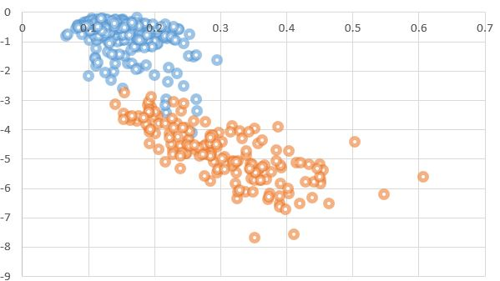

**4) Include discriminant, wTx=bin average, in plot as boundary between classes**

The bin average is -2.325

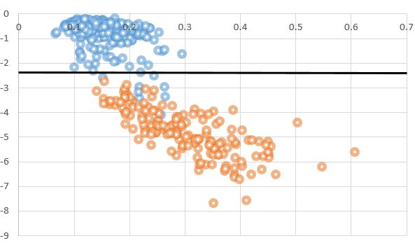

**5) Calculate ECV-1 by leave-one-out**

ECV-1 = 0.7244

**6) Compare ECV-1 with Ein as mean sum squared residuals and number misclassified**

Number of misclassified data (LOO) = 12

The ECV-1 is slightly bigger than Ein and the number of misclassified data are the same.