**CPT_S 534 HW6**

**Yang Zhang**

**11529139**

1. **The result summary and confusion matrix for simple logistic classifier**

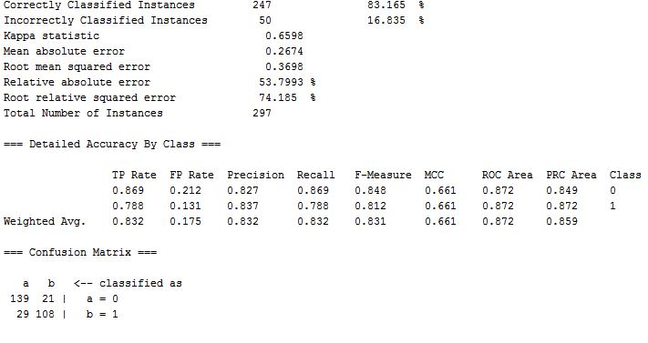

1. **The ROC curve for both classes (left curve is for negative class)**

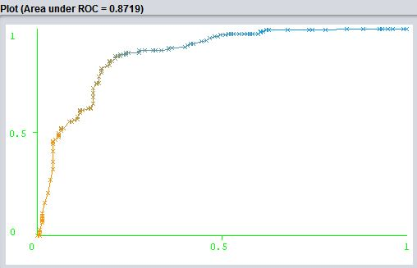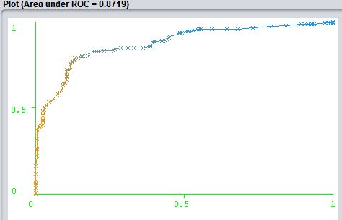

1. **The result summary and confusion matrix for logistic classifier**

