**CPT_S 534 HW8**

**Yang Zhang**

**11529139**

1. **The top 5 ranking genes:**

0.609 143 MPO from Human myeloperoxidase gene, exons 1-4./ntype=DNA /annot=exon

0.607 124 TALDO Transaldolase

0.559 145 Low-Mr GTP-binding protein (RAB31) mRNA

0.555 100 LRPAP1 Low density lipoprotein-related protein-associated protein 1 (alpha-2- macroglobulin receptor-associated protein 1

0.555 148 LPAP gene

1. **The result with selected attributes**

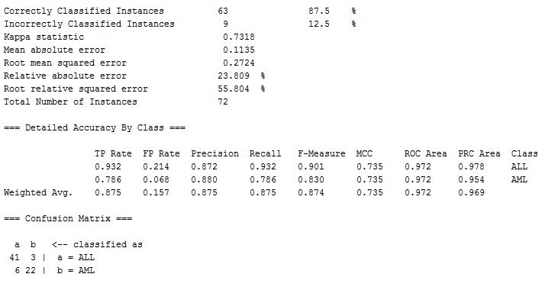

**The percentage of correctly classified instances is 87.5% which is worse than unfiltered KNN result (94.4%).**