**CPT_S 534 HW9**

**Yang Zhang**

**11529139**

1. **Covariance matrix**

Columns 1 through 8

0.0000 0.0001 0.0014 -0.0008 -0.0013 -0.0002 0.0010 -0.0003

0.0001 0.6051 -0.7537 0.2005 -0.1579 -0.1671 0.0027 0.3013

0.0014 -0.7537 2.2776 -0.6766 -0.4516 0.1540 0.0620 -0.6684

-0.0008 0.2005 -0.6766 0.2979 0.1485 -0.0336 -0.1106 0.1886

-0.0013 -0.1579 -0.4516 0.1485 0.5010 0.0601 -0.1467 0.0462

-0.0002 -0.1671 0.1540 -0.0336 0.0601 0.1617 -0.1506 -0.0325

0.0010 0.0027 0.0620 -0.1106 -0.1467 -0.1506 0.5177 -0.1652

-0.0003 0.3013 -0.6684 0.1886 0.0462 -0.0325 -0.1652 0.3487

-0.0000 -0.0210 0.0221 -0.0061 0.0050 0.0019 0.0051 -0.0099

Column 9

-0.0000

-0.0210

0.0221

-0.0061

0.0050

0.0019

0.0051

-0.0099

0.0062

**2. Eigenvalues**

3.0654

0.8180

0.5401

0.1147

0.1051

0.0663

0.0054

0.0008

0.0000

**3. PoV plot**

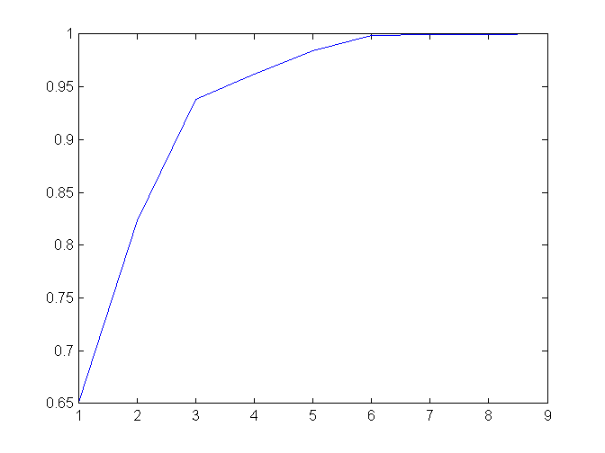

The 3 largest eigenvalues captured 93.8% of variance.

**4. plot of (pc1, pc2)**

