**CPT_S 540 HW3**

**Yang Zhang**

**11529139 (graduate)**

**2. The alpha-beta pruning**

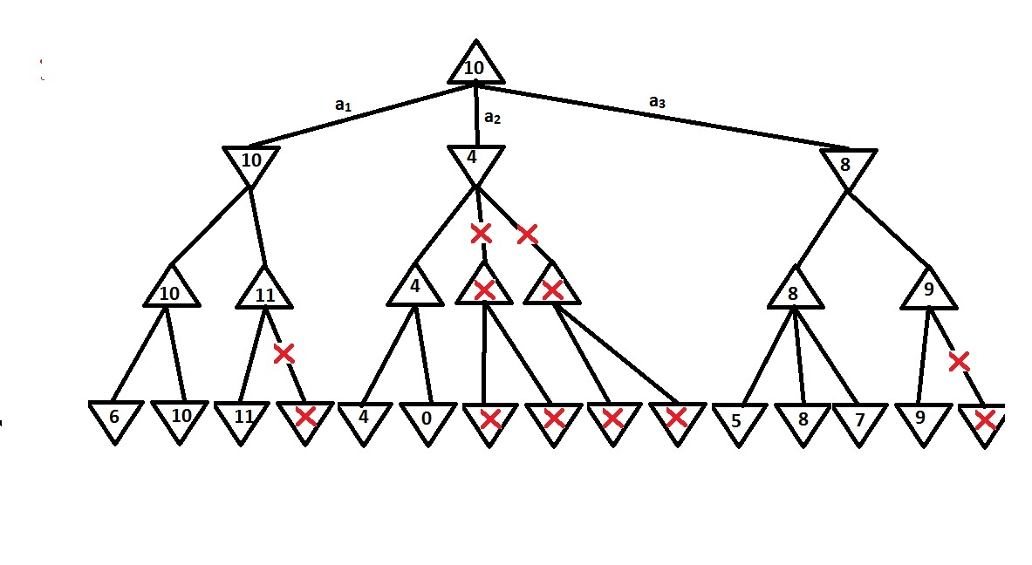

The max player should take the action a1, because a1 provides the best value over other two actions.

**3. Problem 6.2**

**(a)** Variables are K knights.

**(b)** The possible values of each variables are all the possible position on the n2 size board.

**(c)** The constraints:

1. No two knights can stay in the same position

2. Every pair of knights must be separated by a knight’s move

**(d)** Action function: make a move for the input variable (a knight object) in a direction within [up , down, left, right]

Result function: test the input variable (a state of current knights’ positions), return true if no knight violet the constraints.

Sensible objective function: Return the number of knights placed on the board. The optimal result of this function is the optimal solution.