**CPT_S 540 HW4**

**Yang Zhang**

**11529139 (graduate)**

1. (a) s1: ¬LikesRA ^ ¬LikesRC,

s2: ¬LikesDA ^ ¬LikesDT,

s3: ¬LikesBC ^ ¬LikesDC,

(b) s4: ¬LikesBC ^ ¬LikesDC ^ ¬LikesRC ⇒ LikesJC

s5: LikesBC v LikesDC v LikesRC v LikesJC (elimination ⇒ from s4)

(c) s6: ¬LikesRC (using and elimination from s1)

s7: LikesBC v LikesDC v LikesJC (from {s6, s5} ⊨ LikesBC v LikesDC v LikesJC)

s8: LikesJC (from {s7, s3} ⊨ LikesJC)

(d)

s9: LikesBA v LikesDA v LikesRA v LikesJA (from KB)

s10: ¬LikesJA (from s8 ⇒ ¬LikesJA)

s11: ¬LikesDA ^ ¬LikesRA (and elimination from s1 ^ s2)

s12: LikesBA (from {s9, s10 ^ s11} ⊨ LikeRA)

(e) s13: LikesRT v LikesDT v LikesBT v LikesJT (from KB)

s14: ¬LikesJT (from s8 ⇒ ¬LikesJT)

s15: ¬LikesBT (from s12 ⇒ ¬LikesBT)

s16: ¬LikesDT (from s2 by and elimination)

s17: LikesRT (from {s13, s14 ^ s15^s16} ⊨ LikeRT)

1. (a) s1: ¬Likes(Raj, Armageddon) ^ ¬Likes(Raj, Checkers),

s2: ¬Likes(Dmitri, Armageddon) ^ ¬Likes(Dmitri, Tetris),

s3: ¬Likes(Bubba, Checkers) ^ ¬Likes(Dmitri, Checkers),

(b) s4: ∀x ¬Likes(Raj, x) ^ ¬Likes(Dmitri, x) ^ ¬Likes(Budda, x) ^ Likes(Jin, x)

(c) ¬Likes(Raj, x) ^ ¬Likes(Dmitri, x) ^ ¬Likes(Budda, x) ^ Likes(Jin, x) ^ (x=Checkers)

s5: ¬Likes(Raj, Checkers) ^ ¬Likes(Dmitri, Checkers) ^ ¬Likes(Budda, Checkers) ^ Likes(Jin, Checkers)

s6: Likes(Jin, Checkers) ^ ¬Likes(Raj, Armageddon), (from {s5, s1 ^ s3}⊨ Likes(Jin, Checkers) ^ ¬Likes(Raj, Armageddon))

s7: Likes(Jin, Checkers) (from any elimination from s6)

(d)

s8: ∀x ∀y Likes(y, x) ^ ¬Likes(y, ¬x) ^ ¬Likes(¬y, x)

s9: ¬Likes(Jin, Armageddon) (from s8 by and elimination where y = jin, x = Checker)

s11: ¬Likes(Dimitr, Armageddon) ^ ¬Likes(Raj, Armageddon) (and elimination from s1 ^ s2)

s12: ¬Likes(¬Budda, Armageddon) (from s11^s9 ⇒¬Likes(¬Budda, Armageddon))

s13: Likes(Budda, Armageddon) (from s8 by and elimination)

(e)

s14: ¬Likes(Jin, Tetris) (from s8 by and elimination where y = Jin, x = Checker)

s15: ¬Likes(Budda, Tetris) (from s8 by and elimination where y = Budda, x = Armageddon)

s16: ¬Likes(Dmitri, Tetris), (from s2 by and elimination)

s17: ¬Likes(¬Raj, Tetris) (from s16^s15^14 ⇒¬Likes(¬Raj, Tetris))

**Programming Part:**

Run #1 result:

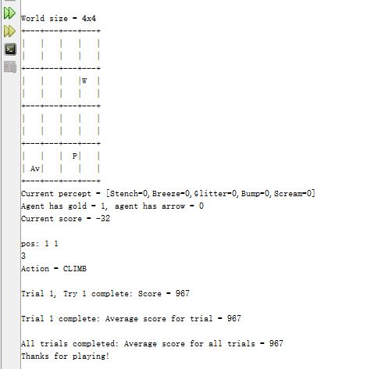

Run #2 result:

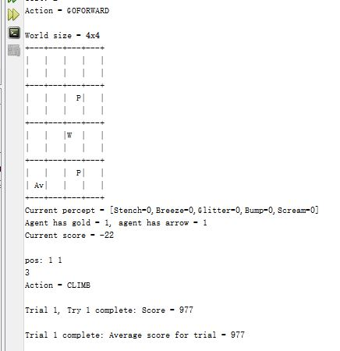

Run #3 result:

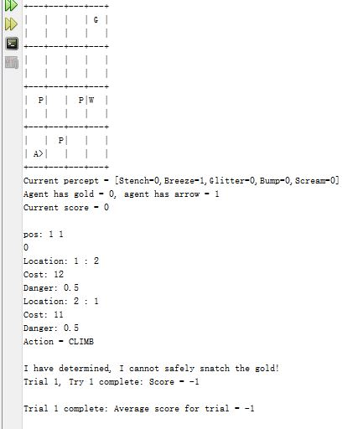

Average score = (967 + 977 – 1)/3 = 647.67