**CPT_S 540 HW5**

**Yang Zhang**

**11529139 (graduate)**

1. **a)** The FOL sentences is invalid, because if the intersection of u and v are empty, the statement is false

**b)** The FOL sentences is invalid, because P(Z) = ~NOT(P(Z)), so P(Z) and NOT(P(Z)) cannot be both true.

**c)** The FOL sentences is valid, because Fast(x) = ~Slow(x), so for any x, it is either fast or slow.

**d)** The FOL sentences is valid, because Fast(y) = ~Slow(y), so for all possible y, it is either fast or slow.

1. **a)** If there are two people who speak the same language, they can understand each other.

**b) 1.** (∀x) (∀y) Empathy (x, y) ⇒ Sympathy (x, y)

**2.** (∀x)(∀y)(∀z)(Sympathy(x, y) ^ Sympathy(y, z)) ⇒ Sympathy(x, z)

1. **a)** The FOL sentences is valid, by applying Existential Instantiation, we got: if there is a person is as brave as Julian, then Julian is as brave as a particular person, and the particular person could be herself.

**b)** The FOL sentences is invalid, because no evidence to show that Ed is the particular person.

**c)** The FOL sentences is invalid, because no evidence to show that neither Ed nor Don is the particular person.

1. **Flag**
2. **a)** It is good news because that the probability of a person with positive test result who actually got the disease is positive correlation with the probability of having the disease. In other word if the probability of having the disease is very low, then the person is not likely to have the disease even if he or she got positive test result.

**b)** A: the event that having the disease

B: the event that having positive test result

And we also know: P(A) = 1/10000, P(B|A) = 0.99

P(B) = P(A) * P(B|A) + ~P(A)*P(B|~A) = 0.009999

P(A|B) = (P(B|A)*P(A))/P(B) = 9.9E-5/0.010098 = 0.01

Therefore, the probability of person with positive test who got the disease is 1%

1. **a) Weather**

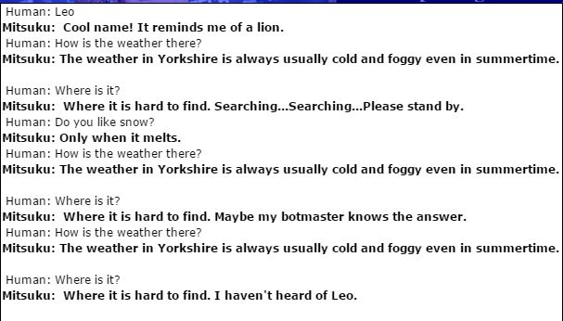

She fails the Turing test on the topic of Weather, because when I ask the same question server times, she gives me the exactly same answer, which is not a real person normally do.

**b) Sports**

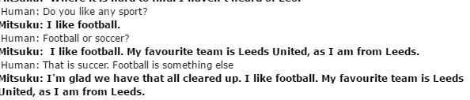

She fails the Turing test on the topic of Sport, because when I ask her does she like football or soccer, she keep saying she like football and her favorite team is Leeds United (a soccer club). Apparently, she doesn’t know the football is usually stands for American football not soccer. A real person won’t answer in her way.

**c) Movies**

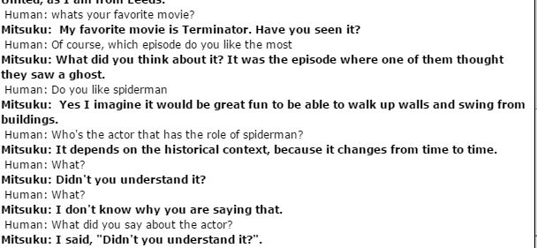

She fails the Turing test on the topic of Movie, because she answers something no-sense, after I ask the actor I mentioned before. A real person can remember the topic that someone talked with him or her before.