**CPT_S 534 HW2**

**Yang Zhang**

**11529139**

1. **(a) Show that the decision boundary of the CLOSE classifier is a linear hyperplane of the form sign(w · x + b). Compute the values of w and b in terms of C+ and C-.**

The function of decision boundary should be (any points that lay on decision boundary should have the same distance to C+ and C-),

sqrt[(x-C+)2]- sqrt[(x-C-)2]=0,

And then we simplify the above equation into (if distances are the same, so does the distances2):

(x-C+)2- (x-C-)2=0,

Expand it, we got:

(2C--2C+)**·**x + (C+2+C-2)=0,

Which is the form w**·**x + b = 0, where w = 2C--2C+ and b = C+2+C-2

**(b) Compute the dual weights (α’s). How many of the training examples are support vectors?**

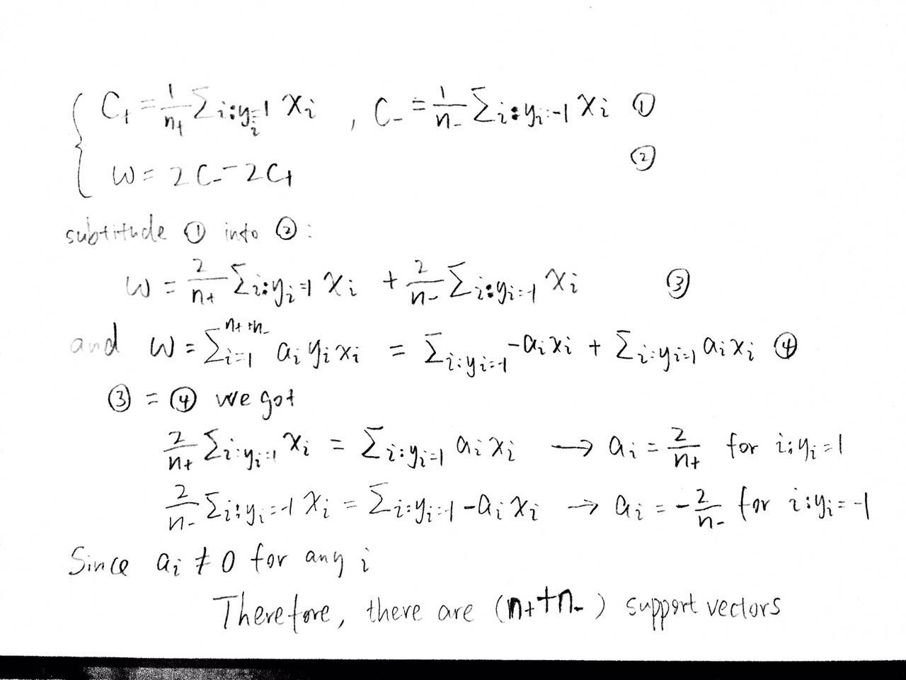

1. **Suppose we use the following radial basis function (RBF) kernel: K(xi , xj ) = exp($-\frac{1}{2}{\left\|x_{i}{-x}_{j}\right\|}^{2}$), which has some implicit unknown mapping φ(x).**
2. **Prove that the mapping φ(x) corresponding to RBF kernel has infinite dimensions.**

K(xi , xj ) = exp($-\frac{1}{2}{\left\|x_{i}{-x}_{j}\right\|}^{2}$) = exp($-\frac{1}{2}(x_{i}^2{-{2x}_{i}x_{j}+x}_{j}^2)$)= exp(-0.5 $x_{i}^2$)*

exp(-0.5 $x_{j}^2$)*exp(xi xj) = exp(-0.5 $x_{i}^2$)*exp(-0.5 $x_{j}^2$) $\sum_{k=0}^{n}{\frac{x_{i}^{k}x_{j}^{k}}{k!}}$

*

Therefore the mapping φ(x) has infinite dimensions.

1. Prove that for any two input examples xi and xj , the squared Euclidean distance of their corresponding points in the higher-dimensional space defined by φ is less than 2, i.e., norm[φ(xi) − φ(xj)]^2 ≤ 2.

norm[φ(xi) − φ(xj)]^2 = φ(xi)^2 − 2 φ(xi)φ(xj) + φ(xj)^2=K(xi,xi) – 2K(xi,xj) + K(xj,xj)

norm[φ(xi) − φ(xj)]^2 = 1-2K(xi,xj)+1

The value range of K(xi,xj) is [0,1] cause -0.5x^2 < 0

Therefore, norm[φ(xi) − φ(xj)]^2 ≤ 2

1. **Prove that f(xfar; α, b) ≈ b with radial basis function (RBF) kernel: K(xi , xj ) = exp($-\frac{1}{2}{\left\|x_{i}{-x}_{j}\right\|}^{2}$), which has some implicit unknown mapping φ(x).**

The distance between xfar and any training data xi is very large which implies that exp($-\frac{1}{2}{\left\|x_{far}{-x}_{i}\right\|}^{2}$)is very small (closed to zero), so that:

f(xfar; α, b) = $\sum_{i=0}^{n}{y_{i}a_{i}exp(-\frac{1}{2}{\left\|x_{far}{-x}_{i}\right\|}^{2}})+b$ = very small value + b ≈ b

1. **The function K(xi , xj ) = − <xi , xj> is a valid kernel. Prove or Disprove it**

The function K(xi , xj ) = − <xi , xj> is not a valid kernel.

We know that K’(xi , xj) = <xi , xj> is a valid kernel, so that based on positivity, K’ follows:

tTK’t > 0

However, K=-K’ implies that:

tTKt = -tTK’t < 0

which violates the positivity property, therefore, K(xi , xj ) = − <xi , xj> is not a valid kernel.

1. **You are provided with n training examples: (x1, y1),(x2, y2), · · · ,(xn, yn,), where xi is the input example, yi is the class label (+1 or -1). The teacher gave you some additional information by specifying the costs for different mistakes C+ and C−, where C+ and C− stand for the cost of misclassifying a positive and negative example respectively. a. How will you modify the Soft-margin SVM formulation to be able to leverage this extra information? Please justify your answer.**

To leverage the extra information, we modify the original objective function:

to soft margin objective function:

$$\min_{w,b}{\frac{1}{2}}{\left\|w\right\|}^{2}+c \sum_{i=1}^{n}{ξ_{i}} s.t. y_{i}\left(w∙x_{i}+b\right)≥1, ξ_{i}≥0$$

$$where c= \left\{\begin{aligned}C_{-} negative x_{i} is incorrectly classified \\ C_{+ } positive x_{i} is incorrectly classified \\ 0 x_{i} is correctly classified\end{aligned}\right.$$

In this way, if the training sample was correctly classified, c would be zero, so no penalty would be applied. If a positive training sample was incorrectly classified as negative class, then the Lagrange multiplier would be C+ corresponding the cost of misclassifying a positive training sample. Vice versa, if a negative training sample was incorrectly classified as positive class, the cost C+ would be applied.

1. **Consider the following setting. You are provided with n training examples: (x1, y1, h1),(x2, y2, h2), · · · ,(xn, yn, hn), where xi is the input example, yi is the class label (+1 or -1), and hi > 0 is the importance weight of the example. The teacher gave you some additional information by specifying the importance of each training example.**
2. **How will you modify the Soft-margin SVM formulation to be able to leverage this extra information? Please justify your answer.**

To leverage the extra information, we modify the original objective function:

to soft margin objective function:

$$\min_{w,b}{\frac{1}{2}}{\left\|w\right\|}^{2}+h_{i}\sum_{i=1}^{n}{ξ_{i}} s.t. y_{i}\left(w∙x_{i}+b\right)≥1, ξ_{i}≥0$$

In this way, if the training sample was correctly classified, c would be zero, so no penalty would be applied. If a training sample was incorrectly classified, then the Lagrange multiplier would be hi corresponding the how importance is training sample.

1. **How can you solve this learning problem using the standard SVM training algorithm? Please justify your answer**

By applying standard SVM, we can modify the data input format from (xi, yi, hi) into (xihi, yi).

In this way, if the training sample is in support vector set, then its Lagrange multiplier would be ai.*hi, which corresponds to its importance.