**CPT_S 580 HW1**

**Yang Zhang**

**11529139**

1.1.22

It is impossible, suppose that <3,3,3,3,3,3,3,3,3> is the degree sequence of that graph, the sum of degree is 9*3 = 27, which is not even. According to the theorem 1.1.5, since the sum of degree is not even, there doesn’t exist such a graph with vertices v1, v2, …, v9 that deg(vi) = 3.

1.1.34

The lower bound is n (a single circle that goes through every vertex), the upper bound is n-1 + n-2 + n-3 + … + 1 = n*(n-1)/2 (any vertex is adjacent to any other vertices).

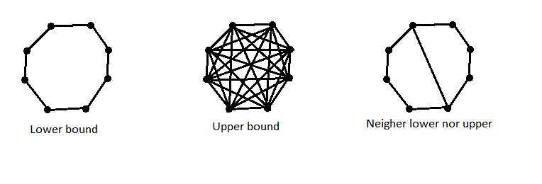

1.2.2

Suppose there are x vertices in one side (m-x in the other side). Then, the number of edges E = x*(m-x). To get the maximum we let the derivative of E be zero, i.e. E’ = m – 2x = 0. Therefore, x = m/2, the maximum number of edges is $\frac{m^{2}}{4}$

1.2.3

The smallest possible non-bipartite graph is a 3-vertex complete graph.

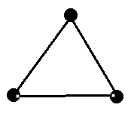

1.2.5

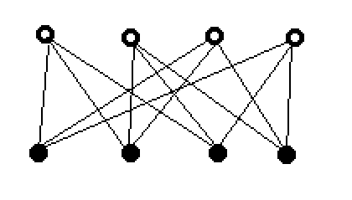

1.3.1

The minimum number of color is 4, any number less than 4 is impossible, because the vertices C, D, E, G are mutually adjacent. Therefore, the minimum frequency is 4.

1.3.13

a) Reflexive, a vertex link to itself

b) Symmetric, there are two vertices have a pair of oppositely directed arcs between them

c) Transitive, there is a path between Vertex A and C, if there exists path between A and B, and path between B and C

d) Asymmetric, no two vertices have a pair of oppositely directed arcs between them

1.4.2

Walks with length 4 between (w, r):

(w, Ewu, u, Euv, v, Evz, z, Ezr, r)

(w, Ewv, v, Evz, z, Ezy, y, Eyr, r)

Walks with length 5 between (w, r):

(w, Ewu, u, Euv, v, Evz, z, Ezy, y, Eyr, r)

(w, Ewu, u, Eux, x, Exv, v, Evz, z, Ezr, r)

(w, Ewv, v, Evz, z, Ezs, s, Esy, y, Eyr, r)

1.4.12

The distance between x and y is 4

**\*1.4.33**

If a digraph that every vertex of it has nonzero outdegree, there exist at least one circle in this graph. And a closed walk requires that every vertex has nonzero outdegree.

Therefore, the circle in that graph is a closed walk.

1.5.1

a. is a walk with length 4, but not a path

b. is not a walk or a path or a circle

c. is not a walk or a path or a circle

d. is a walk with length 5 and it is also a path and a circle

1.5.2

a. is a directed walk with length 4. But not a directed path

b. is a directed walk with length 4, and it is also a directed circle, but not a directed path

c. is not a directed walk or a directed path or a directed circle

d. is not a directed walk or a directed path or a directed circle

1.5.11

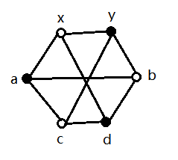

None of length 2 or 4

4 paths with length 3: (x, a, c, y), (x, d, b, y), (x, a, d, y), (x, d, c, y)

**\*1.7.17**

Prove: suppose that there are two longest paths A and B that does not have any common vertex in a connected graph G. Since G is connected, there is walk between vertex a in A and vertex b in B. Therefore, the path A is not the longest path, since there exists outside vertex can link to path A.

Thus, any two longest paths must have a vertex in common in a connected graph.

2.1.2

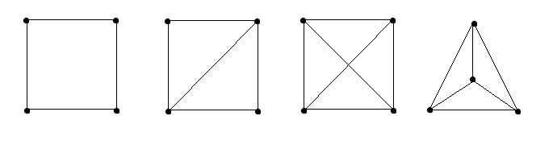

2.1.5

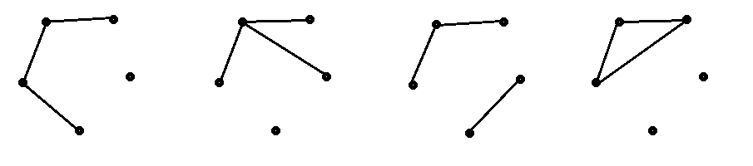

2.1.9

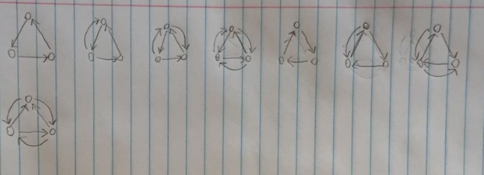

2.1.10

