**CPT_S 580 HW2**

**Yang Zhang**

**11529139 (graduate)**

**2.3.21**

(a) 1 clique (u, v, y)

(b) w = 3

(c) uxz, xyz, xyw, xvz, xuw

**2.3.22**

(a) 3 cliques (u, x, y), (u, v, y), (y, v, w)

(b) w = 3

(c) xvz, xw, uw, uz, yz

**2.3.30**

All possible isomorphism types of a simple 4-vertex graph with exactly 2 components

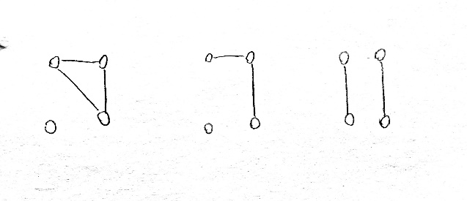

**2.3.36**

A forest with 10 vertices, 7 edges, and 3 components

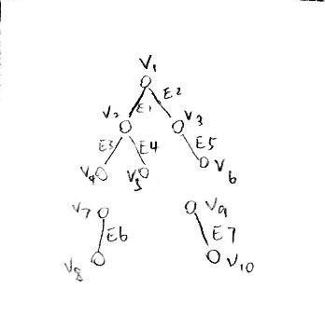

**2.4.8**

Cut-vertices: {u, v, z}

Cut-edges: {uv}

**2.4.9**

Cut-vertices: {u, v, x, z, s}

Cut-edges: {uv, xz, zs, st}

**2.4.30**

Since the **e** is the cutting-edge, removing it will separate parts that connected by **e**, and since any vertex is not removed, which means the two separate parts are connected. Therefore, connected graph G – cutting edge **e** has exactly two components.

**2.5.3**

The left-side graph has 1 4-edge circle, while the right-side graph has none.

**2.5.5**

Yes, they are in the pair of isomorphic

Cause we can map one graph to the other one.

Map: {a->1, b->4, c->2, d->3, e->5}

**3.1.15**

Suppose graph G has n vertices v1 to vn. And suppose the average degree of its vertices is 2, then,

deg(v1) + … + deg(vn) = 2n

which implies that the number of edges in G is n. The graph G has n vertices; thus it cannot be a tree. Thus G has at least one cycle, say C. Let e be an edge in C. Then the graph G − e is connected, and has n − 1 edges, hence it is a tree. By a theorem in the notes, adding one edge e to the tree G − e creates exactly one cycle. Thus G has exactly one cycle.

**3.1.17**

Let G have n vertices and n edges. Since G is a connected graph, it has a spanning tree T with n vertices and n − 1 edges. Let e be the edge not in T, with its endpoints u and v. There is a unique path γ between u and v in T (since T is a tree). The union of e and γ is a cycle. Suppose that there is some other cycle δ. If δ does not contain e, then it is contained in T, contradicting that T has no cycles.

**3.1.18**

We know that n-vertex simple graph with n edge has exactly 1 cycles. Then add 1 edge to the graph would connect 2 non-adjacent vertices (since simple graph), which make the 1 cycle into 2 cycles.

**2.2.10**

For every vertex in hypercube graph Qn, the vertex-degree is identical, which means any vertex has the same local environment. Thus, for any two vertices of Qn, the vertex-bijection that swaps them and fixes all the others is adjacency-preserving. It is its own inverse, so the inverse bijection is also adjacency-preserving.

**2.6.24**

When n = 1, the entry $a_{ij}$ is 1 if {i, j} ∈ E. By definition, i {i, j} j is then an i − j walk of length 1 and this is the only one. So the statement is true for n = 1. Now, we assume the statement is true for n and then prove the statement is also true for n + 1. Since $A_{ij}^{n+1}=A_{ij}^{n}•A_{ij}$, therefore, $a_{ij}^{n+1}=\sum_{k=1}^{m}{a_{ik}^{n}•a_{kj}}$. Because $a_{ki}$ = 0 whenever {k, i} ∈/ E and $a_{ki}$ = 1 if {k, i} ∈ E, it follows that a n $a_{ik}^{n}•a_{kj}$ represents the number of those i−j walks that are i−k walks of length n joined by the edge {k, j}. In particular, all walks from i to j of length n + 1 are of this form for some vertex k.

Thus $a_{ij}^{n+1}=\sum_{k=1}^{m}{a_{ik}^{n}•a_{kj}}$ indeed represents the total number of i − j walks of length n + 1. This proves the statement for n + 1. Then by the principle of induction, we prove the statement for all natural numbers n.