**CPT_S 580 HW3**

**Yang Zhang**

**11529139 (graduate)**

**3.2.10**

A ternary tree of height 3 with 10 vertices.

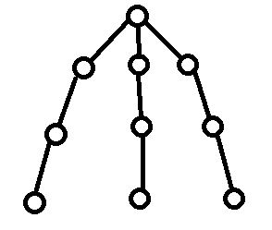

**3.2.12**

A ternary tree of height 3 with 4 vertices.

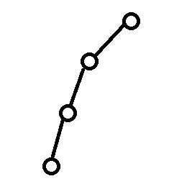

**3.3.1**

Level-order: {1, 2, 3, 4, 5, 6, 7, 8, 9, 10}

Pre-order: {1, 2, 4, 7, 8, 5, 3, 6, 9, 10}

In-order: {7, 4, 8, 2, 5, 1, 9, 6, 10, 3}

Post-order: {7, 8, 4, 5, 2, 9, 10, 6, 3, 1}

**3.3.6**

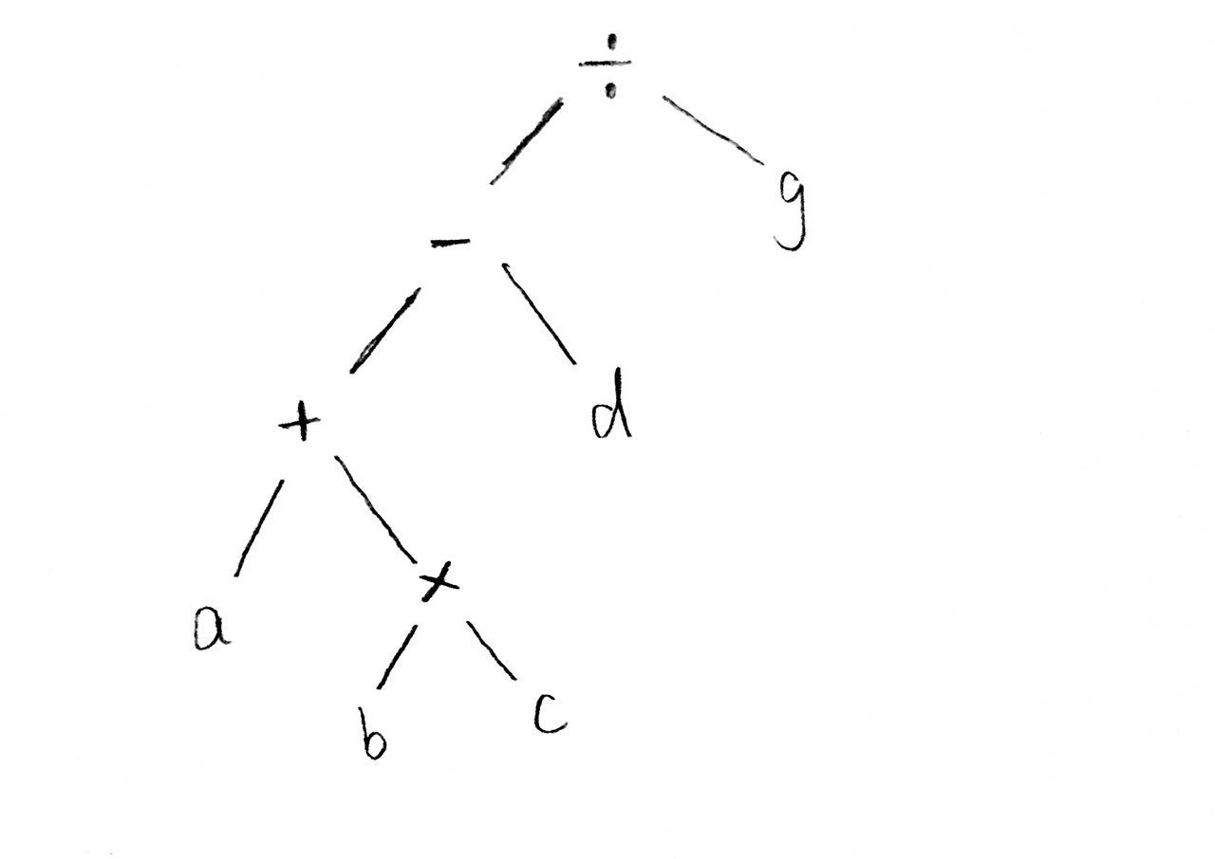

Prefix: {/, -, +, a, *, b, c, d, g}

Postfix: {a, b, c, *, +, d, -, g, /}

**3.5.2**

|  |  |  |  |  |  |  |  |
| --- | --- | --- | --- | --- | --- | --- | --- |
| letter | a | b | c | d | e | f | g |
| codeword | 00 | 0100 | 0101 | 011 | 10 | 110 | 111 |

0100|00|111|111|00|111|10 = baggage

**4.1.2**

Frontier edges (one endpoint in the tree): {l, e, m, g, h}

**4.2.2**

**(a) lexicographic order:**

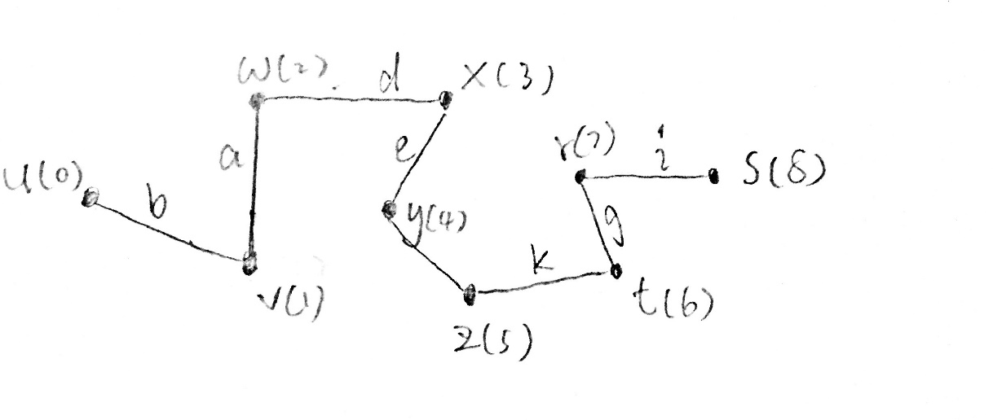

**(b) reverse lexicographic order:**

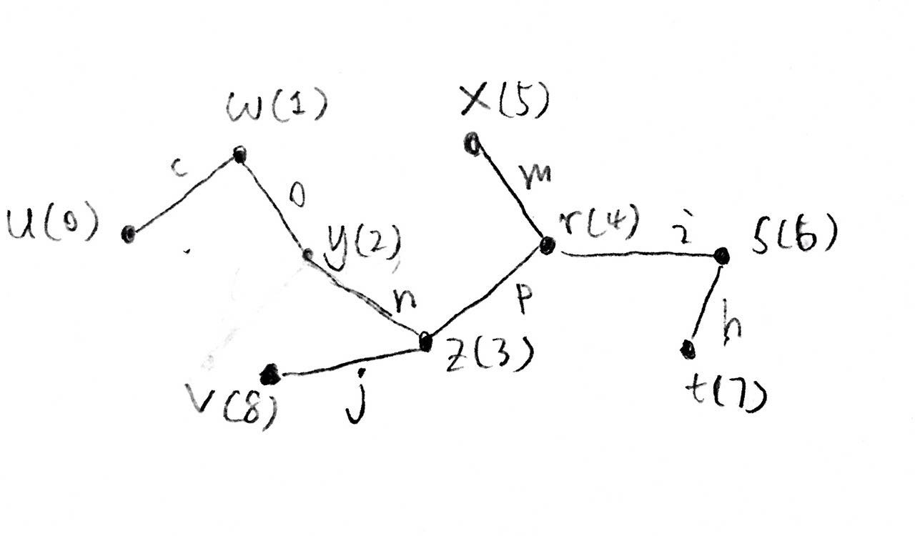

**4.2.9**

**(a) lexicographic order:**

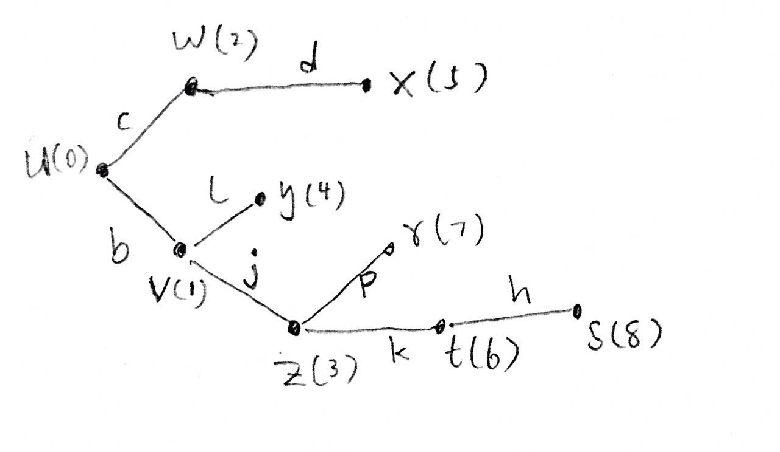

**(b) reverse lexicographic order:**

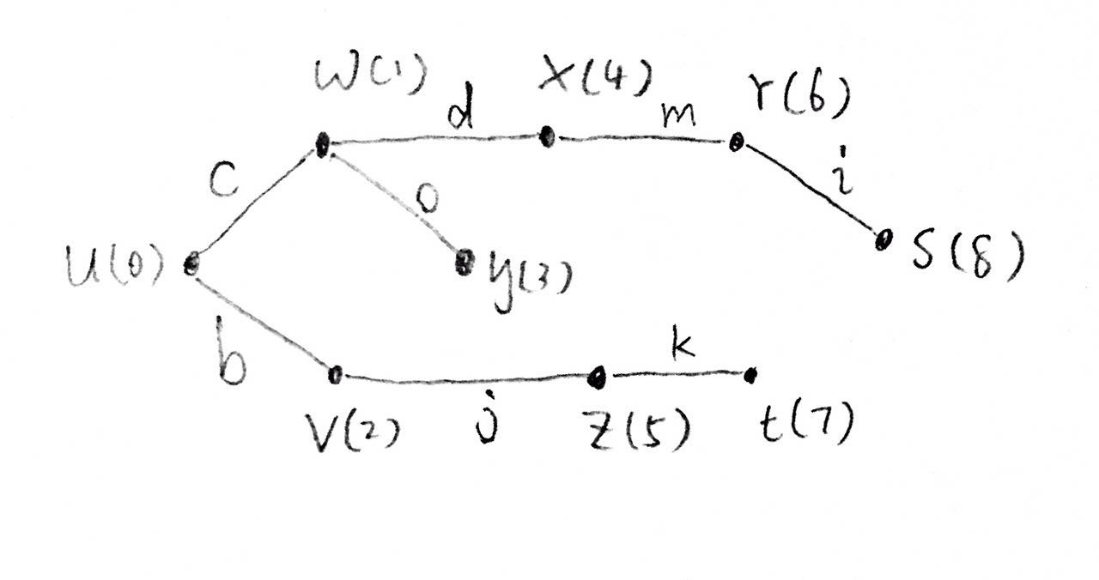

**3.4.16**

According to the definition of BST, any value from the left subtree must be smaller than current root value. Start from the root **r**, the value of left child **c1** of the root is smaller than the value of root, and then we move the cursor from root **r** to **c1**. The value of **c1**’s left child **c2** is smaller than the value of **c1,** so we continue moving the cursor to **c2**.Repeating the steps until the cursor reaches the leaf node which is the left most leaf node. Therefore, the left leaf node has the smallest value in BST.

**4.1.17**

By the process of tree-growing algorithm, it initializes the starting vertex **v** as the root of spanning tree **T**. At each iteration, the algorithm grows the tree **T** by adding the specific frontier edge and a new vertex (the non-tree vertex of the frontier edge) is also discovered**.** Since new added vertex is part of the tree **T**, it can be reached from the starting vertex. Therefore, the starting vertex can reach any vertex discovered by the algorithm.