**CPT_S 580 HW3**

**Yang Zhang**

**11529139 (graduate)**

**4.3**

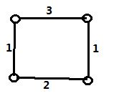

**4.4.1**

|  |  |  |
| --- | --- | --- |
| Vertex | Df# | low# |
| a | 0 | 0 |
| b | 2 | 2 |
| c | 1 | 0 |
| d | 3 | 0 |
| e | 4 | 0 |
| f | 5 | 0 |
| g | 6 | 3 |
| h | 7 | 6 |
| i | 8 | 6 |

Vertex g and c are cut vertices, and dfnumber(c) <= low(b), dfnumber(g) <= low(h), which verifies the assertion of Corollary 4.4.12

**4.4.2**

|  |  |  |
| --- | --- | --- |
| Vertex | Df# | low# |
| a | 2 | 1 |
| b | 0 | 0 |
| c | 1 | 1 |
| d | 4 | 1 |
| e | 3 | 1 |
| f | 6 | 2 |
| g | 5 | 2 |
| h | 7 | 5 |
| i | 8 | 5 |

Vertex g and c are cut vertices, and dfnumber(c) <= low(b), dfnumber(g) <= low(h), which verifies the assertion of Corollary 4.4.12

**4.4.3**

|  |  |  |
| --- | --- | --- |
| Vertex | Df# | low# |
| a | 1 | 0 |
| b | 8 | 8 |
| c | 0 | 0 |
| d | 3 | 0 |
| e | 2 | 0 |
| f | 5 | 1 |
| g | 4 | 3 |
| h | 6 | 4 |
| i | 7 | 4 |

**4.4.4**

Vertex g is cut vertex, and dfnumber(g) <= low(h), which verifies the assertion of Corollary 4.4.12

|  |  |  |
| --- | --- | --- |
| Vertex | Df# | low# |
| a | 1 | 0 |
| b | 3 | 3 |
| c | 2 | 0 |
| d | 4 | 0 |
| e | 0 | 0 |
| f | 6 | 0 |
| g | 5 | 3 |
| h | 6 | 6 |
| i | 7 | 6 |

Vertex g and c are cut vertices, and dfnumber(c) <= low(b), dfnumber(g) <= low(h), which verifies the assertion of Corollary 4.4.12

**5.1.2**

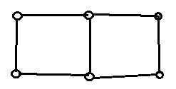

**5.1.4**

It is impossible, because if the 3 connected graph G only has 1 bridge, then kE(G) = 1 and kV(G) = 3, which violates the Corollary 5.1.6 (kV(G) <= kE(G)).

**5.1.14**



**5.1.15**

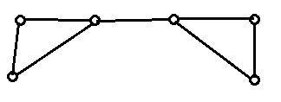

**5.1.20**

Any 3-connected simple graph must have at least 5 vertices and min degree number >= 3. Therefore, the smallest possible 3-connected graph is as shown below:

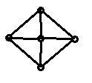

Which has 8 egdes. Therefore, there doesn’t exist such a graph with 7 edges.

**5.2.2**

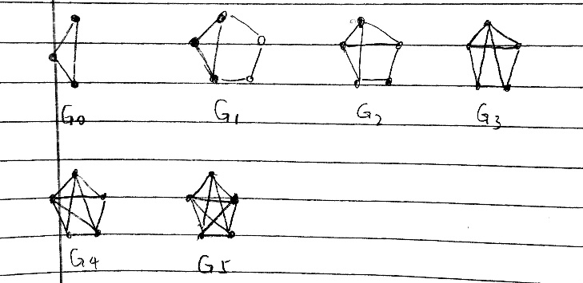

**5.2.3**

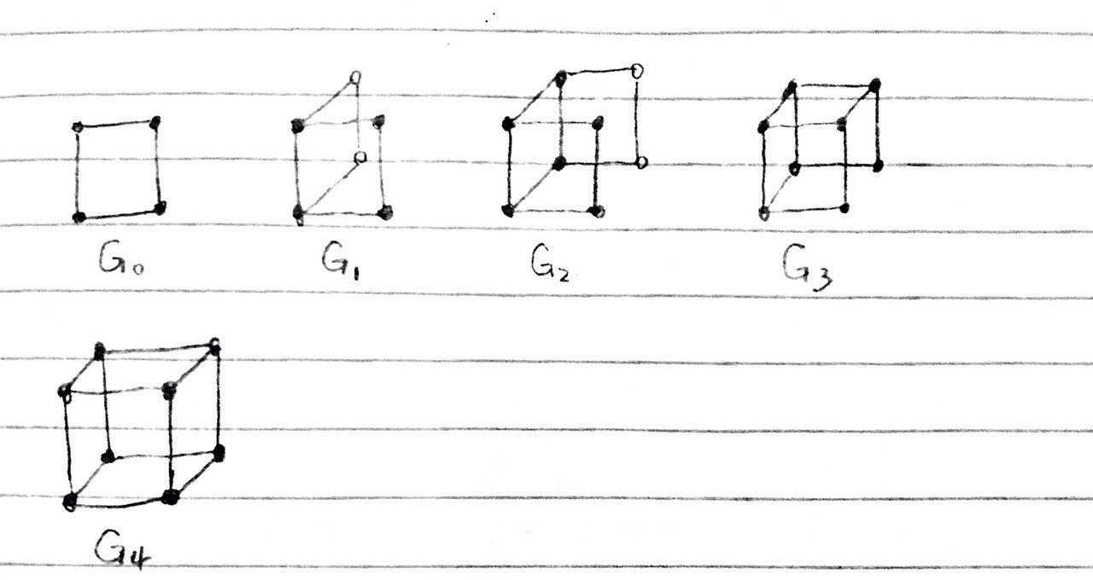

**Is this possible?**

**5.2.6**

A 3-connected graph can be constructed from a wheel graph by applying Tutte Synthesis

Q3 can be constructed from a wheel graph as follow steps:

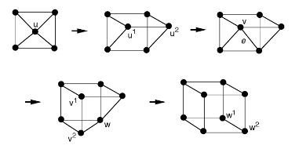

Therefore, Q3 is 3-connected graph.

**5.3.2**

One collection of two internally disjoint paths could be P={(u,t,y,v), (u,s,w,x,v), (u,a,b,v)}. The u-v separating vertex set {t,s,a} shows that P is maximum-size collection.

**5.3.11**

Since SUV is a u-v separating set, each u-v path in Puv must include at least one vertex of Suv. Since the paths in Puv are internally disjoint, no two of them can include the same vertex. Thus, the number of internally disjoint u-v paths in G is at most |Suv|. Therefore, if |Puv| = |Suv|, Puv has the maximum size.