**CSE 413 HW 1**

**Yang Zhang**

1. (a)

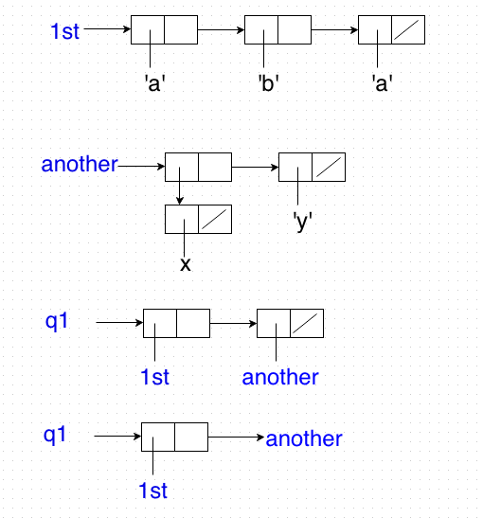

**1 (b) list command 🡪 q1 prints: ‘((a b c) ((x) y))**

**cons command 🡪 q2 prints: '((a b c) (x) y)**

**2 *** app (p q r (a b) c), rev (c (a b)) \*\*\***

1. **(cdr 1st) 🡪 ‘( q r )**
2. **(cddr 1st) 🡪 ‘r**
3. **(cadr more) 🡪 ‘c**
4. **app 🡪 ‘(p q r (a b) c)**
5. **rev 🡪 ‘(c (a b))**
6. **(cons more rev) 🡪 ‘(((a b) c) c (a b))**