CSE 417 HW 8 Q1&2

## Yang Zhang, 1030416, zhy9036@uw.edu

**Problem 1**

1. MaxCut can be testified in Polynomial time:

Suppose given 2 sets of vertices ***g1, g2*** (which are no overlapping with each other), integer ***k,*** and a set of edges ***e***. Then only need to spend **O(n)** time to loop over ***e***, then counts the number of edges that have vertices both in ***g1*** and ***g2***.

Therefore MaxCut is in **NP.**

1. Algorithm for MaxCut:

globle k

func max_cut(subset, index i, vertexes v, edges e):

if i < len(v)

subset.append(v[i])

verify(subset, e)

max_cut(subset, i+1, v, e)

subset.remove(v[i])

verify(subset, e)

max_cut(subset, i+1, v, e)

endif

endfunc

func verify(subset, edge):

count = 0

for e in edge:

if subset only contains one vertex in e

count++

endif

endfor

if count >= k

return subset

endif

endfunc

**Proof:**

Since the above algorithm contains all the cases that can divide a graph into 2 parts, and verify every single case. Therefore, the algorithm is correct.

**Running Time Analyze:**

Each level of recursion reduce the size by 1 and there are n level of recursion. Therefore, the total time is n*(n-1)*(n-2)*…*1, which is O(nn)

**Problem 2**

(x1 ∨ x2 ∨ x4) ∧ (x1 ∨ ~x2 ∨ x3) ∧ (x2 ∨ ~x3 ∨ ~x4)

1. shown as figure below:

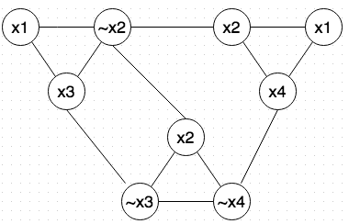

1. x1 = x2 = x3 = False, x4 = True

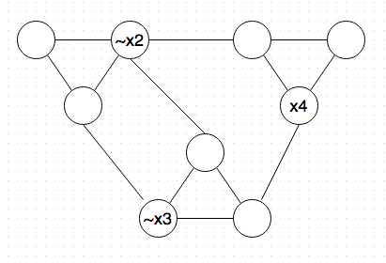

The indSet = {~x2, ~x3, x4}

x1 doesn’t show in the independent set, therefore x1 can be either True or False.

1. x1 = x2 = x3 = False, x4 = True
2. x1 = x4 = True, x2 = x3 = False

Both assignments satisfies the Boolean expression.

CSE 417 HW 8 Q3&4

## Yang Zhang, 1030416, zhy9036@uw.edu

**Problem 3**

(x1 ∨ x2 ∨ x4) ∧ (x1 ∨ ~x2 ∨ x3) ∧ (x2 ∨ ~x3 ∨ ~x4)

1. shown as table below:

|  |  |  |
| --- | --- | --- |
|  | Variables  x1 x2 x3 x4 | Clauses  (x1 ∨ x2 ∨ x4) 　 (x1 ∨ ~x2 ∨ x3) 　 (x2 ∨ ~x3 ∨ ~x4) |
| w1 (x1)  w2 (~x1)  w3 (x2)  w4 (~x2)  w5 (x3)  w6 (~x3)  w7(x4)  w8(~x4) | 1 0 0 0  1 0 0 0  1 0 0  1 0 0  1 0   1. 0   1  1 | 1 1 0  0 0 0  1 0 1  0 1 0  0 1 0  0 0 1  1 0 0  0 0 1 |
| W9  W10  W11  w12  w13  w14 |  | 1 0 0  1 0 0   1. 0   1 0  1  1 |
| C | 1 1 1 1 | 3 3 3 |

(b)

x1 = True 🡪 1000 110 (w1)

x2 = False 🡪 0100 010 (w4)

x3 = False 🡪 0010 001 (w5)

x4 = True 🡪 0001 100 (w7)

add above = **1111221 < 1111333, so the subset must contains slacks**

**There are four subsets:**

Set1: {w1, w4, w5, w7, w9, w11, w13, w14}

Set2: {w1, w4, w5, w7, w10, w11, w13, w14}

Set3: {w1, w4, w5, w7, w9, w12, w13, w14}

Set4: {w1, w4, w5, w7, w10, w12, w13, w14}

**There is only one assignment:**

x2 = x3 = False

x1 = x4 = True

And it satisfy Boolean expression

**Problem 4**

1. Yes, because interval-scheduling problem is in NP and any problem in NP can be reduced to Vertex Cover.
2. Unknown, because it would resolve the question of whether P = NP

CSE 417 HW 8 Q5

## Yang Zhang, 1030416, zhy9036@uw.edu

**Problem 5**

1. This argument is **false.** The reason is that the argument only proofed that

**P ≤p NP**

However, proofing P = NP also need to proof **NP ≤p P**

1. This argument is **false.** The reason is that the transformation can be done in the length of **v** NOT IN u. Since KNAP is NP-complete, the length of v is also not in polynomial