A script for atoms deposition molecular dynamic simulation
## Script Overview
The script was written in **Python 3**, which automates the entire deposition workflow—modeling, parameter setup, cycle-by-cycle deposition, and post-processing—through the **GPUMD** package, allowing users to reproduce atom and cluster deposition simulations with a single command.
If you use this approach in your published work, we kindly ask you to cite the following paper: Li Y, Guo Y, Xiong S, et al. Enhanced heat transport in amorphous silicon via microstructure modulation[J]. International Journal of Heat and Mass Transfer, 2024, 222: 125167.
## Prerequisites
Before launching a deposition run, please prepare:
1. GPUMD input set: ‘run.in’, ‘model.xyz’, and a high-accuracy potential file (NEP is recommended).
2. Place the deposition script ‘deposit.py’ in your working directory.
3. The atoms or atomic clusters you intend to deposit ‘./cluster/0.txt …’.
## Main workflow
1. Preparing deposited species (atoms/clusters) and substrate.
2. Load parameters to global settings, and backup the initial model as `original.xyz`.
3. Enter deposition loop (cycle = 1 … N):
a. Generate or select the next atoms/clusters.
b. Insert atoms via mode 0 (uniform), 1 (probabilistic, fixed layer), or 2 (probabilistic, adaptive layer).
c. Run short MD with GPUMD to deposit the new species.
d. Post-process: remove flying atoms, update `restart.xyz`, record density / defect metrics.
4. Characterization of depositional structure: layer-resolved density, defect maps, etc.
## Sub-routines in `deposit.py`
1. build_dep_atom(dep_atom): Build the to-be-deposited atoms (clusters).
2. build_dep_sub(dep_sub): Build the deposition substrate (exyz/ASE formats supported).
3. para(params): Load parameters, read box info, back up `model.xyz` to `original.xyz`.
4. multi_species(): Used to compute the stoichiometric ratio of the deposition groups, enabling multi-species atomic deposition (Auto).
5. main_dep(): Run the main deposition loop (core logic).
6. add_atom(): Initialize positions and velocities for atoms inserted this cycle (Auto).
7. z_pos_uni(): Locate target layer for non-uniform deposition (Auto).
8. zdir(): Strip flying atoms, update ‘restart.xyz’, append log (Auto).
9. density(dz, z_min, z_max, name_i, name_o): Return layer-resolved density profile along z-axis (Post processing).
10. atom_num(): Create cycle-resolved logs of retained vs. deleted atoms throughout the deposition (Post processing).
## Pasameters in ` build_dep_atom(dep_atom)`
Key | Meaning | Default | Remarks
a_type | Atomic species | - | list
position | XYZ coordinates | - | list
mass | Atomic masses | - | float/list
name | Output file name | - | str
exyz | Produce an exyz file for quick visualization | 0 | 0, 1  (optional)
By default, the standard exyz file is written as: `name`.xyz

## Pasameters in ` build_dep_sub(dep_sub)`
Key | Meaning | Default | Remarks
a_type | Atomic species | - | list
position | XYZ coordinates | - | list
mass | Atomic masses | - | float/list
name | Output file name | - | str
Cell | Simulation-cell lattice | - | list
z | Cell length along z | `Cell[2][2]` | float
vacuum | Vacuum thickness added at the bottom of z | 5 | float
fix | Thickness of the fixed layer | 10 | float
heat_g | Fraction of atoms in the hot-bath group | 0.5 | float
im_file | Input file name | - | str, optional
defect_p | Surface-layer defect ratio | 0.2 | float
defect_l | Thickness of the surface layer | 5 | float
Only orthogonal boxes and thermal transport ensemble (heat_*) are supported; see the example for the exact input syntax.
## Pasameters in `para(params)`
Key | Meaning | Default | Remarks
`x`, `y`, `z` | Cell size of x/y/z-axis | - | auto-read from model.xyz
`path` | GPUMD executable path | - | required
`cycle` | Total deposition cycles | 5 | int
`species` | Number of atom/cluster species to deposit | 1 | int
`number` | Atoms (clusters) inserted per cycle | 15 | int
`vxy` | Initial x, y-velocity (Å/fs) | [0, 0] | list
`vz` | Initial z-velocity (Å/fs) | 0.005 | 1. fixed value (float)  2. uniform random in [0.005, 0.01, 1]  3. Gaussian [0.005, 0.001, 0] ª
` cutoff ` | min separation distance between atoms(Å) | 7 | float
`h_range` | z-bounds of the insertion slab | [`z`-10, `z`] | list
`h_c` | The value of the deposition region in the z-axis (auto-updated each cycle) | - | optional, list ^{b}
`x_range` |  | [0, `x`] | list
`y_range` | y-bounds of the insertion region | [0, `y`] | list
`h_cutoff` | z threshold for pruning undeposited atoms (atoms with `z > h_cutoff` are removed) | `h_range[1]` | float
`group` | Group of deposition atoms (corresponding to group in GPUMD) | 3 | int
`sto_ratio` | Atomic ratio for multi-species deposition. | - | list ^{c}
`prob` | Atom-addition mode: 0: uniform deposition  1: probability-weighted deposition with fixed surface-layer thickness  2: probability-weighted deposition with dynamically calculated surface-layer thickness | 0 | 0, 1, 2
`mesh_xy` | Number of x, y-axis grids for probabilistic deposition (prob = 1, 2) | [10,10] | list
`delta_z` | z-axis grid thickness for probabilistic deposition (prob = 1, 2) | 5 | float
`prob_h` | Surface layer thickness set when adding atoms with prob = 1 | `delta_z` | float
`delta_z_cut` | Defect ratio used to define the surface layer for probabilistic deposition (prob = 1, 2) | 0.1 | float
Note a: Velocity option `vz` offers three formats:
1. single fixed value → 0.005.
2.uniform random in [a, b] → [a, b, 1] (switch flag = 1).
3. Gaussian with mean a and variance b → [a, b, 0] (switch flag = 0).
Note b: Setting `h_c` is mutually exclusive with `h_range`: when `h_c` is provided, the program abandons the fixed `h_range` window and instead places atoms at a constant height above the instantaneous surface.
Note c: When depositing multi-component materials, atoms of the same element can easily be ejected after collision.
To lock the final composition, use `sto_ratio` to specify the target stoichiometry; the code then picks deposition groups probabilistically to keep the ratio constant.
Example for Ga₂O₃: sto_ratio = [[‘Ga’, ‘O’], [2, 3]].
## Pasameters in `density(dz, z_min, z_max, name_i, name_o)`
Key | Meaning | Default | Remarks
dz | z-directional delamination thickness | - | list
z_min | Min z value of the model | `h_range[0]` | list
z_max | Max z value of the model | `h_range[1]` | float/list
name_i | Filename of atoms information | ‘restart.xyz’ | str
name_o | Filename of output density information | ‘density’ | str

##Example
We provide four self-contained examples that show how to drive the code:
Example 1: Different ways to build deposition clusters and deposition substrates.
Example 2: End-to-end workflow for monatomic deposition (Si).
Example 3: End-to-end workflow for diatomic deposition (Ga₂O₃ with locked 2:3 stoichiometry).
Example 4: Post-processing—extract the layer-resolved density profile along the growth direction.
1. Example 1
This example illustrates several ways to build cluster-on-substrate systems with the `build_dep_atom` and `build_dep_sub` functions. The initial files included are:
deposition.py: Core script for the deposition simulation.
example1.py: Configuration file for parameter setup and function invocation.
GaO.xyz: Unmodified initial structure file for the GaO substrate.
Cluster construction
To create deposition clusters—such as a diamond-structured Si cluster—you can use the ASE Python library directly. To check the result, set `exyz = 1`; the script will write ‘0.txt.xyz’ for quick visual inspection.
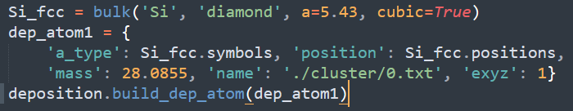
Script of use the ASE Python library create deposition cluster.
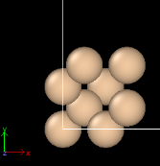
Atomic structure of cluster 0.
Alternatively, you may define clusters by directly inputting atomic species, masses and coordinates.
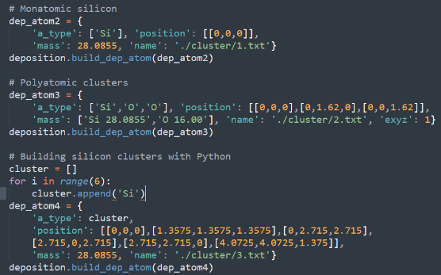
Script of define clusters by directly input.
Substrate Construction
Two primary methods are supported for building deposition substrates:
Method 1: ASE-Based Crystalline Substrate with Reconstruction
First construct a complete crystalline substrate using the ASE Python library, then reconstruct its vacuum layer and surface structure:
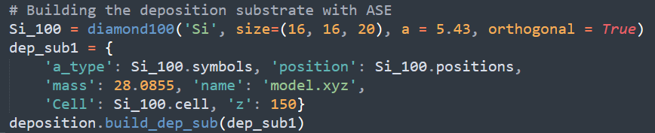
Script of ASE-based crystalline substrate with reconstruction.
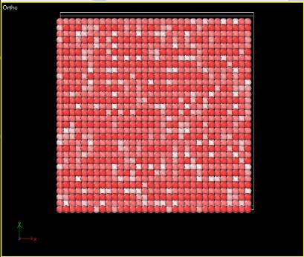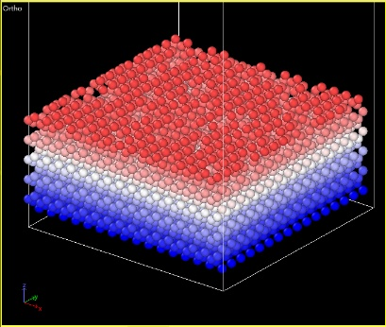
Visual check of the generated substrate, color-mapped by z-height.
The default vacuum layer thickness is 5Å, which prevents the substrate from being displaced out of the simulation box by the kinetic energy of depositing atoms. To enhance the adsorption of depositing atoms, a defective surface layer (default: 5Å thick, 20% defect concentration) is pre-constructed.
In addition, substrate atoms are grouped and colored in OVITO as follows：
Blue (Group 0): Frozen layer (default 10Å thick), used to fix the substrate position.
White (Group 1) & Red (Group 2): Thermal bath layers, used to absorb excess momentum during deposition (default 50:50 ratio).
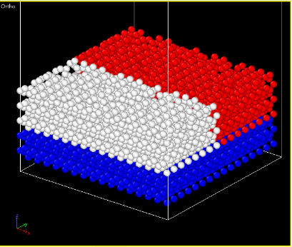
Visual check of the generated substrate, color-mapped by atomic group.
This grouping is designed to avoid thermal bath interference with deposition dynamics: Standard baths (e.g. NPT, NVT) act on all atoms, which can disrupt deposition. By restricting the heat exchange bath (heat_*) to Groups 1 & 2 (the substrate), the dynamics of depositing atoms remain independent. To keep the temperature constant, simply set delta_t = 0 in run.in; Example 2 shows the exact lines.
Method 2: Reconstructing from Existing exyz Files
You can also modify pre-existing exyz files to quickly generate deposition-ready substrates:
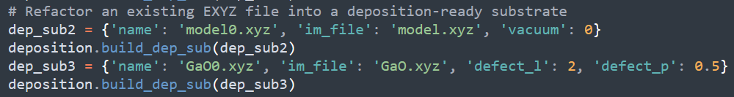
Script of exyz-read substrate with reconstruction.
Substrate Type Recommendations
Using a crystalline substrate may lead to epitaxial crystallization at the interface between the deposited region and the substrate. To avoid crystalline configurations in the deposited part, use an amorphous substrate directly — such substrates can be prepared via simulated melting-quenching processes.
2. Example 2
This example illustrates the full single-element atom deposition workflow: build the starting Si substrate, cycle the deposition, and monitor the growing film. The initial files included are:
deposition.py: Core script for the deposition simulation.
example2.py: Configuration file for parameter setup and function invocation.
model0.xyz: Unmodified initial structure file for the amorphous Si substrate obtained by melt-quenching process.
nep.txt: NEP potential of silicon.
run.in: GPUMD Simulation protocol file.
Parameters setting
Substrate and group preparation are omitted here; the key cycle parameters set in example2.py are as follows:
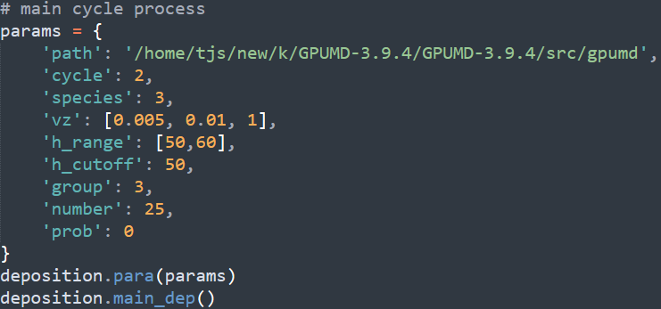
Parameters for deposition process.
Two deposition cycles are displayed in this process, in each, 25 randomly-selected clusters from a pool of three types of clusters are dropped, their incident velocities are uniformly sampled between 0.005 and 0.01 Å/fs and they are inserted within a fixed 50-60 Å window. After every cycle, any silicon drifting above 50 Å is pruned, while newly deposited atoms are assigned to group 3 (groups 0-2 stay with the substrate). Uniform addition is used throughout. In addition, apart from the compulsory `path` keyword, most parameters have its default value.
Once the parameters are set, invoke `para()`, the terminal then echoes the key simulation details before the run begins：
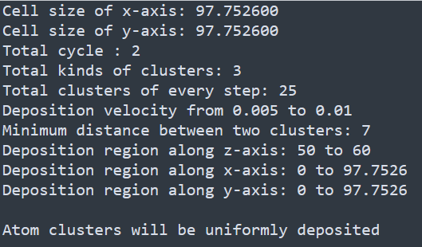
The key simulation details echo by invoke `para()`.
The deposition process
Invoke `main_dep()` to start the deposition loop. Alongside GPUMD’s own output, the terminal reports how many atoms were successfully deposited in each cycle and writes these counts to `count.txt`:
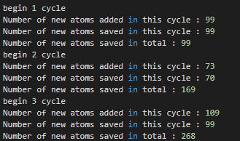
Output on terminal by invoke `main_dep()`.
The coordinates of every added atom are also saved in `.cluster/add.txt`, so you can verify at a glance that the script is being called correctly.
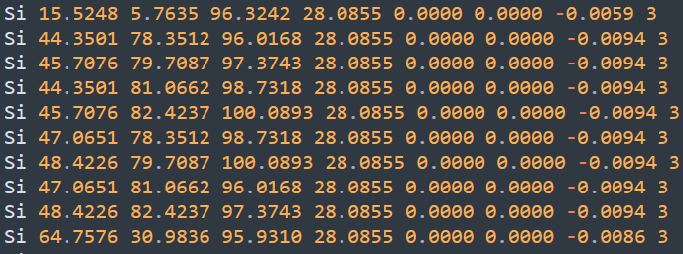
Example of add.txt (partial).
Template for `run.in`
Below is a ready-to-use run.in template for deposition runs; the key parameters are set as follows.
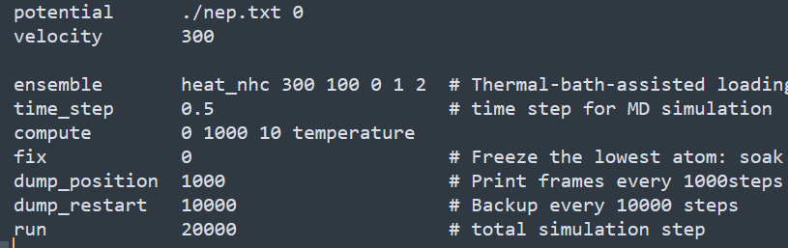
Parameters in run.in.
Note that the usual NPT/NVE/NVT ensembles are not used.
Instead, heat_* applies a heat bath only to the substrate (groups 1-2) while leaving the freshly deposited atoms (group 3) un-thermostated. The temperature difference between groups 1 and 2 is set to zero, giving an effective 300 K constant-temperature zone; group 0 is frozen to soak up excess kinetic energy.
A 0.5 fs time-step is chosen, each cycle runs 20 000 steps, key frames are saved every 1 000 steps, and a full structure backup is written every 10 000 steps.
Output structure (with cuoff_h)
We pre-ran 500 deposition cycles with these settings; the snapshots below color the film by group (left) and by z-coordinate (right). Because everything above 50 Å was deleted after each cycle, the amorphous-Si surface remains smooth and defect-free, giving a quick-and-simple route to a flat, growth-ready substrate.
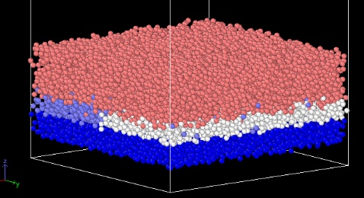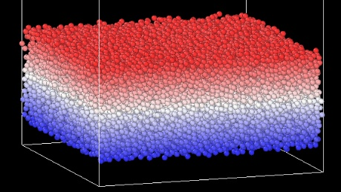
The deposited amorphous Si, colored by groups (left) and z-coordinate (right), respectively.
The figures track the number of deposited atoms and the layer-resolved density along z. During the first 150 cycles the retained atoms increase almost linearly; after ≈ cycle 100 the unsuccessful fraction begins to grow, indicating that the film is becoming dense and defect sites are saturating. Beyond cycle 200 virtually no additional atoms stick. The bulk density fluctuates only slightly (2.22–2.34 g/cm⁻³, crystalline Si = 2.33 g/cm³) and is highest at the outermost surface, confirming the uniformity of the deposit.
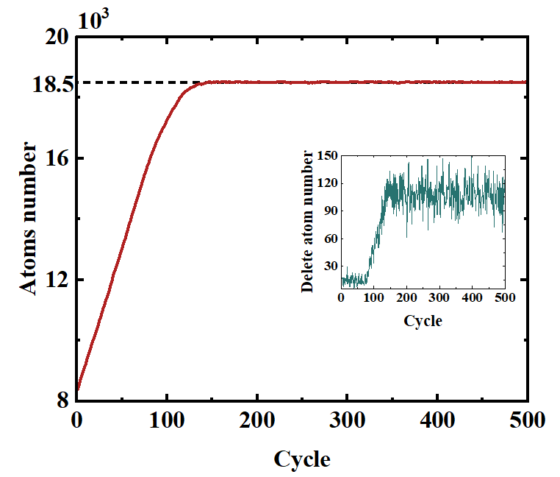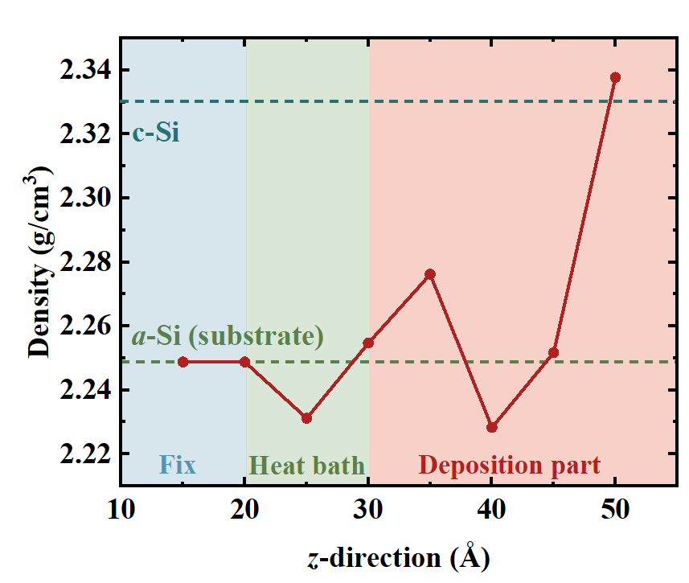
Left: total atoms successfully deposited and atoms deleted after each cycle; right: density profile along z.
Output structure (without cuoff_h, prob = 0)
To keep the film growing, replace the fixed `h_range` window with `h_c` = [a, b]. This switches the injection zone to a dynamic slab that floats a–b Å above the current surface, allowing unlimited thickness build-up.
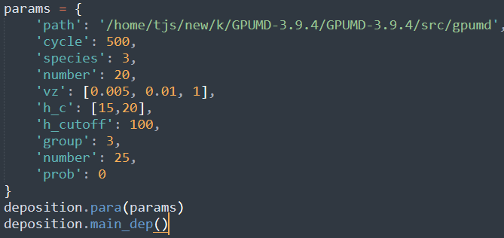
Parameters for deposition process.
Dynamic injection, however, introduces new artefacts: at low deposition rates the surface can reorganize, producing voids and a rough, low-density skin. In the 100 Å film below, a defective band appears around 60 Å where the density drops well below the bulk value.
To regain uniformity without sacrificing open-ended growth, set prob = 1 or 2: the code then biases the injection toward under-coordinated sites, refilling pores as they appear and keeping the film dense throughout.
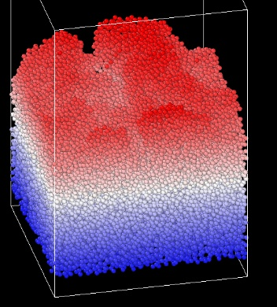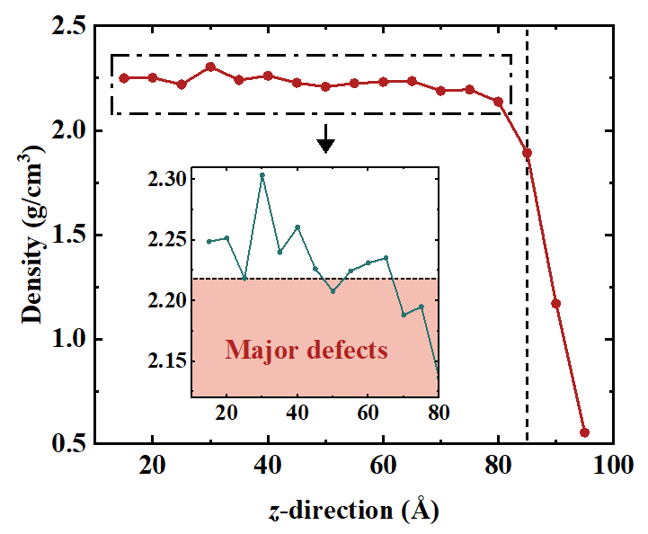
Left: the deposited amorphous Si with unlimited thickness build-up; right: density profile along z.
Output structure (without cuoff_h, prob = 1)
Switching to prob = 1 clearly improves uniformity (see density trace below), although the profile is still not as flat as that obtained with a fixed `h_cutoff`.
The remaining fluctuation stems from poly-atomic clusters and the large number injected each cycle; their collective impact drives long-range X-Y migration and some atoms land far from the intended defect sites. For maximum homogeneity we therefore recommend:
Deposit single atoms instead of clusters, increase the inter-atomic `cutoff`, and reduce the `number` of species added per cycle.
3. Example 3
This example illustrates the full multiple-elements atom deposition workflow: build the starting Ga₂O₃ substrate, cycle the deposition, and monitor the growing film. The initial files are almost same as example2.
Poly-atomic deposition makes the final stoichiometry hard to predict. As sketched below, oxygen atoms often pick up enough energy to dimerise and desorb as O₂, so the film becomes progressively Ga-rich. To keep the composition within a chosen window, please supply `sto_ratio`.
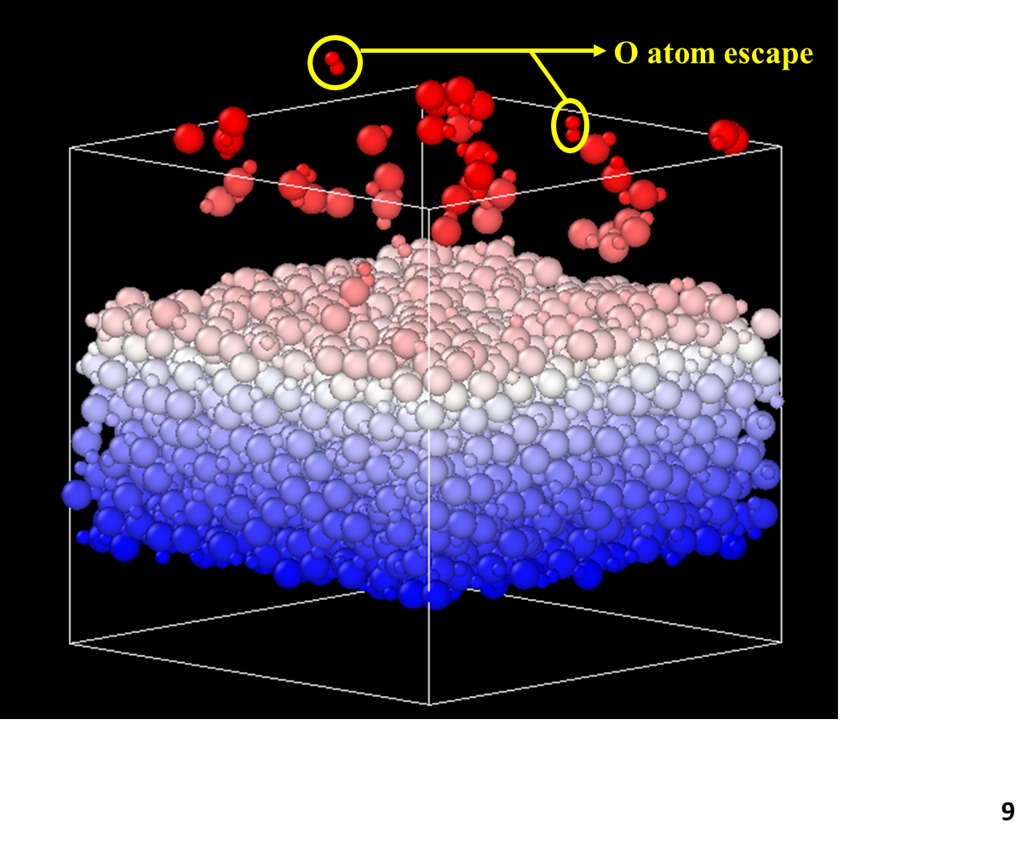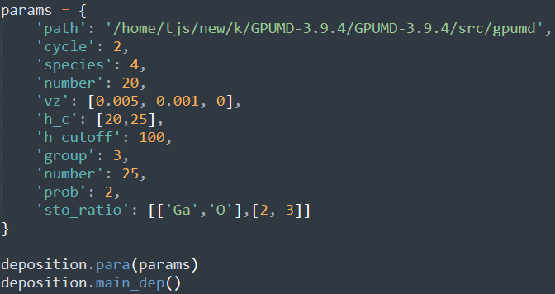
Left: stoichiometry drift in binary deposition; Right: parameters for binary deposition process.
The code now probabilistically selects deposition groups so that the cumulative film ratio stays close to 2: 3, automatically compensating for any O loss.
Note: the group-selection probability is re-evaluated every cycle and is inherently random. To avoid an endless loop, you must provide at least n single-atom deposition structures and list them last in the cluster list (files `n.txt`, `n-1.txt`, …), so the code can always fall back to pure-element insertion when the instantaneous ratio drifts off target.
4. Example 4
This example demonstrates post-processing of the as-deposited structure: computing the layer-resolved density and extracting auxiliary atomic details generated during growth. The initial files included are:
deposition.py: Core script for the deposition simulation.
example4.py: Configuration file for parameter setup and function invocation.
restart.xyz: Amorphous Si films obtained by deposition.
count.txt: Atom insertion and deletion tracked cycle-by-cycle during amorphous-Si deposition.
GaO.xyz: Amorphous Ga₂O₃ structure obtained by melt-quenching process.
The package ships with a utility script `density(dz, z_min, z_max, name_i, name_o)` that computes the layer-resolved density profile along z.
Run it after the parameter reader, or launch it standalone with the same input file to obtain the density curve of any structure. In the first mode, simply supply the layer number `dz`, `z_min` and `z_max` can be automatically taken as the current `h_range` bounds. The program reads `restart.xyz`, performs the calculation, and writes the resulting profile to `density.txt`.
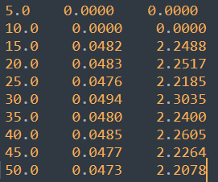
Information in the density.txt file.
The three columns are: z-position (Å), number density (atoms/Å³) and mass density (g/cm³), respectively. You can also specify your own z-range, input structure, and output file—any density profile is one command away. If `para()` is not called before calculation, the program will read the X and Y dimensions of the box for density calculation.
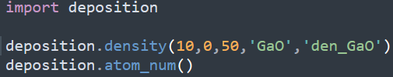
Parameters for density calculation.
In this example, we read the atomic information in `GaO.xyz`, evenly divided the thickness of 0-50 Å along the z direction of the structure into ten parts with a thickness of 5 Å, calculated the thickness of each layer, and saved it to `den_GaO.txt` file.
Use `atom_num()` to parse `count.txt`; it splits the per-cycle totals into “kept” and “deleted” atoms, letting you trace the growth history. The separated lists are written to `del_atom.txt` and `tot_atom.txt`.

