Jackpots

You can use 3 jackpots

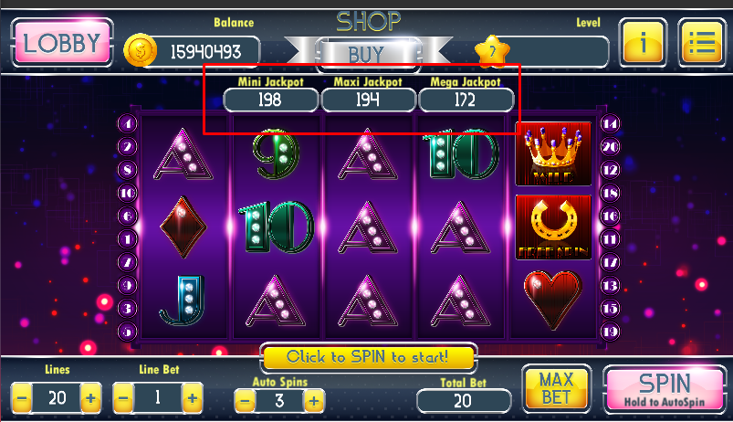

It work very simple. Each spin increase jacpots by value:

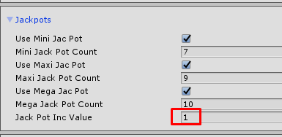

You can select all jackpots or only one.

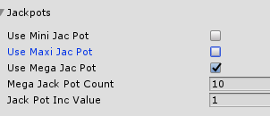

Get Jackpot rules

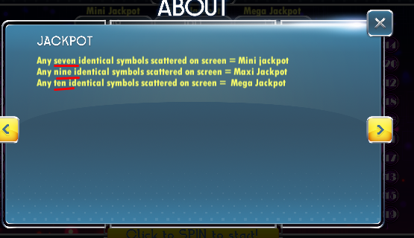

|  |  |
| --- | --- |
| Mini jackpot count – any 7 identical symbols on screen |  |
| Maxi jackpot count – any 9 identical symbols on screen |  |
| Mega jackpot count – any 10 identical symbols on screen |  |