**Wild**

One of the most important symbols in the game is the Wild symbol.

You can select symbol flag Use Wild Substitute. Wilds substitute this symbols and generate wins by completing winning line combinations.

I disable wild susbstite for all major symbols

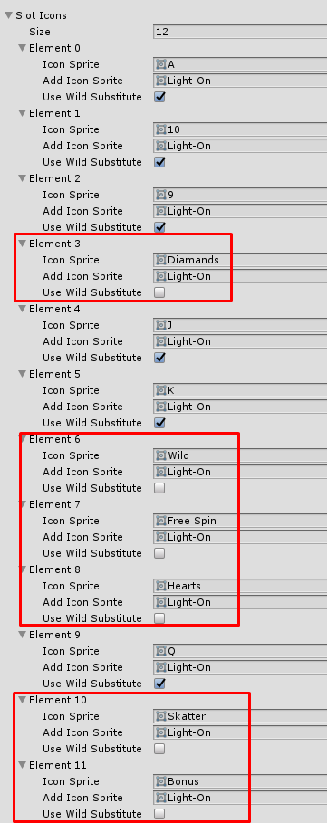

Select wild Symbol

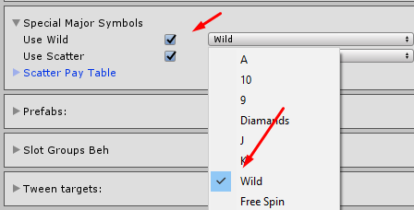

You can check paytable with used wild

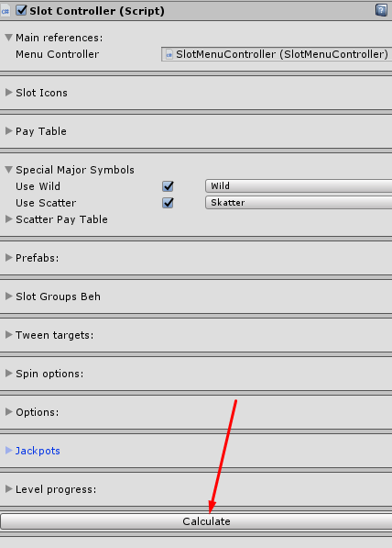

Use wild (we have additional paylines)

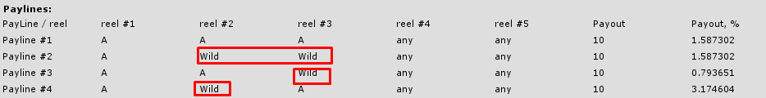

Don’t use wild

