# 阴阳

一天中的阴阳

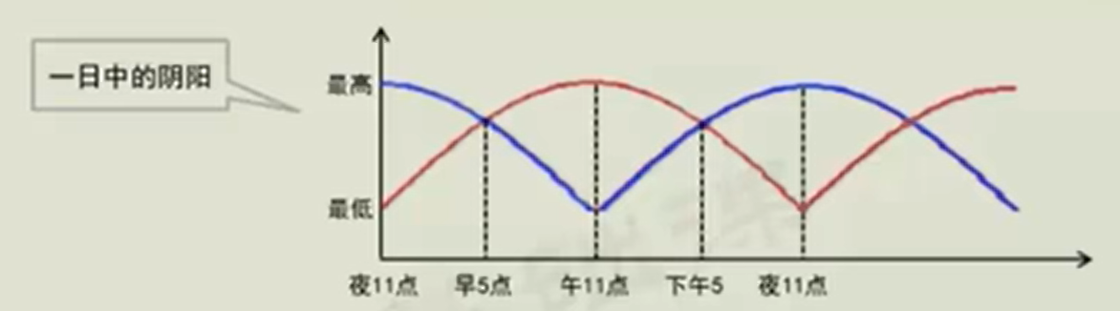

一年中的阴阳

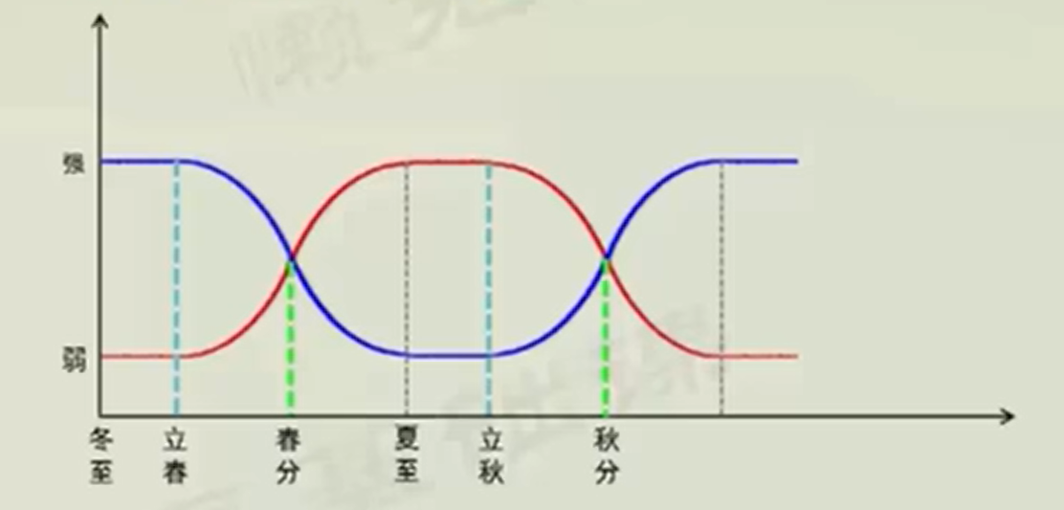

阳气上升，阴气下降，此时阳气在表面，阴气在内，阳气消耗较多，需要滋阴补阳

季节对应五行、温度、五气、五化

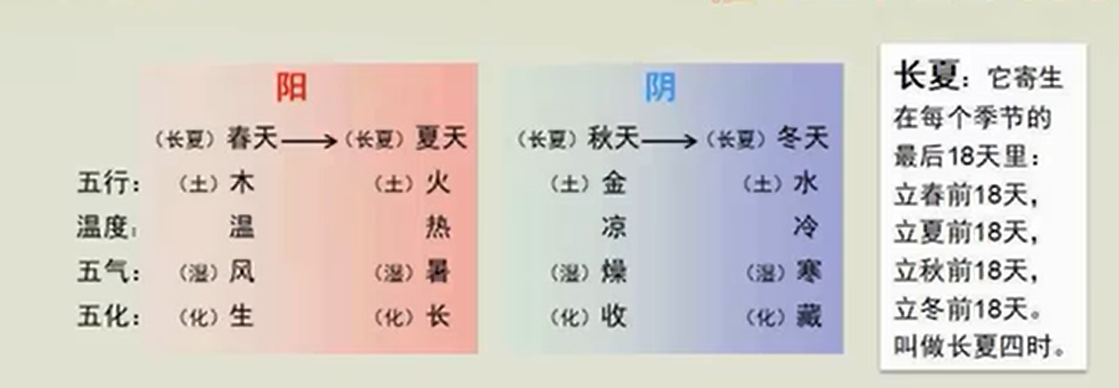

24小时和24节气表

|  |  |  |  |  |  |  |  |
| --- | --- | --- | --- | --- | --- | --- | --- |
| 节气 | 日期 | 时间 | 五行 | 温度 | 五气 | 五化 | 备注 |
|  |  |  |  |  |  |  |  |
|  |  |  |  |  |  |  |  |
|  |  |  |  |  |  |  |  |
|  |  |  |  |  |  |  |  |
|  |  |  |  |  |  |  |  |
|  |  |  |  |  |  |  |  |
|  |  |  |  |  |  |  |  |