### 首先关闭客户机

### 选择虚拟机设置

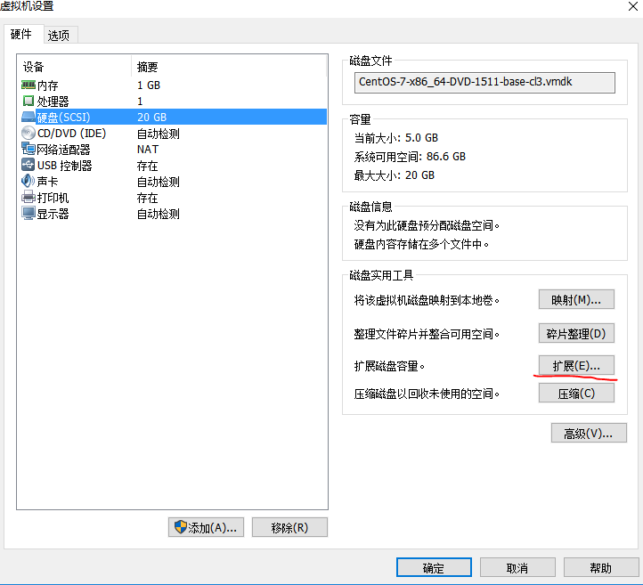

### 点击扩展

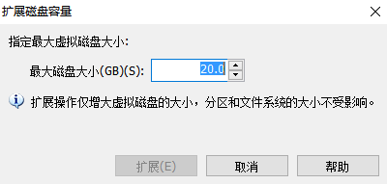

### 填写扩展后的磁盘容量

### 开启客户机

[root@slave2 ~]# df -h

Filesystem Size Used Avail Use% Mounted on

/dev/sda3 18G 17G 922M 95% /

devtmpfs 1.4G 0 1.4G 0% /dev

tmpfs 1.4G 84K 1.4G 1% /dev/shm

tmpfs 1.4G 9.0M 1.4G 1% /run

tmpfs 1.4G 0 1.4G 0% /sys/fs/cgroup

/dev/sda1 297M 144M 154M 49% /boot

tmpfs 284M 16K 284M 1% /run/user/42

tmpfs 284M 0 284M 0% /run/user/0

[root@slave2 ~]# fdisk -l

Disk /dev/sda: 42.9 GB, 42949672960 bytes, 83886080 sectors

Units = sectors of 1 * 512 = 512 bytes

Sector size (logical/physical): 512 bytes / 512 bytes

I/O size (minimum/optimal): 512 bytes / 512 bytes

Disk label type: dos

Disk identifier: 0x000416fe

Device Boot Start End Blocks Id System

/dev/sda1 * 2048 616447 307200 83 Linux

/dev/sda2 616448 4810751 2097152 82 Linux swap / Solaris

/dev/sda3 4810752 41943039 18566144 83 Linux

这是当前磁盘情况，目前容量并没有增加，需要分区

### 分区

[root@slave2 ~]# fdisk /dev/sda

Welcome to fdisk (util-linux 2.23.2).

Changes will remain in memory only, until you decide to write them.

Be careful before using the write command.

Command (m for help): n

Partition type:

p primary (3 primary, 0 extended, 1 free)

e extended

Select (default e): p

Selected partition 4

First sector (41943040-83886079, default 41943040):

Using default value 41943040

Last sector, +sectors or +size{K,M,G} (41943040-83886079, default 83886079):

Using default value 83886079

Partition 4 of type Linux and of size 20 GiB is set

Command (m for help): t

Partition number (1-4, default 4):

Hex code (type L to list all codes): L

0 Empty 24 NEC DOS 81 Minix / old Lin bf Solaris

1 FAT12 27 Hidden NTFS Win 82 Linux swap / So c1 DRDOS/sec (FAT-

2 XENIX root 39 Plan 9 83 Linux c4 DRDOS/sec (FAT-

3 XENIX usr 3c PartitionMagic 84 OS/2 hidden C: c6 DRDOS/sec (FAT-

4 FAT16 <32M 40 Venix 80286 85 Linux extended c7 Syrinx

5 Extended 41 PPC PReP Boot 86 NTFS volume set da Non-FS data

6 FAT16 42 SFS 87 NTFS volume set db CP/M / CTOS / .

7 HPFS/NTFS/exFAT 4d QNX4.x 88 Linux plaintext de Dell Utility

8 AIX 4e QNX4.x 2nd part 8e Linux LVM df BootIt

9 AIX bootable 4f QNX4.x 3rd part 93 Amoeba e1 DOS access

a OS/2 Boot Manag 50 OnTrack DM 94 Amoeba BBT e3 DOS R/O

b W95 FAT32 51 OnTrack DM6 Aux 9f BSD/OS e4 SpeedStor

c W95 FAT32 (LBA) 52 CP/M a0 IBM Thinkpad hi eb BeOS fs

e W95 FAT16 (LBA) 53 OnTrack DM6 Aux a5 FreeBSD ee GPT

f W95 Ext'd (LBA) 54 OnTrackDM6 a6 OpenBSD ef EFI (FAT-12/16/

10 OPUS 55 EZ-Drive a7 NeXTSTEP f0 Linux/PA-RISC b

11 Hidden FAT12 56 Golden Bow a8 Darwin UFS f1 SpeedStor

12 Compaq diagnost 5c Priam Edisk a9 NetBSD f4 SpeedStor

14 Hidden FAT16 <3 61 SpeedStor ab Darwin boot f2 DOS secondary

16 Hidden FAT16 63 GNU HURD or Sys af HFS / HFS+ fb VMware VMFS

17 Hidden HPFS/NTF 64 Novell Netware b7 BSDI fs fc VMware VMKCORE

18 AST SmartSleep 65 Novell Netware b8 BSDI swap fd Linux raid auto

1b Hidden W95 FAT3 70 DiskSecure Mult bb Boot Wizard hid fe LANstep

1c Hidden W95 FAT3 75 PC/IX be Solaris boot ff BBT

1e Hidden W95 FAT1 80 Old Minix

Hex code (type L to list all codes): 8e

Changed type of partition 'Linux' to 'Linux LVM'

Command (m for help): w

The partition table has been altered!

Calling ioctl() to re-read partition table.

WARNING: Re-reading the partition table failed with error 16: Device or resource busy.

The kernel still uses the old table. The new table will be used at

the next reboot or after you run partprobe(8) or kpartx(8)

Syncing disks.

除以上红色标注外，其余默认即可

下面是分区后的结果，多了/dev/sda4

[root@slave2 ~]# fdisk -l

Disk /dev/sda: 42.9 GB, 42949672960 bytes, 83886080 sectors

Units = sectors of 1 * 512 = 512 bytes

Sector size (logical/physical): 512 bytes / 512 bytes

I/O size (minimum/optimal): 512 bytes / 512 bytes

Disk label type: dos

Disk identifier: 0x000416fe

Device Boot Start End Blocks Id System

/dev/sda1 * 2048 616447 307200 83 Linux

/dev/sda2 616448 4810751 2097152 82 Linux swap / Solaris

/dev/sda3 4810752 41943039 18566144 83 Linux

/dev/sda4 41943040 83886079 20971520 8e Linux LVM

### 格式化

格式化执行输入命令partprobe通知内核磁盘已分区

mkfs -t ext4 /dev/sda4 格式化操作

### 挂载

mount /dev/sda4 /data

/data目录必须存在且为空，如果不为空，挂载后会覆盖原数据