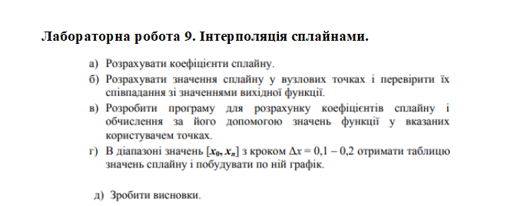

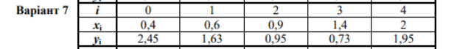

Маємо чотири відрізка [0.4, 0.6][0.6, 0.9][0.9, 1.4][1.4, 2]

H1 = x1 – x0 = 0,2

H2 = x2 – x1 = 0,3

H3 = x3 – x2 = 0,5

H4 = x4 – x3 = 0,6

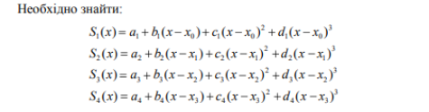

A1 = y0 = 2,45

A2 = y1 = 1,63

A3 = y2 = 0,95

A4 = y3 = 0,73

|  |  |  |  |  |  |  |
| --- | --- | --- | --- | --- | --- | --- |
| i | xi | hi | yi | Yi-y(i-1)/x1–x(i-1) | Mi=2(h1-1 + h1) | Ki |
| 0 | 0,4 | - | 2,45 | -4 | - | - |
| 1 | 0,6 | 0,2 | 1,63 | -2,2 | - | - |
| 2 | 0,9 | 0,3 | 0,95 | -0,44 | 1 | 5,5 |
| 3 | 1,4 | 0,5 | 0,73 | 2,03 | 1,6 | 5,48 |
| 4 | 2 | 0,6 | 1,95 | - | 2,2 | 7,42 |

A1 = b1 = 0

A2 = k2/m2 = **5,5**

B2 = h2/m2 = 0,5 / 1 = **0,5**

A3 = (k3 – h2*a2)/(m3 – h2*b2) = (5,48 – 0,3 * 5,5)/(1,6 – 0,3 * 0,5) = (5,48 - 1,65)/(1,6 – 0,15) = 3,83 / 1,45 = **2,64**

B3 = h3/(m3 – h2*b2) = 0,5/(1,6 – 0,3*0,5) = 0,5 / 1,35 = **0,37**

A4 = (k4 – h3*a3)/(m4 – h3*b3) = (7,42 – 0,5 * 2,64)/(2,2 – 0,5*0,37) = 6,1 / 2,01 = **3,03**

B4 = h4/(m4 – h3*b3) = 0,6/(2,2 – 0,5*0,37)=0,6/2,01 = **0,298**

5c = 0

4c = a4 – b4c5 = a4 = 3,03

3c = a3 – b3c4 = 1,51

2c = a2 – b2c3 = 4,74

1c = 0

4d = -3,03/1,8 = -1,68

3d = 1,52/1,5 = 1,01

2d = -3,23/0,9 = -3,58

1c = 4,74/0,6 = 7,9

4b = 0,8

3b = -0,44 – 1 = -1,44

2b = -2,3 – 1,1 = -3,4

1b = -4,1 – 0,3 = -4,4

|  |  |  |  |  |  |  |  |  |
| --- | --- | --- | --- | --- | --- | --- | --- | --- |
| i | x | Y | Si(x) | Si+1(x) | Si’ | Si+1’ | S”i | S”i+1 |
| 0 | 0.4 | 2.45 | 2.45 | - | -4.4 | - | -1.8 | - |
| 1 | 0.6 | 1.63 | 1.63 | 1.63 | -3.4 | -3.4 | -0.44 | -0.44 |
| 2 | 0.9 | 0.95 | 0.95 | 0.95 | -1.4 | -1,4 | 1,42 | 1.42 |
| 3 | 1.4 | 0.73 | 0.73 | 0.73 | 0.8 | 0.8 | 0.84 | 0.84 |
| 4 | 2.0 | 1.95 | - | 1.95 | - | 0.29 | - | 0.22 |

Код:

import matplotlib.pyplot as plt  
from scipy.interpolate import UnivariateSpline  
import numpy as np  
  
x = [0.4, 0.6, 0.9, 1.2, 2]  
y = [2.45, 1.63, 0.95, 0.73, 1.95]  
  
spl = UnivariateSpline(x, y) *#Побудова сплайна*xs = np.linspace(0.4, 2, 1000)  
plt.plot(x,y,**'ro'**, xs, spl(xs), **'g'**)  
plt.show()

Скрін:

