诚信应考,考试作弊将带来严重后果！
_____________ ________
…

姓名 学号
学院 专业 座位号
( 密 封 线 内 不 答 题 )
……………………………………………………密………………………………………………封………………………………………线……………………………………线………………………………………

_____________ ________
…

姓名 学号
学院 专业 座位号
( 密 封 线 内 不 答 题 )
……………………………………………………密………………………………………………封………………………………………线……………………………………线………………………………………

华南理工大学期中考试
《计算机网络》试卷
注意事项：1. 考前请将密封线内各项信息填写清楚；
2. 所有答案请直接答在答题纸上
3．考试形式：开卷；
4. 本试卷共14题，满分100分，考试时间90分钟。
题 号 | 1 | 2 | 3 | 4 | 5 | 6 | 7 | 8 | 9 | 10 | 11 | 12 | 13 | 14 | 总分
得 分
评卷人

- 某信道的频谱在3MHz至4MHz之间，信噪比SNR_{dB} = 24dB。
  - 该信道容量的理论上限是多少？
  - 要达到该容量，传输的信号应包含多少个离散级数？

B = 1 MHz， SNR = 251
应用Shannon公式得理论上限为8Mbps

再利用C = 2Blong₂N得N=16

- 数据包的大小对于分组交换的效率有重要影响。如下图所示，A现有4000字节的数据要经B、C发送给D，不考虑信号在信道上的传输时间，每个站发送1个字节需要的时间是0.0001ms，每个分组需要3个字节的额外开销（用于控制、路由等），分别计算当把带发送的数据分成1、2、5、10个包时所需要的传输时间。

参考下图：
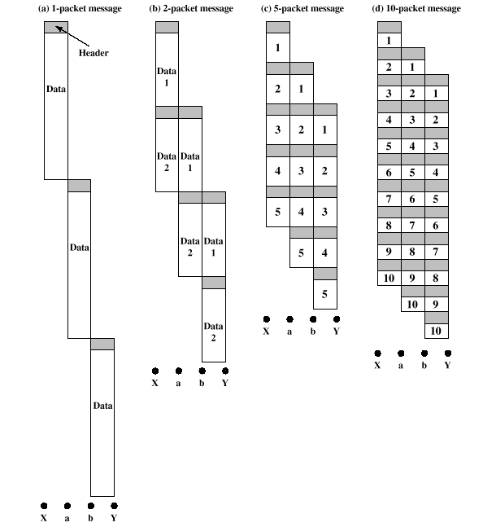
所需要的传输时间分别为1.29ms、0. 92ms、0.77ms和0.084ms.

- 为什么PCM采样时间被设置为125μs？

根据Nyquist定理，每秒采样8000次是语音信道（带宽4KHz）采样频率的上限（过多的采样是没有必要的）。

- 某CDMA接收器收到了如下时间片：
(-1+1-3+1-1-3+1+1)
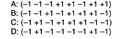
假设时间片序列如上所示，请问那些站发送了数据？每个站发送了什么位？

计算标准内积：
(−1 +1-3 +1-1-3 +1 +1) • (−1-1-1 +1 +1-1 +1 +1)/8 = 1
(−1 +1-3 +1-1-3 +1 +1) • (−1-1 +1-1 +1 +1 +1-1)/8 =-1
(−1 +1-3 +1-1-3 +1 +1) • (−1 +1-1 +1 +1 +1-1-1)/8 = 0
(−1 +1-3 +1-1-3 +1 +1) • (−1 +1-1-1-1-1 +1-1)/8 = 1
因此，A和D发送了1, B发送了0,而C没有发送。

- 假设在某链路层使用位填充法。问：
- 丢失一位、插入一位或者篡改一位而引起的错误是否有可能通过校验和检测出来？描述你的理由。
- 如果能检测出来，则校验和的长度在这里如何起作用？

It is possible. Suppose that the original text contains the bit sequence 01111110 as data. After bit stuffing, this sequence will be rendered as 011111010. If the second 0 is lost due to a transmission error, what is received is 01111110, which the receiver sees as end of frame. It then looks just before the end of the frame for the checksum and verifies it. If the checksum is 16 bits, there is 1 chance in 216 that it will accidentally be correct, leading to an incorrect frame being accepted. The longer the checksum, the lower the probability of an error getting through undetected, but the probability is never zero.

- 假设用优先状态机描述协议4。每个机器需要多少种状态？通信信道上需要多少种状态？忽略校验和错误，整个系统需要多少种状态？

Each machine has two key variables: next_frame_to_send and frame_expected, each of which can take on the values 0 or 1. Thus, each machine can be in one of four possible states. A message on the channel contains the sequence number of the frame being sent and the sequence number of the frame being ACKed. Thus, four types of messages exist. The channel may contain 0 or 1 message in either direction. So, the number of states the channel can be in is 1 with zero messages on it, 8 with one message on it, and 16 with two messages on it (one message in each direction). In total there are 1 + 8 + 16 = 25 possible channel states. This implies 4 × 4 × 25 = 400 possible states for the complete system.

- 利用地球同步卫星在一个1Mbps的信道上发送1000位的帧，该信道离开地球的传输延迟为270ms。确认信息总是被捎带在数据帧上。头部非常短且使用3位序列号，试分析在下面的协议中，最大可获得的信道利用率是多少？
    - 停-等协议
    - 协议5
    - 协议6

Let t = 0 denote the start of transmission. At t = 1 msec, the first frame has
been fully transmitted. At t = 271 msec, the first frame has fully arrived. At
t = 272 msec, the frame acknowledging the first one has been fully sent. At
t = 542 msec, the acknowledgement-bearing frame has fully arrived. Thus,
the cycle is 542 msec. A total of k frames are sent in 542 msec, for an
efficiency of k/542. Hence
(a) k = 1, efficiency = 1/542 = 0.18%
(b) k = 7, efficiency = 7/542 = 1.29%
(c) k = 4, efficiency = 4/542 = 0.74%

- 使用海明校验码的方法传输数据。假定发送方待发送的原始数据为1011，接收方收到的数据为1011001。该数据在传输过程中是否有错误发生？描述接收方的检验过程。

Parity bits are needed at positions 1, 2, 4, 8, and 16, so messages that do not extend beyond bit 31 (including the parity bits) fit. Thus, five parity bits are sufficient. The bit pattern transmitted is 011010110011001110101

- 位序列1010001101使用多项式x⁵+x⁴+x²+1进行校验，实际应传输的位序列是什么？

10100011010110

- 一个无限用户的分槽ALOHA信道的测试表明，10%的时槽是空闲的，则
  - 信道负载G是多少？
  - 吞吐量是多少？
  - 该信道是负载不足还是过载？

(a) From the Poisson law, P0 = e ^{-G}, so G = -lnP0 = -ln 0.1 = 2.3.
(b) Using S = Ge^{-G} with G = 2.3 and e ^{-G} = 0.1, S = 0.23.
(c) Whenever G > 1 the channel is overloaded, so it is overloaded.

- 考虑在一条1km长的电缆上建立一个1Gbps速率的CSMA/CD网络。信号在电缆中的速度是2×10⁵km/s。请问最小帧长度应为多少？

For a 1-km cable, the one-way propagation time is 5 μsec, so 2τ = 10 μsec. To make CSMA/CD work, it must be impossible to transmit an entire frame in this interval. At 1 Gbps, all frames shorter than 10,000 bits can be completely transmitted in under 10 μsec, so the minimum frame is 10,000 bits or 1250 bytes.

- 两个CSMA/CS站都企图传送多个帧，在每一帧被送出后就用二进制指数后退算法竞争信道。在第k轮结束竞争的概率是多少？每个竞争周期的平均轮数是多少？
Number the acquisition attempts starting at 1. Attempt i is distributed among 2^{i - 1} slots. Thus, the probability of a collision on attempt i is 2^{-(i - 1)} . The probability that the first k - 1 attempts fail, followed by a success on round k is
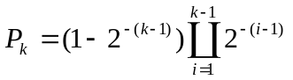
which can be simplified to
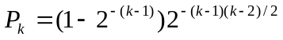
The expected number of rounds is then just ∑kP_{k} .

- 快速以太网的速度是以太网的10倍，但它的最小帧长度也是64字节，其解决方法是什么？

快速以太网中的最大电缆长度是以太网的1/10。

- 中继器、集线器、网桥、交换机和网关有哪些不同？
要点：
  - 各自目标
  - 运行的层次
  - 冲突处理
  - 路由方式等。

