一、选择题
- Suppose Host A wants to send a file to Host B, the path from A to B includes 5 links, and the rates of the 5 links are 10Mbps , 5Mbps , 2Mbps , 5Mbps , 10Mbps .If no any traffic in the network,what is the throughput for the file transfer?(B)
A.5Mbps B.2Mbps C.10Mbps D.32Mbps
//传输速度受限于瓶颈

- Which one of the following ?has characteristics as high-speed operation and immune to electronic noise?(C)
A.Coaxial cable B.Radio C.Fiber optic D.Twisted pair
//光纤

(3)Consider sending a packet from a source host to a destination host over a fixed route,which of the end-to-end delay is variable?(B)
A.processing delay B.queuing delay C.transmission delay D.propagation delay
//哪一种端到端时延是可变的:排队时延

- It is the architecture for TCP/IP protocol stack,which one below belongs to the network layer?(A)?
- ICMP B.ARP C.CSMA D.SMTP

- An application message with 20bytes header and 180bytes user data is encapsulated in a TCP segment , and then encapsulated in an IP datagram(no options fields).What is the percentage of overhead for each IP datagram?(D)
A.30% B.75% C.33% D25%
//overhead：开销，费用
IP datagram header=app message header(题目里给了是20byte)
+TCP header(20bytes)+IP header(20bytes)=60bytes
60/(180+60)=25%

(6)An application of delivering the data in a transport-layer segment to the correct socket is called(C)
A.Multiplexing B.FDM C.Demultiplexing D.TDM

- Consider sending a 4000 byte datagram into a link that has an MTU of 1500 bytes(B)
A.3 fragments are created with offset field value 0,1000,2000 respectively
B.3 fragments are created with offset field value 0,185,370 respectively
C.3 fragments are created with offset field value 0,1000,1000respectively
D.None of these above
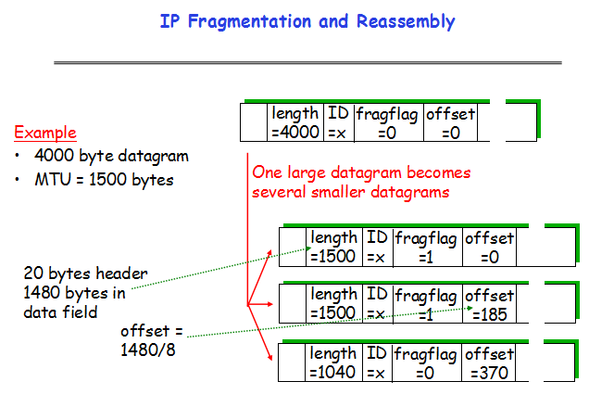
- Which protocol is used for Echo request or reply and Error reporting?(B)
- IGMP B.ICMP C.SMTP D.CSMA

- For sliding window protocol of GBN,if the number of sequence is n(比特编码），then the maximum size of sending window is(C)
- n B.2n-1 C.2^{n}-1 D.2^{n-1}
//SR:2^{n-1}

- For the two-layer device of switch in Ethenet , how does it to establish the forwarding table?(C)
- Manual configuration B.Shortest path algorithm
C.Self-learning D.Routing algorithm
//交换机如何建立转发表：自学习

- Multiple access control protocols include(D)
- Channel partitioning B.Random access C.Taking turns D.All of the above
//5.3 多路访问链路协议[Multiple access protocols]

- In inter-AS routing protocol of BGP , which of the following factors determine a good ‘route’?()
A.Routing Policy B.Reachability information C.A and B D.None of all
//4.6 BGP（边界网关协议[Broder Gateway Protocol]）

- Two important reasons that the Internet is organized as a hierarchy of networks for the purposes of routing are(D)
- Message complexity and speed of convergence
- Least cost and maximum free circuit availability
- Link cost changes and link failure
- Scale and administrative autonomy
//因特网组织为层次体系的原因是路由是……？
规模/比例 管理 的 自治

- Which of following states about Switch of data link layer is error?(C)
- Plug-and-play and self-learning
- Buffer frame and selectively
C.All nodes connected to switch can collide with another one
D.Uses CSMA/CD to access segment

二、填空题
(1)The network layer of Internet adopts datagram subnet which provides network-layer connection less services and the network-layer of ATM adopts virtual circuit subnet which provides network-layer connection-oriented services respectively.

- The task of the data link layer is providing data transmission services between adjacent nodes ; The task of the network layer is providing data transmission services between end-to-end hosts ; and the task of the transport layer is providing data transmission services between application processes .

- The header of IP datagram has a TTL field , when the value of the field is zero , the datagram transmitted will be discarded by router.

- The two key function of network layer is forwarding and routing.

- Two routing protocols have been used extensively for routing within an autonomous system in the Internet:RIP protocol is based on Distance Vector routing algorithm and OSPF protocol is based on Link State routing algorithm.

- The function of ARP protocol is converting IP address into MAC address.

- In the TCP , connection establishment of transport layer uses method of three-way handshaking.

- When a TCP connection is established , the value of Rcv Window in the segment header is set by the receiver.

- DNS system is a established database in which resource records are stored.

- 判断题
- HTTP、FTP and SMTP use TCP to be transport layer rather than UDP for Security.
F

- With a window size of 1,SR,GBN,and the alternating bit protocol are functionally equivalent.T

- Both of the P2P and TCP/IP are network architectures. F

- The goal of the flow control of TCP is same to that of the congestion control of it.
F

- In the E-mail system , SMTP is a protocol used to sending E-mail , and POP3 is a protocol used to receiving E-mail. T

- When a Web page which consists of some text and three images is delivered by a persistent HTTP , there needs to establish connection for each object.F
//persistent是每个请求-响应对都用同一个连接

- The distance vector route algorithm depends on the complete network topology information.F

- An ARP query packet is encapsulated in a link-layer broadcast frame. T

- When a TCP segment arrives to a host , the socket to which the segment is delivered depends on the destination port number and the destination IP address.F

(1)Suppose Host A sends 4 TCP segment back to Host B over a TCP connection . The first segment has sequence number 78 ; the second segment has sequence number 138 ; the third segment has sequence number 258 ; the forth segment has sequence number 348 with 60 byte of data in it .
- How much data are in the first , second , third , segment respectively?
60,120,90byte
//第一：138-78=60
第二：258-138=120
第三：348-258=90
- Suppose that the first segment and the forth segment arrive at B in turn , but the second segment and the third segment are lost . What will be the acknowledgment number respectively that Host B sends to Host A for each arriving segment?
138 138
//ACK为138表示等sequence number 为138的segment
- When Host B receives the second segment and the third segment re-sending by Host A in turn , what will be the acknowledgment number that Host B send to Host 258 408
//收到第二个后：258 收到第四个后：408

- Consider a subnet having the prefix 252.219.176/20
- Give the number of interfaces supported by the subnet and the broadcast address of the subnet (using the a.b.c.d/x notation)
Interfaces supported by the subnet : 2¹²-2=4094//12:8*4-20
broadcast address:252.219.(176+15).(0+255)//+15、+255：后12位 置为1
- Suppose an ISP owns the block of address of the form 252.219.176/20. And suppose it want to create four subnets from this block, with each subnet having the same number of IP address. What are the prefixes(using the a.b.c.d/x notation)for the four subnets?
//原ISP：252.219.1011,0000.0
四个一样大的子网变成：
252.219.1011,0000.0/22
252.219.1011,0100.0/22
252.219.1011,1000.0/22
252.219.1011,1100.0/22
//多了2bit来区分4个子网

(3)A bit stream 101101001 is transmitted using the standard CRC method . The generator polynomial is x³+x²+1
(a)Show the actual bit string transmitted , and the calculating process is required.
(b)Suppose the fifth bit from the left is inverted during transmission . Show that this error is detected at the receiver’s end.

(2)The message D=1010001101 is transmitted using the CRC method described in class using the generator polynomial G= x⁵+x⁴+x²+1.
- What is the transmitted message T.
T=101000110101110
T=1010001101,01110(即D,余数)
G化为 110101（ G=1*x⁵+1*x⁴+0*x³+1*x²+0*x¹+1*x⁰.）
D,0/G即1010001101,000000/110101 得到余数R=1110
补一位到5位（和G的最高位一样是5）得到01110
- How does the receiver check whether the message T was transmitted without error?
receiver计算T/G，余数为0就是没有差错

(3)Assuming TCP is the protocol experiencing the congestion control behavior shown as follows . Please answer the following questions.(10分)
(b)Identify the interfaces of time when TCP congestion avoidance is operating.(2分)
(c)What is the initial value of threshold at the first transmission round ? ……transmission round is the 20th segment sent?(2分)
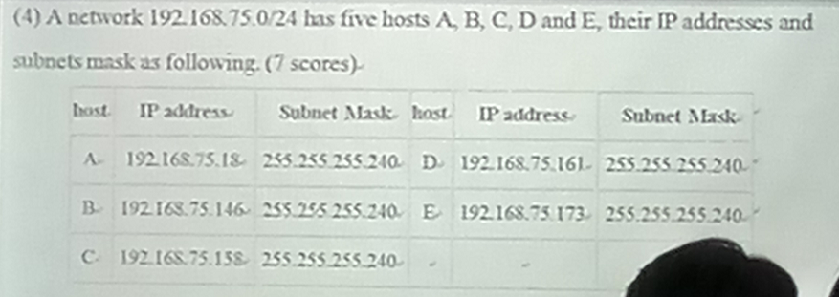
- How many subnets do the five hosts ABCDE belong to.Show which hosts belong to the same subnets.
3 subnets.
A、BC、DE

c)To add the sixth host F,make it together with A belong to the same subnet,what does the IP address range?(2’)
168.192.80.17到168.192.80.29

D)If adding a host in the network, its IP address is 168.192.80.164, what is its broadcast address? Which hosts can receives its broadcast information?
168.192.80.175 DE

How many outgoing switch interfaces will this first frame be transferred to?
Furthermore , now suppose that B replies to A and A sends a second frame to B , then how many outgoing switch interfaces will this second frame be transferred to?
2 interfaces(to B and router R)
1 interface(to B) since switch has learned where B is

(3)Assuming TCP is the protocol experiencing the congestion control behavior shown as follows . Please answer the following questions.
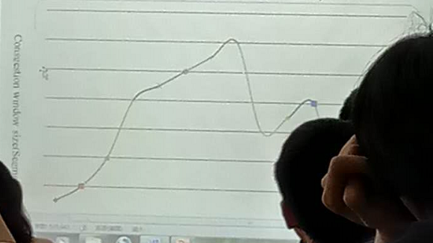
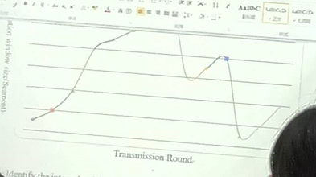
- Identify the intervals of time when TCP slow start is opening . (2分)
[1,4] [12,14]//指数增长时
- Identify the intervals of time when TCP congestion avoidance is opening . (2分)
[4,8] [9,11]
- What is the initial value of threshold at the first transmission round? Don 【】transmission round is the 20th segment sent?
8.5
- After the 8th round , what happened? And 【】protocol(Reno or Taboe) is used base on this information 【】
- Assuming no packet loss is found until the 16th transmission 【】

The number of information supported

