诚信应考,考试作弊将带来严重后果！
_____________ ________
…

姓名 学号
学院 专业 座位号
( 密 封 线 内 不 答 题 )
……………………………………………………密………………………………………………封………………………………………线……………………………………线………………………………………

华南理工大学期末考试
《软件需求分析设计》试卷 (B)
注意事项：1. 考前请将密封线内填写清楚；
2. 所有答案请答在答题纸上；
3．考试形式：闭卷；
4. 本试卷共 五 大题，满分100分， 考试时间120分钟。
题 号 | 一 | 二 | 三 | 四 | 五 | 总分
得 分
评卷人
- 单项选择题.
NO. | 1 | 2 | 3 | 4 | 5 | 6 | 7 | 8 | 9 | 10 | 11 | 12 | 13 | 14 | 15
solution

- View are “slices” of architecture . Which view focus on structural issue ?
A. Use – case B. Process C. Implementation D. Logical
- Which of the following are not part of Extension Mechanisms of UML?
A. Tagged Value B. Constraint C. Concurrent D. Stereotype
- Which of the following is not part of a use-case realization ?
A. Sequence diagrams B. Use case C. Communication D. Class diagram
- A car has 4 wheels . What type of relationship is between the class car and the class wheel ?
A. Association B. Aggregation C. Inheritance D. Dependency
- Scheduling project activities such as functional increment and test case development , which one of the following OOA/D artifacts is the most useful ?
A. Use cases B. Interaction diagrams C. Activities diagrams D. Class diagrams
- In a well-design layered architecture , which layers should know about which ?
A. Model knows view and persistence , View knows Model and Persistence.
B. View knows Model , Model knows Persistence.
C. View knows Model , Persistence knows View and Model.
D. View knows Model , Model knows View and Persistence , Persistence knows Model.
- For showing how several objects collaborate in single use case , which one of the following OOA/D artifact is the Most useful ?
A. Sequence Diagrams B. Activities Diagrams
C. State Diagram D. Class Diagram
- Which of the following is not one of the dimensions of software engineering according to UP recommendations ?
A. Develop iteratively B. Model the software visually
C. Control changes D. Freeze requirements at the start of a project to provide stability
- Which of the following is not one of the dimensions of software quality ?
A. Supportability B. Performance C. Assessment D. Usability
- Which of the following use case is a valid use case because it can pass the Boss Test , EBP Test and Size Test ?
A. Negotiate a Supplier Contract B. Handle Returns
C. Log In D. More Piece on Game Board
- Which of the following statement is false ?
A. An Object can be in more than one state at a time
B. A state machine can have multiple termination states
C. A state can remember which sub state was the last state
D. A transition can fire conditionally
- Which model represents the following code generated by a Modeling tool ?
Class Order {
private Customer recipient ;
// ….
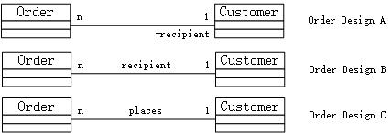
A. Design A B. Design B C. Design C D. None of the above
- 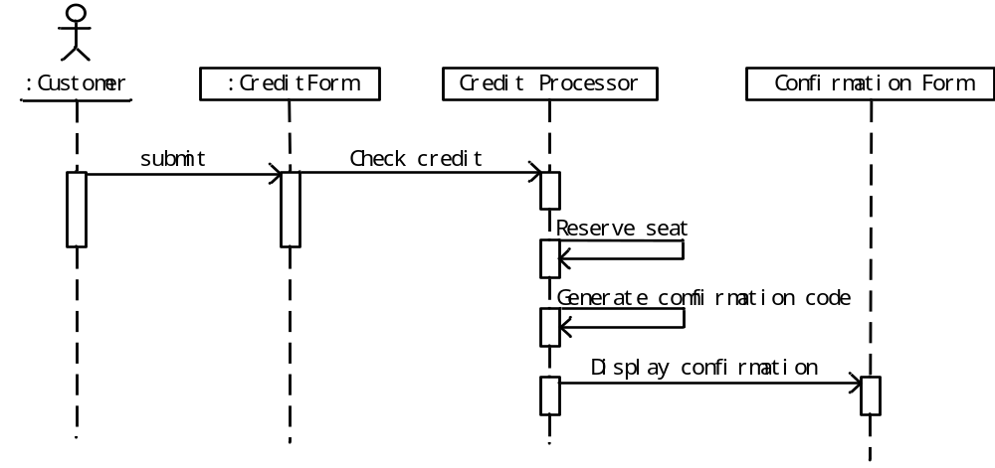What methods MUST be implemented by the CreditProcessor class in the payment Sequence diagram ?
A. check Credit , generate Confirmation Code , display Confirmation
B. check Credit , generate Confirmation Code
C. check Credit , generate Confirmation Code , Reserve seat
D. check Credit , Reserve seat , display Confirmation
- When doing domain analysis , the class diagram should be drawn PRIMARILY to represent :
A. messages sent between object.
B. implementation objects such as wrappers and devices.
C. business object and implementation objects such as wrappers and devices.
D. business object.

- The following are the requirements for a Report-generation module in an application :
- When new data is generated m the user-interface should be refreshed automatically to reflect the largest values.
- Multiple view types are possible.
Which of the following Model and View interactions BEST satisfies the above requirement ?
A. Establish subscribe/notify mechanism between the view and model , with the model updating the view based upon the view type.
B. Establish subscribe/notify mechanism between the view and model layers so that the views get notified of the charge.
C. Develop intelligence within the model so that it decides which views are to be refreshed based on the view type.
D. Combine the view and model layers into a single entity so that the interactions are localized and notifications are instantaneous.

- 判断:
NO. | 1 | 2 | 3 | 4 | 5 | 6 | 7 | 8 | 9 | 10
T/F
- Stereotypes can be applied to many UML elements such as class , package and associations. T
- Use case are an object oriented way to handle requirement. Therefore they don’t fit very well into non-object oriented projects. F
- A dependency between packages indicates that some element in the dependent package depends on some element(s) in the independent package. T
- It is worthwhile to draw a state chart diagram for every class you create. F
- Although the communication diagram has the same semantic with the sequence diagram they have different representations. T
- The idea of Protected Variation-GRASP pattern is to design objects and system so that in stability in them does not have undesirable effects on other elements. T
- The inception phase in UP usually is more than a few weeks long for most projects. F
- The purpose of elaboration is to fully and carefully define models , which are translated into code during construction. F
- A system sequence diagram is a picture that shows , for one particular scenario of a use case , the events that external actors generate , their order , and inter-system events. T
- Strategy pattern allow one of a family of algorithms to be selected on-the-fly at runtime. T

- 简答题:
- What are the main phases of the Unified process ? Explain them in a few words.
1)inception初始阶段：大体上的构想、业务案例、范围和模糊评估
2)elaboration细化阶段：已精化的构想、核心架构的迭代实现、高风险的解决、确定大多数需求和范围以及进行更为实际的评估
3)construction构造阶段：对遗留下来的风险较低和比较简单的元素进行迭代实现，准备部署
4)transition移交阶段：进行beta测试和部署

- Explain briefly what is the Adapter design pattern. Example of it use.
adapter适配器模式，通过中介适配器对象，解决不相容的接口问题，或者如何为具有不同接口的类似构建提供稳定的接口。将一个类的接口转换成客户希望的另一个接口，使得原本由于接口不兼容而不能一起工作的那些类可以一起工作。

- Please name and briefly describe the “4+1 view” of software architecture adopted in RUP.
Logic view逻辑视图：分析者、设计者
Implementation view实现视图：编程者
Process view进程视图：系统迭代器
Deployment view部署视图：系统工程
Use case view用例视图：终端用户

- 简单建模:
- Draw class diagram for the following scenario. Be sure to include multiplicities on the ends of the connectors.
The following scenario is for a pet store. Each pet store has up to 20 furry(毛皮的) friends and 10 birds. Each pet has a vaccination（疫苗） history. Furry friends are either dogs or cats. Each furry friend has a microchip（微型芯片） implant for identification. Each microchip has a unique id number.

- 画顺序图相关的题目.

- 建模分析题:
Suppose you are asked for developing a point of sale (POS) system using OOA/D technologies. A POS system is a computerized application used to record sales and handle payments and it is typically used in a retail store. Processing sale would be one of the key functions that the system has to perform. Please model the key function via the methodology of object-oriented analyze and design.
Suppose the simplified context of processing sale is under-consideration: a customer arrives at a checkout of a retail store with items to purchase. The cashier uses register of the POS system to record each purchased item. Each of the items is described a product specification, which belongs to a product catalogue. The system presents a running total and line-item details. The customer enters payment information, which the system validates and records. The system updates inventory (inventory: The quantity of goods in stock. ). The customer receives a receipt from the system and then leaves with the items and the sale is logged on a ledger with which the manager can checked the information for a period of time.

- Draw a UML use case diagram for the system including their relationships (Score 5).

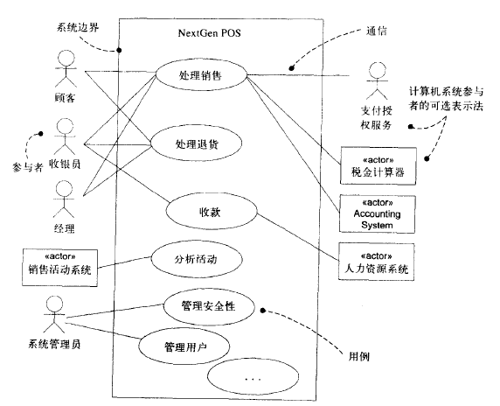

- Give the class diagram with the analysis classes representing business entities involved in the system (names and brief descriptions only – no attributes or operations), along with their relationships and multiplicities (Score 10).

- Give the boundary classes、control classes and entity classes involved in the system to bear responsibility of “process sale” in the case of J2EE (names and brief descriptions with UML class stereotypes only – no attributes or operations) (Score 5).

- Draw a UML sequence diagram to model the use case of “process sale” in the case of J2EE (Score 10).

