第四部分

问答题

老师透漏的题目有

（1）RUP 四个阶段，六个最佳实践

【迭代的开发软件Develop Iteratively

需求管理Manage Requirements

使用基于构件的体系结构Use Component Architectures

可视化软件建模Model Visually (UML)

验证软件质量Continuously Verify Quality

控制软件变更Manage Change】

初始阶段: Inception目标是为系统建立商业案例和确定项目的边界

细化阶段：Elaboration目标是分析问题领域，建立健全的体系结构基础，编制项目计划，淘汰项目中最高风险的元素

构建阶段：Construction所有剩余的构件和应用程序功能被开发并集成为产品,所有的功能被详尽的测试

交付阶段：Transition目的是将软件产品交付给用户群体】

（2）4+1 view



1. OO三大特点，四大原则

三大特点：Encapsulation + Modularity + Hierarchy

四大原则？

1. UML 各种图的定义

1) usecase diagram

【A use case models a dialog between actors and the system.

A use case is initiated by an actor to invoke a certain functionality in the system. 】

2)Activity diagram

【An activity diagram in the use-case model can be used to capture the activities in a use case.

It is essentially a flow chart, showing flow of control from activity to activity. 】

3) sequence diagram

【A sequence diagram is an interaction diagram that emphasizes the time ordering of messages. 】

4) Collaboration diagram

【A collaboration diagram emphasizes the organization of the objects that participate in an interaction. 】

5) class diagram

【Static view of a system. Include The vocabulary of a system, Collaborations, A logical database schema.】

6) statechart diagram

【A statechart diagram shows a state machine. 】

7) deployment diagram

【The deployment diagram shows:

Configuration of processing nodes at run-time.

Communication links between these nodes.

Component instances and objects that reside on them. 】

（5）依赖关系的各种衍型(stereotype),及其具体用法

<<include>> <<extend>> <<realize>>

1. Reason for modeling and four principles

Helps you to visualize a system as you want it to be

Permits you to specify the structure or behavior of a system

Gives you a template that guides you in constructing a system

Documents the decisions you have made

1. The models you create influences how the problem it attacked;
2. Every model may be expressed at different levels of precision
3. The best models are connected to reality
4. No single model is sufficient

总之，还是IBM课件为主，尤其是FAQS。

第五部分

分析题

（我搞不懂老师说必考UML集萃中的状态机图放在那一部分，先放在这）

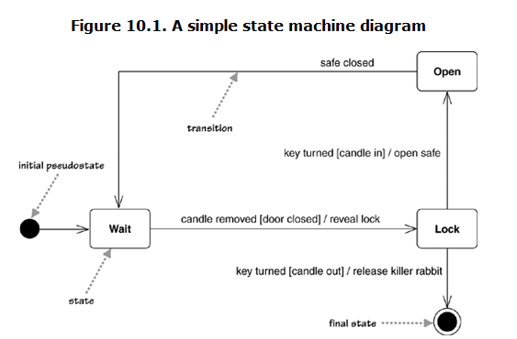

Each transition has a label that comes in three parts: trigger-signature [guard]/activity.

参见华辉发过的《Addison.Wesley.UML.Distilled.A.Brief.Guide.3rd.Edition.eBook-LiB》，状态机图首页。

下面才是真正分析题部分（30分）

记得去年是按这个顺序考得：

①　（10分）画出用例图（着重用例间关系、参与者间关系）

②　（10分）找实体类，画出实体类图，重点是类与类之间的关系，不需要找属性和方法

③　（5分）画界面类、控制类、必要的抽象类（标出图符，写明名称及相应说明即可）

④　（5分）画时序图

老师曾透漏说今年考得案例是《APPLYING UML AND PATTERNS》中的POS机案例，不要高兴的太早，那本书是严格按照RUP方法进行的，整本书就是借这个案例讲了RUP

给个阶段完成的任务（可参考目录），所以不从头到尾认真看的话，很难从整体上把握。

自己看吧。、