1. 选择题（2分*15题=30分）

1、书本原题

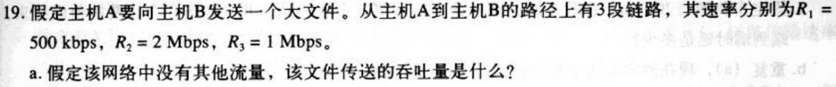

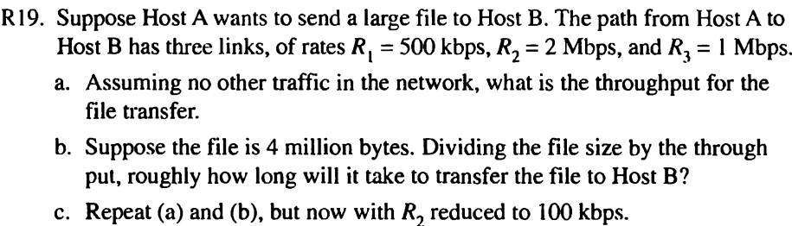

2、Ethernet interface address 由谁分配

3、选不同：CSMA/CD TDMA ALOHA CSMA

4、ARP query包封装于 什么之中？

5、IP datagram go through source host and router，host和router知道完整的路由路径吗？

6、a router 有几个ip address？至少两个，一个，没有

7、TCP的特性：Flow control, connection establishment, Congest control, All

8、120Bytes data per second, in TCP without option fields, Data占了百分之几？

9、deliver data in transport-layer segment to correct socket是叫做: Demultiplexing, multiplexing, TDM, FDM

10、ICMP用于: Error reporting, Ping, both, nor

11、Internet分层的原因（两个重要原因）

12、Ethernet two-layer switches, forward table 如何建立？有一个选项是自学习

13、999 bytes into MTU 500 byte，有几个包，offset分别是

14、inter-AS 主宰因素: distance, policy, As’s traverse 数， 途经AS的用塞度。

15、transfer a web document: loss-tolerant? Time sensitive?

1. 填空题（1分*10个空=10分）
2. Data link, network, transport分别是什么之间的链接。
3. 四个时延
4. OSPF，BGP分别基于哪种算法（Link state ， distance vector）
5. RIP、BGP的区别，（目的地和跳数；路径）
6. TCP建立链接的方法In the TCP，connection establishment of transport layer use method of ________
7. IP头部有______field，if 这个值是0，router就会discard it。

三，判断题（1分*10题=10分）

1. Emails are delivered to receiver's server using POP3 protocol. T
2. The Traceroute program in the source host will sent a series of ICMP message to determine the route between source host and destination host.
3. When a user request a Web page that consists of some text and two images. For this page, the client will send one request message and receive three response message.
4. When using distance vector route algorithm, the complete network topology information must be known by a router.
5. CSMA/CD have no collisionCollisions will not occur under CSMA/CD MAC protocol.
6. With a window size of 1, SR, GBN are functionally equivalent.
7. TCP到达接收方，用port和IP去Demultiplexing。（这个翻译略去太多细节，不可信）
8. ARP 取得 the mapping between IP and human-readable-name.
9. TCP链接建好后，RcvWindow won’t change.
10. AS know 5 routers to a destination prefix, it will announce all 5 router to its neighbors. If an Autonomous system learns of 5 different routes to a destination prefix it will announce all 5 routes to its neighbors .F

四、简答题20分

1、数据包在网络传输中，有几种封包头？说出他们的名字

2、Domain Name System (DNS) uses a distributed approach as opposed to a single server. Why?

Assume a client needs to find the IP address of www.newpool.org using the DNS. And assume the client has a local DNS server, but that server does not have any addresses cached. What are the DNS servers that are queried (in order) to find the IP address?

①Why: A distributed hierarchy of servers gives better **scalability** and does not present a **single point of failure**.

一个服务器的分布式层次提供了更好的可扩展性，不存在单点故障。

3、Suppose Host A sends 4 TCP segments back to Host B over a TCP connection . The first segment has sequence number 56 ; the second has sequence number 216 ; the third has sequence 296 ; the fourth has sequence number 346 with 40 byte of data in it .(5 scores)

* + - * 1. How much byte of data are in the third TCP segment?
        2. Suppose that the first and the fourth segment arrive at B in turn , but the second and the third segments are lost . What will be the acknowledgment number respectively that Host B sends to Host A for each arriving segment ?
        3. When Host B receives the second segment and the third segment re-sending by Host A in turn , what will be the acknowledgment number that Host B sends to Host A for each arriving segment.

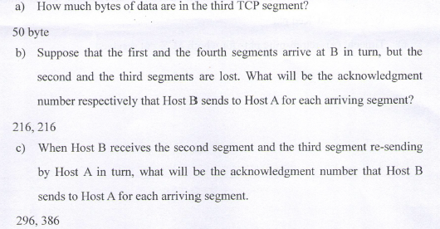

4、mac through router，问IP和MAC的变动情况，掌握例题就没有问题

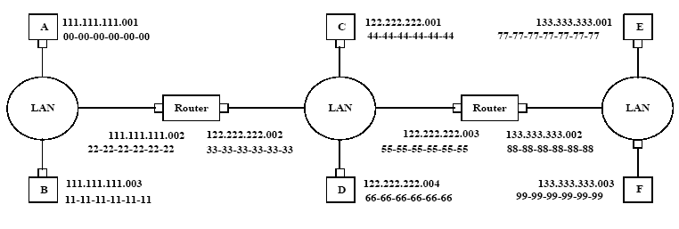

**i) from A to left router: Source MAC address: 00-00-00-00-00-00**

**Destination MAC address: 22-22-22-22-22-22**

**Source IP: 111.111.111.001**

**Destination IP: 133.333.333.003**

**ii) from the left router to the right router: Source MAC address: 33-33-33-33-33-33**

**Destination MAC address: 55-55-55-55-55-55**

**Source IP: 111.111.111.001**

**Destination IP: 133.333.333.003**

**iii) from the right router to F: Source MAC address: 88-88-88-88-88-88**

**Destination MAC address: 99-99-99-99-99-99**

**Source IP: 111.111.111.001**

**Destination IP: 133.333.333.003**

五、计算题？

1、纯粹的DIj算法，只要求给出起点的下一跳，总花费（对应不所有的目的地）

2、Congestion控制，掌握例题即可

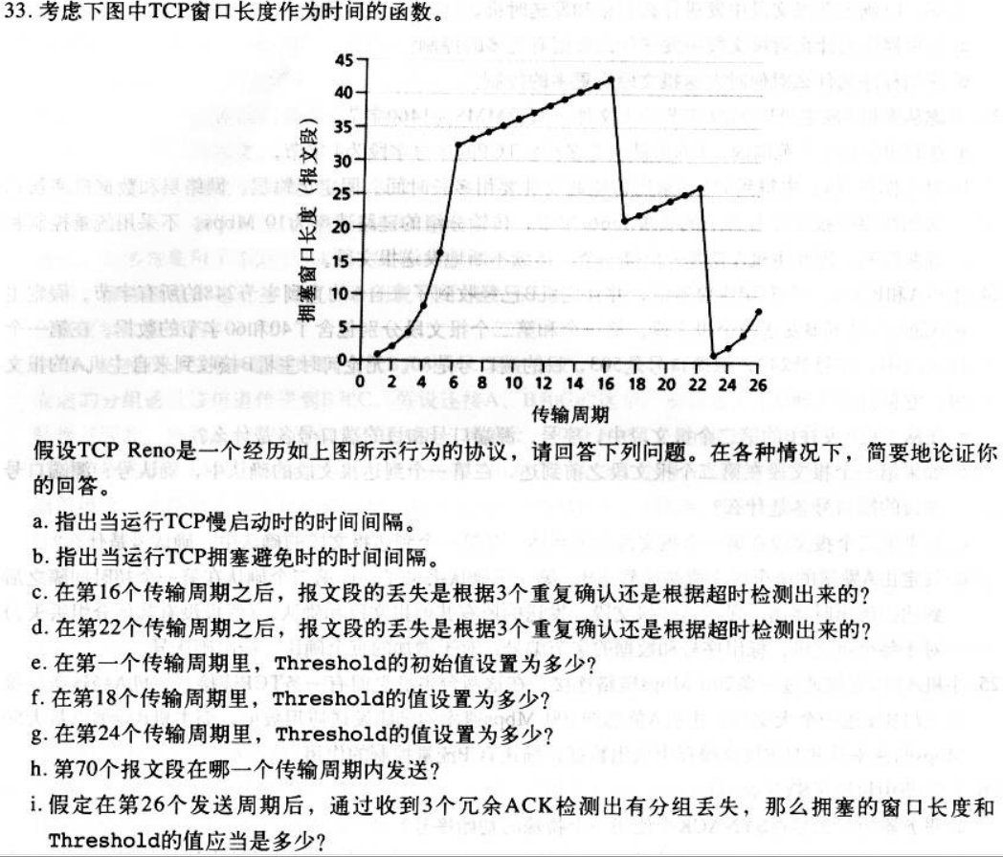

连图象的样子都一样，就是数值不同，还问了版本号。

3、CRC循环校验码的应用。D=1001 1101，G=X*x*x+1.

1.问传输的bit string是？

2.从左边第三个inverted后，CRC是怎样发现错误的？

Tip：G给了生成式，要先转化成1001哦（不排除我自己也转换错）

4、子网划分

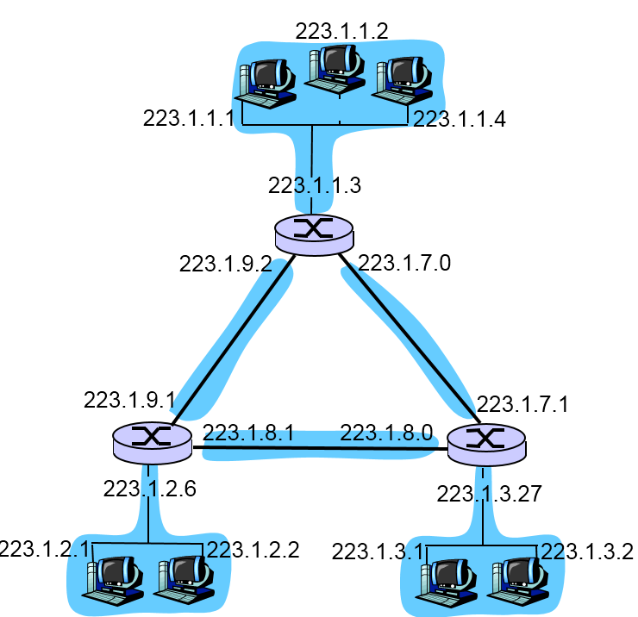

图是这样的，但是数据不同。

这个图是ISP所拥有的网络，上左右分别是ABC子网，分别有250，120，120 interfaces。

ISP有的IP是214.97.24/23

1. 问ISP可以带多少台机器（interfaces）
2. ABC按顺序划分子网，分别求他们的划分（格式a.b.c.d/mask）

没了，总体来说也简单，不过判断选择里面有些英文表达比较难理解*（我没过六级），所以有几题难以理解，卷子是整张英文的啦。

Tony 2012.12.19回忆