Amazon API Gateway — Unused API Cleanup: Design & Process Document
Version: 1.0 Date: April 27, 2026 Status: Active Audience: API Platform Team, Cloud Engineering, Cloud Ops, DevOps Teams

Table of Contents
- [Overview & Goals](#1-overview--goals)
- [Definition of "Unused"](#2-definition-of-unused)
- [Discovery Process](#3-discovery-process)
- [Analysis Methodology](#4-analysis-methodology)
- [Classification Framework](#5-classification-framework)
- [Stakeholder Communication & Approval](#6-stakeholder-communication--approval)
- [Safe Cleanup Process](#7-safe-cleanup-process)
- [Rollback & Recovery Plan](#8-rollback--recovery-plan)
- [Automation Approach](#9-automation-approach)
- [Governance & Ongoing Monitoring](#10-governance--ongoing-monitoring)

1. Overview & Goals

1.1 Business Drivers
Unused APIs in Amazon API Gateway accumulate silently over time and create several organisational risks:
Driver | Description
**Cost** | Each API Gateway stage with custom domains, WAF associations, or data transfer incurs charges even with zero invocations.
**Security** | Orphaned APIs with lingering IAM policies, API keys, or Lambda integrations expand the attack surface unnecessarily.
**Operational overhead** | Teams spend time investigating alerts, logs, and quota limits for APIs that serve no traffic.
**Compliance** | Unmanaged endpoints may violate internal security policies or regulatory requirements (e.g. PCI-DSS, SOC2).

1.2 Scope
This process applies to all three API Gateway types across all AWS regions and all accounts in the organisation:
- REST APIs (v1)

1.3 Success Metrics
- Number of APIs identified as unused
- Number of APIs safely decommissioned

2. Definition of "Unused"
An API is considered unused if it meets one or more of the following criteria over a configurable look-back window (default: 90 days).

2.1 Primary Signals
Signal | CloudWatch Metric | Threshold
Zero invocations | `Count` | `SUM == 0` over look-back window
No successful responses | `5XXError`, `4XXError` | All requests erroring (no healthy traffic)
No integration latency recorded | `IntegrationLatency` | `SampleCount == 0`

2.2 Secondary Signals
- No deployment: API has no active stage or deployment
- No usage plan / API key: REST API has no usage plan attached (suggests it was never integrated into a client)
- No custom domain: API has never been given a friendly DNS name
- No CloudWatch log group: Access logging was never configured

2.3 Look-back Window
The default look-back window is 90 days. Teams can override this per API via the last-reviewed tag. APIs tagged lifecycle: protected are excluded from automated cleanup.

3. Discovery Process

3.1 Prerequisites
- Appropriate IAM permissions (see §3.2)
- AWS Organizations access (for multi-account discovery)

3.2 Required IAM Permissions
{
"Version": "2012-10-17",
"Statement": [
{
"Effect": "Allow",
"Action": [
"apigateway:GET",
"apigatewayv2:GET",
"cloudwatch:GetMetricStatistics",
"cloudwatch:ListMetrics",
"logs:DescribeLogGroups",
"logs:StartQuery",
"logs:GetQueryResults",
"tag:GetResources",
"config:SelectAggregateResourceConfig",
"account:ListRegions",
"organizations:ListAccounts"
],
"Resource": "*"
}
]
}

3.3 AWS Config Aggregator Query
For organisations using AWS Config, the automation uses the following advanced query to retrieve all API Gateway resources in one call:
SELECT
resourceId,
resourceName,
resourceType,
awsRegion,
accountId,
configuration,
tags
WHERE
resourceType IN (
'AWS::ApiGateway::RestApi',
'AWS::ApiGatewayV2::Api'
)

Discovery across all accounts and regions is performed automatically by **Lambda: Scanner** (see §9.2). No manual CLI steps are required.

4. Analysis Methodology
The automation pipeline analyses each discovered API against the following signals. All data collection is performed automatically by Lambda: Scanner (see §9.2).

4.1 Invocation Count (CloudWatch)
The scanner pulls the Count metric from the AWS/ApiGateway namespace over the configured look-back window (default: 90 days). A Sum of 0 or an empty Datapoints array means no traffic in the period.

4.2 Access Log Analysis – Zero Invocations
If access logging is enabled on a stage, the scanner queries CloudWatch Logs Insights to confirm zero real requests by counting log entries in the look-back window.

4.3 Stages and Deployments – No Deployments
The scanner checks whether each REST API has at least one active stage and deployment. An API with no stages or no deployments is an immediate candidate for deletion.

4.4 Usage Plans – No Usage Plan
The scanner checks whether each REST API is referenced by a usage plan. APIs not attached to any usage plan have never been formally integrated into a client workflow.

5. Classification Framework
Each API discovered in §3 is assigned one of four tiers after analysis in §4.

Tier Definitions
Tier | Criteria | Recommended Action | Timeline
**Active** | Traffic in the last 30 days | No action | —
**Low-Traffic** | < 10 requests/day averaged over 90 days | Tag for review; notify owner | Review within 60 days
**Dormant** | Zero invocations for 30–90 days, but has active deployment/stage | Notify owner; begin deprecation | 30-day notice, then cleanup
**Orphaned** | No stage, no deployment, no usage plan, or no traffic ever | Immediate cleanup candidate | 7-day notice, then delete

Classification Decision Tree
Does the API have any invocations in the last 90 days?
├── YES
│ └── Avg > 10 req/day? → ACTIVE
│ Avg < 10 req/day? → LOW-TRAFFIC
└── NO
├── Has an active stage/deployment? → DORMANT
└── No stage / no deployment? → ORPHANED

6. Stakeholder Communication & Approval

6.1 Owner Identification
The automation resolves the API owner in the following order:
- Check the owner and team resource tags on the API.
- Fall back to the AWS account owner if no other signal is available.

6.2 Notification Template
Subject: [ACTION REQUIRED] Unused AWS API Gateway API scheduled for deletion — <API_NAME> (<API_ID>)
Hi <OWNER_NAME>,

Our automated API hygiene scan has identified the following API Gateway endpoint
as unused based on 90 days of CloudWatch metrics:

API Name: <API_NAME>
API ID: <API_ID>
Region: <REGION>
Account: <ACCOUNT_ID> (<ACCOUNT_NAME>)
Last seen: <LAST_TRAFFIC_DATE or "Never">
Tier: <DORMANT | ORPHANED>

Scheduled deletion date: <DATE + 30 days>

Actions you can take before deletion:
1. Reply to confirm this API can be deleted.
2. Reply to request a 30-day extension (one extension allowed).
3. Tag the API with `lifecycle: protected` to permanently exclude it.

If no response is received by <DATE + 14 days>, deletion will proceed automatically.

Questions? Contact: apiplatformbau@corebridgefinancial.com

6.3 Approval Workflow
Scan identifies Dormant/Orphaned API
│
▼
Notify owner via email + Jira ticket
│
┌────┴────┐
│ │
Response No response
received in 14 days
│ │
▼ ▼
Owner approves? Escalate to team lead
YES → proceed │
NO → keep API ▼
Auto-approve after
30-day total window

6.4 Jira Ticket Schema (For API Platform BAU Followup)
Field | Value
**Issue Type** | Task
**Summary** | `[API Cleanup] Delete unused API: <API_NAME> (<API_ID>)`
**Labels** | `api-cleanup`, `aws`, `api-gateway`
**Components** | Platform Engineering
**Priority** | Low
**Due Date** | Scheduled deletion date
**Custom fields** | `api_id`, `region`, `account_id`, `tier`, `owner_email`

7. Safe Cleanup Process

7.1 Pre-Deletion Checklist
Before the automation proceeds with any deletion, the following conditions are automatically verified:
- [ ] API is classified as Dormant or Orphaned (§5)
- [ ] Owner has been notified and notice period has elapsed (§6)
- [ ] OpenAPI spec has been exported and archived to S3 (§8.1)
- [ ] Service Now(SNOW) approval is recorded
- [ ] No active CloudWatch alarms reference this API

7.2 Phase 1 — Soft Deprecation (Day 0)
Performed automatically by Lambda: Cleaner (CLEANER_MODE=soft):
- Exports and archives the OpenAPI spec to S3
- Detach Custom Domain (If any)
- Throttles all stages to 0 requests/second (detach usage plans from the API)
- Sets soft_deleted_at in the DynamoDB inventory
The pipeline then waits 7 days (Step Functions Wait state). If any Count metric > 0 appears during this window, the pipeline halts and alerts via SNS.

7.3 Phase 2 — Hard Delete (Day 7+)
Performed automatically by Lambda: Cleaner (CLEANER_MODE=hard):
- Calls delete-rest-api (v1) or delete-api (v2)
- Sets deleted_at in DynamoDB
- Full audit trail is preserved in DynamoDB and the S3 archive

8. Rollback & Recovery Plan

8.1 Pre-Deletion Archival to S3
Before any deletion the automation automatically exports the full OpenAPI 3.0 spec and uploads it to the configured S3 archive bucket:
s3://api-archive-bucket/api-gateway/<ACCOUNT_ID>/<REGION>/<API_ID>/<DATE>-oas30.json

The S3 bucket is configured with versioning enabled, AES-256 encryption, and a lifecycle policy that transitions objects to Glacier after 90 days with a 7-year retention period.

8.2 Re-Import Procedure
If an API needs to be restored after deletion, retrieve the archived spec from S3 and re-import:
# Download spec from S3
aws s3 cp \
s3://api-archive-bucket/api-gateway/<ACCOUNT_ID>/<REGION>/<API_ID>/<DATE>-oas30.json \
/tmp/<API_ID>-oas30.json

# Re-import REST API from OpenAPI spec
aws apigateway import-rest-api \
--fail-on-warnings \
--body fileb:///tmp/<API_ID>-oas30.json

# Re-deploy to a stage
aws apigateway create-deployment \
--rest-api-id <NEW_API_ID> \
--stage-name <STAGE>

8.3 RTO / RPO Targets
Scenario | RTO | RPO
Accidental deletion of non-critical API | 2 hours | 0 (spec archived pre-deletion)
Accidental deletion of critical API | 30 minutes | 0 (spec archived pre-deletion)
Full region failure | N/A (redeploy from IaC) | 0

9. Automation Approach

9.1 Pipeline Architecture
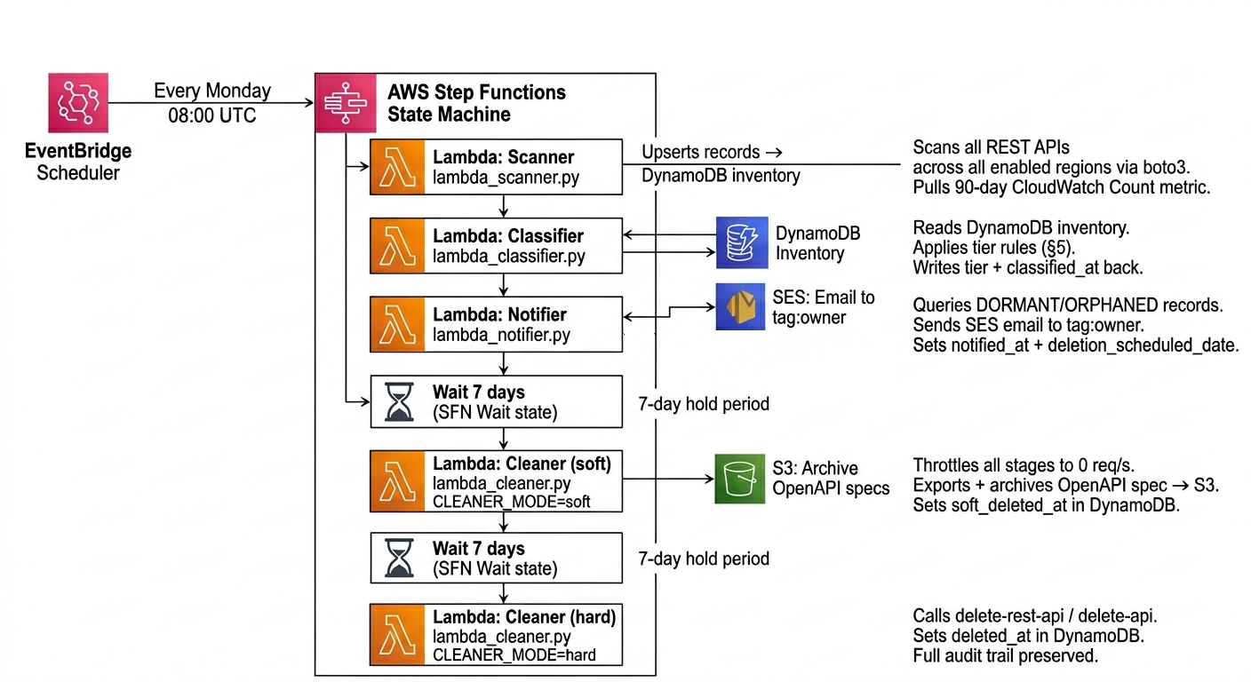

9.2 DynamoDB Inventory Table Schema
Table name: api-gateway-inventory Partition key: api_id (String) | Sort key: region (String) GSI: tier-index on tier (for efficient tier-based queries)
Attribute | Type | Description
`api_id` | String | API Gateway API ID
`region` | String | AWS region
`account_id` | String | AWS account ID
`api_name` | String | Human-readable name
`protocol` | String | `REST`, `HTTP`, `WEBSOCKET`
`created_date` | String | ISO8601 creation date
`last_invocation` | String | ISO8601 of last recorded traffic, or `never`
`invocation_count_90d` | Number | Sum of `Count` metric over 90 days
`has_stages` | Boolean | Whether API has an active stage
`tier` | String | `ACTIVE`, `LOW_TRAFFIC`, `DORMANT`, `ORPHANED`
`classified_at` | String | ISO8601 of last classification run
`owner_email` | String | Resolved from `owner` tag or fallback
`notified_at` | String | ISO8601 of last notification sent
`approved_for_deletion` | Boolean | Owner approval flag
`deletion_scheduled_date` | String | ISO8601 scheduled deletion date
`soft_deleted_at` | String | ISO8601 of throttle-to-zero
`archived_s3_key` | String | S3 key of the exported OpenAPI spec
`deleted_at` | String | ISO8601 of actual hard deletion
`scanned_at` | String | ISO8601 of last scan
`tags` | Map | Raw AWS resource tags

9.3 Configuration Reference
All settings are controlled via environment variables on the Lambda functions (sourced from configs/config.yaml):
Variable | Default | Description
`DYNAMODB_TABLE` | `api-gateway-inventory` | DynamoDB table name
`S3_ARCHIVE_BUCKET` | `api-archive-bucket` | S3 bucket for OpenAPI spec archives
`SES_SENDER_EMAIL` | `apiplatformbau@corebridgefinancial.com` | Verified SES sender
`LOOKBACK_DAYS` | `90` | CloudWatch metric look-back window
`LOW_TRAFFIC_THRESHOLD` | `10` | req/day threshold for LOW_TRAFFIC tier
`DORMANT_DAYS` | `30` | Zero-traffic days before DORMANT
`SOFT_DELETE_WINDOW_DAYS` | `7` | Days between soft and hard delete
`NOTICE_PERIOD_DAYS` | `30` | Days owners have to respond
`ESCALATION_DAYS` | `14` | Days before auto-escalation
`CLEANER_MODE` | `soft` | `soft` or `hard` — set per Lambda invocation

